RELEASE NEW TRACK ‘NIGHTMARES’ FOLLOWING ITS FIRST PLAY ON RADIO 1 (UK) AS CLARA AMFO’S ‘HOTTEST RECORD’

RELEASE THE OFFICIAL VIDEO FOR ‘NIGHTMARES’

LISTEN | WATCH

DEBUT ALBUM ‘MADRA’ OUT JANUARY 26th VIA FAIR YOUTH/ATLANTIC

UK TOUR ANNOUNCED FOR JANUARY/FEBRUARY 2024
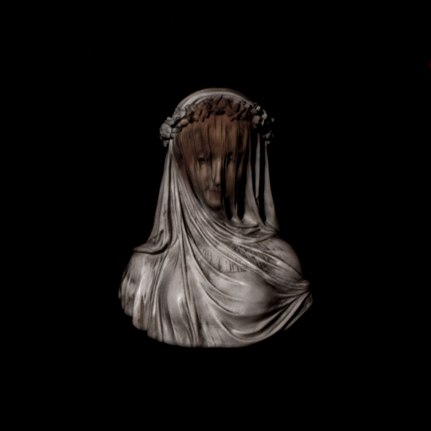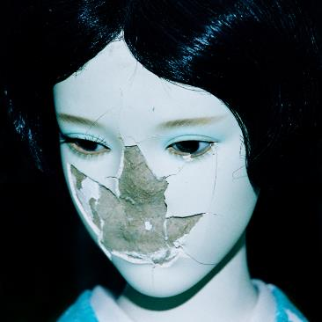
Hi-Res Artwork + Press Images
Irish alt/rock band NewDad have shared their latest track ‘Nightmares’ – the third track to be released from their upcoming album, MADRA. A rousing track that battles with temptation, and also had its premiere on Clara Amfo’s Radio 1 (UK) show earlier this week, Julie Dawson (singer/guitarist) says: “Nightmares is about longing for something or someone, even though you shouldn’t, for whatever reason. It’s about not wanting to fall for someone because you know it’d never work. Basically, just wishing you despised them instead of adoring them.”

The official video was directed by Zack Arlo with Co-Direction by Oliver Day. In their words – “The Irish word for Nightmares is tromluí, meaning trom (heavy; burden; oppression) + luí (lying down; state of rest). We took this as inspiration for the concept of the Nightmares video, given how much the Irish language has inspired the band. As Julie escapes the mundanity of her bedroom, her fate is sealed with the bite of a forbidden plum.”

Announced recently, Madra (meaning “dog” in Irish) is an 11-song, guitar-stacked visceral outing, as singer/guitarist Julie Dawson embarks on a journey of self-exploration, self-sabotage, and reflection. Soaked in dysfunction, Madra searches for solace in pain, tackling themes of bullying, self-medication/depression, destruction, co-dependency and resistance. The album artwork, photographed by Irish creative, Joshua Gordon, shows a broken doll that serves as a metaphor for the album’s themes of fragility and vulnerability. Upon its unveiling, NewDad dropped their grunge-fuelled album opener ‘Angel’ and soon followed-up with ‘Let Go.’

The album finds NewDad reconnect with their musical roots, digging deep into the shoegaze/rock sonics that soundtracked their formative years (the band cite Pixies, The Cure and Slowdive as some of their biggest early influences), together with glimmers of indie/pop that harks back to their earlier material: ‘Waves EP’ (2021) and ‘Banshee EP’ (2022). Written in their home city of Galway, Ireland, before the band moved to London this year, and recorded at the legendry Rockfield Studios (Black Sabbath, Queen), the album has been produced by NewDad’s long-time collaborator Chris W Ryan (Just Mustard) and mixed by Alan Moulder (The Smashing Pumpkins, Nine Inch Nails, Wet Leg). Bound together by Julie’s ghostly vocal - a vessel for her weighty, introspective songwriting – Madra firmly marks NewDad as one of Ireland’s most promising debut guitar bands.

Madra track listing
Angel
Sickly Sweet
Where I Go
Change My Mind
In My Head
Nosebleed
Let Go
Dream Of Me
Nightmares
White Ribbons
Madra

UK & Ireland Tour

DECEMBER 2023
1 - Galway - Roisin Dubh SOLD OUT

FEBRUARY 2024
24 - Leeds - Belgrave Music Hall
25 - Manchester - Band on The Wall
26 - Glasgow - St Luke’s
28 - Dublin - Button Factory SOLD OUT

MARCH 2024
2 - Birmingham - O2 Institute
3 - Bristol - Trinity
5 - London - Koko

About NewDad
Galway-formed band NewDad (a moniker they picked from a random name generator) formed in Galway, Ireland in 2020 after coming together for a musical practical at school, as part of a final year project. It’s a songwriting journey that began at the age of nine, when singer/guitarist Julie Dawson took up guitar after falling for Mexican guitar duo Rodrigo y Gabriele via her parent’s record collection before developing her skill set at various summer camps.

NewDad have released two hyped EP’s previously - Waves (2021) and Banshee (2022) - both of which were produced by Chris W Ryan, with the latter mixed by John Congleton (St Vincent, Phoebe Bridgers). Since signing to Atlantic Records earlier this year, the band have dropped two tracks, ‘In My Head’ (which will feature on their debut) and ‘Break In.’

Part of the Ireland’s fruitful music scene - one that’s generated Fontaine’s D.C, CMAT and Just Mustard over recent years - NewDad are here to remind us of the restlessness, anxieties, and the sometimes-flawed relationships that we’ve all had to navigate throughout our lives. Straddling the autobiographical with the fantastical, the band also draw influence from modern-day cinema/TV and their home city of Galway.

NewDad recently returned to their homeland to playa sold out show at Dublin’s Grand Social. They have previously opened for Paolo Nutini at Alexandra Palace, Fontaines DC at Custom House Square and Inhaler at Fairview Park.

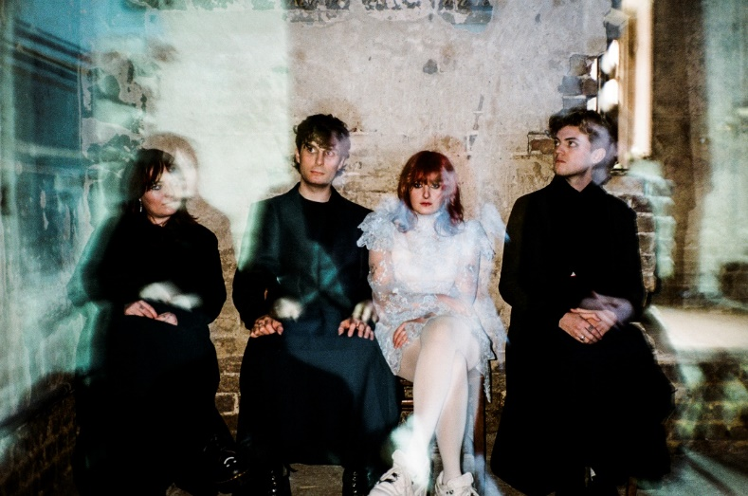
Hi-Res Artwork + Press Images

FOLLOW NEWDAD:
official website | instagram | facebook | youtube | soundcloud | twitter | tiktok

PRESS CONTACT
Christina.Kotsamanidis@atlanticrecords.com

