OLIVER TREE TO JOIN DIPLO ON UNPRECEDENTED JOURNEY TO ANTARCTICA

7-DAY EXPEDITION TO FEATURE EXCLUSIVE DJ SETS FROM DR. OLIVER TREE,
ALONG WITH LIVE PERFORMANCES, AMBIENT SOUND EXPERIENCES, ENGAGING DISCUSSIONS, WELLNESS, AND MORE

ONCE-IN-A-LIFETIME ADVENTURE TAKES PLACE DECEMBER 13-20, 2023;
LIMITED AVAILABILITY STARTS AT $15,999

TREE AND DIPLO FOLLOW METALLICA AS THE ONLY MAJOR MUSICAL ACTS
TO PLAY IN ANTARCTICA

OLIVER TREE PRESENTS: ALONE IN A CROWD NORTH AMERICAN TOUR
BEGINS JANUARY 13, 2024 IN CHICAGO

ACCLAIMED NEW ALBUM, ALONE IN A CROWD, AVAILABLE NOW
VIA ATLANTIC RECORDS
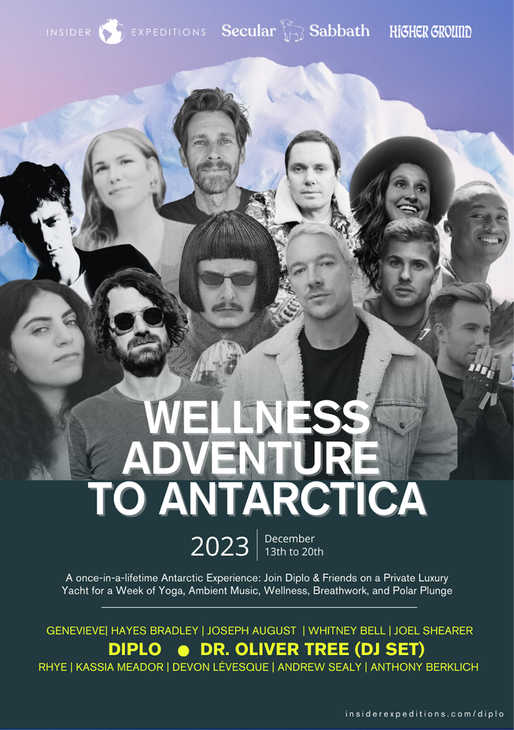
DOWNLOAD GRAPHIC HERE

Oliver Tree, in his guise as DR. OLIVER TREE (DJ SET), will join superstar DJ/recording artist Diplo for an unprecedented journey into one of the most mind-blowing locations on Earth: Antarctica. Presented by Higher Ground and also featuring Secular Sabbath, the 7-day expedition will include live performances, ambient sound experiences, engaging discussions, breathwork, yoga and more, all aboard The World Voyager, the newest and most luxurious vessel in the polar regions. Limited to an intimate group of only 100 people, the once-in-a-lifetime adventure takes place December 13-20, 2023; Limited Availability starts at $15,999. For complete details, please visit insiderexpeditions.com/diplo.

“After countless years of failed attempts, I am finally fulfilling my life long dream to perform in Antarctica. When I spoke to Metallica drummer Lars Ulrich last summer who played there in 2013, his only advice was urging me to go now because it’s about to melt away. I’ll be filming a documentary of my journey and my performances in the South Pole in hopes of bringing awareness and raise money to fight against the climate change that’s rapidly contributed to ocean warming and ice shelf melting which is making Antartica disappear at an alarming rate.
I’ll be riding across the Antartica ocean December 13-20th in a boat with Insider Expeditions where there is limited spots available for the trip of a life time. I am exhilarated to not only be performing some live vocals alongside Diplo but also unveiling my return as a DJ, playing two different dance sets as well as an ambient set I’ve been secretly working on for the past few years under the alias Dr. Oliver Tree. This is the first show I am DJing in 13 years since I opened up for Skrillex in high school at Whobbleland 2011 in San Francisco.”
- Oliver Tree

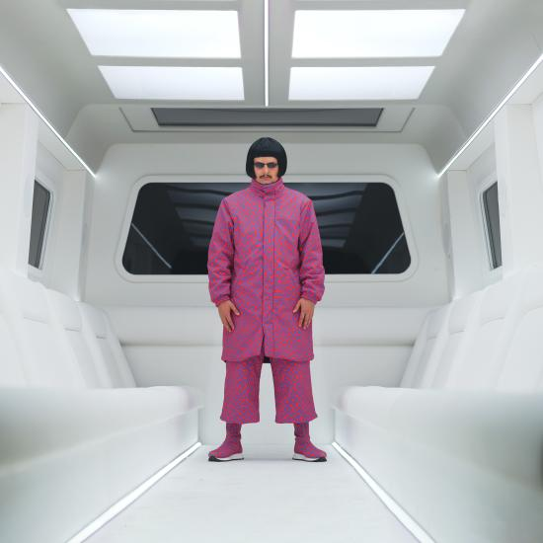
DOWNLOAD PRESS IMAGES

Oliver Tree will follow his extraordinary journey to Antarctica by embarking on the first North American leg of his biggest headline tour to date, OLIVER TREE PRESENTS: ALONE IN A CROWD. Produced by Live Nation, the 13-city run begins January 13, 2024 at Chicago, IL’s historic Byline Bank Aragon Ballroom and then makes additional stops across the US and Canada before concluding February 15 at Los Angeles, CA’s world famous Hollywood Palladium. Special guests include American rock outfit FIDLAR and rapper/songwriter Jasiah. For complete details and ticket availability, please visit www.olivertreemusic.com.

The world-spanning activity follows the recent arrival of Oliver’s third full-length release, ALONE IN A CROWD, available now via Atlantic Records HERE. The album includes such tracks as “Bounce,” “One & Only,” and “With You,” all of which are joined by a trilogy of self-written and directed music videos, filmed in Serbia and following the ongoing adventures of Oliver’s latest character creation, London-based fashion designer Cornelius Cummings.

ABOUT OLIVER TREE
Now boasting more than 4B global streams, over 1B YouTube views, over 14.7M TikTok followers, and an cumulative social reach of over 30M, Oliver Tree satisfies his dedicated and growing audience with Andy Kaufman-esque Dadaist, “meta-humor,” all while continuing to explore and dissect the absurdity of modern culture, obsession with fame, and social media. ALONE IN A CROWD serves to reflect both the light and the darkness of human nature within popular culture while exploring themes of loneliness, disconnect, and the human experience. Among its many highlights are the recently released “Essence,” and “Fairweather Friends,” both accompanied by signature visuals written, created, directed, and edited by the self-proclaimed workaholic himself.

ALONE IN A CROWD also includes last year’s high-energy collaboration with GRAMMY® Award-nominated producer Robin Schulz, “Miss You,” which swiftly amassed over 300M global streams following top 10 debuts on both Billboard’s “Hot Dance/Electronic Songs” chart and the UK’s Official Singles Chart. Recently certified 2x Platinum in Australia as well as Platinum in both the UK and Canada, the track is accompanied by a typically quirky, Oliver Tree-directed official music video, currently boasting more than 237M views via YouTube HERE.

# # #

OLIVER TREE PRESENTS: ALONE IN A CROWD
NORTH AMERICAN TOUR 2024
Produced by Live Nation
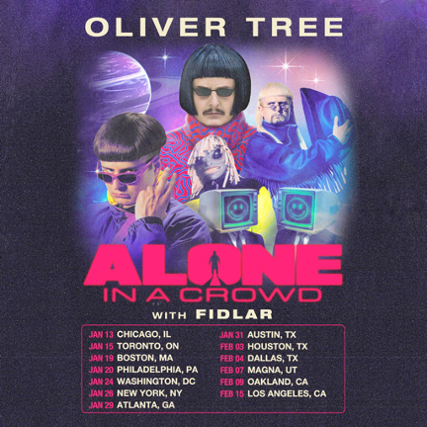

w/ Special Guests FIDLAR and Jasiah (Select Dates)

JANUARY 2024
13 - Chicago, IL - Byline Bank Aragon Ballroom
15 – Toronto, ON - HISTORY – Toronto, ON
19 – Boston, MA - MGM Music Hall at Fenway
20 – Philadelphia, PA - The Met Philadelphia
24 – Washington, DC - The Anthem
26 – New York, NY - Hammerstein Ballroom
29 – Atlanta, GA - Coca-Cola Roxy
31 – Austin, TX - ACL Live at the Moody Theater

FEBRUARY 2024
03 – Houston, TX - 713 Music Hall
04 – Dallas, TX - South Side Ballroom
07 – Magna, UT - The Great Saltair
09 – Oakland, CA - Fox Theater ^
15 – Los Angeles, CA - Hollywood Palladium

^ Not Produced by Live Nation

# # #

CONNECT WITH OLIVER TREE
WEBSITE | FACEBOOK | INSTAGRAM | SPOTIFY | TIK TOK | TWITTER | YOUTUBE
# # #

For All Media Inquiries, Please Contact:
Jessica Nall | jessica.nall@atlanticrecords.com

