FOR IMMEDIATE RELEASE
NOVEMBER 3, 2023

OVERALL RECORDINGS UNWRAPS OVERALLIDAYS

HOLIDAY EP FEATURES FESTIVE NEW FAVORITES AND TIMELESS CLASSICS
FROM OVERALL’S FAMILY OF ARTISTS INCLUDING
DANIEL LEGGS, GNASH, LILY WILLIAMS AND MADDY HICKS

INCLUDES STANDOUT TRACK “DOESN’T FEEL LIKE CHRISTMAS” FROM LILY WILLIAMS

OVERALLIDAYS AVAILABLE NOW VIA OVERALL RECORDINGS/ATLANTIC RECORDS
LISTEN HERE

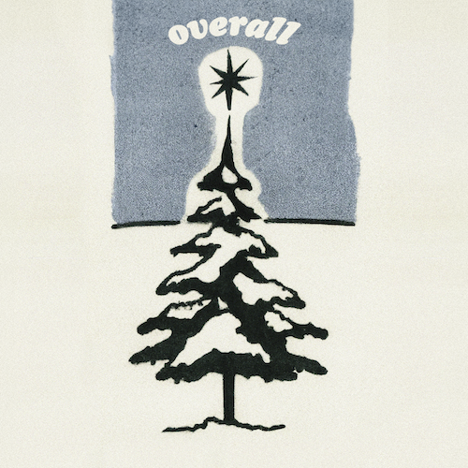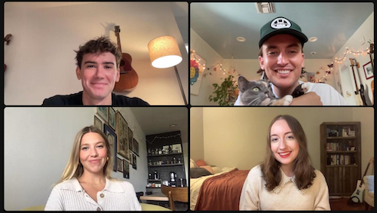
DOWNLOAD ASSETS HERE // CLOCKWISE FROM TOP LEFT: DANIEL LEGGS, GNASH, MADDY HICKS, LILY WILLIAMS

Overall Recordings is unwrapping an early Christmas present with Overallidays, a brand-new holiday EP featuring songs from Overall’s family of remarkable, rising artists, songwriters, and producers, available now via Overall Recordings/Atlantic Records HERE. The six-track collection includes new favorites and timeless classics performed by such gifted performers as 6x RIAA Platinum-certified singer-songwriter gnash, Daniel Leggs, Maddy Hicks, British-born, Southern California-based singer-songwriter Lily Williams, with the standout, heartfelt track “Doesn’t Feel Like Christmas.”

“[‘Doesn’t Feel Like Christmas’] is about spending Christmas five thousand miles away from your family,” says Lily Williams. “I wrote it last November, knowing that I wasn't going home for the holidays. I'm from England, and in my opinion there is nowhere better on earth to be than my home town in the British countryside at Christmas! There's a fire burning, tea and coffee, Christmas tree farms, dancing, carol services, mince pies, and presents! Instead of getting cozy and festive, LA can feel a bit like a ghost town at Christmas because everyone leaves to go visit their families. This song for me is about how my favorite time of year doesn't really feel like it until I'm at home with all the people I love.”

Overallidays – which features songwriting and production from gnash (also known under his birth name of Garrett Nash), Hicks, Leggs, Williams, Michael Blum, Gabe Simon, and Ben Abraham – showcases Overall Recordings’ remarkable roster with such instantly unforgettable tracks as gnash’s rendition of Elvis Presley’s “Blue Christmas” and Daniel Leggs & Maddy Hicks’ take on “What Are You Doing New Year’s Eve?” – the first-ever collaboration between Overall artists. In what will surely be the first of many, Overallidays wishes everyone a very happy holiday season and spreads the joy into the new year.

“With Overallidays, we wanted to showcase all of our amazing artists in a new light,” says gnash, “one with some twinkle. We hope these songs find a home in your holiday playlists and bring warm cheer all year round.”

# # #

OVERALLIDAYS EP
(Overall Records/Atlantic Records)

Tracklist:
Lily Williams – Doesn’t Feel Like Christmas
Daniel Leggs & Maddy Hicks – What Are You Doing New Year’s Eve?
Maddy Hicks – December
Daniel Leggs – Linus And Lucy
Lily Williams – O Little Town Of Bethlehem
gnash – Blue Christmas

# # #

CONNECT WITH OVERALL RECORDINGS
WEBSITE | INSTAGRAM | THREADS

CONNECT WITH DANIEL LEGGS
OFFICIAL | INSTAGRAM | SOUNDCLOUD | TIKTOK | TWITTER | YOUTUBE

CONNECT WITH GNASH
WEBSITE | FACEBOOK | INSTAGRAM | TIKTOK | TWITTER | YOUTUBE

CONNECT WITH LILY WILLIAMS
WEBSITE | FACEBOOK |INSTAGRAM |TIKTOK | TWITTER | YOUTUBE

CONNECT WITH MADDY HICKS
WEBSITE | INSTAGRAM | TIKTOK | YOUTUBE

