FOR IMMEDIATE RELEASE
NOVEMBER 3, 2023

SIR CHLOE RETURNS WITH “HOME WHERE”

EVOCATIVE NEW SINGLE FOLLOWS CRITICALLY-ACCLAIMED DEBUT ALBUM, I AM THE DOG

“HOME WHERE” AVAILABLE NOW VIA ATLANTIC RECORDS
LISTEN HERE

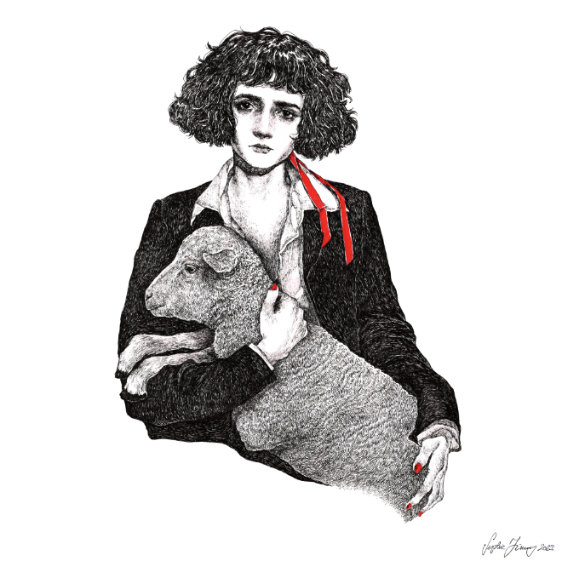
DOWNLOAD HI-RES IMAGE

Sir Chloe – the acclaimed project of vocalist, songwriter, and guitarist Dana Foote – is back with the mesmerizing new single, “Home Where,” available now via Atlantic Records HERE.

Sir Chloe celebrated a whirlwind year with I Am The Tour, highlighted by sold-out headline dates in North America and Europe, as well a special guest run on the epic Phoenix and Beck co-headline tour alongside Japanese Breakfast, Weyes Blood, and Jenny Lewis. For updates, please visit www.sirchloemusic.com/tour.

“Home Where” continues the path struck by Sir Chloe’s acclaimed debut album, I Am The Dog. Produced by GRAMMY® Award-winner John Congleton (Lana Del Rey, St. Vincent, Angel Olsen) with songwriting contributions from Teddy Geiger (Caroline Polachek, Sylvan Esso, Lizzo) and Sarah Tudzin (Weyes Blood, Amen Dunes, Slowdive), the album includes such thrillingly paradoxical singles as “Should I,” “Salivate,” “Hooves,” and “Know Better,” the latter of which proved a favorite at Triple A radio outlets nationwide.

Anchored by Foote’s emotional songcraft and dynamic voice, I Am The Dog was met by critical applause around the world including NPR, Rolling Stone, and with The Line of Best Fit declaring it “Sir Chloe’s most developed and intricate release to date” in a 9-out-of-10 review, adding, “The tongue-in-cheek and aloof record finds its roots in covert sapphic, and paradoxical narratives, kaleidoscopic soundscapes and cool, grunge-fueled vocals. Complete with obscure and frank lyricism, I Am The Dog staples itself as a strong entry amongst this year’s releases.” “A fast-paced and cool sound that should only be played at max volume,” raved Flaunt. “Foote’s voice is effortless, unbothered, yet emotionally vigorous.” “It’s grungy, it’s shoegazey, it’s weird,” wrote DIY. “It’s not afraid to go off-piste. It’s full of guitar lines that are simultaneously super clean and gut-wrenching…Sir Chloe have perfectly grasped the entire concept of anticipation, building up and dropping out at the flick of a switch, never sticking to the status quo.”

ABOUT SIR CHLOE
Now boasting over 500M worldwide streams, Dana Foote put Sir Chloe together in college to serve as her senior thesis, going on to write the band’s first major hits in “Michelle” (211M) and “Animal” (93M) on the floor of her dorm room. Sir Chloe’s 2020 EP, Party Favors, was recorded in a warehouse that the band transformed into a recording space with just one hundred dollars and sheer will. Following the success of the EP (which earned over 200M global streams) and two additional singles in 2022, Sir Chloe – which consists of Foote, Emma Welch, Teddy O’Mara, Palmer Foote, and Austin Holmes – toured arenas with Portugal. The Man and alt-J, supported Pixies, Phoenix and Beck, and headlined two tours of their own in the United States and Europe, with sold-out stops in New York, Los Angeles, London, Paris, Amsterdam, and more. In addition, Foote has been profiled in such publications as Vogue and PAPER, was featured in a recent campaign for Harry Styles’ Pleasing lifestyle brand and is also slated to be in an upcoming modeling campaign for Prada.

# # #
CONNECT WITH SIR CHLOE
OFFICIAL | FACEBOOK | INSTAGRAM |SPOTIFY | TIKTOK | TWITTER | YOUTUBE

CONTACT
Jessica Nall / Jessica.Nall@atlanticrecords.com
Libby Kober / Libby.Kober@atlanticrecords.com

