FOR IMMEDIATE RELEASE
NOVEMBER 2, 2023

FLOWERKID UNVEILS SURPRISE NEW EP
LET IT BE ENOUGH

LISTEN HERE

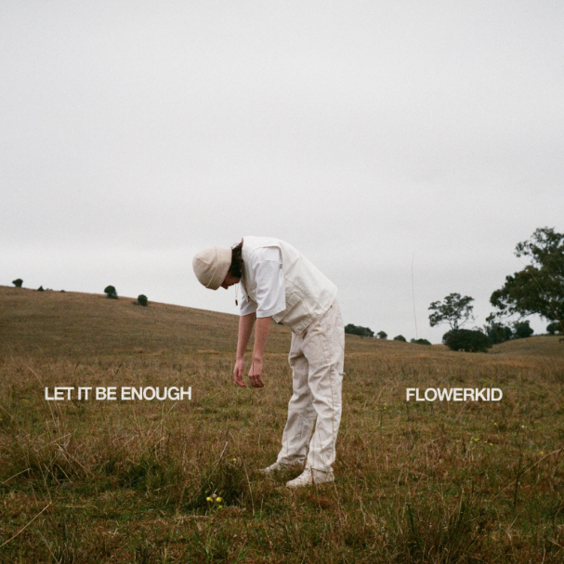
DOWNLOAD ASSETS HERE
PRESS PHOTO SUPPLIED BY flowerkid

Today flowerkid AKA Flynn Sant has surprised released his second EP LET IT BE ENOUGH – Listen HERE. The hauntingly beautiful body-of-work includes seven brand new songs. To explain where he’s been over the past couple of months following the release of “Diss & Disappoint,” and to introduce this EP, Flynn has written a letter directly to the listener.

“Hi everyone,

If i’m being honest, I don’t even know where to start. I have been bottling these feelings inside me for so long out of fear that I wouldn’t receive support, but I always preach to you all that being honest and being vulnerable is the best way to overcome life's hurdles. So here it goes. This past year has taken me through the motions. Gradually my strength has deteriorated and I have been left feeling so weak and scared. This year alone, I have received an enormous amount of online harassment and hate for simply being who I am. I have always tried to be the strongest I can be, but these things have really taken a toll on me. The hate I have received has made me withdraw from people, life, and the things I love most. I have been terrified to post ANYTHING because these people’s words have just kept hitting me where it hurts. I was always so embarrassed to share this, because the way I saw it, it made me look ‘weak’ or too ‘sensitive’. Not releasing music and not posting made me feel like I was failing. But I am officially done with this mindset. I AM A HUMAN BEING. I AM NOT A MACHINE. I HAVE FEELINGS. After a long break from posting and releasing music this year, I am finally ready to come back. My own insecurities that were born from this hate, are no longer going to hold me back from doing what I love. So I will officially be releasing an EP that I’ve had under wraps for a long time. This collection of songs means so much to me, and I am itching to bring it to your ears. My second EP, ‘LET IT BE ENOUGH’ will be on all streaming platforms on the 2nd of November. To those who have supported me no matter what, I truly thank you. You are the people that keep me going.

All my love,
Flowerkid”

CONNECT WITH FLOWERKID:
FACEBOOK | INSTAGRAM | OFFICIAL WEBSITE

CONTACT:
Andrew George // Andrew.George@AtlanticRecords.com

