FOR IMMEDIATE RELEASE
NOVEMBER 10, 2023

OHGEESY SHARES WITH FANS WITH NEW SINGLE “MAX PAYNE”

LOS ANGELES-BASED RAP SENSATION PAYS HOMEAGE TO
ACTION-PACKED, CRIME-FILLED VIDEO GAME SERIES

LISTEN TO THE SINGLE HERE | WATCH THE MUSIC VIDEO HERE

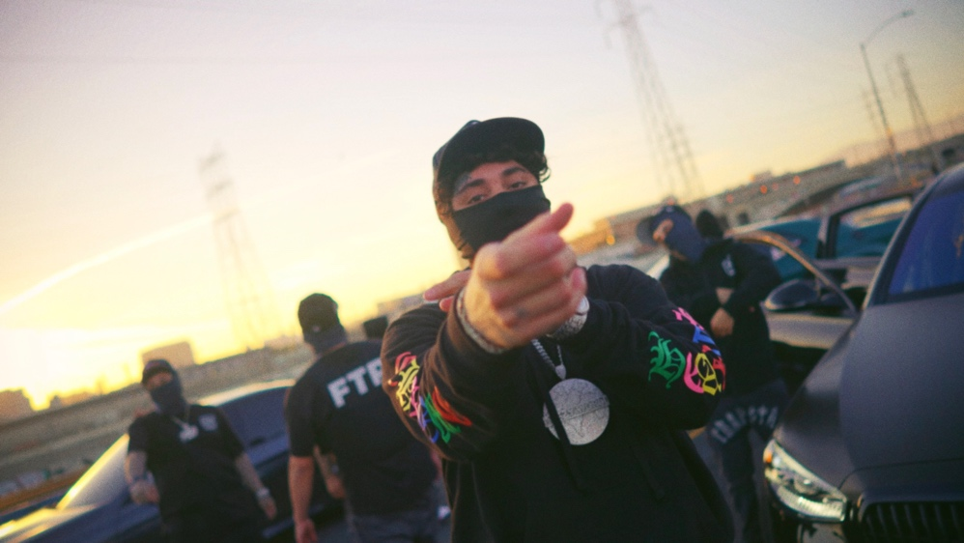
DOWNLOAD HI-RES THUMBNAIL HERE

Multiplatinum Los Angeles rap hero OHGEESY drops visuals for his newest single, “Max Payne”. Based off the detective-turned-vigilante video game, OHGEESY gives viewers a glimpse into his enticing, fast-paced lifestyle. The single can be streamed HERE and the official visual can be viewed HERE.

OHGEESY recently wrapped his True Religion Presents GW2 Tour, which celebrated his highly acclaimed GEEZYWORLD 2. GEEZYWORLD 2 includes the breakout hit single, “GEEKALEEK (Ft. Cash Kidd),” as well as the special bonus remix, “GEEKALEEK REMIX (Ft. BIA).” The project additionally features “Games (Ft. Bino Rideaux & 03 Greedo),” features from Kalan.FrFr, Chrishan, Kamaiyah, Guapo, and Mozzy, and such anthems as “Gallery,” “Knock Knock,” “Up, “1st Day of School,” and “Chrome Hearted (Ft. Tyga),” all of which are joined by official music videos currently boasting a combined 10M+ views via YouTube alone.

ABOUT OHGEESY:
California never gave rise to a rapper quite like OHGEESY. The Los Angeles-born Mexican American multiplatinum artist, entrepreneur, and visionary not only continues the legacy of his hometown, but he also puts a whole culture rarely represented in hip-hop on his back with pride, poise, and power. As such, he emerges as a trailblazer with vicious wordplay, vibrant storytelling, and a vital message. Breathing new life into the culture, he co-founded Shoreline Mafia during 2016. He locked down the group’s legacy with the double-platinum “Bands,” platinum-certified “Musty” and “Nun Major,” and the gold-certified “Bottle Service” and “Whuss The Deal.” During 2021, he served up his solo debut, GEEZYWORLD, which led him to his first sold-out tour. Among many highlights, “Get Fly” [feat. DaBaby] raked in over 37 million Spotify streams, while “Keeper” [feat. A Boogie Wit Da Hoodie] posted up 23 million Spotify streams. Right out of the gate, Pitchfork proclaimed, “GEESY is well placed to thrive as a lone star. GEEZYWORLD is a quintessential L.A. rap record.” On its heels, he supported the release with a massive sold-out headline tour. His world as a rising super star has expanded to include exclusive merchandise with his line OTXBOYZ sold through his GEEZYWORLD web site. At the same time, he co-owns Mexican seafood spot Sunset Mariscos inside of the famed Fred Segal store in West Hollywood. Posting up hundreds of millions of streams and attracting widespread praise from GQ, Complex, UPROXX, XXL, OkayPlayer, and HotNewHipHop, he instigates another era for the West on GEEZYWORLD 2 released on May 5th. Lead single, “Up,” bass thumps through ominous piano as the punchy production underlines his laidback flow. Produced by DJ Vision, a cinematic samurai-style guitar loop dissolves into a glitchy beat on “Knock Knock. The highest streaming record to date at 14.7 million global streams from the upcoming project, “GEEKALEEK (Feat. Cash Kidd),” samples Petey Pablo’s 2003 smash, “Freek-a-Leek.” Elsewhere, he teams up with Tyga bringing South Central heat to the hypnotic “Chrome Hearted,” as well as trading bars with another current West Coast leader, Kalan.Fr.Fr on “Saturday.” Fittingly, GEEZYWORLD 2 ends with the introspective “Shoebox” [feat. Mozzy], while other features on the project include acts such as Kamaiyah, Bino Rideaux, 03 Greedo and Mozzy.
# # #

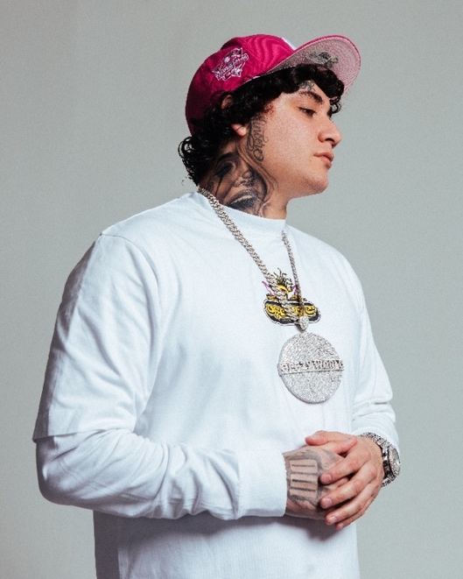
DOWNLOAD HI-RES PRESS IMAGE HERE // PHOTO CREDIT: EMILIO SANCHEZ

CONNECT WITH OHGEESY
OHGEESYOFFICIAL.COM | FACEBOOK | INSTAGRAM | TWITTER | YOUTUBE

PRESS CONTACT
BRITTANY BELL | BRITTANY.BELL@ATLANTICRECORDS.COM

