DAISY JONES & THE SIX RELEASE AURORA SUPER DELUXE – FOLLOWING GRAMMY® NOMINATION FOR BEST COMPILATION SOUNDTRACK FOR VISUAL MEDIA

NEW EXTENDED ALBUM FEATURES PREVIOUSLY UNRELEASED TRACKS – OUT NOW IN PHYSICAL + DIGITAL FORMATS

BUY/STREAM HERE | ORDER ON VINYL, CASSETTE + CD HERE

CO-WRITTEN & PRODUCED BY GRAMMY® AWARD-WINNER BLAKE MILLS
BUY/STREAM AURORA (ORIGINAL) HERE | PURCHASE ON VINYL HERE

9x EMMY-NOMINATED LIMITED SERIES ADAPTATION OF NEW YORK TIMES BESTSELLING LITERARY PHENOMENON OUT NOW ON PRIME VIDEO; PRODUCED BY AMAZON MGM STUDIOS AND HELLO SUNSHINE

“…classic rock sensibilities with an effortlessly modern feel...” – VARIETY

“Aurora is an unprecedented project for a book-to-screen adaptation and musical storytelling on television.” – ENTERTAINMENT WEEKLY

“Stillwater walked so Daisy Jones & The Six could stage-dive… the harmonies on ‘Look At Us Now (Honeycomb)’ are infectious… you can imagine that The Six really were the biggest band in the world for a minute.” – ROLLING STONE

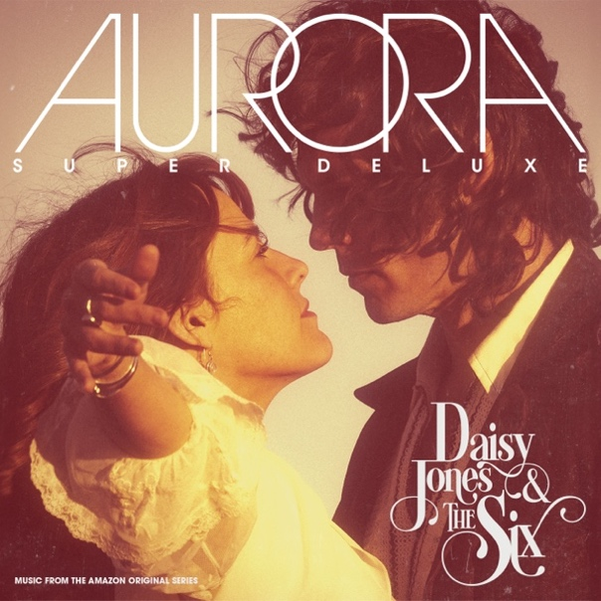
download hi-res artwork here

December 1, 2023 – Atlantic Records is proud to release Aurora Super Deluxe, a 25-track, ultra-extended version of the debut album from Daisy Jones & The Six. The new version arrives on DSPs and in all-new physical formats today, Friday, December 1 – buy/stream here + order on vinyl, cassette, and CD here.

Today’s release follows last month’s exciting news that Aurora (the original album from Daisy Jones & The Six) was honored with a 66th Annual GRAMMY® Award Nomination for Best Compilation Soundtrack for Visual Media.

Aurora Super Deluxe includes all 11 cuts from the GRAMMY®-nominated LP, plus beloved standalone singles such as “Aurora (Live from SNL),” Demi Lovato’s electric rendition of “Let Me Down Easy,” and Maren Morris + Marcus Mumford’s stunning reimagination of “Look At Us Now (Honeycomb).” Rounding out the expanded tracklist is Daisy Jones’s revered solo track, “It Was Always You,” plus early material from The Dunne Brothers.

Co-written and produced by GRAMMY®-winning songwriter, producer, and multi-instrumentalist Blake Mills (Bob Dylan, Fiona Apple, Alabama Shakes, John Legend, Perfume Genius), Aurora Super Deluxe arrives in response to fans’ continued massive demand for new music – a demand which has only increased since the Prime Video Original Series’ final episodes aired in late March.

Daisy Jones & The Six’s growing catalog has amassed over 260 million global streams across platforms thus far.

Taken from page to screen to recording studio, Aurora – the original, 11-song record – marked the debut LP from the titular band of Taylor Jenkins Reid’s beloved, New York Times bestselling novel Daisy Jones & The Six.

Aurora was released to tremendous acclaim from critics and fans alike in early March, debuting at #1 on Billboard’s Soundtracks chart, #4 on the Billboard Vinyl Albums & Americana/Folk Albums charts, #9 on Top Current Albums, #10 on Top Albums, and more. Daisy Jones & The Six themselves debuted at #1 on Billboard’s Emerging Artists chart – becoming the first act from a scripted series or film to do so. (They also became the first such act to hit #1 on the iTunes Top Albums chart.)

With over 25 original songs, co-written by GRAMMY®-winning songwriter, producer, and multi-instrumentalist Blake Mills, Aurora and other music from throughout Daisy Jones & The Six boasts co-writing credits from several of the biggest names in music, including Marcus Mumford and Jackson Browne, with additional production from renowned record producer Tony Berg (Phoebe Bridgers, Andrew Bird), and alongside instrumentalists from The Who, Nine Inch Nails, Pearl Jam, David Bowie, Elton John, Jeff Beck, The Wallflowers, and more. Other co-writers on Aurora include Chris Weisman, Ethan Gruska, and Z Berg, among others.

‘Daisy Jones & The Six’ debuted as the #1 Prime Video series upon its March 3 premiere, and boasted a massive 1.5 billion social impressions within the first 3 days of the show’s rollout (watch all ten episodes of the limited series here). The highly-anticipated series arrived via Amazon MGM Studios and Reese Witherspoon’s media company Hello Sunshine, who optioned Reid’s work in 2018 – before Daisy Jones & The Six ever even hit bookshelves. Upon the novel’s release in early 2019, it received coveted recognition as a ‘Reese’s Book Club Pick.’

In July, the series received a standout 9 Primetime Emmy Award nominations, including for Outstanding Limited or Anthology Series, Outstanding Lead Actress in a Limited or Anthology Series or Movie (Riley Keough), and Outstanding Music Supervision (Frankie Pine).

###

DAISY JONES & THE SIX – AURORA SUPER DELUXE TRACKLIST:
- Aurora
- Let Me Down Easy
- Kill You To Try
- Two Against Three
- Look At Us Now (Honeycomb)
- Regret Me
- You Were Gone
- More Fun To Miss
- Please
- The River
- No Words
- Look At Us Now (Honeycomb) [Acoustic Demo]
- Regret Me (Acoustic Demo)
- Let Me Down Easy (Acoustic Demo)
- The River (Acoustic Demo)
- Look At Us Now (Honeycomb) [Live from Soldier Field – 1977]
- Look Me In The Eye (The Dunne Brothers feat. Daisy Jones) [Live from Diamond Head Festival – 1975]
- The River (feat. Simone Jackson) [Live from Soldier Field – 1977]
- Ooh La La (Cassette Singalong)
- Aurora (Live from SNL)
- Daisy Jones – It Was Always You
- The Dunne Brothers – Flip The Switch (Eddie’s Version)
- The Dunne Brothers – Susie Q (Live)
- Maren Morris & Marcus Mumford – Look At Us Now (Honeycomb)
- Demi Lovato – Let Me Down Easy

ABOUT DAISY JONES & THE SIX – THE LIMITED SERIES:
Based on the best-selling novel by Taylor Jenkins Reid, Daisy Jones & The Six is a limited musical-drama series detailing the rise and precipitous fall of a renowned rock band. In 1977, Daisy Jones & The Six were on top of the world. Fronted by two charismatic lead singers—Daisy Jones (Riley Keough) and Billy Dunne (Sam Claflin)—the band had risen from obscurity to fame. And then, after a sold-out show at Chicago's Soldier Field, they called it quits. Now, decades later, the band members finally agree to reveal the truth. This is the story of how an iconic band imploded at the height of its powers.

The series stars Riley Keough as Daisy Jones, Sam Claflin as Billy Dunne, Camila Morrone as Camila Dunne, Will Harrison as Graham Dunne, Suki Waterhouse as Karen Sirko, Josh Whitehouse as Eddie Roundtree, Nabiyah Be as Simone Jackson, and Tom Wright as Teddy Price, with a special guest appearance by Timothy Olyphant as Rod Reyes.

From Amazon MGM Studios and Hello Sunshine, Daisy Jones & The Six is executive produced by Reese Witherspoon and Lauren Neustadter for Hello Sunshine and Brad Mendelsohn for Circle of Confusion. Scott Neustadter and Michael H. Weber created the series based on the novel by Taylor Jenkins Reid, who also produces. Scott Neustadter is executive producing and co-showrunning with Will Graham, who also serves as an executive producer. James Ponsoldt directed the first five episodes and serves as an executive producer, Nzingha Stewart directed four of the remaining episodes, and Graham directed one.

Daisy Jones & The Six premiered March 3, with new episodes releasing every Friday through March 24, exclusively on Prime Video in more than 240 countries and territories worldwide. For more information, visit the Amazon MGM Studios Press Site.

***

CONNECT WITH DAISY JONES & THE SIX
WEBSITE | FACEBOOK | X | INSTAGRAM | YOUTUBE | TIKTOK

***

Atlantic Records Press Contact:
Libby Kober | Libby.Kober@atlanticrecords.com

Prime Video Press Contacts:
Melissa Armstrong | Melissa.Armstrong@amazonstudios.com
Kevin McAlpine | Kevin.McAlpine@amazonstudios.com
Reegan Smyth | Reegan.Smyth@amazonstudios.com

