Fred again.. joins forces with Baby Keem
on new single
‘leavemealone’

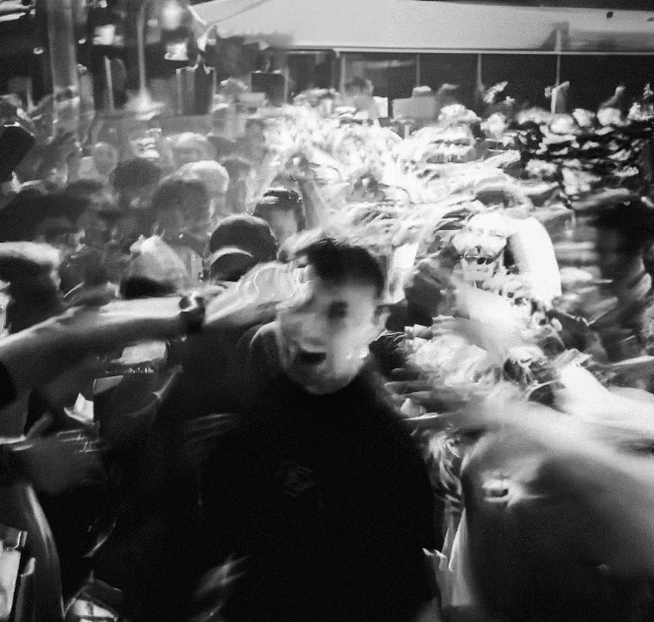
DOWNLOAD ARTWORK HERE

LISTEN HERE

Fred again.. has teamed up with Baby Keem to close out 2023 with new single, “leavemealone.”

Listen to “leavemealone” HERE.

Following quick on the heels of recent single “ten” with Jozzy, and tender late-summer anthem ”adore u” with Obongjayar, “leavemealone” sees Fred join forces with Baby Keem for the first time on a record long-teased in his sets.

Baby Keem shot to prominence as a rapper and record producer in the late 2010s after contributing songs to the Black Panther (2018) movie soundtrack and producing tracks for both Schoolboy Q and Beyonce’s soundtrack album, The Lion King: The Gift. He released his debut mixtape, ‘The Sound of Bad Habit’, in 2018, before ushering in his acclaimed debut album, ‘The Melodic Blue’, in 2021 – a record that spawned GRAMMY-winning single ‘Family Ties’, featuring Kendrick Lamar.

“leavemealone” is out now: https://fredagain.lnk.to/leavemealone

Fred again.. in 2023
Last autumn, Fred again.. released his GRAMMY-nominated Actual Life 3 (January 1 - September 9 2022). 2023 saw Fred kickstart the year by joining forces with Skrillex & veteran grime MC, Flowdan, on Skrillex single ‘Rumble’ in January – which was teased during his Boiler Room debut last summer and is now nominated for the 2023 GRAMMY award for Best Dance/Electronic Recording.

After playing a series of pop-up shows in London alongside Skrillex and Four Tet later that month, the trio then went on to sell-out the iconic Madison Square Garden in New York in February – over 19,000 tickets were sold in less than 10 minutes – and later headline the final night of Coachella, playing to over 125,000 people and an additional 3+ million who have since re-watched their set on YouTube.

Elsewhere in 2023, Fred also recorded a special Tiny Desk Concert for NPR in April, which saw him relearn the marimba, play a vibraphone, sit at a piano and loop beats on his laptop simultaneously, while in May, he joined forces with Brian Eno on ‘Secret Life’ – a surprise-drop 13 track ambient album released on Four Tet’s Text Records imprint.

In June Fred made his Glastonbury debut which pulled in one of the largest crowds in the Other Stage’s history, before going on to sell-out a total of 5x shows at London’s Alexandra Palace in just one week back in early September. This was followed up by a sold-out EU tour run, before heading to the US to play 3x sold-out shows at NY’s Forest Hills Stadium and a further 9x sold-out shows at LA’s Shrine Expo Hall. Most recently, Fred was nominated for four GRAMMY awards including Best New Artist, Best Dance/Electronic Album for Actual Life 3 and Best Dance/Electronic Recording for “Rumble” with Skrillex and Flowdan and “Strong” with Romy.

CONNECT WITH Fred again..
OFFICIAL SITE / INSTAGRAM / TIK TOK

CONNECT WITH BABY KEEM:
INSTAGRAM / TWITTER / FACEBOOK / YOUTUBE

CONTACT
Kelly McWilliam // Kelly.McWilliam@atlanticrecords.com

