FOR IMMEDIATE RELEASE
NOVEMBER 29, 2023

R&B SENSATION JOSH LEVI SHARES SPECIAL HOLIDAY GIFT WITH “LET IT SNOW”

FESTIVE SINGLE DROPS AS LEVI’S “BIRTHDAY DANCE” BECOMES A TIK TOK SENSATION AFTER HALLOWEEN DANCE CLIP GOES VIRAL HERE

LISTEN TO “LET IT SNOW” HERE | WATCH THE OFFICIAL LIVE PERFORMANCE HERE

DISC TWO (SCRATCHED UP) AVAILABLE NOW VIA RAEDIO/ATLANTIC RECORDS HERE

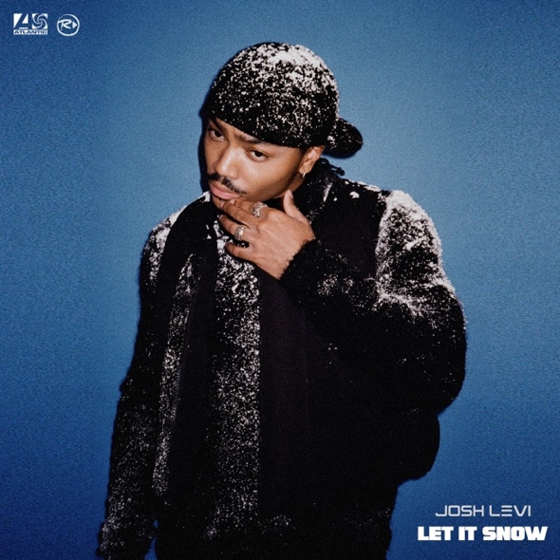
DOWNLOAD OFFICIAL ARTWORK HERE

R&B sensation Josh Levi treats fans with a special rendition of the holiday classic, “Let It Snow”, available now via Raedio/Atlantic Records HERE. The soulful single is joined with an official live performance available HERE (thumbnail available HERE).

In addition to the release of his holiday single, Levi has been receiving social media viral status for his festive record, “Birthday Dance”. The esteemed vocalist sparked a trend of dancing to his single after posting a hilarious Tik Tok, embracing the Halloween spirit in a Chuck E. Cheese costume. The viral video has amassed over 3.3M views and the official sound for “Birthday Dance” has exceeded 6.8K creates on the app. Levi has gained over 16K followers since the song’s initial viral moment, bringing him to over 400K followers on Tik Tok and counting.

Levi dropped DISC TWO (SCRATCHED UP) earlier this year, adding three brand new tracks to his acclaimed 2022 EP, DISC TWO. The expanded deluxe edition includes “Birthday Dance,” “SEE LOW,” a sped-up reworking of DISC TWO’s hit single, “ALL OVER AGAIN,” and the braggadocious “EGO,” the latter accompanied by a high-energy ESTA. Remix (available HERE). To celebrate the release of this deluxe project, Levi participated in an exclusive interview on Apple Music’s The Travis Mills Show as well as stunning one-take live performances of “EGO“ and “SEE LOW“ for The EYE Sessions.
Levi, known for his astounding live performances, was also featured on The Recording Academy’s “Reimagined” series, where he performed a sublime rendition of Jazmine Sullivan’s GRAMMY® Award-nominated hit single, “Lions, Tigers & Bears”. Levi’s live performance of “Lions, Tigers & Bears (ReImagined)” is now available on DSPs HERE

Levi’s sophomore EP, DISC TWO, includes hit track “VICES“, a personal favorite of Justin Bieber (who shared the song on his Instagram feed and story), with additional acclaim on GRAMMY.com‘s “R&B Is Alive And Well“ playlist, accompanied by an exclusive feature which named Levi among the next-gen R&B “Artists Who Are Pushing The Genre Forward,” hailing him for his “soulful and electric sounds.” DISC TWO also includes such powerhouse singles as “NASA,” “DON’T THEY REMIX (FEAT. NORMANI)“ and “SHE KEEPS COMIN,” the latter joined by an astonishing self-shot live performance video streaming via YouTube HERE. Levi marked DISC TWO with his first ever headline tour run to date, “The VICES Tour,” kicking off with a sold-out show at Los Angeles, CA’s Peppermint Club and followed by full houses in San Francisco, Chicago, Houston, New York, Atlanta, and other major markets across the country.

Named by PEOPLE as one of “25 Emerging Musical Artists You Should Add to Your Playlist,” Los Angeles-based singer, songwriter, and actor Josh Levi immediately captivates with each inhale of experience and exhale of emotion. Levi’s voice is featured on the GRAMMY® Award-nominated, RIAA Gold-certified worldwide smash, “Nobody Like U,” as Aaron Z, a member of the teenage heartthrob boyband 4*Town in Disney/Pixar’s blockbuster Turning Red. Levi’s 2020 debut EP, DISC ONE – highlighted by such tracks as “IF THE WORLD”– earned high profile media attention from the likes of Billboard, Wonderland, V, and Earmilk, in addition to the attention of Issa Rae’s label imprint, Raedio, featuring his 2021 single, “What’s The Use,” on the soundtrack to her critically acclaimed HBO Series, Insecure: Season 5. The track proved an instant smash for Levi, named by Billboard at #6 on their “Tunefind Top TV/Movie Syncs of 2021.”

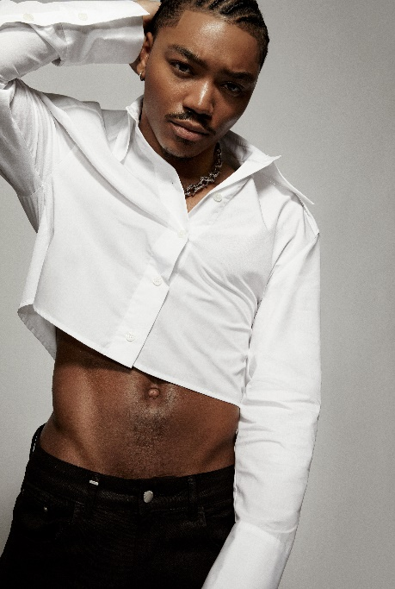
DOWNLOAD HI-RES PRESS IMAGE HERE | PHOTO CREDIT: BLAIR CALDWELL

CONNECT WITH JOSH LEVI
OFFICIAL | FACEBOOK | INSTAGRAM | TIKTOK | TWITTER | YOUTUBE

PRESS CONTACT:
Brittany Bell | Brittany.Bell@atlanticrecords.com

