FOR IMMEDIATE RELEASE
DECEMBER 1, 2023

TANNER USREY UNVEILS THE CROSSING LINES TOUR

RISING ALT-COUNTRY TROUBADOUR SET FOR BIGGEST HEADLINE RUN THUS FAR KICKING OFF JANUARY 5 IN COLORADO SPRINGS, CO

HIGHLIGHTS INCLUDE EAGERLY AWAITED HEADLINE DEBUTS AT SUCH LEGENDARY VENUES AS NYC’S BOWERY BALLROOM AND NASHVILLE’S BASEMENT EAST

TICKETS ON SALE NOW HERE

ACCLAIMED DEBUT ALBUM, CROSSING LINES, AVAILABLE NOW VIA ATLANTIC RECORDS

LISTEN TO CROSSING LINES

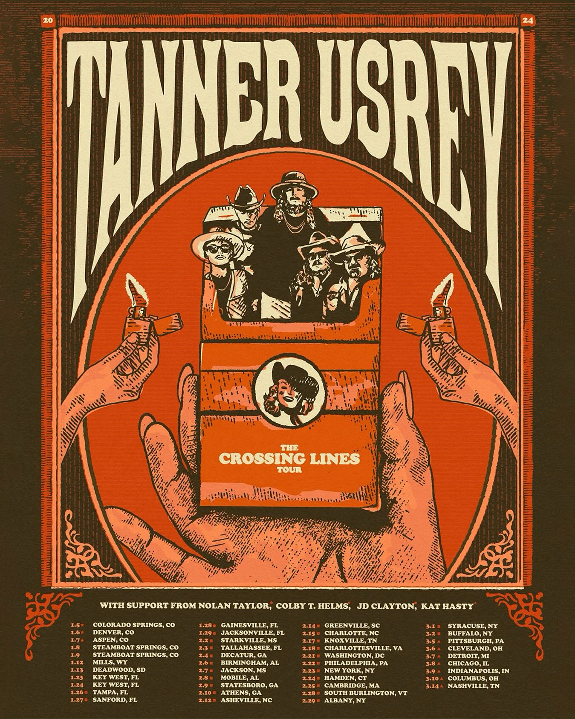

“Tanner Usrey is a star on the brink of shooting across the sky.” – WHISKEY RIFF

“Usrey is rugged to the bone and real as they come…It’s humility, debauchery and redemption all wrapped into one.” – HOLLER

“Tanner Usrey is a quick riser in the Texas country world.” – THE COWBOY CHANNEL

“There are very few artists in country music today who have the ability to bend genres and styles quite like Tanner Usrey.” – COUNTRY CHORD

Rising Texas-based country star Tanner Usrey has announced plans for an epic US tour – his biggest headline run to date. The Crossing Lines Tour gets underway January 5 at Colorado Springs, CO’s Boot Barn Hill and then continues through his eagerly awaited headline debut at Nashville, TN’s legendary Basement East on March 14. Highlights include stops at such famed venues as Aspen, CO’s Belly Up (January 7), Athens, GA’s 40 Watt Club (February 10), New York City’s Bowery Ballroom (February 23), South Burlington, VT’s Higher Ground (February 25), and Cleveland, OH’s Beachland Ballroom & Tavern (March 6). Support throughout includes Nolan Taylor, Colby T. Helms, JD Clayton, and Kat Hasty. Tickets for all announced dates are on sale now. For complete details, please visit www.tannerusreymusic.com/tour-dates.

The Crossing Lines Tour celebrates the acclaimed arrival of Usrey’s much anticipated debut album, Crossing Lines, available now via Atlantic Records HERE. Produced by Beau Bedford (Orville Peck, Paul Cauthen, The War and Treaty), Crossing Lines is highlighted by a brand new version of Usrey’s breakout hit, “Beautiful Lies,” now featuring rising country songstress Ella Langley. The collaboration received immediate praise from Billboard, which named it among the week’s “8 Must-Hear Country Songs,” writing, “Usrey trades in resignation rather than angst here, layered with Langley’s impassioned drawl, as they sing about a self-destructive relationship…Their harmonies are pristine, soaring over understated guitar and softened percussion. A superb pairing of two earnest vocalists.” “Beautiful Lies” is joined by the duo’s official performance video, streaming HERE. Crossing Lines further features such critically acclaimed singles as “Crossing Lines,” “Destiny,” “Who I Am,” “Last Goodbye,” and this spring’s label debut, “Give It Some Time,” all available now at all DSPs and streaming services.

An electrifying and energetic live presence who played over 180 shows in 2022 alone, Usrey has proven just as unrelenting in recent months, traveling on a non-stop live schedule which has included headline shows, festival appearances, and dates alongside Charles Wesley Godwin, Turnpike Troubadours, and a very special show at Nashville’s historic Ryman Auditorium supporting Shane Smith & The Saints. Usrey will wrap up his landmark 2023 with a December run highlighted by West Coast dates alongside Paul Cauthen. For complete details and remaining ticket information, please see www.tannerusreymusic.com/tour-dates.

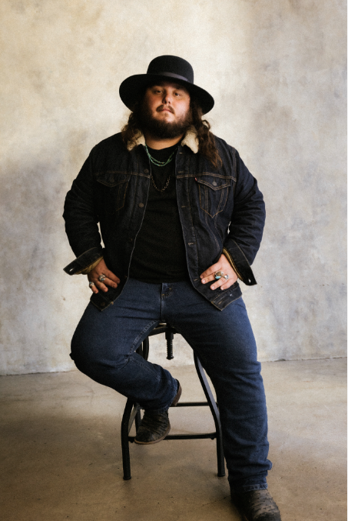
TANNER USREY
ON TOUR 2023-2024

DECEMBER
1 – St. Louis, MO – Off Broadway
2 – Stillwater, OK – Calf Fry Christmas *
5 – Albuquerque, NM – El Rey Theater †
6 – Tempe, AZ – Marquee Theatre †
7 – Las Vegas, NV – Rodeo Vegas (Free Show)
8 – San Francisco, CA – The Independent †
10 – Stateline, NV – Harrah’s †
12 – Bend, OR – Midtown Ballroom †
14 – Seattle, WA – Showbox †
15 – Spokane, WA – Knitting Factory †
16 – Portland, OR – Crystal Ballroom †
17 – Boise, ID – Knitting Factory
23 – Fort Worth, TX – Billy Bob’s

JANUARY 2024
5 – Colorado Springs, CO – Boot Barn Hill #
6 – Denver, CO – The Oriental Theater #
7 – Aspen, CO – Belly Up #
8-9 – Steamboat Springs, CO – The MusicFest at Steamboat *
12 – Mills, WY – Beacon Club
13 – Deadwood, SD – Deadwood Mountain Grand Red Dirt Festival *
23-24 – Key West, FL – Mile 0 Festival *
26 – Tampa, FL – The Orpheum ^
27 – Sanford, FL – Tuffy’s Music Box ^
28 – Gainesville, FL – Heartwood Soundstage ^
29 – Jacksonville, FL – Jack Rabbits ^

FEBRUARY 2024
2 – Starkville, MS – Rick’s Café ‡
3 – Tallahassee, FL – Duke’s & Dottie’s ‡
4 – Decatur, GA – Eddie’s Attic ‡
6 – Birmingham, AL – Zydeco ‡
7 – Jackson, MS – Hal & Mal’s ‡
8 – Mobile, AL – Soul Kitchen Music Hall ‡
9 – Statesboro, GA – The Blue Room ‡
10 – Athens, GA – 40 Watt Club ‡
12 – Asheville, NC – The Grey Eagle ‡
14 – Greenville, SC – Radio Room ‡
15 – Charlotte, NC – Amos’ Southend ‡
17 – Knoxville, TN – Open Chord Music ‡
18 – Charlottesville, VA – The Southern Café & Music Hall ‡
21 – Washington, DC – Pearl Street Warehouse ‡
22 – Philadelphia, PA – The Fillmore Philadelphia ‡
23 – New York, NY – Bowery Ballroom ‡
24 – Hamden, CT – Space Ballroom ‡
25 – South Burlington, VT – Higher Ground ‡
29 – Albany, NY – Empire Live ‡

MARCH 2024
1 – Syracuse, NY – The Song & Dance ‡
2 – Buffalo, NY – Buffalo Iron Works ‡
5 – Pittsburgh, PA – Thunderbird Café & Music Hall +
6 – Cleveland, OH – Beachland Ballroom & Tavern +
7 – Detroit, MI – The Shelter +
8 – Chicago, IL – Joe’s Bar +
9 – Indianapolis, IN – Hi-Fi +
10 – Columbus, OH – A&R Music Bar +
14 – Nashville, TN – The Basement East +

APRIL 2024
12-14 – Gonzalez, TX – Cattle Country Fest *

* Festival Performance
† w/ Paul Cauthen
# w/Special Guest Nolan Taylor
^ w/Special Guest Colby T. Helms
‡ w/Special Guest JD Clayton
+ w/Special Guest Kat Hasty

# # #

ABOUT TANNER USREY
Tanner Usrey has earned national applause for channeling a classic spirit from a personal perspective, blending straight-shooting storytelling with country grit, rock ‘n’ roll energy, and Americana eloquence. Inspired by a range of influences – spanning George Strait, Tom Petty, Lynyrd Skynyrd, and The Rolling Stones to his favorite band, Whiskey Myers – Usrey grew up in the small town of Prosper, TX, where he worked as a skip tracer while honing his signature style by writing countless songs and performing gigs anywhere that had a stage. In 2019, he quit his job and unveiled the Medicine Man EP, followed in 2021 by the SÕL Sessions EP, earning tens of millions of streams and featured placement on the highly rated Yellowstone Season 4 finale. Now, his catalog has over 190M streams globally. Usrey kicked off 2023 with “Take Me Home,” drawing over 20M streams thus far. Now, as the latest member of the world-renowned Atlantic Records roster, Tanner Usrey is poised to fly even higher with the long awaited arrival of Crossing Lines and The Crossing Lines Tour.

“I hope you hear what you want to hear, enjoy it, resonate with it, and know it’s real,” Usrey says. “It’s been a wild ride. I’ve busted my ass. I started off doing all of this on my own, so it’s crazy to see how this and the team around me have grown. People are going after real music right now, and that’s great. I’m looking forward to seeing where it goes next.”

# # #

TANNER USREY
CROSSING LINES
(Atlantic Records)

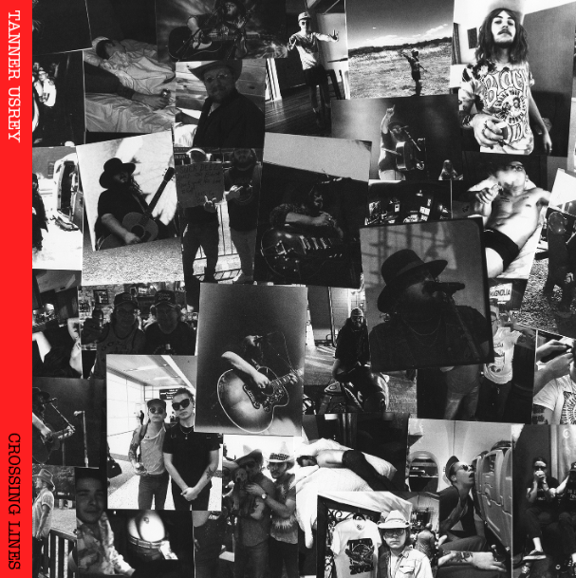
DOWNLOAD HI-RES ASSETS

TRACKLIST:
Echo in the Holler
Guns Drugs and Allergy Pills
Take Me Home
Tanner Usrey & Ella Langley – Beautiful Lies
Crossing Lines
Who I Am
Give It Some Time
Pick Up Your Phone
Tanner Usrey & Graycie York – Last Goodbye
Black Widow
Make You Weep
Destiny
Evelyn’s Eyes (Feat. Jessi England)
Down Here at The Bottom
Beautiful Lies

# # #
CONNECT WITH TANNER USREY
OFFICIAL | FACEBOOK | INSTAGRAM | TWITTER | YOUTUBE

