FOR IMMEDIATE RELEASE
OCTOBER 25, 2023

RISING POP-SOUL SENSATION ALICIA CRETI RETURNS WITH HER
LATEST TRACK “CRAZY”

FOLLOW-UP TO PREVIOUSLY RELEASED SINGLES “GUILT TRIP,” “PITY PARTY,”
AND “STRANGE”

LATEST TRACK FROM EAGERLY AWAITED EP SELF/LESS ARRIVING NEXT YEAR

FOLLOW UP TO HER ICONIC PERFORMANCES IN NY, SAN FRAN, AND LA DURING BIRDY’S
NORTH AMERICAN TOUR

DOWNLOAD/STREAM “CRAZY”

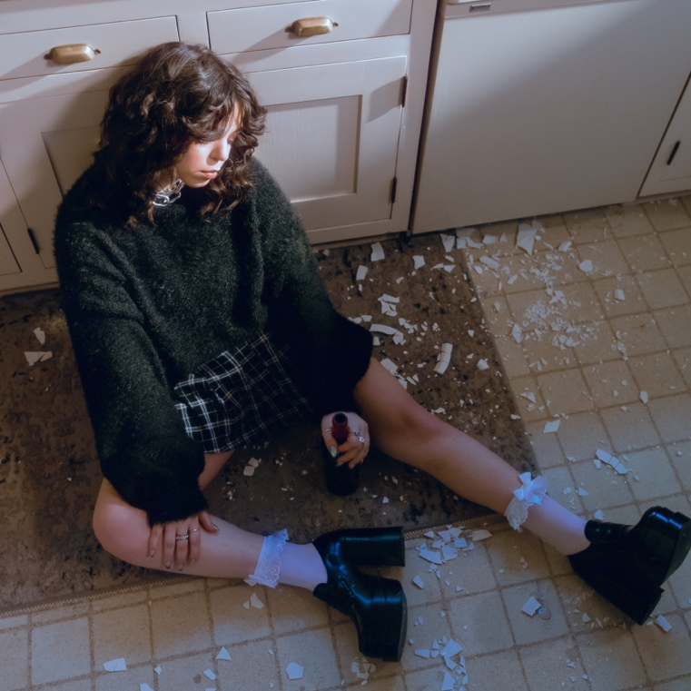
DOWNLOAD HI-RES ARTWORK

Highly acclaimed singer-songwriter, Alicia Creti, is back with her fourth track of the year, “Crazy.” “Crazy” also comes on the heels of her previously released singles “Guilt Trip,” “Pity Party” and her debut single, “Strange.” All three tracks arrive ahead of Alicia’s eagerly awaited EP, Self/Less, slated to arrive at the top of 2024. Each song on Alicia Creti's debut EP, Self/Less, tells the unfolding of a toxic and painful relationship. "Crazy" was important for her to include in building this narrative. The release of “Crazy” also comes on the heels of Alicia opening for Birdy along several stops on her North American tour including New York, San Francisco, and Los Angeles.

“What’s the first thing a man’s gonna tell you when you call them out on their shit?
“Oh she’s just fucking crazy”. This song is about taking your power back.
Remember that the craziest (and best) thing you can do is leave.”
– ALICIA CRETI

# # #

Alicia Creti absorbs the highs and lows of life in her music, rolling with the ups and downs and genuinely embracing both. As such, the Los Angeles-based singer and songwriter holds nothing back when she sings, amplifying her emotions through a distinct and dynamic delivery. Hailing from the suburbs of Montreal, Creti started to sing at barely three-years-old and hasn’t stopped since. Inspired by artists such as Rihanna, Beyonce, Brandy, and Stevie Wonder, she began penning songs of her own by the age of six and soon developed chops on both the piano and on the microphone, taking advantage of every opportunity to perform, whether it be at school or in the street.

In 2020, Creti began posting on social media and immediately achieved viral impact with a soulful rendition of Summer Walker’s “Session 32,” followed by covers of Kehlani, Jazmine Sullivan, and Ari Lennox that were viewed more than 6 million times around the world. Linking up with Amisha Sarkar of TRST. RCRDS, Creti released her debut original single, “Congratulations,” in 2022, reaping over 3 million global streams and critical applause as “a flawless masterpiece” from Lyrical Lemonade. Boasting co-signs from such like-minded artists as Summer Walker, Kehlani, Sam Smith, Lil Nas X, Ty Dolla $ign, and Keri Hilson, among others, Creti’s star has continued to ascend in 2023. A recent cover of Beyonce’s “Cuff It” garnered close to 2 million views on TikTok and Instagram Reels, while a tender acoustic rendition of “Congratulations” over 500K combined views and has led to more than 25K new followers on Instagram. Alicia followed the success of “Congratulations” with “Strange,” her debut single for Atlantic Records released earlier this year.

Elegant with an edge, strong but sensitive, and humbly confident, Creti crafts her own story of self-reflection, heartbreak, and the other facets of the human experience, not unlike a page out of her journal. Now, with Self/Less and more new music to follow, Alicia Creti is poised to show the world not only how far she has come but where she’s headed next.

“I tend to think in song,” says Creti. “I write from the heart. I’m a very sensitive and emotional person, but I like to put on a tough shell. The music is where the honesty comes out.”

# # #
CONNECT WITH ALICIA CRETI
INSTAGRAM | TIKTOK | TWITTER | YOUTUBE

PRESS INQUIRIES
ASHLEY KALMANOWITZ | ASHLEY.KALMANOWITZ@ATLANTICRECORDS.COM
FAIRLEY MCCASKILL | FAIRLEY.MCCASKILL@ATLANTICRECORDS.COM

