FOR IMMEDIATE RELEASE
AUGUST 25, 2023

RISING SONGSTRESS ALICIA CRETI RETURNS WITH HER LATEST SINGLE
“PITY PARTY”

FOLLOW-UP TO RELEASE OF DEBUT SINGLE “STRANGE”

ACCOMPANIED BY A COMPANION VISUALIZER AVAILABLE FOR STREAMING NOW

SECOND SINGLE FROM EAGERLY AWAITED EP SELF/LESS ARRIVES LATER THIS YEAR

WATCH/SHARE “PITY PARTY”
DOWNLOAD/STREAM “PITY PARTY”

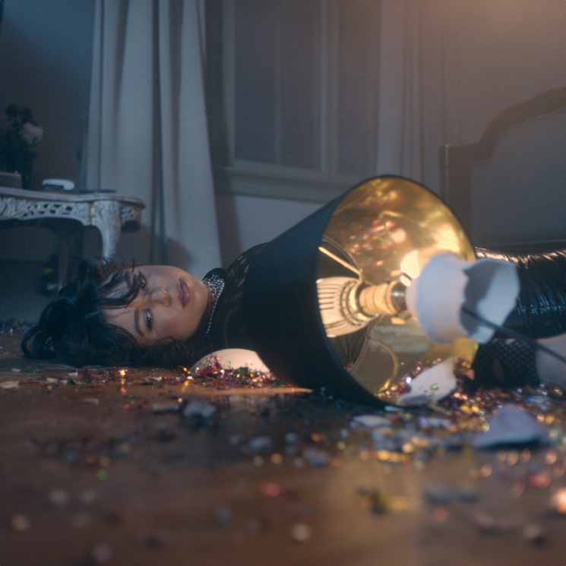
DOWNLOAD HI-RES ARTWORK

Acclaimed singer-songwriter Alicia Creti has released her second official single of the year since her signing, “Pity Party.” Accompanied by a companion visualizer, “Pity Party,” is the second single from her upcoming EP Self/Less. The single also follows Alicia’s debut single for Atlantic Records, “Strange.”

"I am a firm believer in feeling all your emotions to get through something. This allows you to heal and process what's weighing on you. This song is a mantra to yourself that it's okay to be human,
but not to dwell and live in the sadness." – ALICIA CRETI

# # #

Alicia Creti absorbs the highs and lows of life in her music, rolling with the ups and downs and genuinely embracing both. As such, the Los Angeles-based singer and songwriter holds nothing back when she sings, amplifying her emotions through a distinct and dynamic delivery. Hailing from the suburbs of Montreal, Creti started to sing at barely three-years-old and hasn’t stopped since. Inspired by artists such as Rihanna, Beyonce, Brandy, and Stevie Wonder, she began penning songs of her own by the age of six and soon developed chops on both the piano and on the microphone, taking advantage of every opportunity to perform, whether it be at school or in the street.

In 2020, Creti – who always managed to find the time to look out for her younger brother who has autism – began posting on social media and immediately achieved viral impact with a soulful rendition of Summer Walker’s “Session 32,” followed by covers of Kehlani, Jazmine Sullivan, and Ari Lennox that were viewed by more than 6 million views around the world. Linking up with Amisha Sarkar of TRST. RCRDS, Creti released her debut original single, “Congratulations,” in 2022, reaping over 3 million global streams and critical applause as “a flawless masterpiece” from Lyrical Lemonade. Boasting co-signs from such like-minded artists as Summer Walker, Kehlani, Sam Smith, Lil Nas X, Ty Dolla $ign, and Keri Hilson, among others, Creti’s star has continued to ascend in 2023. A recent cover of Beyonce’s “Cuff It” garnered close to 2 million views on TikTok and Instagram Reels, while a tender acoustic rendition of “Congratulations” over 500K combined views and has led to more than 25K new followers on Instagram. Alicia followed the success of “Congratulations” with “Strange,” her debut single for Atlantic Records released earlier this year.

Elegant with an edge, strong but sensitive, and humbly confident, Creti crafts her own story of self-reflection, heartbreak, and the other facets of the human experience, not unlike a page out of her journal. Now, with Self/Less and more new music to follow, Alicia Creti is poised to show the world not only how far she has come but where she’s headed next.

“I tend to think in song,” says Creti. “I write from the heart. I’m a very sensitive and emotional person, but I like to put on a tough shell. The music is where the honesty comes out.”

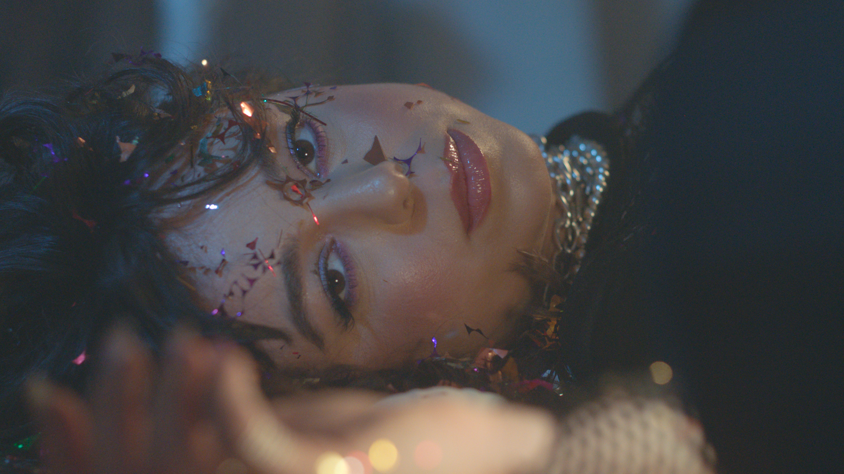

# # #
CONNECT WITH ALICIA CRETI
INSTAGRAM | TIKTOK | TWITTER | YOUTUBE

PRESS INQUIRIES
ASHLEY KALMANOWITZ | ASHLEY.KALMANOWITZ@ATLANTICRECORDS.COM

