FOR IMMEDIATE RELEASE
DECEMBER 13, 2023

RIAA GOLD-CERTIFIED ARTIST BIGWALKDOG RELEASES HIS SECOND MIXTAPE PLAYOFF VIA THE NEW 1017/ATLANTIC RECORDS

THE MISSISSIPPI RAPPER’S 15-TRACK PROJECT FEATURES APPEARANCES FROM
GUCCI MANE, VEEZE, AND MORE

ARRIVES ALONGSIDE OFFICIAL VISUAL FOR “FLOCK TOGETHER” FEAT. GUCCI MANE

FOLLOW-UP TO WALK’S DEBUT MIXTAPE RELEASED EARLIER THIS YEAR TRICK CITY

MIXTAPE ALSO INCLUDES THE PREVIOUSLY RELEASED TRACK “CROWN ME”

DOWNLOAD/STREAM PLAYOFF
WATCH/SHARE “FLOCK TOGETHER” FEAT. GUCCI MANE
WATCH/SHARE “CROWN ME”

DOWNLOAD HI-RES ARTWORK

Magnolia State rapper BigWalkDog is back with the release of his second mixtape, Playoff. The 15-track mixtape features appearances from Gucci Mane, Veeze, and more. Playoff also arrives alongside the official visual for “Flock Together” feat. Gucci Mane. Prior to the release of Playoff, Walk released the track and visual for “Crown Me.” Playoff also serves as the follow-up to Walk’s debut mixtape Trick City.

“One of the most promising artists of the New 1017, BigWalkDog
boasts a gruff and intense delivery. It’s no surprise Gucci Mane signed him…
one of the leaders of a new generation of Southern rappers
putting their lives on wax.” – AUDIOMACK

PLAYOFF TRACKLIST

Day In The Life
Cold Blooded
No Limit
On They Neck
Talk To Em feat. Veeze
Multiple and Double
Flock Together feat. Gucci Mane
In The Ghetto
I Promise
Like Tyreek
Freestyle
One Foot feat. NoHeart Shad
A Million
Crown Me

# # #

One of the most hard-hitting and compelling new artists on The New 1017 roster, the Tutwiler, MS born BigWalkDog has unleashed a string of releases that showcase commanding bars and knockout hooks that prove impossible to shake - all spiced with the rapper’s one-of-a-kind brand of Southern gusto. Independent tracks such as “Tyson” and “B.T.D.” soon caught catching the attention of Gucci Mane, who swiftly signed BigWalkDog to his fast-growing The New 1017 label.

A wide span of powerful releases followed, including striking appearances on such The New 1017 label compilations as SO ICY BOYZ and the recently released SO ICY GANG: THE REUP, all of which drew millions of streams alongside critical acclaim from such media outlets as REVOLT, which raved, “BigWalkDog is quickly becoming one of the bigger faces on the Southern rap scene.” “BigWalkDog's approach is best described as relentless,” agreed XXL. “He finds the pocket of every song he's on and never lets up, and does so with the vigor of a rapper who knows he's meant for this.”

“Mississippi made me,” says BigWalkDog, “but I want BigWalkDog to be for the world. You can take your own feelings from it – whether they’re good or bad. I’m just being honest.”

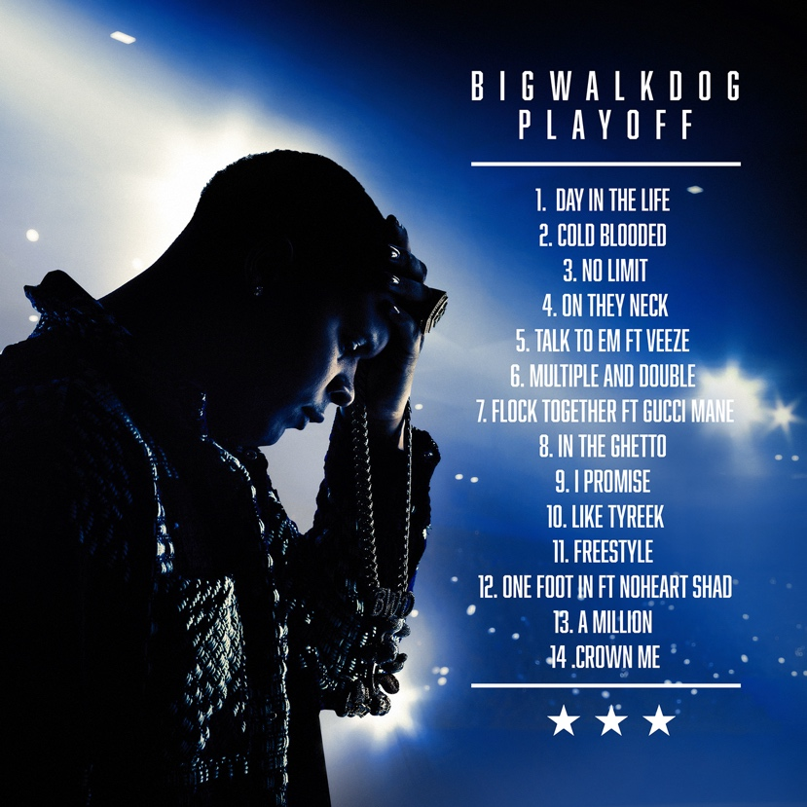

# # #

CONNECT WITH BIGWALKDOG
BIGWALKDOGMUSIC.COM | FACEBOOK | INSTAGRAM | YOUTUBE

BIGWALKDOG + 1017 GLOBAL MUSIC PRESS CONTACT:
Ashley Kalmanowitz | Ashley.Kalmanowitz@atlanticrecords.com

