BRISTON MARONEY SHARES NEW SINGLE “I TOLD YOU SO” – LISTEN HERE + WATCH OFFICIAL MUSIC VIDEO HERE

KICKS OFF 2024 NORTH AMERICAN HEADLINE TOUR TONIGHT –
JANUARY 25 – IN RALEIGH, NC

2 SOLD OUT NIGHTS IN: NEW YORK, BOSTON, DC, CHICAGO + DENVER
MAJORITY OF TOUR SOLD OUT

SOPHOMORE ALBUM ULTRAPURE OUT NOW – BUY/STREAM HERE

PLAYING WEBSTER HALL IN NYC ON JANUARY 30 + 31
& THE FONDA THEATRE IN LA ON MARCH 14 + 15

“Pretty flawless. Briston Maroney has pulled it off.”
ZANE LOWE

“Briston Maroney tells stories that feel personal without posturing. ‘Sunburn Fades’ is an example of the minimalist, home-spun sound the artist is continuing to craft…”
CONSEQUENCE

“Maroney manages to distinguish himself from the throes of indie-folk musicians by way of sheer and steadfast integrity, and a commitment to emotional honesty… His tender vulnerability offers a type of magnetism that is impossible to feign.”
PASTE

“…risen through the ranks to become a renowned alternative musician…”
THE TENNESSEAN

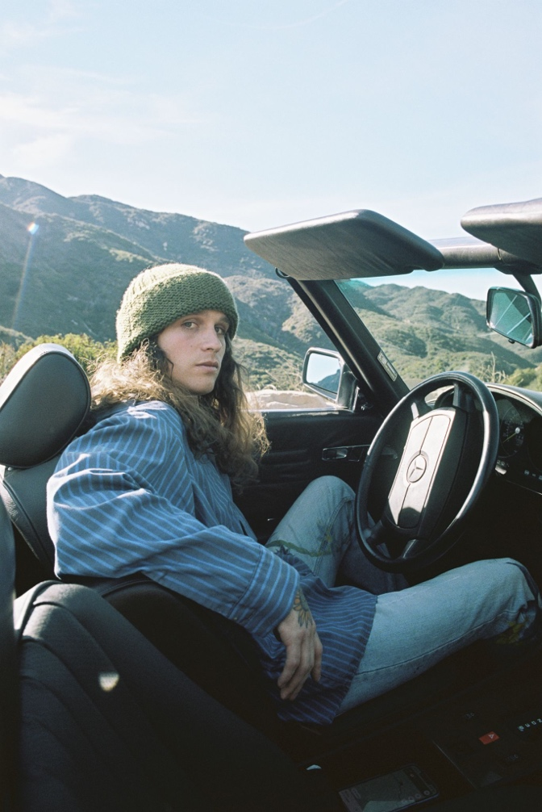
download hi-res press photo HERE; credit: Natalie Hewitt

January 25, 2024 – Today, acclaimed and newly LA-based artist Briston Maroney shares new single, “I Told You So,” produced by Andrew Sarlo (Big Thief, Bon Iver, Weyes Blood) – buy/stream here + watch the official music video (shot & edited by Natalie Hewitt) here.

Of “I Told You So,” Maroney shares:

“It’s such a beautiful thing to learn about the life someone you love had before you. This is a song about the beauty of that experience and what it’s like to fall even more in love once you know someone’s story!!”

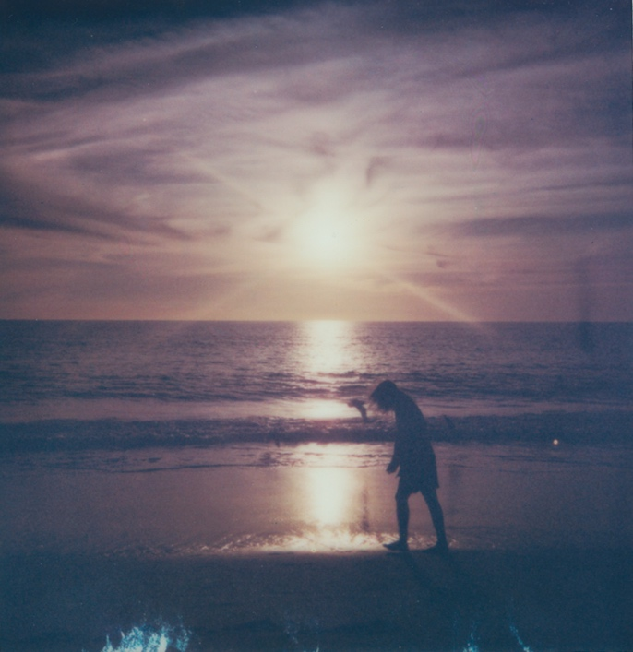
download hi-res single artwork HERE; credit: Natalie Hewitt

The standout track arrives timed to the start of Maroney’s 2024 North American headline tour, which kicks off tonight, January 25, in Raleigh, NC, in support of his stunning sophomore album, Ultrapure (buy/stream here).

The highly-anticipated run includes two sold-out nights at Webster Hall in NYC [January 30 + 31], two nights at The Fonda in LA [March 14 + 15], and already boasts sold-out shows in Boston, DC, Toronto, Chicago, San Francisco, Seattle, Denver, and many more cities in between [buy remaining tickets here; full routing enclosed below].

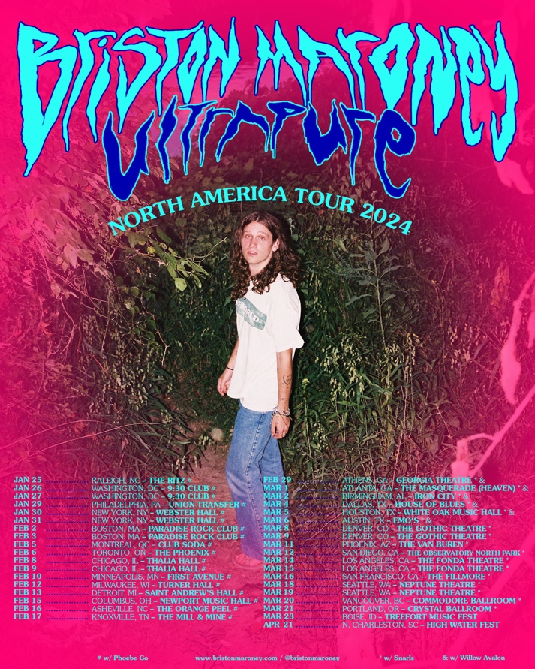
download hi-res admat HERE

Produced by 2x GRAMMY®-winner Daniel Tashian (Kacey Musgraves) and engineered by Konrad Snyder (Noah Kahan, Rainbow Kitten Surprise), Ultrapure arrived via Canvasback Music/Atlantic Records in September 2023. The 13-track LP was crafted in Maroney’s former home base of Nashville, TN and showcases the artist playing every instrument.

Ultrapure garnered widespread critical acclaim upon release and led to Maroney’s national TV debut on CBS Saturday Morning, performing recent singles “Chaos Party” and “Body,” plus his RIAA Platinum-certified hit “Freakin’ Out On The Interstate.”

Last fall, Maroney celebrated the album’s release with an official US Record Store Tour, bringing solo acoustic sets to beloved shops including Nashville’s Grimey’s, NYC’s Rough Trade, and San Francisco’s Amoeba SF, and in October 2023, he hosted his second annual ‘Paradise Festival’ at Brooklyn Bowl Nashville. Featuring a handpicked lineup of peers – including Samia, Hovvdy, and Skullcrusher joining the most recent iteration – the annual event further cemented Maroney’s status as an artist who “has helped define a new generation of local music” (Nashville Scene).

###

BRISTON MARONEY | UPCOMING TOUR DATES
% festival performance
# w/ Phoebe Go
* w/ Snarls
^ w/ Willow Avalon

JANUARY
25 – Raleigh, NC @ The Ritz # – SOLD OUT
26 – Washington DC @ 930 Club # – SOLD OUT
27 – Washington DC @ 930 Club # – SOLD OUT
29 – Philadelphia, PA @ Union Transfer # – SOLD OUT
30 – New York, NY @ Webster Hall # – SOLD OUT
31 – New York, NY @ Webster Hall # – SOLD OUT

FEBRUARY
2 – Boston, MA @ Paradise Rock Club # – SOLD OUT
3 – Boston, MA @ Paradise Rock Club # – SOLD OUT
5 – Montreal, QC @ Club Soda #
6 – Toronto, ON @ The Phoenix # – SOLD OUT
8 – Chicago, IL @ Thalia Hall # – SOLD OUT
9 – Chicago, IL @ Thalia Hall # – SOLD OUT
10 – Minneapolis, MN @ First Avenue # – SOLD OUT
12 – Milwaukee, WI @ Turner Hall #
13 – Detroit, MI @ Saint Andrew’s Hall # – SOLD OUT
15 – Columbus, OH @ Newport Music Hall # – LOW TICKETS
16 – Asheville, NC @ The Orange Peel # – SOLD OUT
17 – Knoxville, TN @ The Mill & Mine # – SOLD OUT
29 – Athens, GA @ Georgia Theatre * ^ – SOLD OUT

MARCH
1 – Atlanta, GA @ The Masquerade (Heaven) * ^ – LOW TICKETS
2 – Birmingham, AL @ Iron City * ^ – LOW TICKETS
4 – Dallas, TX @ House of Blues * ^
5 – Houston, TX @ White Oak Music Hall * ^
6 – Austin, TX @ Emo’s * ^ – SOLD OUT
8 – Denver, CO @ The Gothic Theatre * – SOLD OUT
9 – Denver, CO @ The Gothic Theatre * – SOLD OUT
11 – Phoenix, AZ @ The Van Buren *
12 – San Diego, CA @ The Observatory North Park * – SOLD OUT
14 – Los Angeles, CA @ The Fonda *
15 – Los Angeles, CA @ The Fonda * – LOW TICKETS
16 – San Francisco, CA @ The Fillmore * – SOLD OUT
18 – Seattle, WA @ Neptune Theatre * – SOLD OUT
19 – Seattle, WA @ Neptune Theatre *
20 – Vancouver, BC @ Commodore * – SOLD OUT
21 – Portland, OR @ Crystal Ballroom * – LOW TICKETS
23 – Boise, ID @ Treefort Music Fest %

APRIL
21 – North Charleston, SC @ High Water Festival %

###

CONNECT WITH BRISTON MARONEY:
OFFICIAL I INSTAGRAM I YOUTUBE I FACEBOOK I X I TIKTOK

FOR ALL PRESS INQUIRIES, PLEASE CONTACT:
Libby Kober (National) | Libby.Kober@AtlanticRecords.com
Gabby Reese (National) | Gabrielle.Reese@AtlanticRecords.com
Katy Carmichael (Tour) | Katy.Carmichael@AtlanticRecords.com

