FOR IMMEDIATE RELEASE
SEPTEMBER 08, 2023

ICONIC DUO CARDI B AND MEGAN THEE STALLION CLOSE OUT THE SUMMER WITH “BONGOS”

THE GRAMMY® AWARD-WINNING DIAMOND SELLING SUPERSTAR RETURNS
WITH NEW SINGLE

ACCOMPANIED BY AN OFFICIAL COMPANION VISUAL DIRECTED BY TANU MUINO

ARRIVES ALONGSIDE ANNOUNCEMENT OF HISTORIC 12 NOMINATIONS AT THIS
YEAR’S BET HIP-HOP AWARDS

COMES ON THE HEELS OF CARDI B’S BREATHTAKING VOGUE MÉXICO
AND LATIN AMERICA COVER

LIMITED QUANTITIES CD SINGLE AVAILABLE HERE

WATCH/SHARE “BONGOS”
DOWNLOAD/STREAM “BONGOS”

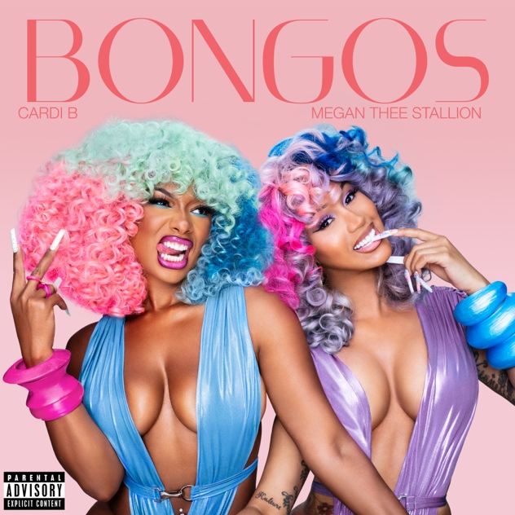
DOWNLOAD HI-RES ARTWORK

GRAMMY® Award-winning, Diamond selling superstar Cardi B is back to close out the summer with her latest single, “Bongos” featuring Megan Thee Stallion. “Bongos” was released via Atlantic Records and is accompanied by a lively, colorful visual directed by Tanu Muino. The visual takes place in Cardi B’s own sun-drenched oasis featuring an assortment of dazzling dancers surrounding the iconic duo throughout. “Bongos” arrives alongside a limited-edition CD for the single available for purchase HERE.

“Bongos” made its global broadcast premiere on MTV, MTV Live, MTVU, MTV Biggest Pop, YO! MTV, BET Jams, and BET Hip Hop, as well as on the Paramount Times Square billboards. It also arrives alongside the announcement of Cardi’s historic 12 nominations at this year’s upcoming BET Hip-Hop Awards. Tied with 21 Savage for most awarded artist, her nominations include: two nominations each for Best Hip Hop Video and Best Collaboration two nominations each for Song of the Year and Sweet 16: Best Featured Verse, Best Live Performer, Lyricist of the Year, Hip Hop Artist of the Year, and Hustler of the Year. “Bongo” comes on the heels of Cardi B’s breathtaking Vogue México and Latin America cover shoot for the famous September issue. The breathtaking cover shoot was accompanied by an in-depth, intimate interview that is available to read HERE. Both the single and cover shoot serve as the follow to a massive string of collaborations with her fellow rap peers. Some of these include Glorilla’s Platinum-certified “Tomorrow 2,” Latto’s Gold-certified “Put It On The Floor,” Offset’s “Jealousy,” and FendiDa Rappa’s “Point Me 2.”

Prior to “Bongos,” the pair released the historic and viral sensation, “WAP.” “WAP (Feat. Megan Thee Stallion)” affirmed Cardi B as one of Apple Music’s most popular artists of all time, earning the platform’s highest-ever debut by a female artist as well as the fastest song in Apple Music history by a female artist to peak at #1. It also went on to go #1 on the Billboard Hot 100 and peaked at #1 on rhythmic radio and peaked at #2 on urban radio. “WAP” also won Favorite Song - Rap / Hip-Hop at the American Music Awards and won Best Collaboration and Video of the Year at the BET Awards. It was also nominated for Collaboration of the Year at the American Music Awards, nominated for five categories at the MTV Video Music Awards, and nominated for Best Music Video at the iHeart Music Awards. The visual has now reached over 510M views and the audio now has over 3B streams.

Cardi B is among the most significant musical artists of all time, regardless of genre, gender, or generation- all accomplished in less than a decade. Some of her accolades include the most #1 singles (5) on the Billboard Hot 100, the first lead artist to top the Billboard Global 200 with an album that has sold 100M certified units, the most diamond-certified songs (3) by the RIAA, and the most songs with a billion streams on Spotify including the most-streamed female rap album. In 2023, Cardi is staying quite active with her feature in a Beats By Dre ad this past May and her collaboration with Whipshots sees a new flavor release for this fall: Pumpkin Spice. Cardi and Offset also appeared in McDonald’s 2023 Super Bowl Commercial, announcing the first-ever celebrity duo meal.

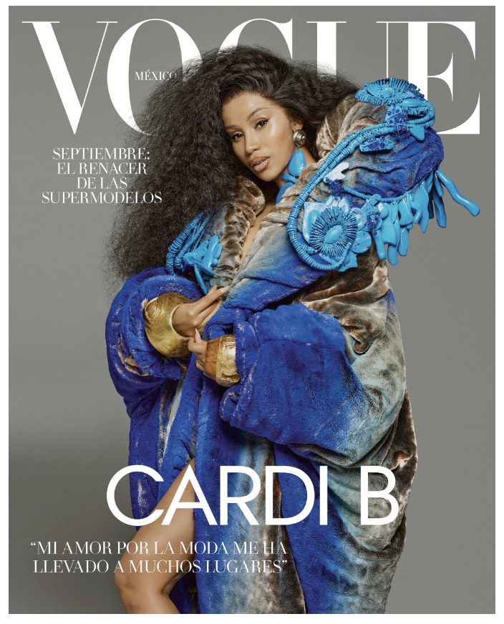

ABOUT CARDI B

Cardi B is among the most significant musical artists of all time, regardless of genre, gender, or generation- all accomplished in less than a decade. Among her seemingly unstoppable list of accomplishments, she stands as the highest-certified female rapper of all time on the RIAA’s “Top Artists (Digital Singles)” ranking, the female rap artist with the most RIAA diamond certifications, and the only female rapper with multiple billion-streamers on Spotify, where her chart-topping, GRAMMY® Award-winning, 4x RIAA platinum-certified debut album, Invasion of Privacy, remains the most streamed album by a female rap artist to date. All 13 tracks on Invasion of Privacy are now certified at least Platinum, and the smash 2018 album also includes the history-making Diamond-certified “Bodak Yellow.” Her extensive list of awards, nominations, and high-profile honors currently includes nine total GRAMMY® Award nominations, eight Billboard Music Awards, six Guinness World Records, five Spotify One Billion Streams Awards, two ASCAP Songwriter of the Year Awards, eight ASCAP Pop Music Awards, 23 ASCAP Rhythm & Soul Music Awards, six American Music Awards, four MTV Video Music Awards, three iHeartRadio Titanium Awards, six BET Awards, 14 BET Hip Hop Awards, inclusion on TIME’s “TIME100: The 100 Most Influential People of 2018,” being named Entertainment Weekly’s 2018 “Entertainer of the Year” and Billboard’s 2020 “Woman of the Year,” along with countless other triumphs. Last year, she was named as iconic lifestyle brand Playboy’s first-ever Creative Director in Residence and founding member of Playboy’s creator-led platform. Since then, Cardi B’s has been on countless features including Platinum-certified single, “Tomorrow 2” with Glorilla, and Gold-certified “Put It On The Floor” with Latto.

CREDIT: Jora Frantzis

CONNECT WITH CARDI B:
CARDIBOFFICIAL.COM | TWITTER | INSTAGRAM | SOUNDCLOUD | ATLANTIC RECORDS

PRESS CONTACT:
Ashley Kalmanowitz | Ashley.Kalmanowitz@atlanticrecords.com

