FOR IMMEDIATE RELEASE
JANUARY 19, 2023

FTO SETT RELEASES LEGENDARY COLLABORATION FEATURING
LIL BABY “CBFW”

ACCOMPANIED BY AN OFFICIAL COMPANION VISUAL

FOLLOW-UP TO FTO SETT’S 2-DISC DEBUT MIXTAPE LIFE OF A SLIMECROOK

WATCH/SHARE “CBFW”
DOWNLOAD/STREAM “CBFW”

DOWNLOAD HI-RES ARTWORK

Today, Memphis rising star, FTO Sett, kicked off 2024 in a major way with the release of “CBFW” featuring rap giant, Lil Baby via The New 1017/Atlantic Records. The iconic collaboration is accompanied by an official companion visual. “CBFW” also serves as the follow-up to FTO Sett’s 2-disc debut mixtape Life Of A Slimecrook which features Key Glock, NLE Choppa, Rob49, NoCap, Co3, Action Pac, Gucci Mane, Finesse2tymes, and label mates Mac Critter and KATO2X. The single arrives on the heels of FTO Sett’s Preme Magazine cover shoot and his interview with XXL’s The Break.

Life Of A SlimeCrook symbolized how FTO Sett is a 'smooth criminal' in his music. Signed to The New 1017 label at the end of 2022, it was only a few months later when FTO Sett's talents were recognized by his peers and industry tastemakers. “2 For 1” was the final standalone single prior to the release of his debut mixtape and comes on the heels of his breakout Memphis anthems, “Piss Sett Off” (7.8M streams to date, #1 on Spotify Local Pulse Memphis chart, #52 on Spotify Top Songs Memphis, #1 Shazam in Memphis) and “Snap” (highest weekly streaming number to date, #1 on Spotify Memphis Local Pulse Chart). The anthem went on to be featured on rap legend Jay-Z’s “Couple Songs of ‘23” end-of-the-year playlist.

# # #

FTO SETT

When you think of Memphis, TN from the outside, landmarks like Sun Studio, Graceland, or Beale Street may immediately come to mind. At the bottom of the city though, you will find South Vegas. This stretch of town flaunts its own “lingo” and what locals refer to as “a little casino with fast cars and gambling.” FTO Sett calls this neighborhood home. He absorbs the unrestrained energy around him and transfers it into searing and scorching rhymes. Piling up millions of views and streams, he welcomes everyone into this world on his forthcoming debut for The New 1017/Atlantic Records and more to come.

He gained traction with “Free Marvin”—a tribute to his incarcerated brother—before landing back behind bars. After hearing FTO Sett on “GOT MOTION” featuring TayG in 2022, Gucci Mane signed him to The New 1017. “Gucci got me out,” he recalls. “He had confidence in me. He said, ‘We’re going to get this paper’. He showed me how to get myself right. He’s very wise. I watched him, and I learned to make everything count.”

During 2022, the buzzing rapper ignited his next era with “Break Out Dat Cake” with Gucci Mane. Right out of the gate, it gathered over 700k streams and 500K YouTube views. On its heels, he tore through a Zaytoven beat on “First Day in the A.” He consistently developed an incendiary flow punctuated by hard-hitting hooks.“I’m different,” he says. “I have my own joint. I’m not forcing it. I’m not in competition with anyone. I do what I do. I stick in my lane. I can run anybody over.”

Now, he’s about to take off at full speed. “When you hear my songs, I hope you’re motivated,” he leaves off. “I stand firm on everything. If I want this shit, I’m going to get it. You can just make it happen. I’m proof you can.”

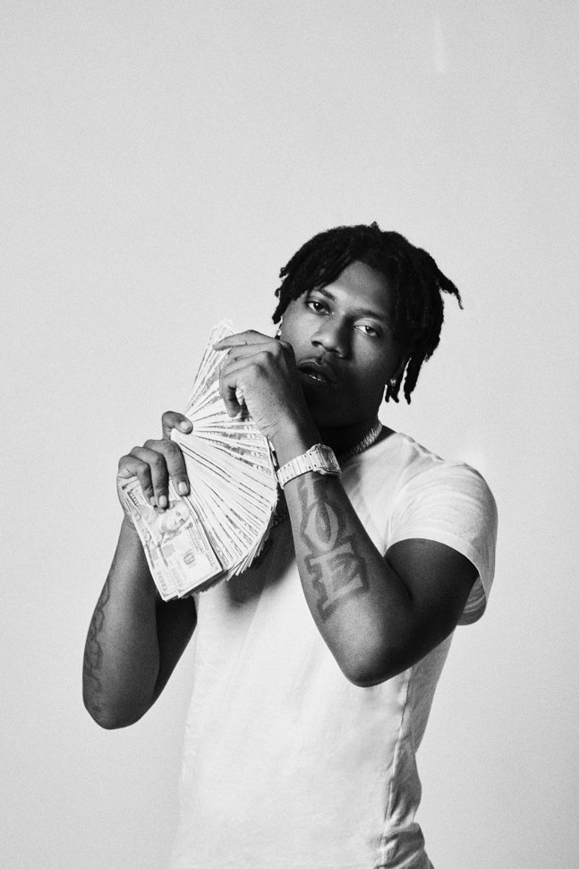

CONNECT WITH FTO SETT
TWITTER | INSTAGRAM | FACEBOOK | YOUTUBE | TIKTOK

FTO SETT + 1017 GLOBAL MUSIC PRESS CONTACT:
Ashley Kalmanowitz | Ashley.Kalmanowitz@atlanticrecords.com

