MULTI-PLATINUM SUPERSTAR GUCCI MANE RETURNS WITH LATEST SINGLE
“COLD” FEATURING NOLA LEGEND B.G. AND MIKE WILL MADE-IT

THE SINGLE IS ACCOMPANIED BY A COMPANION VISUAL

FOLLOW-UP TO RECENT ALBUM RELEASE BREATH OF FRESH AIR

GUCCI MANE CELEBRATED HIS ALBUM RELEASE BY BEING GIVEN HIS OWN
“GUCCI MANE DAY” IN ATLANTA PRESENTED BY THE ATLANTA CITY COUNCIL

GUCCI MANE RECENTLY ADDED 12 NEW PLATINUM AND GOLD CERTIFICATIONS TO HIS
EVER-GROWING CATALOG

WATCH/SHARE “COLD”
DOWNLOAD/STREAM “COLD”

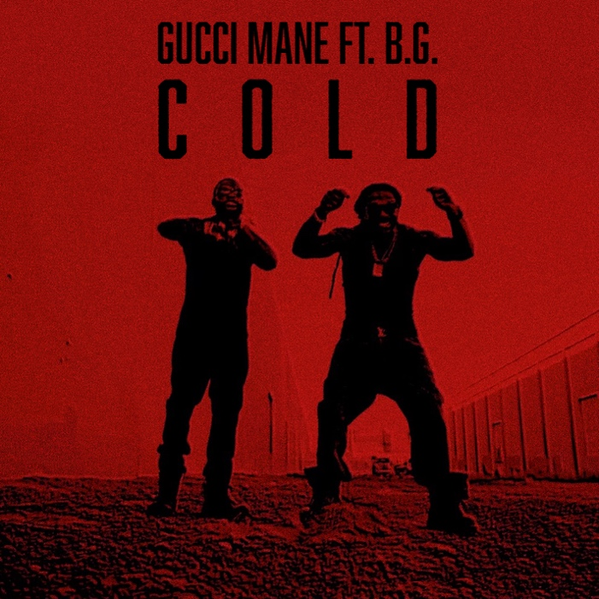
DOWNLOAD HI-RES ARTWORK

GRAMMY® Award-nominated, 14+ billion streaming superstar Gucci Mane has returned with his latest collaboration “Cold” featuring New Orleans legend B.G. and super producer Mike WiLL Made-It. The single is accompanied by an official companion visual available for streaming now. “Cold” serves as the follow-up to Gucci Mane’s recent album release, Breath Of Fresh Air. Gucci Mane celebrated his album release not only with a one-night-only, sold-out concert in Atlanta, Gucci Mane & Friends; in addition to being given his own “Gucci Mane Day” on 10/17 in Atlanta presented by the Atlanta City Council.

ABOUT GUCCI MANE
Currently boasting over 14 billion global streams and more than 3.7 billion official views on YouTube, Gucci Mane wrapped up 2022 with his latest New 1017 compilation, SO ICY BOYZ: THE FINALE, available via Atlantic Records/The New 1017 Records. The 24-track collection sees Gucci Mane joined by some of the most recent members of The New 1017 roster, including KATO2X, Li Rye, Mac Critter, Sett, And TLE Cinco, along with features from such certified R&B/hip-hop superstars as Jeremih, Trey Songz, 2 Chainz, and OJ Da Juiceman. Among the anthology’s undeniable highlights are such bangers as Gucci Mane’s “Met Gala Remix (Feat. Offset, Sett, Mac Critter, KATO2X),” Li Rye’s “Too Many (Feat. Gucci Mane),” and TLE Cinco x Gucci Mane’s “Hitting,” all of which are joined by companion music videos streaming now via the official Gucci Mane YouTube channel HERE.
Widely regarded as one of the most influential rappers of the past decade, Gucci Mane has more top 10 albums on Billboard’s “Top Rap Albums” chart than any other hip-hop artist in history. Along with new releases from Gucci Mane himself, the seasoned A&R has taken his eye for the next big thing to his own record label, The New 1017, in partnership with Atlantic Records. The New 1017 showcases Gucci Mane’s platinum-certified A&R skills with a roster that includes BiC Fizzle, Big Scarr, BigWalkDog, Enchanting, Foogiano, Hotboy Wes, KATO2X, Li Rye, Lil Zay, Mac Critter, Pooh Shiesty, Sett, and TLE Cinco.Last month Gucci hosted his Gucci Mane & Friends’ show on October 17th alongside the release of his latest album, Breath Of Fresh Air.
CONNECT WITH GUCCI MANE
OFFICIAL | INSTAGRAM | TWITTER I FACEBOOK I YOUTUBE

GUCCI MANE & THE NEW 1017 PRESS CONTACT
Ashley Kalmanowitz | Ashley.Kalmanowitz@atlanticrecords.com

