FOR IMMEDIATE RELEASE
JANUARY 19, 2023

EMERGING R&B SONGSTRESS HONEY BXBY LINKS UP WITH KALIII FOR
REMIX TO VIRAL HIT “TOUCHIN’”

THE ICONIC COLLABORATION IS ACCOMPANIED BY AN OFFICIAL VISUALIZER

FOLLOW-UP TO HONEY’S TELEVISION DEBUT AND PERFORMANCE
AT THE 2023 SOUL TRAIN AWARDS

COMES ON THE HEELS OF HONEY AND KALIII AS DIRECT SUPPORT ON SEXYY RED’S
HOOD HOTTEST PRINCESS TOUR

MORE MUSIC TO COME FROM THE RISING SONGSTRESS IN 2024

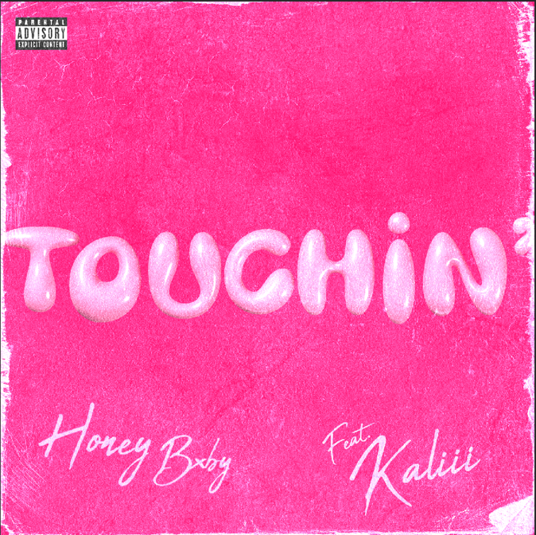
DOWNLOAD HI-RES ARTWORK
WATCH “TOUCHIN’” FT. KALIII | DOWNLOAD “TOUCHIN’” FT. KALIII

Emerging R&B songstress, Honey Bxby, returns with her first release of the year, the official “Touchin’” remix. The new iteration of the viral single features rap’s it-girl and fellow labelmate, Kaliii. The titillating track is also accompanied by an official visualizer available for streaming now. Keep an eye out for more music to come from the rising songstress in 2024.

Last November, New Jersey’s rising star, Honey Bxby, made her television debut during the 2023 Soul Train Awards. The songstress performed her hit single “Touchin’” from her previously released EP, 3 Words, 8 Letters. The historic performance came on the heels of Honey’s visual release for the track “Poseidon.” Honey also recently sat down with the Pink Room with Drea powered by MajorStage as she discussed growing up in New Jersey, meeting Kehlani, opening for Sexyy Red, and more. Honey, along with Kaliii, recently wrapped as direct support on Sexyy Red’s Hood Hottest Princess Tour.

# # #

HONEY BXBY

Few stars burn as bright as Honey Bxby. A New Jersey native, the multi-hyphenate singer-songwriter developed her talents from an early age. Raised on contemporary artists like Drake, Alicia Keys, and Kehlani, she spent hours studying their melodies, cadences, and lyrics. Inspired by their introspective approaches to storytelling and applied that to her writing style. Honey would go on to begin performing privately to friends before uploading covers of songs online. A siren for the YouTube generation, Honey dropped her first song back in 2019 while simultaneously attending cosmetology school. While working, briefly, as an exotic dancer and on a hiatus from music, she was discovered through Instagram. A chance meeting with her now manager, K Mack, helped launch her career. Merging disarming truthfulness with flesh-and-blood-sex appeal, her emotional honesty has garnered rising notoriety. Her singular soundscape blends serene, honey-laced vocals with unbridled and cold-blooded raps. On her debut EP, she flits through genres with bullish command. In a sea of sameness, while the bulk of her peers are more concerned with aesthetics and manufactured personas, Honey’s self-contained authenticity is reassuring to a generation still forming the language around complex emotions. Honey has a knack for using Instagram as a personal and unfiltered diary while encouraging her fans to be their most true selves. “There’s no persona, this is me all the time. I’m talking a lot of shit. I try to show myself. I just wanna inspire people to be the best versions of themselves. As an artist it’s not just about your music. It’s about your image, your personality, your character, all of that.” Since the release of her debut EP, the songstress has stayed quite active. She’s since released Touchin’: The Pack; a compilation of several variations of Honey’s hit single. She followed up with the release of the official visual for her EP track “Poseidon.” This past fall, Honey embarked on her first tour as direct support, along with labelmate Kaliii, on Sexyy Red’s Hood Hottest Princess tour. Honey made her television debut at the 2024 BET Soul Train Awards where she performed “Touchin’.”

CONNECT WITH HONEY BXBY
TWITTER | TIKTOK | INSTAGRAM | YOUTUBE

FOR PRESS INQUIRIES
ARIANA WHITE | ARIANA.WHITE@ATLANTICRECORDS.COM

