FOR IMMEDIATE RELEASE
DECEMBER 13, 2023

MULTI PLATINUM SUPERSTARS JASON DERULO AND MEGHAN TRAINOR TRY OUT THE SIMPLE LIFE IN “HANDS ON ME” OFFICIAL MUSIC VIDEO

CLASSIC REALITY TV TAKEOFF FEATURES SPECIAL APPEARANCE FROM PARIS HILTON

WATCH “HANDS ON ME (FEAT. MEGHAN TRAINOR)” OFFICIAL MUSIC VIDEO HERE
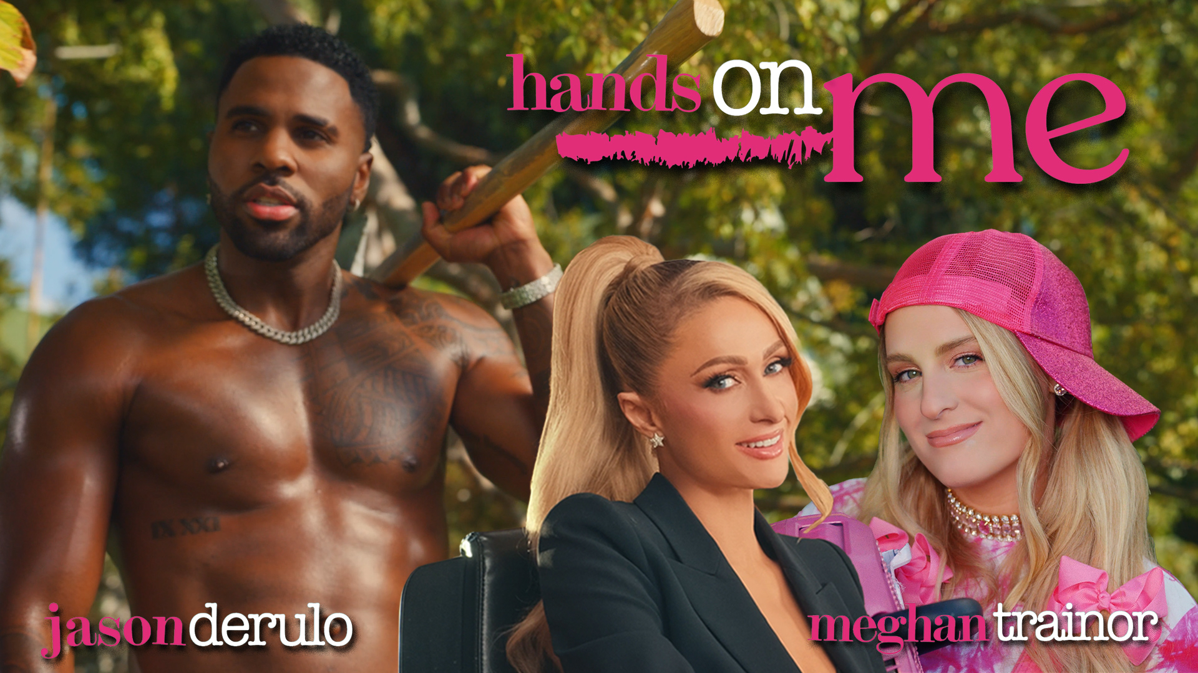
DOWNLOAD HI-RES THUMBNAIL HERE

Jason Derulo has unwrapped the official music video for his acclaimed collaboration with fellow Multi Platinum global superstar, GRAMMY® Award-winner Meghan Trainor, “Hands On Me (Feat. Meghan Trainor),” premiering today at YouTube HERE. Directed by Daniel Russell (SZA, Justin Timberlake, Missy Elliott), the colorfully clever visual sees both superstars trying out “The Simple Life” in a classic reality TV takeoff, highlighted by a special appearance from the one and only Paris Hilton. The hit reality show starring Paris Hilton and bestfriend Nicole Richie, recently celebrated its 20 year anniversary.

“I couldn’t remember the last time I had this much fun shooting a music video. Thank you to Paris and Meghan for making this so special.” – Jason Derulo

“I had so much fun shooting this video with Jason and paying homage to the queen, Paris Hilton and the Simple Life. Can’t believe I’m in a music video with these two legends!” – Meghan Trainor

“Hands On Me” is available now via Atlantic Records HERE. The track – which was teased across social media by both artists, and showcased by Derulo with a spectacular live performance on NBC’s America’s Got Talent, streaming HERE – was met by critical applause from the likes of American Songwriter, which raved, “Derulo has made a career of consistently switching up his sonic direction. Both artists seem in their element on this nostalgic song.”

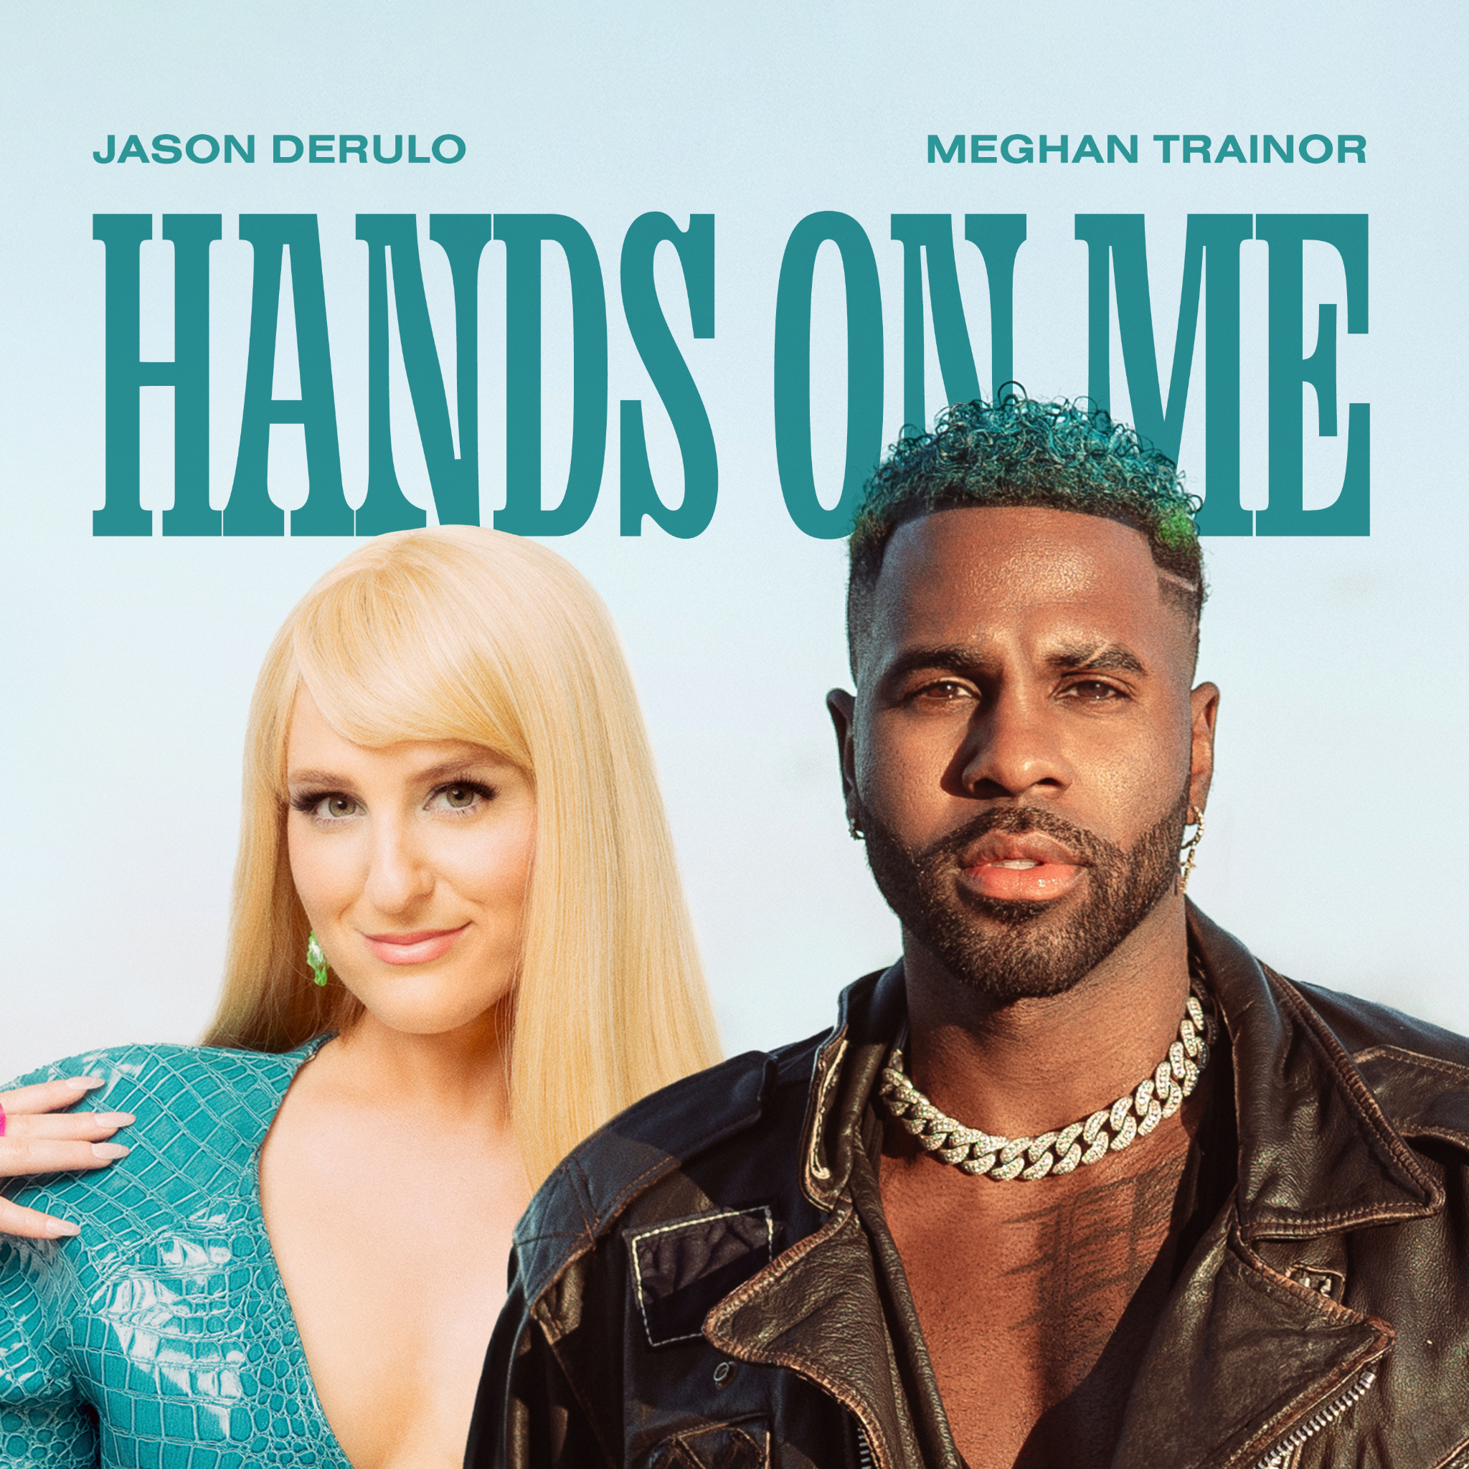
DOWNLOAD HI-RES IMAGE HERE

Last month saw Derulo kicking off the holiday season with his joyous new single, “Closer to Christmas.” The festive track marks the latest in the indefatigable superstar’s non-stop series of releases, including such hits as the tempo-changing smash, ”Slow Low” (and the Latin-flavored “Slow Low (Remix) [Feat. Yng Lvcas]”) and the smoothly dynamic “Glad U Came,” joined by an official music video, directed by Derulo on location in beautiful Bali and streaming now at YouTube HERE. In addition, Derulo stripped back “Glad U Came” to create the ideal romantic theme for summer wedding season, “Glad U Came (Acoustic Wedding Version),” available now HERE. Other recent favorites include the sultry club-pop hit, “When Love Sucks (Feat. Dido),” interpolating Dido’s 1999 top 3 hit single, “Thank You,” famously sampled in Eminem’s classic “Stan.” The ultimate showcase for both artists’ signature approach towards club-ready pop anthems, the irresistibly energetic track is joined by an official dance video streaming at Derulo’s hugely popular YouTube channel HERE.

Derulo is currently traveling on the typically globe-straddling “Nu King World Tour,” with dates in Portugal, Kazakhstan, Sweden, Norway, Denmark, France, Netherlands, Luxembourg, Belgium, the United Kingdom, Ireland, Germany, Austria, Czech Republic, Italy, Switzerland, and Spain slated through June 2024. For complete details, please visit www.jasonderulo.com/tour.

The ever-active Derulo is following his recently-wrapped first season as judge on The Voice Australia by co-starring alongside Alexandra Shipp (Barbie, X-Men: Apocalypse) in Underwater, a neo-noir romantic thriller presented by Interval Presents, Warner Music Group’s in-house podcast network. A rollercoaster love story told in the form of a narrative album, the series features brand new, original music from Derulo woven into the story and score, creating an innovative and immersive listening experience and making for a groundbreaking event at the cutting edge of audio entertainment. Underwater premiered October 31 on all major podcast platforms, with new episodes released weekly on Tuesdays HERE. The podcast topped the Apple Podcast charts at #1.

# # #

ABOUT JASON DERULO
Forward-thinking, genre-defying, and massively creative, Jason Derulo has staked his claim as one of the most dynamic forces on the global pop landscape. Since breaking through with his 5x RIAA Platinum-certified single, “Whatcha Say,” the award-winning singer-songwriter who has a net worth in excess of $100 million, has sold more than 250M singles worldwide and achieved 22 Platinum singles including “Wiggle“, “Talk Dirty“, “Want to Want Me,” “Trumpets,” “It Girl“, “In My Head,” “Ridin’ Solo,” “Don’t Wanna Go Home,” “Marry Me,” “ The Other Side,” “Get Ugly,” “Swalla,” “Savage Love” and “Take You Dancing.” Since the start of his solo recording career in 2009, he has earned over 18.2B worldwide streams, and built an unstoppable social media following of over 175M followers across all platforms. Now at work on his highly anticipated fifth album – and full-length debut for Atlantic Records – Derulo has delivered an ongoing series of smash singles that have drawn a stunning 700M+ views, including the irresistibly buoyant “Acapulco,” the RIAA platinum-certified “Take You Dancing,” and Jawsh 685 x Jason Derulo’s 3x platinum-certified chart-topper, “Savage Love (Laxed – Siren Beat).” The latter track – and its official BTS remix – proved an unstoppable international sensation upon its 2020 arrival, peaking at #1 on Billboard’s “Hot 100” as well as atop charts in 16 additional countries around the world.

A truly multi-dimensional creator, Derulo has also established himself as an actor and businessman, becoming part-owner of Rocket Car Wash and Pro Volleyball Team, investing in enterprises like Catch L.A. and Rumble Boxing launching an innovation-minded podcast, and developing a line of supplements and fitness products with the Najafi Group. What’s more, Derulo unveiled Jason Derulo’s UZO, an immersive new graphic novel from Z2 Comics based on a TikTok character created by the artist himself. With his TikTok regularly amassing over 10M views per post, Derulo notes that the platform has drastically reshaped his relationship with his fans. Derulo is now amongst TikTok’s biggest superstars, currently the 4th most followed male on the video-sharing platform with the 11th biggest account overall. He continues to see his already astronomical TikTok presence growing daily, now boasting more than 58.2M followers worldwide and over 1.3B likes.

ABOUT MEGHAN TRAINOR
Meghan Trainor first made history in 2014 with her Diamond-certified smash single, “All About That Bass.” Since then, the award-winning singer, songwriter, and multi-instrumentalist has garnered a GRAMMY® for “Best New Artist,” achieved eight Multiplatinum singles and two Multiplatinum albums, sold out three world tours, penned Multiplatinum hits for peers across pop and country, and received countless industry awards and nominations. Expanding her influence on pop culture, she starred on FOX’s hit series, THE FOUR: Battle for Stardom, and on the superstar coaching panel of The Voice UK. She kicked off 2020 with the release of her third full-length album, Treat Myself (Epic Records), which includes the platinum smash “No Excuses” as well as blockbuster anthems and collaborations such as “Nice To Meet Ya” [Feat. Nicki Minaj], “Genetics” [Feat. Pussycat Dolls], and “Wave” [Feat. Mike Sabath]. At the end of 2020 she released her first ever Christmas album, A Very Trainor Christmas, featuring the #1 holiday radio single, “White Christmas,” featuring Seth MacFarlane. In 2021, we got to watch her as the host of Top Chef Family Style on Peacock and as a judge on Clash of the Cover Bands on E!. In September of 2021 she launched her podcast, Workin’ On It, which she hosts alongside her brother, Ryan Trainor. In 2022 Meghan released her fourth full-length album, Takin’ It Back, which takes you through her journey into marriage, motherhood, and achieving a new level of confidence. The album features the colossal platinum-certified hit, “Made You Look,” which has garnered over 300M streams and become a global sensation, being used in over 6M videos on social media to date. The track also took the #1 spot on Billboard’s “Adult Pop Airplay” and “Hot AC” charts and won the first ever Rolling Stone “Sound of the Year” Award at the Streamys. She kicked off 2023 by joining the judging panel of the iconic star-maker series, Australian Idol, in its highly anticipated return to air. In March, Meghan released Made You Look (Deluxe), which features three new songs including the single, “Mother.” To celebrate the holiday season, Meghan teamed up with Jimmy Fallon to release their playful collaboration, “Wrap Me Up.” This year, Meghan made her literary debut with Dear Future Mama, a humorous, unflinching guide to pregnancy and motherhood. Recently, Meghan also gave birth to her second child with husband Daryl Sabara, Barry Bruce Trainor. For more, please visit www.meghan-trainor.com.

# # #

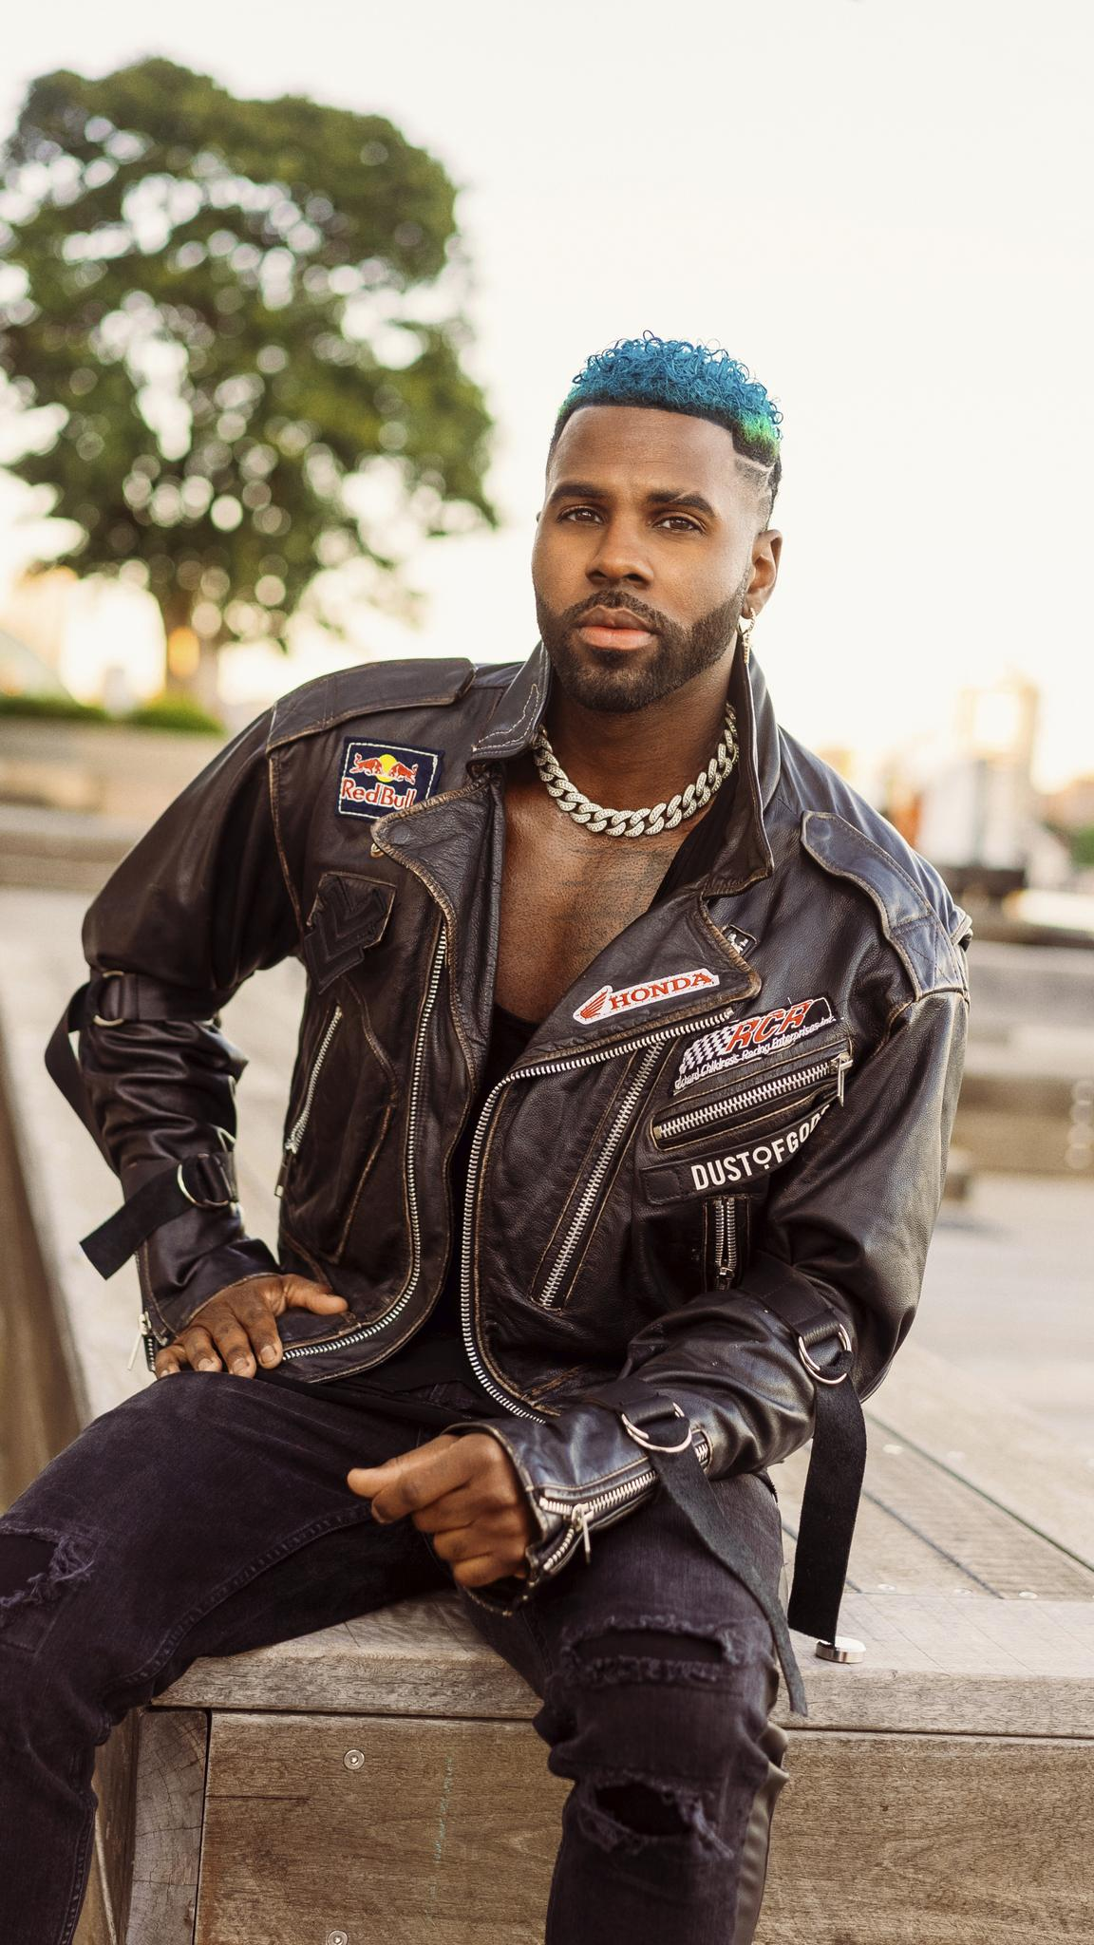
DOWNLOAD HI-RES PRESS IMAGE HERE
PHOTO CREDIT: PETER O’DOWD

CONNECT WITH JASON DERULO
OFFICIAL | FACEBOOK | INSTAGRAM | TIKTOK | TWITTER | YOUTUBE

CONNECT WITH MEGHAN TRAINOR
OFFICIAL | FACEBOOK | INSTAGRAM | TIKTOK | TWITTER | YOUTUBE

PRESS CONTACT FOR JASON DERULO
FAIRLEY MCCASKILL | FAIRLEY.MCCASKILL@ATLANTICRECORDS.COM

PRESS CONTACT FOR MEGHAN TRAINOR
LUKE BERLAND | LUKE@2BENTERTAINMENT.NET
BAILEY KATLER | BAILEY@2BENTERTAINMENT.NET

