FOR IMMEDIATE RELEASE
JANUARY 12, 2023

THE GENERAL KICKS OFF 2024 WITH LATEST SINGLE “BIRDS CALLING”

ACCOMPANIED BY OFFICIAL COMPANION VISUAL

FOLLOW-UP TO SINGLE AND VISUAL FOR “YONCE FREESTYLE”
FEATURING SEXYY RED AND B.G.

ARRIVES AHEAD OF THE CEREMONY ALBUM RELEASING JANUARY 26

EXCLUSIVE THE CEREMONY HOODIE AND VINYL FAN PACK AVAILABLE FOR PURCHASE

CURRENTLY ON HIS ONLY THE GENERALS TOUR WITH THE NEXT STOP IN ALBUQUERQUE, NM

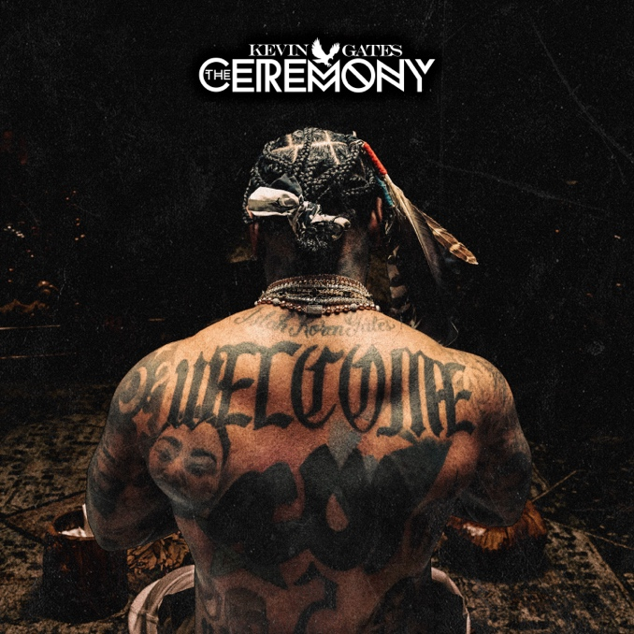
DOWNLOAD HI-RES ARTWORK
WATCH “BIRDS CALLING” | DOWNLOAD “BIRDS CALLING”

Raps’ reigning general, Kevin Gates, kicks off 2024 with the release of his latest single, “Birds Calling.” The single is accompanied by an official companion visual available for streaming now. This track sees Kevin revisiting his past life in terms of the experiences and hardships that he survived in Baton Rouge when he was younger. “Birds Calling” serves as the follow-up to last year’s single and visual release for “Yonce Freestyle” featuring Sexyy Red and B.G. The single will be included on Kevin’s upcoming album, The Ceremony, which will be released on January 26. “Birds Calling” also arrives alongside exclusive The Ceremony hoodie and vinyl fan pack available for purchase HERE.

PURCHASE HOODIE & VINYL FAN PACK

To accompany the release “Yonce Freestyle” Kevin announced the official pre-order for, The Ceremony. The album is centered around Kevin's spiritual growth and personal development through religious ceremony. He has released six tracks from the album to date - “I Don’t Apologize” (13M+ Streams), “Do It Again” (7M+ Streams), “Yonce Freestyle" ft. Sexyy Red & B.G. (5M+ Streams), "God Slippers" (4M+ Streams), “RUMORS” (4M+ Streams), and “Walmart” (3M+ Streams). Kevin is wrapped up the second leg of his Only The Generals Tour at the end of last year and will pick back up on 1/12 in Albuquerque, New Mexico at Revel Entertainment Center and will also be performing at Power 98.3's Powerhouse Concert in Glendale, AZ on 1/13.
# # #

ABOUT KEVIN GATES
Kevin Gates transformed into one of the game's most impactful and inimitable rappers by simply being Kevin Gates. Nearly 15 years into an unbelievable career, he doesn’t chase trends. He doesn’t censor himself. He doesn’t hold back. Instead, he speaks his mind and fulfills every promise. It’s why the Baton Rouge, LA native has racked up over 6 billion streams, 6 billion views, and dozens of multiplatinum, platinum, and gold certifications. It’s why his 2013 song “Thinking With My Dick” reached Billboard’s Hot 100 for the first time in 2022 and became #1 overall sound on TikTok. It’s why he’s logged four Top 5 entries on the Billboard Top 200 in addition to seven Top 5 entries on both the Top Rap Albums Chart and the Top R&B/Hip-Hop Albums Charts. It’s why he’s sold-out successive headline tours, delivered show-stopping sets at Rolling Loud and JMBLYA, and ignited arenas with Cardi B. It’s why he’s received various high-profile award nominations. It’s why he’s reached rarified air, emerging as the second best-selling hip-hop artist of 2016 only behind Drake. It’s why he’s also spawned countless think pieces. Among those, Pitchfork described 2019’s gold-certified I’m Him as “another showcase for the Baton Rouge rapper’s fully formed and gloriously weird personality” and praised, “The hooks are magnificent, his most boisterous and fine-tuned since Islah.” As always, he doesn’t compromise on 2021’s Only The Generals Part II [Bread Winner Alumni/Atlantic Records] and more music on the horizon. He’s only gotten better at being Kevin Gates. Kevin continues his reign with the release of his third full-length LP, KHAZA. Since the album’s release Kevin has released several singles to keep the momentum building including: “Big Lyfe,” “Bad For Me,” “Intro,” “Metro,” “Major League,” and his explosive “Super General (Freestyle).” His KHAZA national tour supported the album with several sold-out dates across the country first kicking off in Dallas, TX. Kevin recently wrapped his latest national tour, Only The Generals Tour.

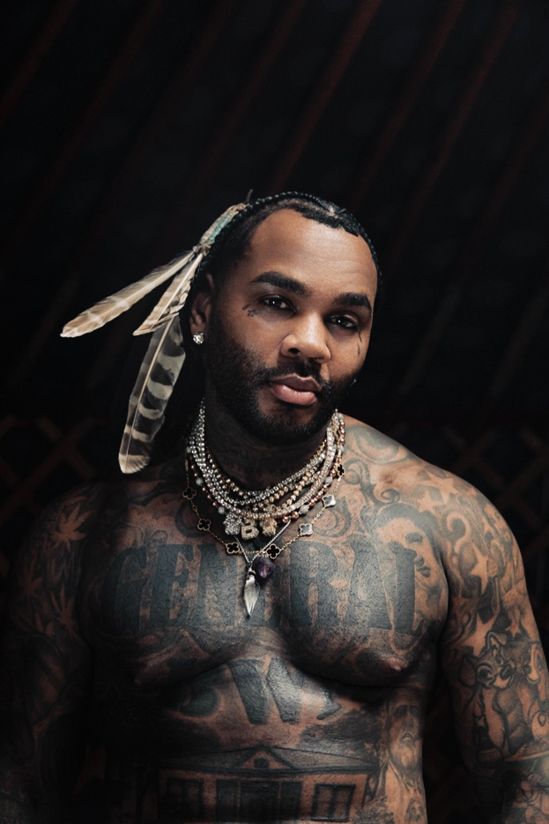

CONNECT WITH KEVIN GATES
WEBSITE | TWITTER | TIKTOK | INSTAGRAM | FACEBOOK | SOUNDCLOUD | YOUTUBE

FOR KEVIN GATES INQUIRIES, CONTACT
ARIANA.WHITE@ATLANTICRECORDS.COM

