**ONE OF ATLANTIC RECORDS’ LATEST SIGNINGS RE6CE**

**RELEASES 1ST LABEL SINGLE "**[**LUVSICK**](https://re6ce.lnk.to/luvsick)**!” (FEAT. THXSOMCH)**

**VIA GOOD LUCK HAVE FUN/ATLANTIC RECORDS**

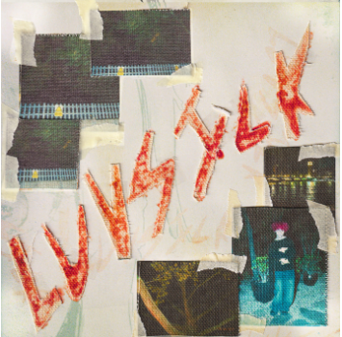

[DL images here](https://warnermusicgroup.box.com/s/earl1gfl1eo8wefh2dt6cqp8050rx22p)

*“…re6ce’s music is difficult to categorize; it’s a “choose your own adventure” type of experience. Each song is unique and offers something different from the last. His music has a distinct style that sets it apart from other artists, with a youthful teenage energy and mostly guitar driven production.”* -**COMPLEX**

Already co-signed by glaive, ThxSoMch, Complex and Lyrical Lemonade amongst others, Alt Pop artist re6ce (pronounced reece) continues their ride to the top with new single "LUVsick!" featuring ThxSoMch. Out today, the release marks their first single on a joint venture between Good Luck Have Fun and Atlantic Records. Listen [HERE.](https://re6ce.lnk.to/luvsick)

ABOUT RE6CE

The future of alternative pop music lies in re6ce’s hands. The 17-year-old Liverpool singer and multi-instrumentalist is a symbol of the wide cast of young, DIY-centric Internet musicians. Self-taught and still young in their career, re6ce is a student of this modern Internet music game. Each release features a different style of influence, yet the young talent still finds a way to each track a cohesive, signature experience when listened to all together.

Their exceptional combination of modern rock, futuristic hyperpop, and sentimental indie pop has helped them garner acclaim from both fans and critics alike. They’ve been a TikTok sensation this early in their career, as well as amassing numerous editorial playlist placements, write-ups from the likes of Complex via Pigeons & Planes, Lyrical Lemonade, and successful tours with glaive and ThxSoMch.

**CONNECT WITH RE6CE**

[INSTAGRAM](https://instagram.com/re6ce) | [TIKTOK](https://tiktok.com/@re6ce) | [SPOTIFY](https://open.spotify.com/artist/4ULUpM5hJYKWhWdIViYrGK) | [TWITTER](https://twitter.com/reecewithasix?ref_src=twsrc%5Egoogle%7Ctwcamp%5Eserp%7Ctwgr%5Eauthor)

**PRESS CONTACT**: [gabrielle.reese@atlanticrecords.com](mailto:gabrielle.reese@atlanticrecords.com)