FOR IMMEDIATE RELEASE
JANUARY 19, 2024

AFRICAN DANCE MUSIC SENSATIONS MAJOR LEAGUE DJZ ENLIST VICTONY FOR “MARGARET”

LISTEN HERE

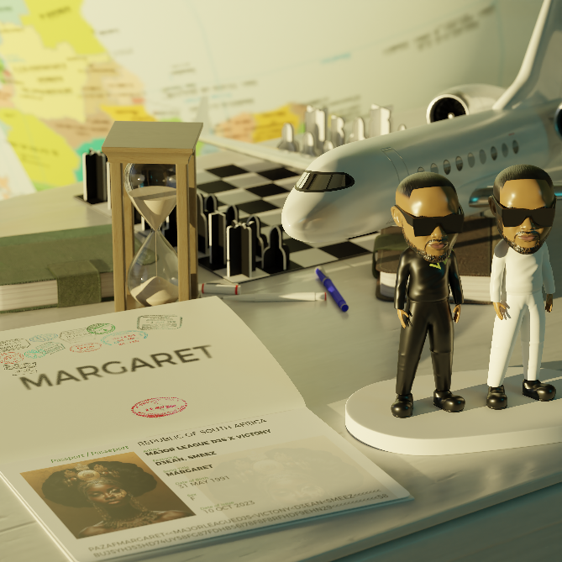
DOWNLOAD HI-RES ARTWORK + PRESS IMAGES

Global Amapiano Stars Major League DJz are kicking off the year with new single “Margaret” featuring Nigeria’s own Victony. The track produced by Dean & Smeez is available now via Atlantic Records HERE.

“Margaret” arrives as a 4 pack single featuring remixes catered to the Southern and Western parts of Africa. This single also marks the first of a series of new releases coming this year for the duo and follows previously released tracks, “Bad For Business (Ft. Kojey Radical & Magicsticks),” and “All Night Long Ft. Elaine and Yumbs.”

Tracklist
- Margaret
- Margaret (Mas Music & Aymos Remix)
- Margaret (Thakzin & Morda Remix)
- Margaret (Tyler ICU, D3an & Smeez Remix)

“Major League DJz are positioned as the frontrunners in Amapiano’s shift from a South African sensation to a cornerstone of global dance music.”
BILLBOARD

“A new form of South African dance music is thriving. A pair of twin brothers, known as Major League DJz, want the rest of the world to pay attention.”
THE NEW YORKER

“Major League DJz are bringing Amapiano to a global stage”
HYPEBEAST

“Major League Djz’s game-changing and record-setting party series and live stream Balcony Mix has been at the forefront of Amapiano’s global takeover.”
FORBES

“Major League Djz are taking the sound of amapiano into spaces that others cannot reach. The South African twins may not have been the first to start pioneering the genre, but they have picked up the mantle and run with it.”
DJ MAG

# # #

Hailed by Forbes for being “at the forefront of Amapiano’s global takeover,” Major League DJz are crafting the sound of the future with an exciting blend of immersive African sonics and revolutionary production. For more than a decade, the duo have played a critical role in rewiring modern dance music, experimenting with elements from hip-hop, Kwaito, Afrobeats, and Amapiano. Thanks to their throbbing brand of party-starting, genre-blurring music, Major League DJz have achieved cultural icon status in the African continent and around the world, spanning collaborations with Major Lazer, Diplo, Black Coffee, and more; show-stopping sets on international stages from Coachella to London’s famed O2 Brixton Academy; and an array of accolades including a prestigious BET Award nomination for “Best International Act.”

Born in exile to a family of anti-apartheid campaigners, the Mbere brothers grew up in Boston, MA, where their family moved in the same social circle as legendary South African musicians like Hugh Masekela and Miriam Makeba. These associations provided the twins with an unconventional education on South African jazz and popular African music, sounds which they paired with the hip-hop that they loved in America.

Upon the end of South Africa’s apartheid regime, the brothers returned to their home country and began building a platform as top party organizers, hosting special edition events in honor of such western stars as Akon, Fat Joe, and 50 Cent. Eventually, the Mberes evolved into music creation, arriving in the early 2010s with a series of dance-ready hip-hop-influenced mixtapes that melded their love for rap culture with the swaggering dance music of South Africa. These early drops won them a core following, as did a culture-shifting series of annual live events dubbed Major League Gardens, drawing over 20K fans each year through 2019.

Always innovative, Major League DJz embraced the homebrewed sounds of Kwaito and Amapiano just as the latter was rising to national popularity in early 2020. The duo launched their “Balcony Mix” series during the pandemic, earning millions of global views with live DJ sets at spectacular locations around the world from Africa to Amsterdam to Australia. In 2022, Major League DJz broke records with “The Balcony Mix Xperience: The Book Of The Music Journey,” a celebratory event which saw the twins perform a whopping 75-hour DJ set – the longest duo DJ set in history. The duo made history again this summer as the first Amapiano act to host and sell out a residency in London at the Here @ Outernet venue.

Major League DJz continue on their avowed path to celebrate African Culture while making the world dance, showcasing the beauty of Amapiano and more with trailblazing invention and game-changing energy.

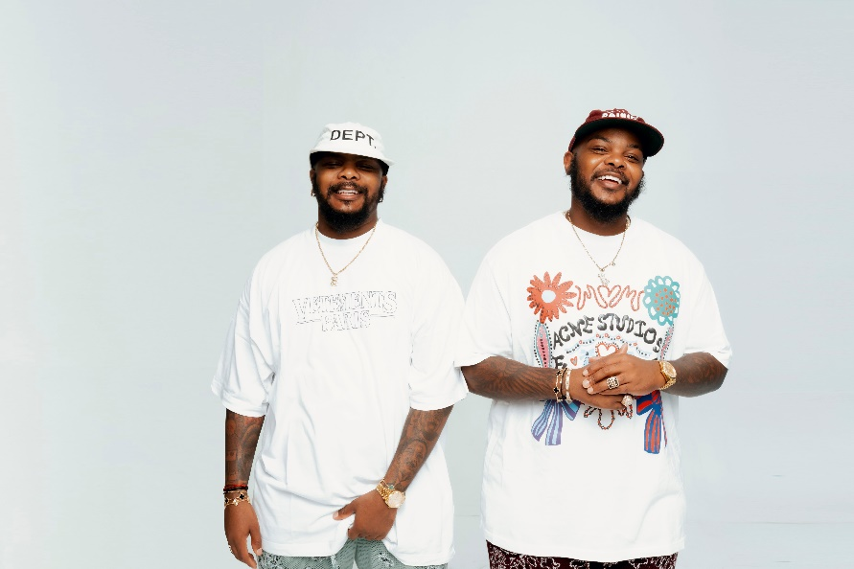
DOWNLOAD HI-RES PRESS IMAGES + ARTWORK

# # #

CONNECT WITH MAJOR LEAGUE DJz
WEBSITE | FACEBOOK | INSTAGRAM | X | YOUTUBE

PRESS CONTACT
COREY BREWER | COREY.BREWER@ATLANTICRECORDS.COM

