MASON RAMSEY RELEASES COMING-OF-AGE EP FALLS INTO PLACE

DOWNLOAD/STREAM FALLS INTO PLACE

COUNTRY PHENOM PERFORMS SOLD-OUT EP RELEASE SHOW AT NEW YORK CITY’S MERCURY LOUNGE TONIGHT

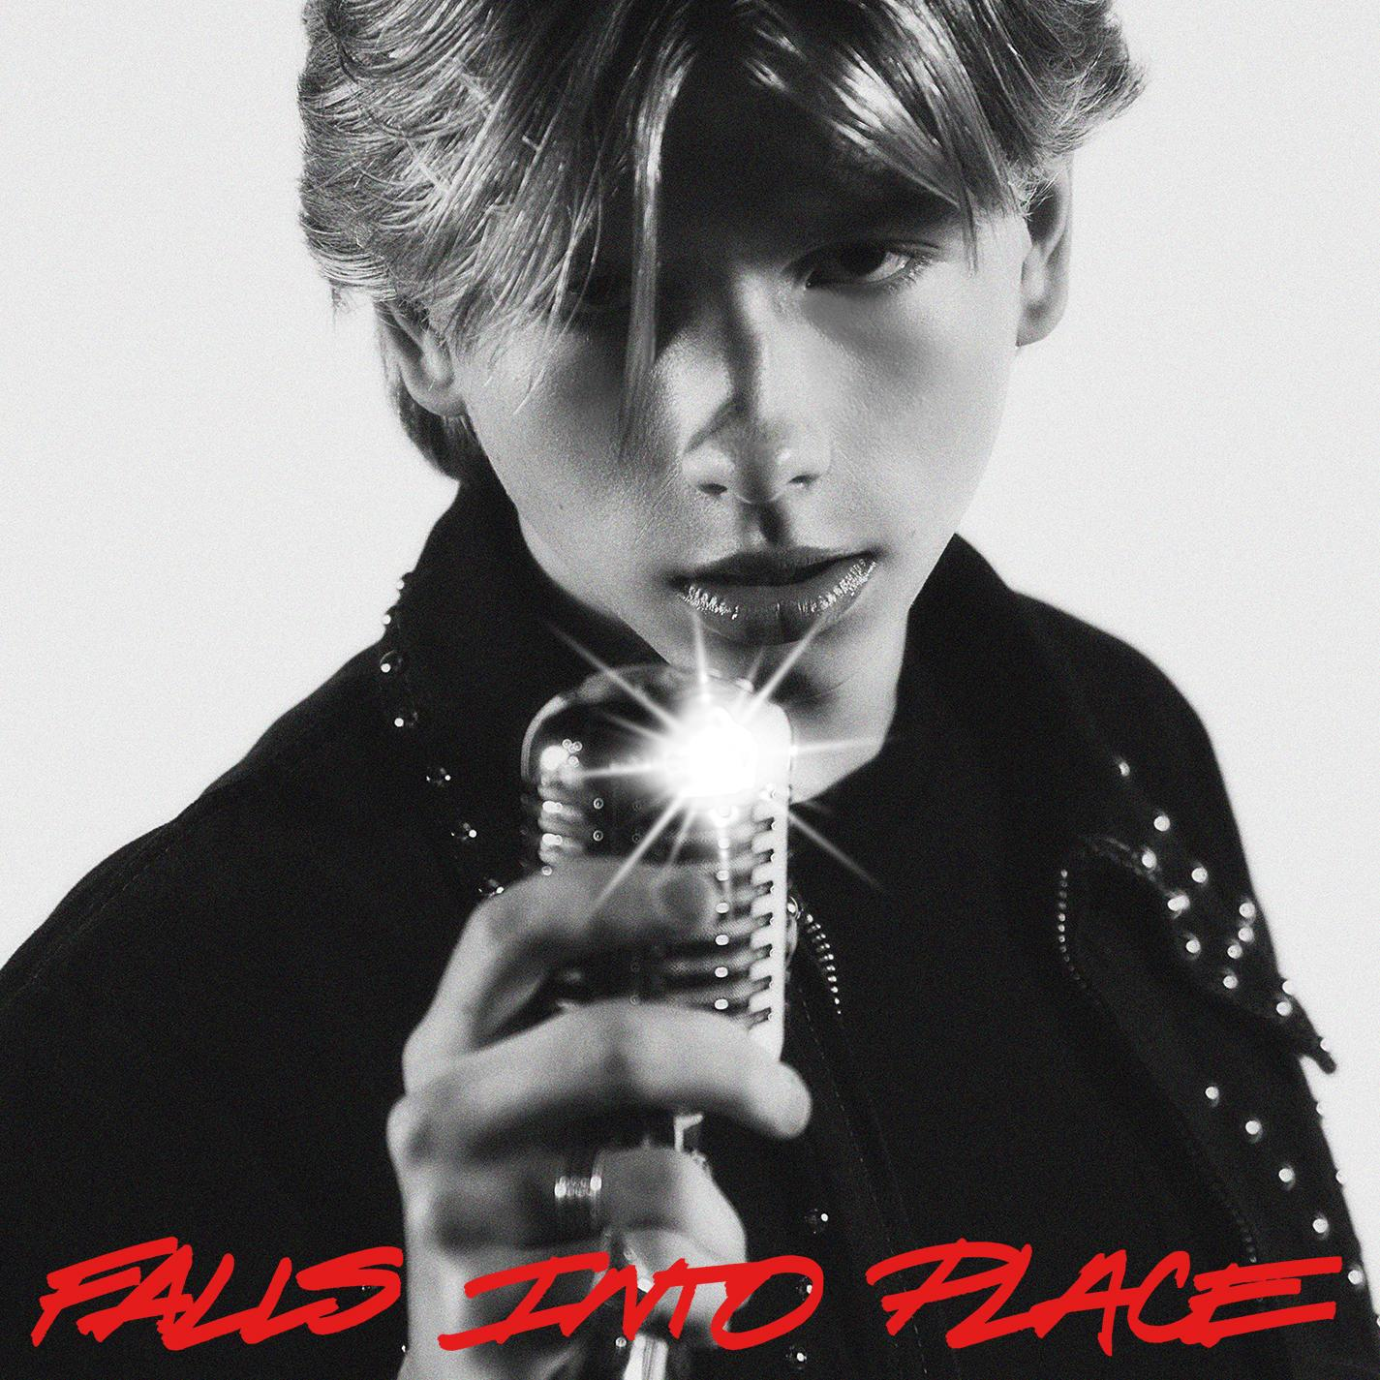
DOWNLOAD HI-RES ARTWORK

(New York, NY- October 20, 2023) – 16-year-old Country phenom, Mason Ramsey has released his coming-of-age EP, Falls Into Place, out today (10/20) via Atlantic Records. The five-song project marks his first new studio collection since 2019, and a new era for the breakout singer-songwriter. Available across all streaming platforms and digital retailers, listen to Falls Into Place here.

“I took some time to settle back in at home in Golconda the past few years where I was able to do some big life things like get my first job, go to prom, and work on remodeling my truck. I also was able to spend time playing the guitar, focus on my songwriting, and figure out what I really wanted to say with my music. My fans have never forgotten about me, and this EP is for them. The support I’ve felt since the beginning has changed my life, and I’m so excited to connect with everyone back out on the road with these new songs. It really feels like things are beginning to fall into place just how they should be. Buckle up everybody, there’s so much more to come!”
-MASON RAMSEY

Ramsey’s “sharpened his chops and returned with a deeper voice and some deeper lyrics,” applauds PEOPLE, as proven in early releases like the heartfelt hometown ballad “Reasons To Come Home,” the up-tempo romantic fun of “She Got It Outta Me,” and optimistic honky-tonk rocker “Next Right Thing.” Matching coming-of-age themes and personal growth with Ramsey’s famous pure-Country charm, the global star now “older and more reflective,” according to Billboard, is credited as a co-writer on all but one track.

Tonight, Ramsey celebrates his EP release with a SOLD-OUT New York City show at Mercury Lounge. He’ll also make his anticipated return to Nashville’s Grand Ole Opry on October 28. Find the full lineup and tickets here.

Since catapulting onto the Country music scene as the youngest major label Country artist signed in the genre in nearly two decades at 11, Ramsey has already delivered two acclaimed EPs, earned a Gold-certified single, headlined two tours in addition to supporting a Las Vegas residency, and surpassed 300 million global streams since 2018.

FALLS INTO PLACE EP TRACKLIST
1. “Next Right Thing”
2. “Falls Into Place”
3. “All I Wanna Be”
4. “She Got It Outta Me”
5. “Reasons To Come Home”

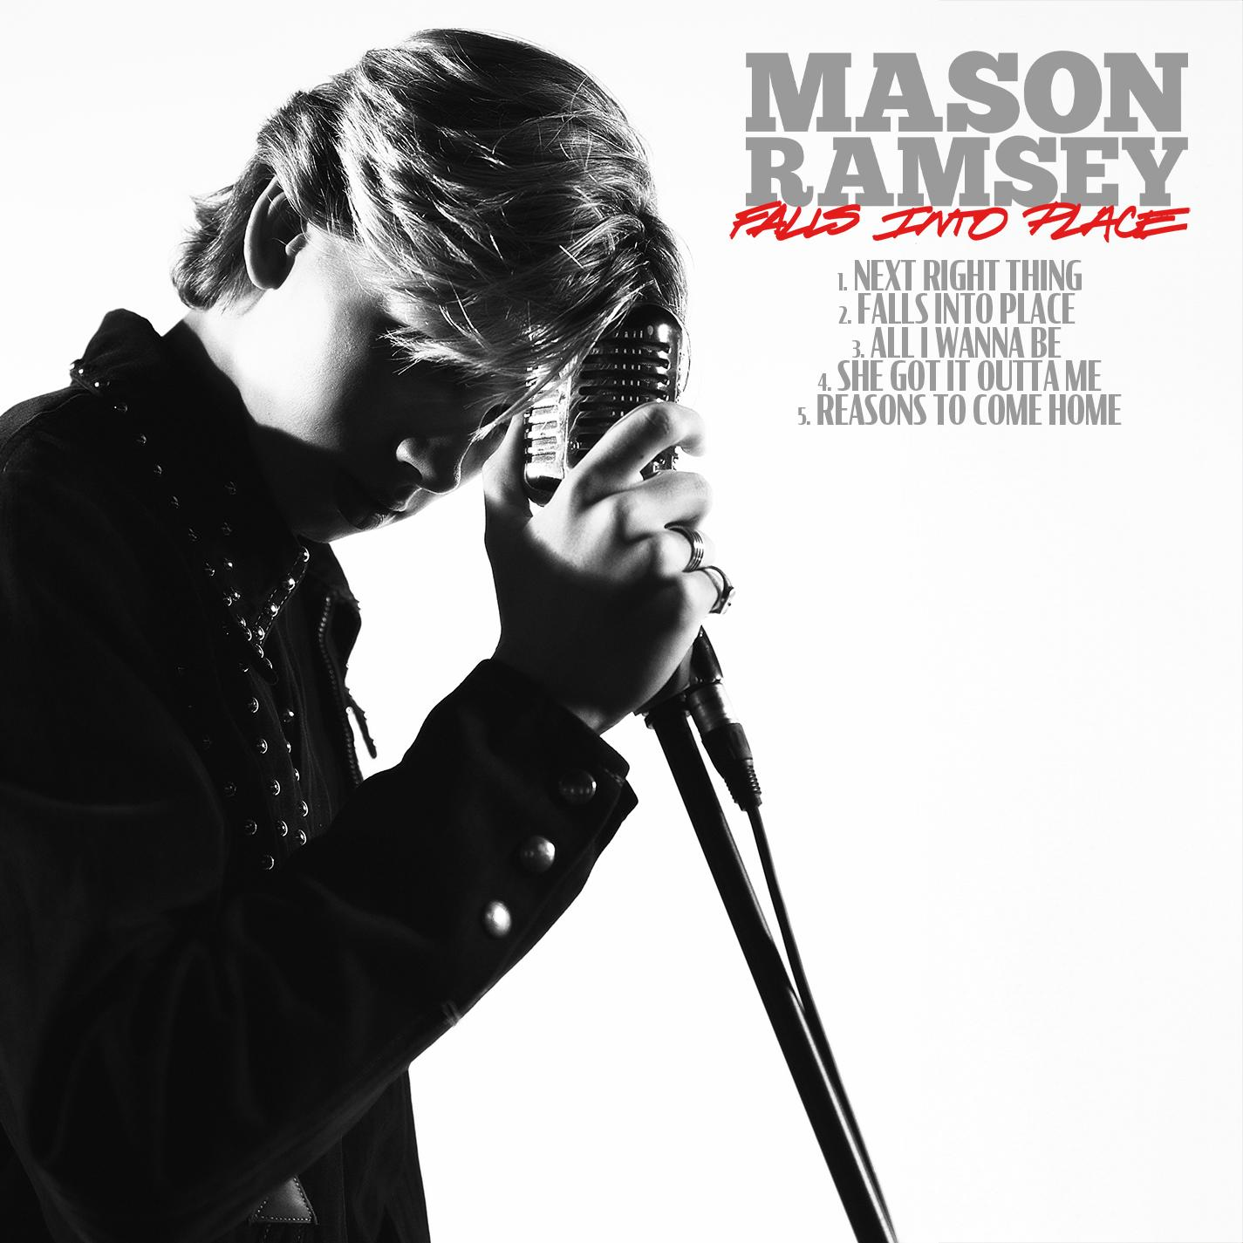

ABOUT MASON RAMSEY
As the youngest major label Country artist signed in the genre in nearly two decades, MASON RAMSEY continues his fast-track to stardom after being discovered singing in an aisle at his local Walmart. Ramsey’s new music illustrates how far he’s come – the differences prove instantly apparent as his voice boasts with the kind of confidence only gained through experience and his songwriting brims with unfiltered truth buoyed by intimate creativity.
Praised by THE NEW YORK TIMES as delivering "a stylistically diverse country and roots music EP,” the ATLANTIC RECORDS artist’s debut FAMOUS EP (Atlantic Records/Big Loud Records) spawned a hit single of the same name which scored a #4 spot on Billboard’s Hot Country Songs Chart. In addition to making his debut at the famed Grand Ole Opry, the Golconda, IL-bred phenom has also performed at several high-profile festivals including CMA FEST, COACHELLA, iHEARTCOUNTRY FESTIVAL, and STAGECOACH. He has made high-profile TV performances on ELLEN, GOOD MORNING AMERICA, and TODAY; as well as esteemed award show appearances on the CCMA AWARDS, CMA AWARDS, CMT MUSIC AWARDS, and GRAMMY AWARDS.

(Press Photo Credit – Libby Danforth; DOWNLOAD HI-RES PHOTOS)

Connect with Mason Ramsey:
INSTAGRAM | TWITTER | FACEBOOK | TIKTOK
For all Mason Ramsey press inquiries, please contact:
Jason Davis (Atlantic Records) – Jason.Davis@atlanticrecords.com
Jensen Sussman (Sweet Talk Publicity) – Jensen@sweettalkpr.com
Julianne Cassidy (Sweet Talk Publicity) – jcassidy@sweettalkpr.com

# # #

