MASON RAMSEY PUTS COUNTRY TWIST ON HOLIDAY CLASSIC “RUN RUN RUDOLPH”

DOWNLOAD/STREAM “RUN RUN RUDOLPH (MASON’S VERSION)”

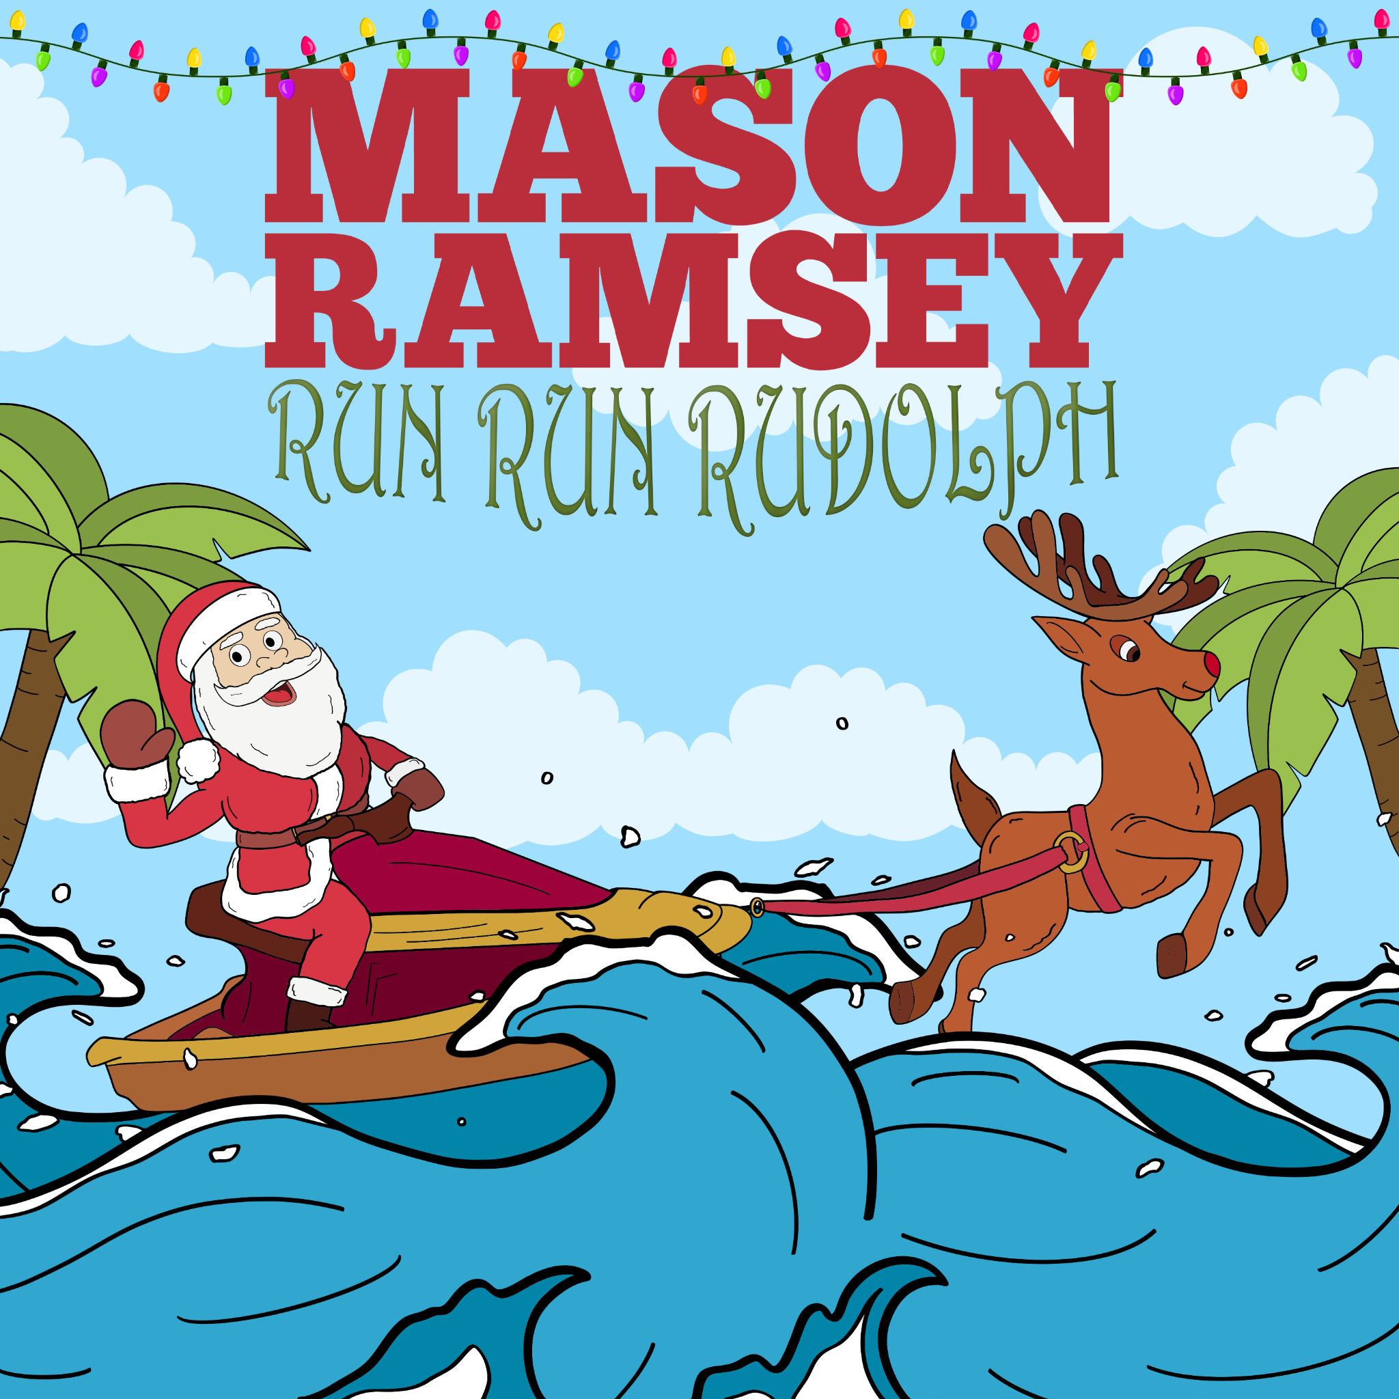
DOWNLOAD HI-RES ARTWORK

16-YEAR OLD PHENOM GOES VIRAL ONCE AGAIN WITH NOSTALGIC ‘THEN & NOW’ PERFORMANCE CLIP FROM THE FAMED GRAND OLE OPRY STAGE CURRENTLY WITH 15M+ VIEWS AND COUNTING

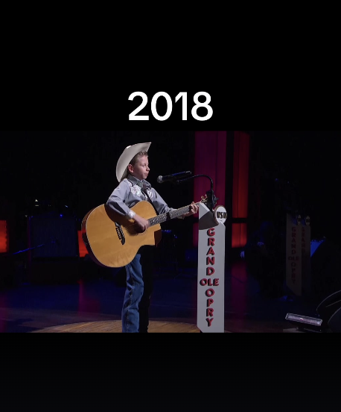

RECENTLY RELEASED COMING-OF-AGE EP FALLS INTO PLACE AVAILABLE EVERYWHERE NOW
DOWNLOAD/STREAM FALLS INTO PLACE

(New York, NY- November 10, 2023) – 16-year-old phenom, Mason Ramsey puts a Country twist on the holiday classic, “Run Run Rudolph,” accompanied by an animated visualizer. Download/Stream “Run Run Rudolph (Mason’s Version)” here.

The young sensation has gone viral once again with a nostalgic ‘then & now’ performance clip from the famed Grand Ole Opry stage – currently with 15M+ views on social media and rising.

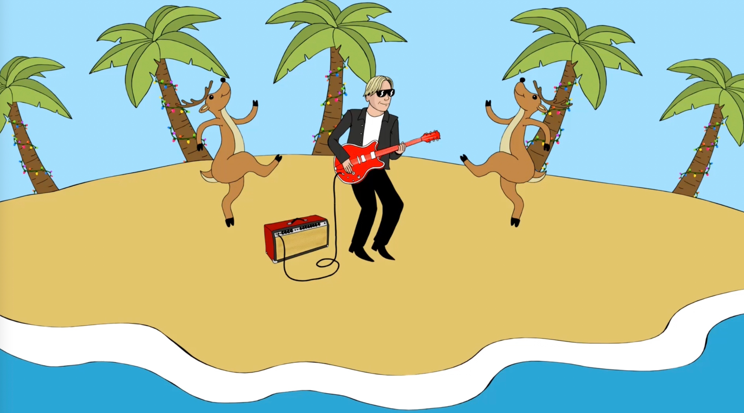

Last month, Ramsey released his coming-of-age EP, Falls Into Place, via Atlantic Records. The five-song project marks his first new studio collection since 2019, and a new era for the breakout singer-songwriter. Available across all streaming platforms and digital retailers, listen to Falls Into Place here. He celebrated his EP release with SOLD-OUT shows at New York City’s Mercury Lounge and Nashville’s Grand Ole Opry.

Ramsey’s “sharpened his chops and returned with a deeper voice and some deeper lyrics,” applauds PEOPLE, as proven in the heartfelt hometown ballad “Reasons To Come Home,” the up-tempo romantic fun of “She Got It Outta Me,” and optimistic honky-tonk rocker “Next Right Thing.” Matching coming-of-age themes and personal growth with Ramsey’s famous pure-Country charm, the global star now “older and more reflective,” according to Billboard, is credited as a co-writer on all but one track.

Since catapulting onto the Country music scene as the youngest major label Country artist signed in the genre in nearly two decades at 11, Ramsey has already delivered two acclaimed EPs, earned a Gold-certified single, headlined two tours in addition to supporting a Las Vegas residency, and surpassed 300 million global streams since 2018.

ABOUT MASON RAMSEY
As the youngest major label Country artist signed in the genre in nearly two decades, MASON RAMSEY continues his fast-track to stardom after being discovered singing in an aisle at his local Walmart. Ramsey’s new music illustrates how far he’s come – the differences prove instantly apparent as his voice boasts with the kind of confidence only gained through experience and his songwriting brims with unfiltered truth buoyed by intimate creativity.
Praised by THE NEW YORK TIMES as delivering "a stylistically diverse country and roots music EP,” the ATLANTIC RECORDS artist’s debut FAMOUS EP (Atlantic Records/Big Loud Records) spawned a hit single of the same name which scored a #4 spot on Billboard’s Hot Country Songs Chart. In addition to making his debut at the famed Grand Ole Opry, the Golconda, IL-bred phenom has also performed at several high-profile festivals including CMA FEST, COACHELLA, iHEARTCOUNTRY FESTIVAL, and STAGECOACH. He has made high-profile TV performances on ELLEN, GOOD MORNING AMERICA, and TODAY; as well as esteemed award show appearances on the CCMA AWARDS, CMA AWARDS, CMT MUSIC AWARDS, and GRAMMY AWARDS.

(Press Photo Credit – Libby Danforth; DOWNLOAD HI-RES PHOTOS)

Connect with Mason Ramsey:
INSTAGRAM | TWITTER | FACEBOOK | TIKTOK
For all Mason Ramsey press inquiries, please contact:
Jason Davis | Jason.Davis@atlanticrecords.com
Taylor Apel | Taylor.Apel@atlanticrecords.com

# # #

