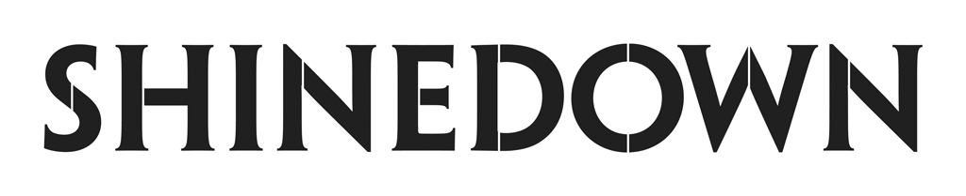

Announces The Revolutions Live Fall Tour
With Support From Papa Roach and Spiritbox

Tickets On Sale This Friday, May 5th at 10am Local at LiveNation.com

“A Symptom Of Being Human” Jumps Into The Top 25 at Hot AC Radio

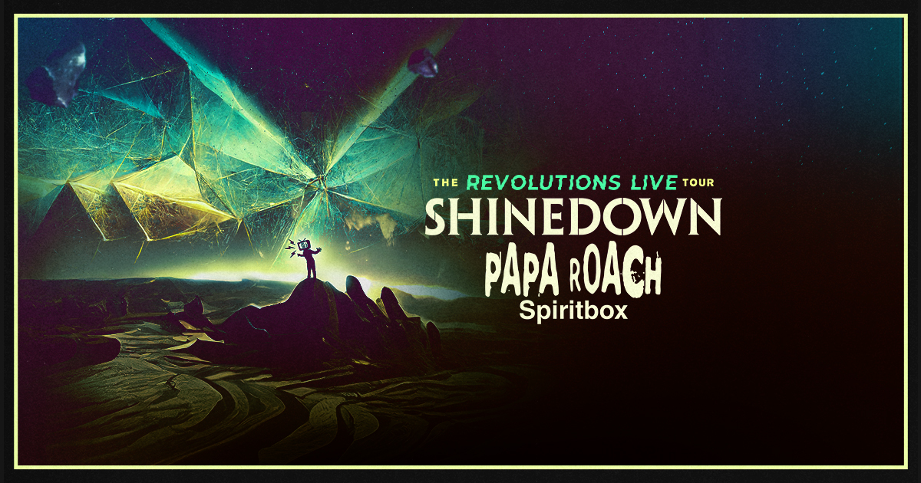
May 2, 2023 – Multi-platinum, chart-topping band Shinedown has announced their upcoming fall leg of The Revolutions Live Tour, co-produced by Live Nation and FPC Live, with support From Papa Roach and Spiritbox.

The fall run of shows starts off in St. Louis, MO on September 3, kicking off a 26-date run of fall headline shows and festivals. Tickets are on sale this Friday May 5th at 10am Local at LiveNation.com. Various presales will be available Wednesday, May 3 through Thursday, May 4. VIP packages featuring exclusive access available for purchase. Full tour routing below. For all show/ticketing details for the fall dates and previously announced dates please visit www.shinedown.com.

This week, the band’s hit single “A Symptom of Being Human” jumped into the Top 25 at Hot AC Radio. Unfolding with gentle acoustic guitar, soaring strings, delicate piano, and a powerful vocal delivery from front man Brent Smith, “A Symptom Of Being Human” celebrates the beauty of our individual differences and embraces the ups and downs of life, while showcasing Shinedown’s gift for making us feel connected through our common humanity.

This follows Shinedown’s recent #1 at Active Rock Radio with "Dead Don't Die." The single notched Shinedown their 20th #1 at the format. It became the most spun #1 song at the Active Rock format in a single week since 2016 when Metallica’s “Hard Wired” hit that milestone, and it is also the most played Shinedown #1 in one week at Active Rock. The defiant track, featuring pummeling drums and searing off-the-rails guitar solos, is a rousing declaration of survival and an anthem about the resilience of the human spirit after trying times.

Shinedown is currently on their spring tour playing to sold out arenas across the country, with support from fellow chart-toppers Three Days Grace and From Ashes To New. For this current run of shows, Shinedown has partnered with the American Foundation for Suicide Prevention (AFSP) to donate $1 for every ticket sold.

The Planet Zero album debuted in the Top 5 on the Billboard 200 Chart and the Official UK Albums Chart, and at #1 on six other Billboard charts including Top Album Sales, Rock, Hard Rock, and Alternative Albums Charts. Featuring searing and incisive tracks like "Dead Don’t Die" and #1 rock hit "Planet Zero", as well as uplifting and unifying songs like the soaring pop-rock anthem and #1 rock hit "Daylight," Planet Zero boldly confronts the societal forces that perpetuate divisiveness while offering a restorative path forward through empathy and open conversation - ultimately serving as a reminder that it is our human connections that matter the most. The band's video for “Daylight,” set to the Amazon Original version of the song, is a love letter to their fans and shows the impact that the song’s message – that you are never alone - had during Shinedown’s sold-out Planet Zero World Tour. PRESS HERE to watch.

SHINEDOWN: THE REVOLUTIONS LIVE FALL TOUR DATES 2023

September 3 – St Louis, MO @ Hollywood Casino Amphitheatre #
September 4 – Kansas City, MO @ T-Mobile Center #
September 6 – Cuyahoga Falls, OH @ Blossom Music Center #
September 8 – Burgettstown, PA @ The Pavilion at Star Lake #
September 9 – Blue Ridge Rock Festival @ The Virginia International Raceway *^
September 12 – Detroit, MI @ Pine Knob Music Theatre ~
September 13 – Syracuse, NY @ St. Joseph's Health Amphitheater at Lakeview #
September 15 – Ocean City, MD @ Ocean City Bike Fest*^
September 16 – Camden, NJ @ Freedom Mortgage Pavilion +
September 19 – Gilford, NH @ Bank of New Hampshire Pavilion #
September 21 – Bangor, ME @ Maine Savings Amphitheater #
September 23 – Mansfield, MA @ Xfinity Center #
September 24 – Newark, NJ @ Prudential Center #
September 26 – Simpsonville, SC @ CCNB Amphitheatre at Heritage Park #
September 27 – Atlanta, GA @ Lakewood Amphitheatre #
September 29 – Tampa, FL @ MIDFLORIDA Credit Union Amphitheater #
September 30 – Hollywood, FL @ Hard Rock Live #
October 3 – Franklin, TN @ FirstBank Amphitheater #
October 5 – Rogers, AR @ Walmart AMP #
October 6 – Allen, TX @ Credit Union of Texas Event Center #
October 8 – Houston, TX @ The Cynthia Woods Mitchell Pavilion #
October 9 – San Antonio, TX @ Freeman Coliseum #
October 12 – Phoenix, AZ @ Talking Stick Resort Amphitheatre #
October 13 – Las Vegas, NV @ MGM Grand Garden Arena #
October 15 – Irvine, CA @ FivePoint Amphitheatre #
October 17 – Salt Lake City, UT @ USANA Amphitheater #
October 19 – Albuquerque, NM @ Isleta Amphitheater #
October 20 – Denver, CO @ Ball Arena #

PREVIOUSLY ANNOUNCED TOUR DATES:
May 3 – Bozeman, MT @ Brick Breeden Fieldhouse =
May 6 – Spokane, WA @ Spokane Arena =
May 7 – Everett, WA @ Angel of the Winds Arena =
May 9 – Portland, OR @ Moda Center =
July 14 – Fargo, ND @ Red River Valley Fair ^$
July 16 – Madison, WI @ The Sylvee +$
July 17 – Green Bay, WI @ EPIC Events Center +$$
July 20 – Monticello, IA @ Jones County Fair *##
July 21 – Gary, IN @ Hard Rock Live ^$$
July 23 – Niagara Falls, ON @ Fallsview Casino Resort ^$$

Newly Added Dates in Bold
#Papa Roach and Spiritbox supporting
~ Spiritbox supporting
$ Saint Asonia and Sleep Theory supporting
## Saint Asonia supporting
$$ Sleep Theory supporting
*Festival date, with no support, just Shinedown
^Not a Live Nation & FPC Live Produced Date
+An Intimate Night with Shinedown
= Three Days Grace and From Ashes To New

WHAT PRESS IS SAYING:
“With 20 number-one singles (including their latest hit ‘Dead Don’t Die’), more than 10 million albums sold, and a staggering 6.5 billion global streams, their hard-hitting style has become the soundtrack of a generation.” - Men’s Journal

“Shinedown are not just a band that plays culturally relevant music, they are a movement in themselves for the greater good, for seeing the best in each other and, most importantly, to not give up on humanity, even when it seems so increasingly bleak out there.” Under the Radar

"Superstars Shinedown continue their creative evolution...Taken as a whole, Planet Zero continues Shinedown’s good work but widens their stride. Most of these songs could stand alone, but together they’re the work of a band unafraid of veering from one side of life’s road to another, and of rock stars totally in tune with the people who put them there.” - KERRANG!

“'Daylight' is the most powerful of pop-rock songs created to remind us that we are truly all in this together." - PEOPLE

“... intelligent, uncompromising rock... a fiery epic that’s delivered as sci-fi but is actually a trenchant dissection of the surreal and fractured state of our very own world.” – American Songwriter

“We're lucky to have Planet Zero as a warning flare. The album is Shinedown’s most strident statement yet. From cancel culture to Twitter addiction to divisive politics, Shinedown take shots at the forces that undermine our shared humanity.” - GRAMMY.com

“a blatant warning—lose connection and lose humanity.” – Parade

“...a high-concept treatise on societal affairs during the past 22 months, including the travails of living through a pandemic, the pitfalls of social media, mental health issues, political divisiveness, partisan media and cancel culture.” - Billboard

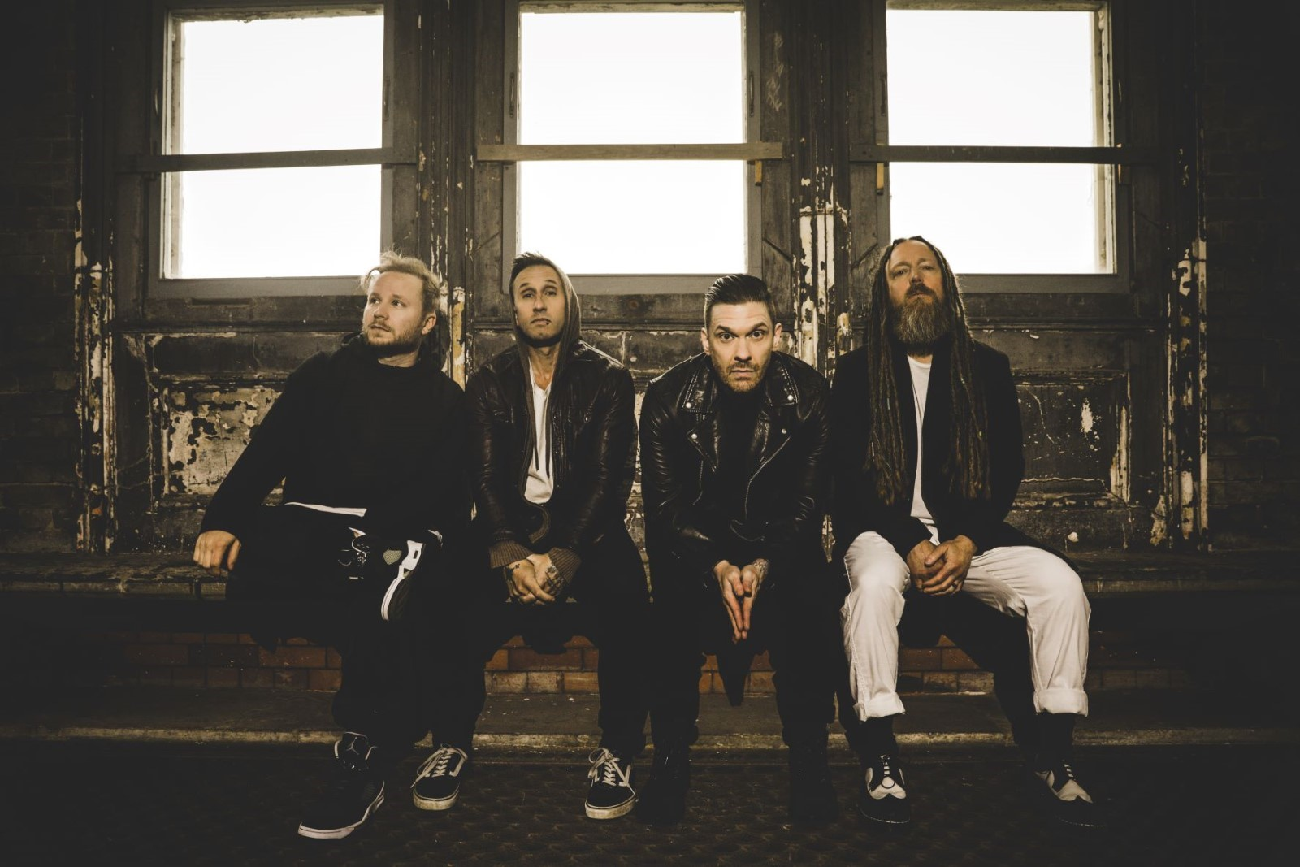
(Photo Credit: Sanjay Parikh)

ABOUT SHINEDOWN
Multi-platinum band Shinedown - Brent Smith [vocals], Zach Myers [guitar], Eric Bass [bass, production], and Barry Kerch [drums] - have cemented their status as one of the most vital and forward-thinking powerhouses in modern rock, embodying the kind of creative dynamism, constant evolution, singular vision, and an uncompromising honesty that transcends boundaries. The record-breaking band, known for their timely messages behind their chart-topping songs that resonate with not only their global audience and the rock community, but our culture at large, has achieved astronomical success with over 6.5 billion global streams, 20 #1 rock hits, 15 platinum and gold singles, platinum or gold certification for every album, and 10 million albums sold worldwide. Shinedown have also become an essential cultural force as evidenced by their major media acclaim and participation in the prestigious 92Y Talks series. The band is currently named #1 on Billboard’s Greatest Of All Time Mainstream Rock Artists Chart, after notching the most ever #1s (18) in the 40-year history of the Mainstream Rock Songs Chart with a string of consecutive #1 hit singles including "Daylight," "Planet Zero" “Atlas Falls,” “GET UP,” ATTENTION ATTENTION,” “MONSTERS,” and “DEVIL”, and landed each of their 30 singles in the Top 10 on Billboard’s Mainstream Rock Airplay Chart, the most out of any artist in history.

2018’s acclaimed album ATTENTION ATTENTION, a story album that confronts such complex matters as mental health and the resolve of the human spirit, was certified RIAA Gold. Its accompanying 2021 feature film, directed by Bill Yukich (Beyoncé, Metallica), is a riveting visual counterpart to the album’s narrative, weaving its 14 songs into a provocative and thought-provoking cinematic journey that illuminates yet another dimension of their limitless creativity.

Hailed for their high-octane live shows, explosive rock ‘n’ roll spirit, thought-provoking lyrics, and melodic sensibility, Shinedown continues to engender diehard love from millions of global fans and has racked up countless sold-out arena tours and festival headlining sets propelled by the undeniable power of front man Brent Smith’s voice.

ABOUT LIVE NATION ENTERTAINMENT
Live Nation Entertainment (NYSE: LYV) is the world’s leading live entertainment company comprised of global market leaders: Ticketmaster, Live Nation Concerts, and Live Nation Sponsorship. For additional information, visit www.livenationentertainment.com.

ABOUT FPC LIVE
FPC Live, a promoter division of Frank Productions, is a full-service concert promotion company involved in every facet of event management. FPC Live produces and promotes entertainment events across the country and manages eight owned-and-operated venues. For additional information, visit FPC-Live.com.

FOLLOW SHINEDOWN
Facebook | Instagram | TikTok | Twitter | Website | Atlantic Records

Shinedown PR Contacts:

Press Here
Linda Carbone / linda@presshereproductions.com
Carla Senft / carla@pressherepublicity.com
Amanda Curtis / amanda@pressherepublicity.com

Atlantic Records
Glenn Fukushima / glenn.fukushima@atlanticrecords.com

Live Nation PR Contacts:

Live Nation Concerts
Monique Sowinski / moniquesowinski@livenation.com
Nadine Peña / nadinepena@livenation.com

