FOR IMMEDIATE RELEASE
JANUARY 26, 2024

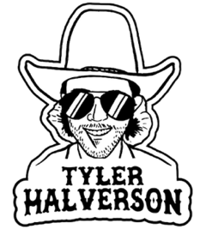

TYLER HALVERSON RIDES HARD WITH “TAKES 8”

ACCLAIMED SOUTH DAKOTA TROUBADOUR SHARES FIRST SINGLE OF NEW YEAR

NON-STOP LIVE SCHEDULE INCLUDES HEADLINE TOUR AND DATES WITH
SHANE SMITH AND THE SAINTS AND IAN MUNSICK

LISTEN TO “TAKES 8” HERE | WATCH OFFICIAL MUSIC VIDEO

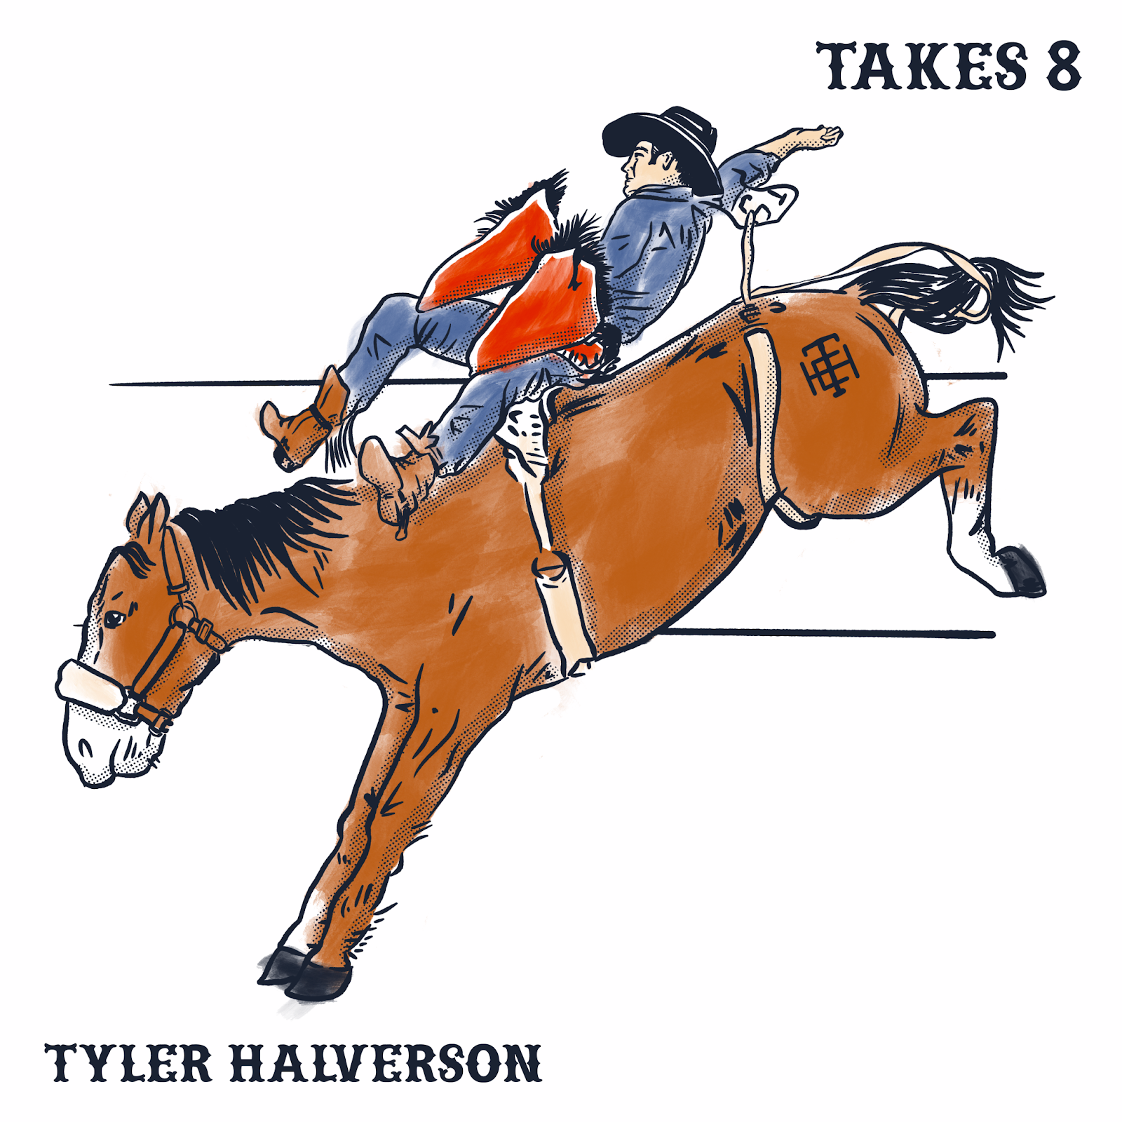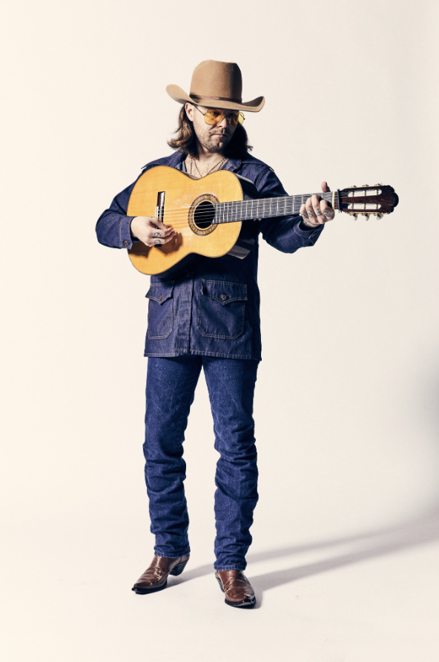
DOWNLOAD HI-RES ASSETS

“Tyler Halverson knows how to infuse his folk/country/rock songs with a little bit of psychedelia…This guy has been on a roll and he’s only gonna keep rising.” – BROOKLYN VEGAN

South Dakota troubadour Tyler Halverson has shared his first single of the new year, “Takes 8,” available everywhere now via Atlantic Records HERE. An official music video/visualizer is streaming now at YouTube HERE.

“It takes 8 to win a buckle,” says Tyler Halverson, “and nine to get me drunk. This one’s about being on the good side of luck by getting in the money and winning over a heart.”

“Takes 8” follows what was unquestionably been a landmark year for Halverson, highlighted by a string of singles that included “Tiffany Blue” (his duet with rising country singer-songwriter Carter Faith), “Yella Rose,” “As They Did,” “Her,’ “Cut You Loose,” and the boisterous “Run Wild,” all joined by official music videos streaming HERE. As if all that weren’t enough, Halverson celebrated the Yuletide season with his new holiday single, “Christmas By Myself,” streaming HERE.

Hailed by Country Swag as “the real deal,” Halverson is already set to spend much of his time on the road in coming months, including The Run Wild Tour – his biggest headline run to date – and dates supporting Shane Smith and the Saints and Ian Munsick. For complete details and ticket information, please see tylerhalverson.com/shows. Halverson is represented by legendary Nashville manager Erv Woolsey (George Strait, LeeAnn Womack) and Allen Mitchell of The Erv Woolsey Company.

ABOUT TYLER HALVERSON
Born and raised in the tiny town of Canton, SD (pop. 3054), Tyler Halverson isn’t just any cowboy. He’s got the hat and the boots, but he also plays a mean guitar and writes an even meaner tune. He has no problem bouncing around the country chasing adventure and is telling his different kind of cowboy tale with his self-described “Western Amerijuana Music,” bridging honest storytelling with songcraft inspired by country powerhouses Garth Brooks, George Strait, and Hayes Carll as much as Boyz II Men, Taking Back Sunday, and The Used.

Halverson fell in thrall to music at an early age, receiving his first guitar while in middle school. A local bluegrass festival convinced him to focus on music, throwing down at 4H and FFA festivals before heading to Nashville to attend the prestigious Belmont University. Upon graduation, he decided to hit the road and spent an extended run traveling around South Dakota, Montana, and Wyoming, all the while writing and playing his songs on social media. Halverson’s original approach caught fire with a string of independent releases including “Beer Garden Baby,” “Mac Miller,” and “Your Bar Now” (with Kylie Frey), amassing tens of millions of streams. Now, with The Run Wild Tour and more new music still to come, Tyler Halverson is eager to take the next step on what has already proven an amazing journey.

“I’m finding myself,” says Tyler Halverson. “I feel like I’m an artist and I’m finally about to do something.”

# # #

TYLER HALVERSON
ON TOUR 2024

JANUARY
26 – Fort Smith, AR – Temple Live
27 – Tulsa, OK – Vanguard

FEBRUARY
2 – Rapid City, SD – Black Hills Stock Show & Rodeo
8 – St. Louis, MO – Old Rock House
9 – Kansas City, MO – PBR Big Sky: A Coors Banquet Bar
10 – Kearney, NE – Buffalo County Fairgrounds *
16 – Houston, TX – Goode Company Armadillo Palace
23 – Indianapolis, IN – LO-FI Lounge

JUNE
8 – Deadwood, SD – Holiday Inn Resort Deadwood Mountain Grand †

* w/ Shane Smith and the Saints
† w/ Ian Munsick

# # #

CONNECT WITH TYLER HALVERSON
OFFICIAL | FACEBOOK| INSTAGRAM | TIKTOK | TWITTER | YOUTUBE

PRESS CONTACT
Jessica Nall // Jessica.Nall@atlanticrecords.com

