RISING SINGER SONGWRITER MARYJO RELEASES NEW SINGLE “DRUNK TATTOO”

TO ACCOMPANY FELLOW ATLANTIC RECORDS ARTIST KNOX ON HIS SOLD-OUT HEADLINE TOUR

LISTEN | WATCH

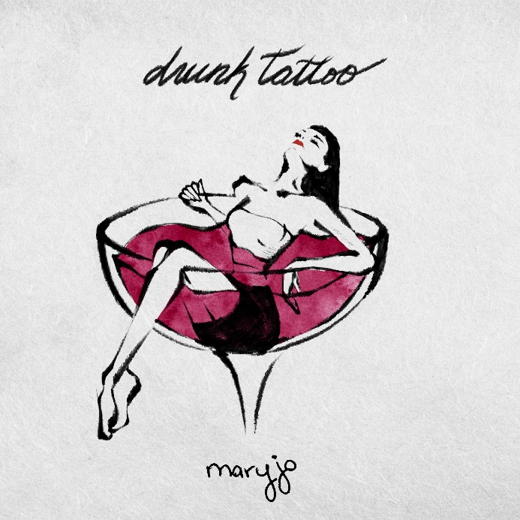
DOWNLOAD HI-RES ARTWORK

“‘Drunk Tattoo’ is about falling for the wrong person,” says maryjo. “Whether crushing hard or falling in love, you eventually hit that “ah ha” moment where you question why you ever liked the person. Kind of like getting a drunk tattoo. Sounds great in the moment, then reality hits. But hey, no regrets, lesson learned.”

Rising singer-songwriter maryjo is starting off the new year with today’s release of her newest single, “Drunk Tattoo,” available now via Atlantic Records. The pop anthem is joined by an official lyric video.

Maryjo will be on the road opening for fellow Atlantic Records artist Knox on his upcoming sold-out headline tour.

“Drunk Tattoo” follows a series of striking singles which quickly earned the Cleveland, OH-based artist more than 4M worldwide streams thus far. Among the fan favorites are such heartfelt tracks as “Don’t Call Me,” the compelling “Traffic,” and “Cleveland,” the latter celebrating her hometown with an official music video showcasing her high school and other meaningful locations plus fashion from several Cleveland-based vendors.

Maryjo made her label debut with last spring’s acclaimed single, “Love Fools,” accompanied by an official music video which follows the intimate highs and lows of a stormy relationship via her home security cameras. Hailed by Billboard as “a showcase for Cleveland singer-songwriter Maryjo, whose words tumble out with searing emotion and who untangles some knotty melodies on this beautifully rendered piano ballad... a great introduction,” the tender ballad features backing from GRAMMY® Award-nominated, 2x ACM Award-winning blind piano virtuoso Gordon Mote.

Currently boasting more than 1.3M TikTok followers and over 27.5M total likes, maryjo has the kind of phenomenal vocal command made for heart-melting piano ballads, often drifting from full-throated belting to a gorgeously fragile delivery inflected with cracks. Though it took years for the artist to overcome her fear of singing in front of others, she worked through her shyness by sharing videos on social media and quickly earned a devoted fan following for her singular and evocative vocal power. The 22-year-old artist continued to capture attention as a fan-favorite contestant on Season 19 of the landmark singing competition series, American Idol, earning praise for her unique renditions of songs by Ed Sheeran, James Bay, Tate McRae, and Jewel, teaming with the latter for a memorable duet performance of the classic “Foolish Games.” Now, with the sentimental “Cleveland” – and more new music on the way – maryjo remains steadfast in her goals, relating breathtaking emotion and musical artistry by simply staying true to her instincts.

“With every song I sing, I try to think about every single angle that people could hear it from and all the ways they could possibly connect to it,” says maryjo. “I’m already getting my therapy from the whole process of writing and recording, so I want to make sure that I’m giving people something that helps them tap into their own emotions and makes them feel better about whatever they’re going through.”
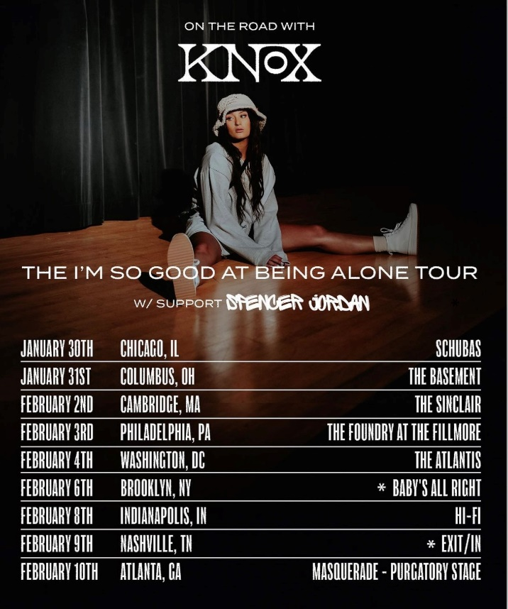

# # #

CONNECT WITH MARYJO
INSTAGRAM | TIKTOK | YOUTUBE

PRESS CONTACT
Christina.Kotsamanidis@atlanticrecords.com

