FOR IMMEDIATE RELEASE
JANUARY 26, 2024

BRELAND APPEARS ON ESPN’S THE PAT MCAFEE SHOW TO TALK SPORTS PREDICTIONS & REVEALS BRAND-NEW SONG “HEARTBREAK & ALCOHOL” COMING 2/16

TICKETS FOR THIRD ANNUAL BRELAND & FRIENDS BENEFIT FEATURING CHASE RICE, JOSH GROBAN, WALKER HAYES, AND MORE ON SALE NOW

BRELAND & FRIENDS: VOL. 1 (LIVE) AVAILABLE ACROSS ALL DIGITAL PLATFORMS NOW

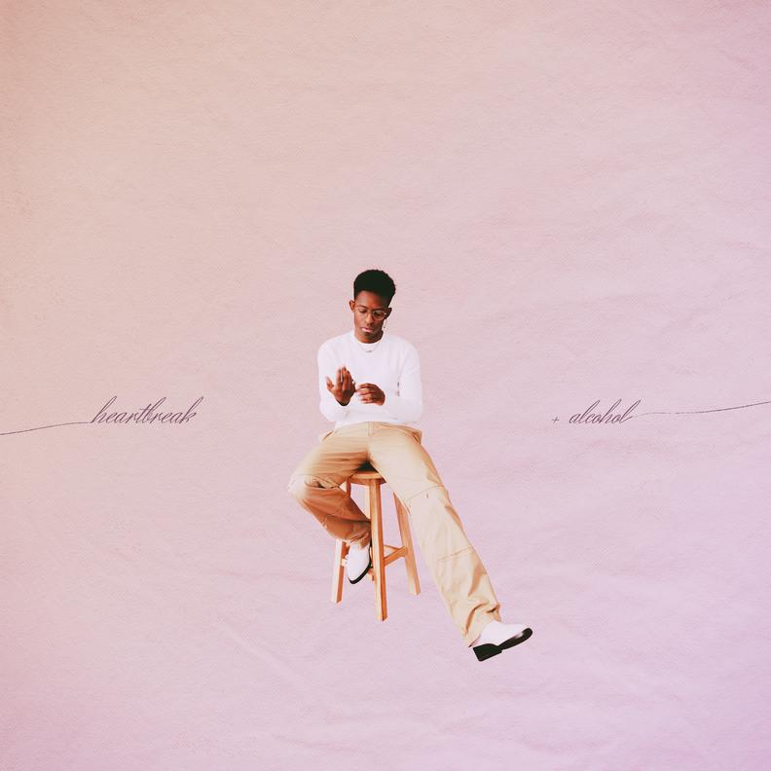

DOWNLOAD ART
PHOTO CREDIT: HENRY AMMANN
ARTWORK CREDIT: NADA TAHA / GOODCOPBADCOP

Getting in the game day spirit, boundary-breaker BRELAND appeared on ESPN’s The Pat McAfee Show this afternoon (1/26) to talk all things sports, including his foretelling NFL predictions over the past few weeks on TikTok, plus his next set of strategic picks for this round of the playoffs. McAfee then broke the news that BRELAND’s brand-new song “Heartbreak & Alcohol” is releasing February 16. Watch the full segment here (starting at 2:43:52).

Taking to socials immediately following the show, BRELAND shared, "Y’all ready for some new music? You heard it first on The Pat McAfee Show. 'Heartbreak & Alcohol' coming 2/16." Fans can pre-save/pre-add here.

Meanwhile, BRELAND & Friends is returning to Nashville’s Ryman Auditorium on March 26, with tickets on sale now for the star-studded evening of community. Hosted and headlined by BRELAND, the annual charity concert features big names and a big-hearted mission – a night of high-energy collabs in support of Middle Tennessee’s at-risk youth via the Oasis Center.

With announced performers Avery Anna, Caitlyn Smith, Chase Rice, Dalton Dover, Drake White, Josh Groban, The War And Treaty, Walker Hayes, and more to come, this year’s event builds on a sold-out tradition which has previously included Dierks Bentley, Keith Urban, Nelly, Sam Hunt, Thomas Rhett, and more. So far, the BRELAND & Friends series has raised over $300,000.

GET IN-DEMAND TICKETS FOR BRELAND & FRIENDS 2024 HERE

In addition to the show, BRELAND celebrates today’s on-sale by releasing a set of live recordings from the very first BRELAND & Friends concert – BRELAND & FRIENDS: Vol. 1 (Live). Available across all digital platforms, stream/download here.

This year’s BRELAND & Friends concert follows another blockbuster year for one of Nashville’s most exciting singer-songwriters. On top of receiving the Lift Every Voice Award at the ACM Honors for his country-expanding efforts, BRELAND released the deluxe album CROSS COUNTRY: THE EXTRA MILE (Bad Realm Records/Atlantic Records/Warner Music Nashville) and spent much of the year on the road.

Firing up huge crowds in support of country legend Shania Twain’s QUEEN OF ME TOUR in the U.S. and U.K. (with stops at iconic venues like Madison Square Garden), BRELAND also headlined THE EXTRA MILE TOUR, traveling across the U.K., Germany, Netherlands, Denmark, Sweden, and Norway.

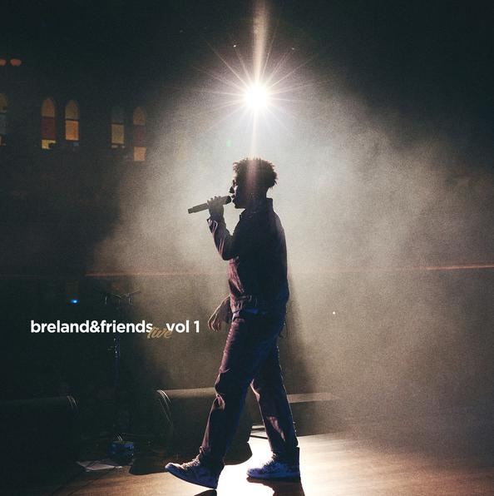
DOWNLOAD GRAPHIC
PHOTO CREDIT: JOHNNIE IZQUIERDO
ARTWORK CREDIT: NADA TAHA / GOODCOPBADCOP

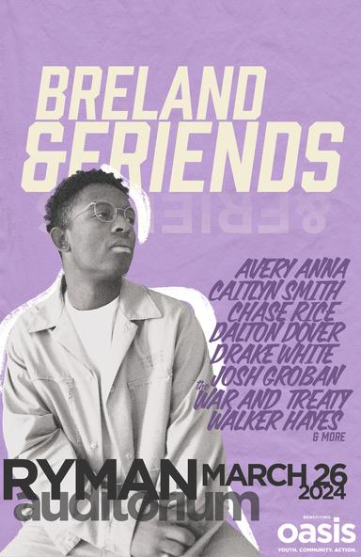
DOWNLOAD GRAPHIC
PHOTO CREDIT: HENRY AMMANN
ARTWORK CREDIT: NADA TAHA / GOODCOPBADCOP

ABOUT BRELAND:
Boundary-shattering, breakout star BRELAND is pushing the possibilities of Country music on a global scale. Since the arrival of his PLATINUM-certified debut single “My Truck,” the New Jersey-bred singer/songwriter/producer has amassed over 1.1 BILLION career streams, brought his crowd-thrilling live show to an international headline tour, and gained acclaim from many of the world’s leading music publications (with Rolling Stone hailing him as “a symbol of Country music’s ongoing evolution” and Billboard calling him a “keen, visionary solo artist”). On his critically acclaimed 2022 debut album CROSS COUNTRY, the Bad Realm Records/Atlantic Records/Warner Music Nashville artist introduced a high-energy sound that blurs the barriers between Country, Pop, Hip-Hop, Soul, and Southern Gospel, offering up smash hits like the GOLD-certified “Praise The Lord (feat. Thomas Rhett).” A blockbuster year for BRELAND, 2023 has included such triumphs as teaming up with superstar Keith Urban to open the 16th annual Academy of Country Music Honors by performing their GOLD-certified collaboration “Throw It Back” and — immediately following the performance — receiving the ACM Lift Every Voice Award, recognizing his role in “elevating underrepresented voices throughout the Country music genre, transcending demographics and geography.” Released in September, CROSS COUNTRY: THE EXTRA MILE delivered a star-packed bonus version of his full-length debut, with the expanded album’s six fresh tracks including a brand-new feature with Brittney Spencer as well as longtime live favorite “Cowboy Don’t.” With his high-profile TV appearances to date including Good Morning America, Jimmy Kimmel Live!, The Voice, and TODAY, he also spent much of 2023 on the road as support for the legendary Shania Twain’s QUEEN OF ME TOUR in the U.S. and U.K. (with stops at iconic venues like Madison Square Garden), in addition to taking his THE EXTRA MILE TOUR across the U.K., Germany, Netherlands, Denmark, Sweden, and Norway. A truly magnetic live performer, BRELAND has also graced the stage at major festivals like Stagecoach and C2C: Country to Country Festival, fulfilling his mission of uniting audience members from all walks of life with his wildly joyful music.
# # #

CONNECT WITH BRELAND
WEBSITE | INSTAGRAM | FACEBOOK | X
AMAZON MUSIC | YOUTUBE | SOUNDCLOUD

PRESS CONTACTS FOR BRELAND
FAIRLEY MCCASKILL / FAIRLEY.MCCASKILL@ATLANTICRECORDS.COM
JENSEN SUSSMAN / JENSEN@SWEETTALKPR.COM
KRISTI BRADSHAW / KRISTI.BRADSHAW@WMG.COM

