FOR IMMEDIATE RELEASE
JANUARY 22, 2024

BRELAND ANNOUNCES DETAILS BEHIND THIRD ANNUAL
BRELAND & FRIENDS BENEFIT CONCERT

RETURNS TO NASHVILLE’S RYMAN AUDITORIUM MARCH 26,
TICKETS ON SALE JANUARY 26

CHASE RICE, JOSH GROBAN, WALKER HAYES, AND MORE
CONFIRMED AS GUEST PERFORMERS
BRELAND & FRIENDS: VOL. 1 (LIVE) COMING JANUARY 26

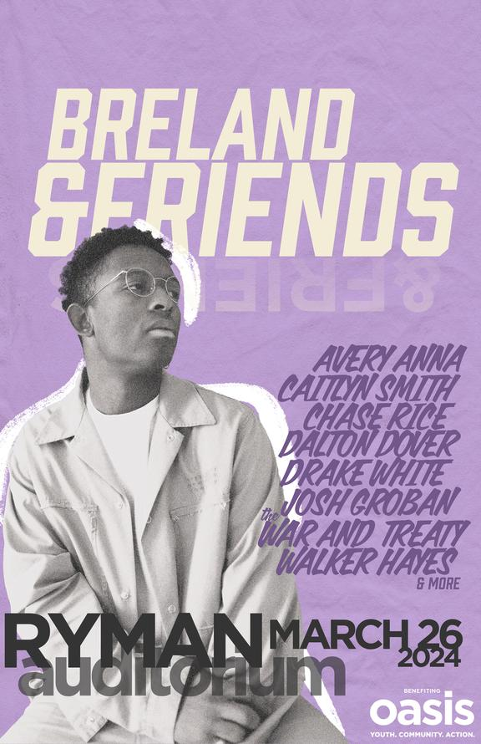
DOWNLOAD IMAGE HERE
PHOTO CREDIT: HENRY AMMANN
ARTWORK CREDIT: NADA TAHA / GOODCOPBADCOP

Returning for his third year of star-studded community support, PLATINUM artist BRELAND announces the details of his BRELAND & Friends 2024 concert.

Set for March 26, 2024, and once again taking place at the Mother Church of Country Music – Nashville’s Ryman Auditorium – the event will be another night of collaborative surprises from one of the most exciting new entertainers.

Well-known for its thrilling lineup, this year’s BRELAND & Friends will feature guest appearances by Avery Anna, Caitlyn Smith, Chase Rice, Dalton Dover, Drake White, Josh Groban, The War And Treaty, Walker Hayes, and more, with proceeds benefiting Middle Tennessee’s at-risk youth through the Oasis Center.

Selling out in each of its previous years, past events have featured the likes of Dierks Bentley, Keith Urban, Nelly, Sam Hunt, Thomas Rhett, and beyond, raising over $300,000 to date. Watch last year’s recap video here.

Tickets for BRELAND & Friends 2024 go on sale this Friday, January 26 at 10am CT and will be available here.

To celebrate this year’s benefit, BRELAND is releasing BRELAND & Friends: Vol. 1 (Live), a must-hear throwback set of six electrifying live collaborations from the very first BRELAND & Friends (April 12, 2022). Dropping January 26, the same day as the ticket on-sale, BRELAND & Friends: Vol. 1 (Live) will be available across all digital platforms. Pre-save/pre-add here.

BRELAND & Friends: Vol. 1 (Live) Track List:
- “Praise the Lord (feat. Thomas Rhett) [Live from the Ryman]”
- “High Horse (feat. Nelly) [Live from the Ryman]”
- “Told You I Could Drink (feat. Charles Kelley) [Live from the Ryman]”
- “Beers on Me (feat. Dierks Bentley) [Live from the Ryman]”
- “My Truck (feat. Sam Hunt) [Live from the Ryman]
- “Alone at the Ranch (feat. Seaforth) [Live from the Ryman]”
BRELAND & Friends follows another blockbuster year for the rising star. On top of receiving the Lift Every Voice Award at the ACM Honors for his country-expanding efforts, BRELAND released the deluxe album CROSS COUNTRY: THE EXTRA MILE (Bad Realm Records/Atlantic Records/Warner Music Nashville) and spent much of the year on the road.
Firing up huge crowds in support of Shania Twain’s QUEEN OF ME TOUR in the U.S. and U.K. (with stops at iconic venues like Madison Square Garden), BRELAND also headlined THE EXTRA MILE TOUR, traveling across the U.K., Germany, Netherlands, Denmark, Sweden, and Norway.
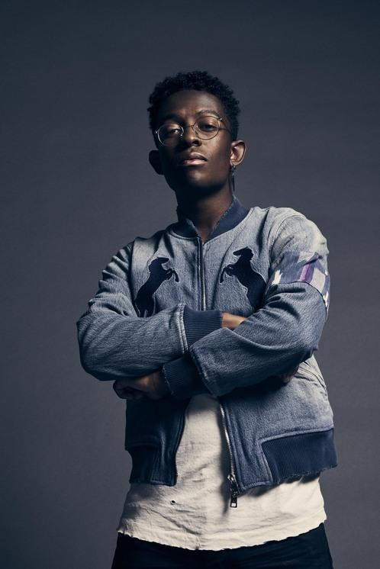
DOWNLOAD PRESS PHOTO HERE
PHOTO CREDIT: JIMMY FONTAINE

CONNECT WITH BRELAND
WEBSITE | INSTAGRAM | FACEBOOK | X
AMAZON MUSIC | YOUTUBE | SOUNDCLOUD

MEDIA CONTACTS
Fairley McCaskill / Fairley.McCaskill@atlanticrecords.com
Jensen Sussman / Jensen@sweettalkpr.com
Kristi Bradshaw / Kristi.Bradshaw@wmg.com

