COLDPLAY GIVE UPDATE ON TOUR EMISSIONS SUCCESS

BAND REACH 47% REDUCTION IN CO2E EMISSIONS AS WORK IS HERALDED BY MIT PROFESSOR AS “CRITICALLY IMPORTANT”
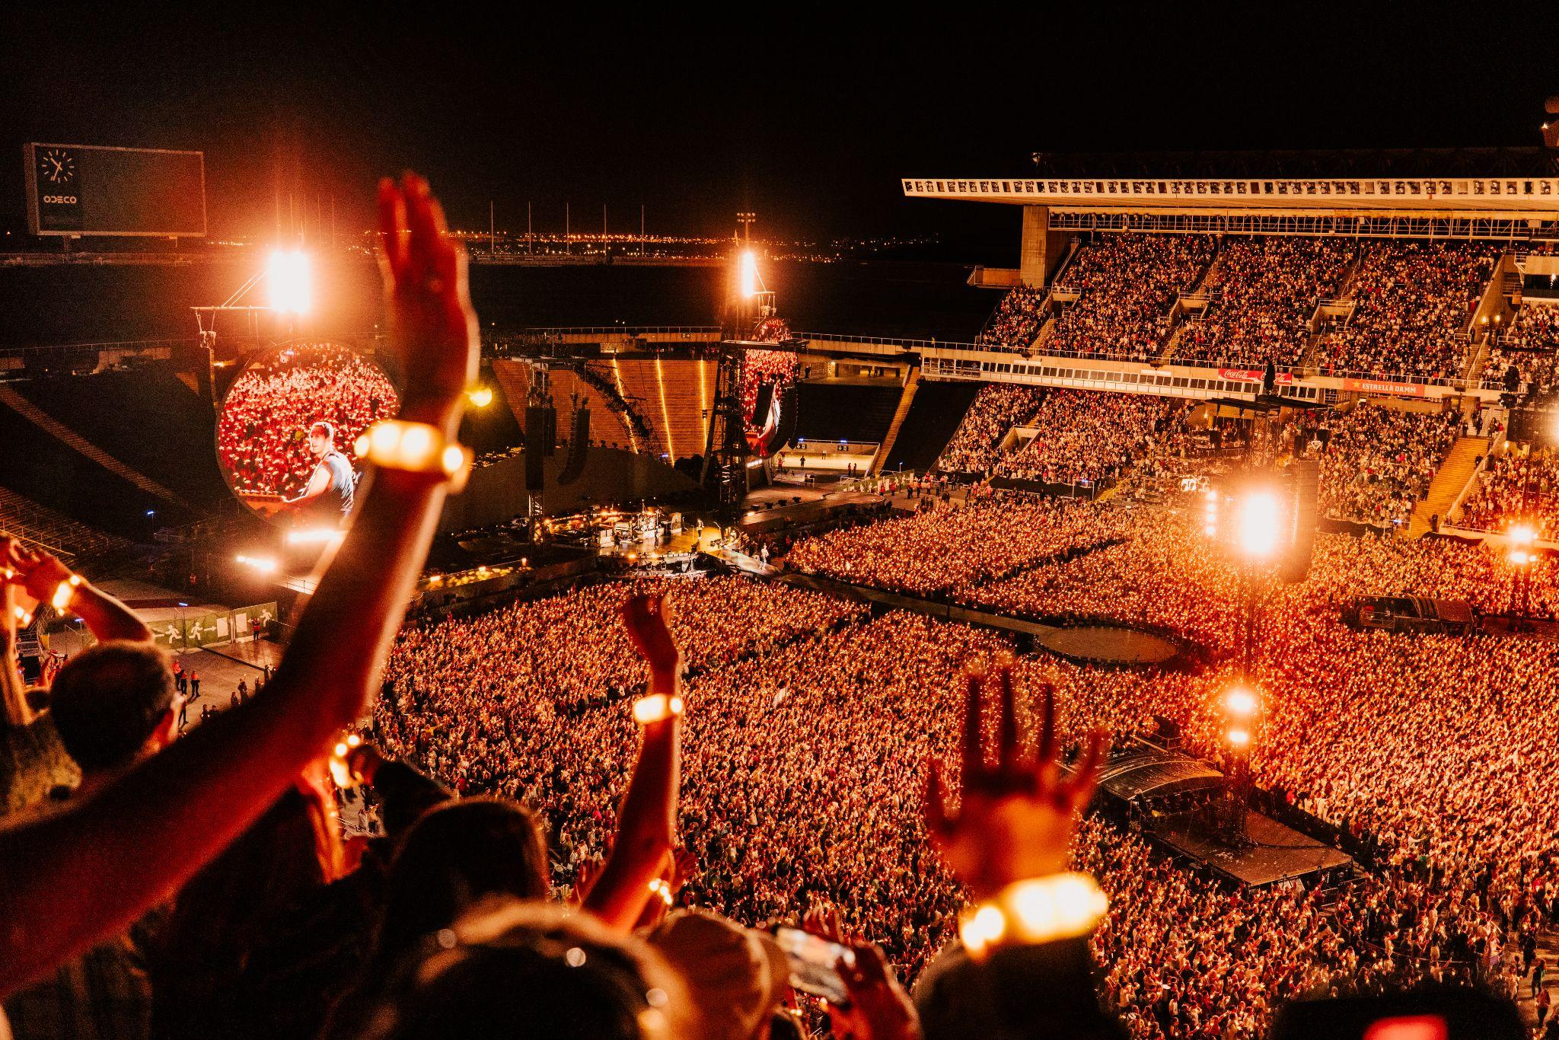
Photo: Anna Lee

Coldplay have today given an update on the sustainability initiatives that form a central part of their Music Of The Spheres World Tour, which began in March 2022 and has so far sold more than 7 million tickets.

The band, currently playing a four night residency at Manchester’s Etihad Stadium, revealed that their current tour has so far produced 47% less CO2e emissions than their previous stadium tour in 2016/17, and that 5 million trees have already been planted (one for each concert goer).

The band’s efforts have been assessed and validated by Professor John E. Fernandez of MIT (Massachusetts Institute of Technology) Environmental Solutions Initiative, who said: “We fully endorse this effort as critically important, scientifically rigorous and of the highest quality.”

Coldplay’s full statement is below:

When we first announced the Music Of The Spheres Tour, we hoped to make it as environmentally beneficial as possible and reduce our direct carbon emissions (from show production, freight, band and crew travel) by 50%. We’d like to share how it’s been going; some things work and some things need improving.

The emissions data from the first 12 months of the tour has now been collated, assessed and independently validated by Prof. John E. Fernandez of the MIT Environmental Solutions Initiative.

On a show-by-show comparison, the Music Of The Spheres Tour has so far produced 47% less CO2e emissions than our last stadium tour (2016-17).

This is a good start - and something that our incredible crew should be very proud of - but clearly there’s still room for improvement.

Now that we’re into the second year of the tour, we’ve started to run the entire show (audio, lights, lasers etc) from an electric battery system that allows us to use 100% renewable energy as efficiently as possible. We have been using electric vehicles and alternative fuels wherever we can, as well as reducing waste and plastic usage to a minimum.

Thankyou to all the brilliant people and creative minds who’ve helped us so far.

Thankyou too, SO MUCH, to everyone who’s come to a show and made all of this possible. You have helped charge the show batteries on the power bikes and kinetic dance floors; travelled to shows by foot, bicycle or public transport; used the recycling bins; ride-shared; brought refillable water bottles; returned the LED wristbands after the show. And just by coming you have had a tree planted, and helped a range of environmental organisations like The Ocean Cleanup and ClientEarth (a team of lawyers who defend the environment).

Thankyou all and hopefully this time next year we will have made big improvements. If anyone has any ideas please feel free to send them via this link.

With love
Coldplay

All of the band’s data and environmental impact assessments from both the A Head Full Of Dreams Tour (2016/2017) and the first year of the Music Of The Spheres Tour were shared with the team and leadership at the MIT Environmental Solutions Initiative, who said:

“Based on a detailed review of the work of Coldplay’s sustainability team in assessing and advising the band and management on the CO2e impact of touring, we fully endorse this effort as critically important, scientifically rigorous and of the highest quality.

MIT ESI endorses this work as an important and substantive step toward a new era of eventually achieving carbon neutral music events by major artists. The band deserves significant praise in commissioning the work and acting as the vanguard for the global music industry as it begins to take seriously the reality of living and making music in the Anthropocene.”

- Prof. John E. Fernandez, MIT Environmental Solutions Initiative

Highlights of the band’s sustainability initiatives are listed below. Please see http://www.coldplay.com/emissions-update/ for more information,

- 47% reduction in direct CO2e emissions compared to our previous tour (2016-17), on a show-by-show basis

- 5 million trees planted that will be supported to maturity via One Tree Planted - one for each concert goer. 5,000 hectares of land restored across 17 countries and 21 planting projects

- 1 solar-powered River Interceptor deployed in March 2021 in the Klang River, Malaysia via The Ocean Cleanup. 158 tonnes of waste and 13 tonnes of ocean-bound plastic removed since start of tour

- 86% average return rate of the reusable, plant-based LED wristbands
- 15kWh average power per show generated via in-venue solar installations, kinetic dance floors and power bikes - enough to power the C-stage performance each night and provide the crew with phone, laptop and tool-charging stations

- 66% of all tour waste diverted from landfill

- 3,770 meals + 73 kg of toiletries donated from tour catering to the unhoused and unsheltered

- Financial support to environmental organisations including ClientEarth,The Ocean Cleanup, Climeworks, Sea Shepherd, Project Seagrass, Sustainable Food Trust, Cleaner Seas Group, Food Forest Project, Knowledge Pele, Conservation Collective and others

