FOR IMMEDIATE RELEASE
FEBRUARY 16, 2024

GALANTIS RELEASE “ONE, TWO & 3”

THIRD-ANNUAL MIDSOMMAR SHOWS AT BROOKLYN MIRAGE ANNOUNCED FOR JUNE

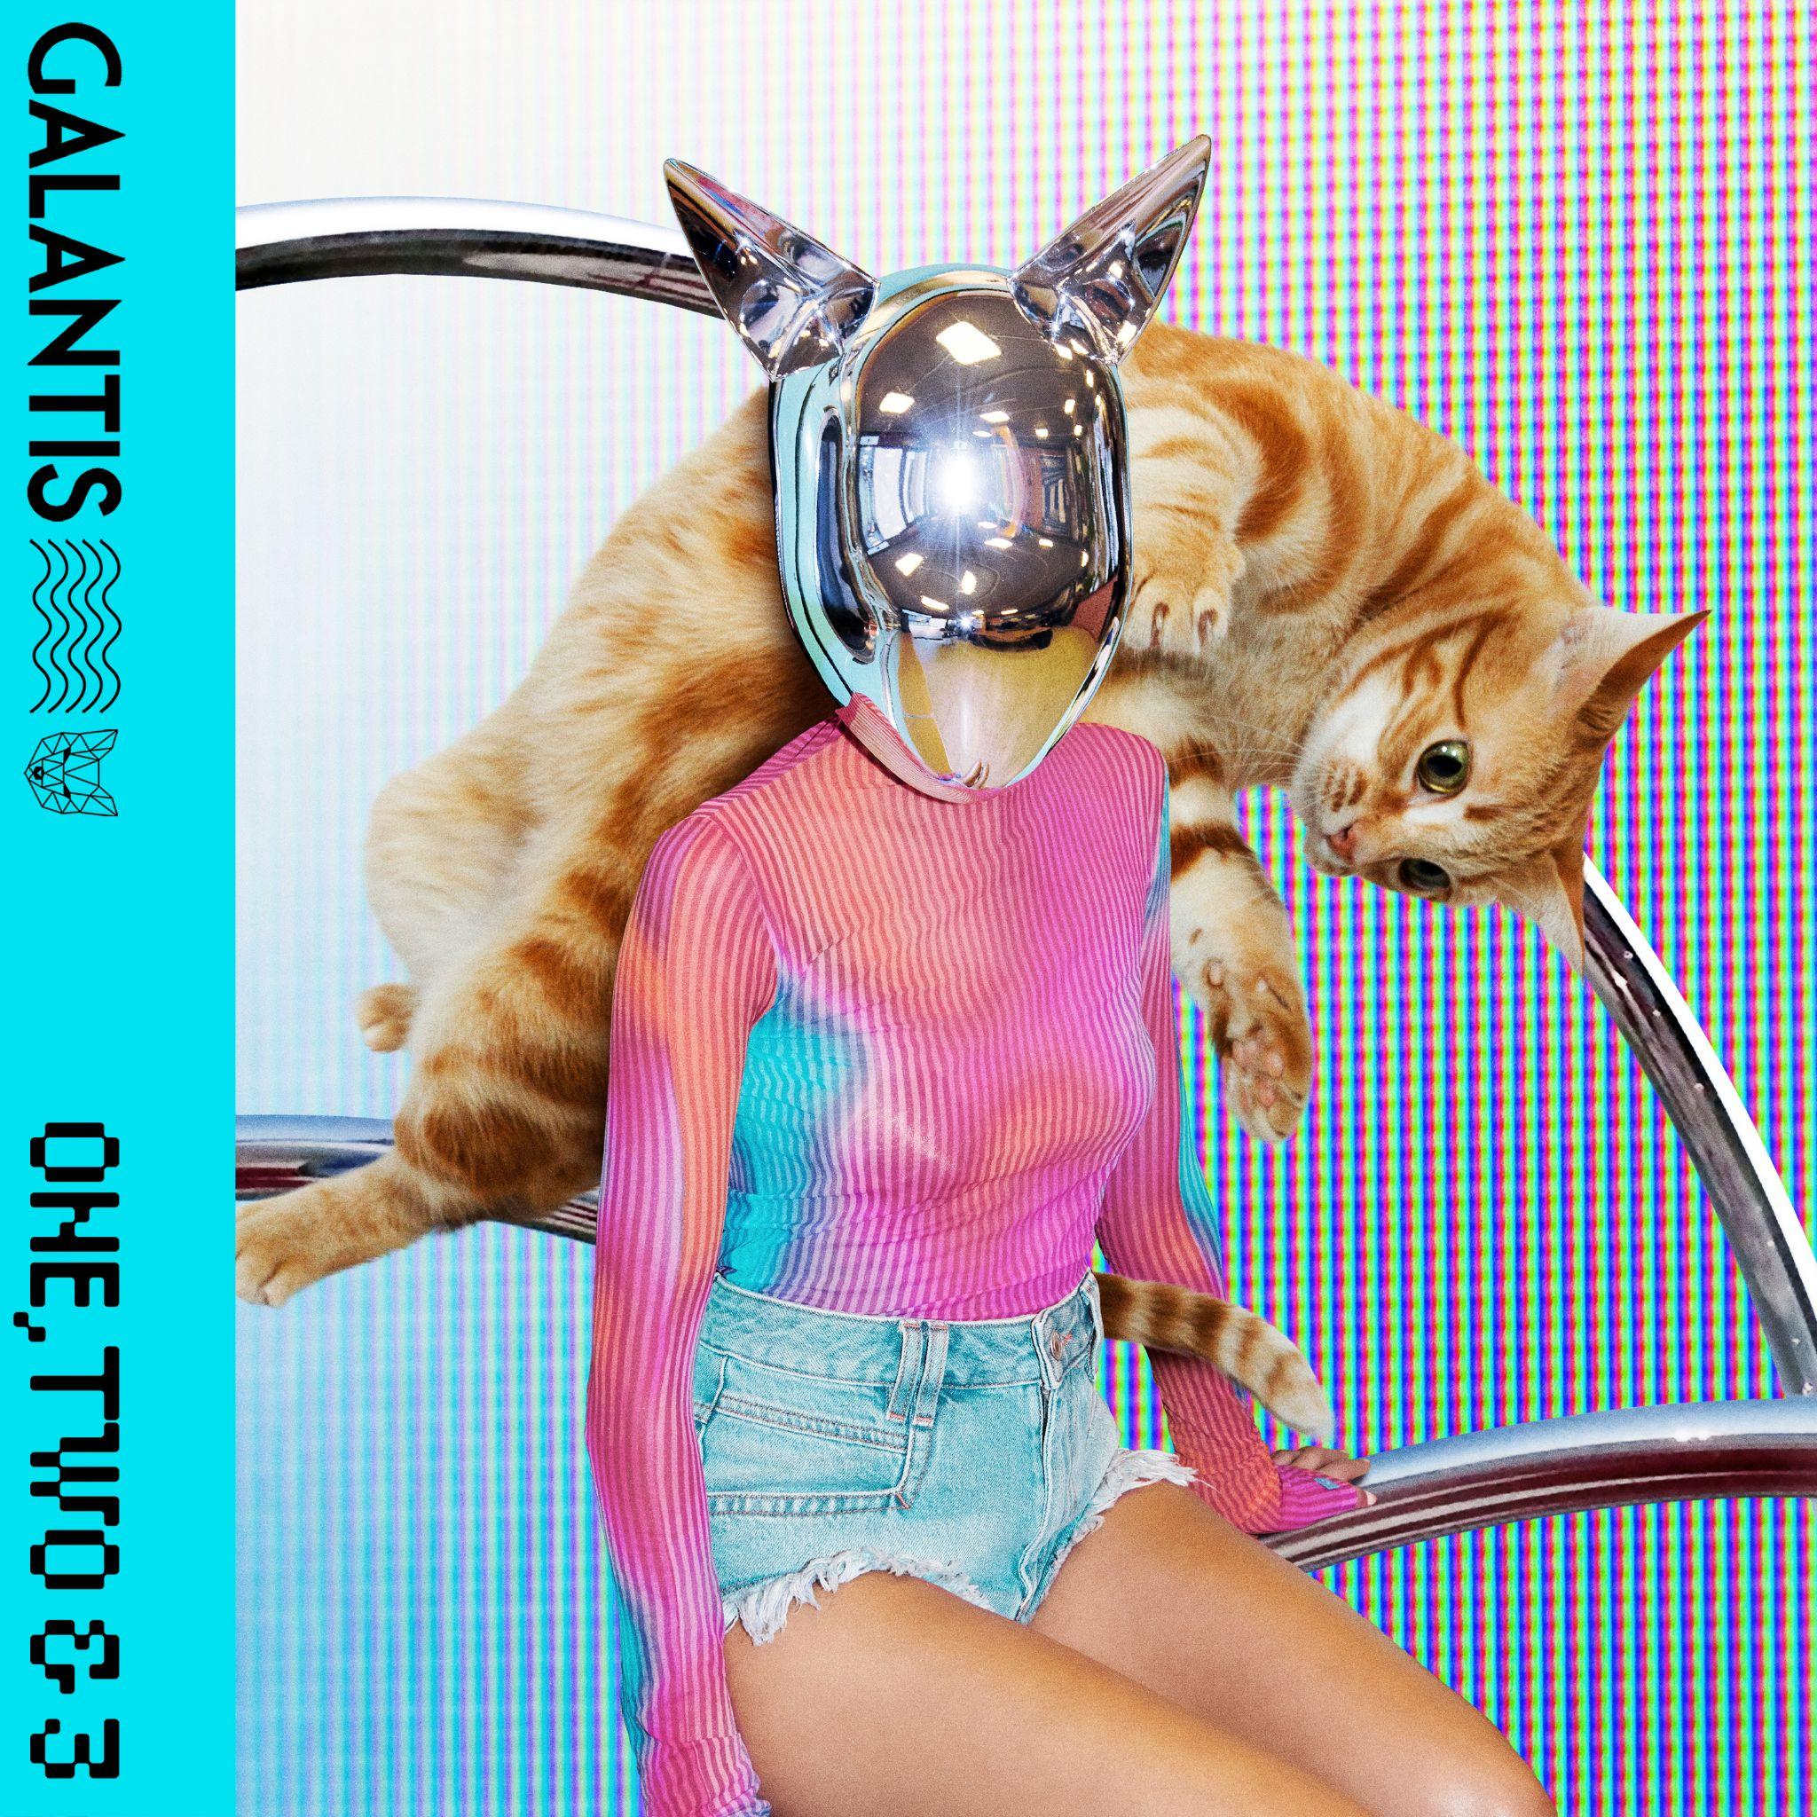
DOWNLOAD HIGH-RES IMAGES/ARTWORK

STREAM “ONE, TWO & 3”: LINK

“one of the most influential and untamed voices in modern music” – GRAMMY.com

Internationally-acclaimed dance music powerhouse Galantis has dropped their first new track of the year, “One, Two & 3” – available now via Big Beat Records.

“'One, Two & 3’ is channelling the classic dance energy Galantis was built on and continues to be at the core of its DNA... I'm dedicating this tune to the fans who are with me on this journey, I'm truly grateful for their unwavering support.” – Christian Karlsson (Galantis)

2023 saw the release of a blockbuster collection of singles and collaborations from Galantis, ushering in a hotly anticipated fourth album era which will mark the first full-length since 2020’s Church. “One, Two & 3” follows “Dreamteam” with Neon Trees and “Little Bit Yours” with Hannah Boleyn, the latter of which boasts over 3 million streams globally while continuing to ascend the US Dance radio chart. The album is due to also feature “Koala” which was declared “another dance hit” by American Songwriter and “BANG BANG! (My Neurodivergent Anthem)” which Rolling Stone praised as “an upbeat festival-ready banger” alongside a candid statement from Christian Karlsson revealing his ADHD diagnosis and neurodivergent journey.

One of dance music's most dynamic and in-demand live performers, Galantis has sold out countless venues around the world and has thrilled crowds across the global festival circuit. This year will mark the third-annual return to Brooklyn Mirage for Midsommar on June 22nd and 23rd following Miami Music Week performances at DAER Nightclub on March 23rd and Surfcomber Hotel on March 24th. For full live routing and ticket information please visit wearegalantis.com/tour.

Galantis is the dance music project of Christian Karlsson (aka Bloodshy). Their RIAA gold-certified debut album Pharmacy reached No. 1 on the Billboard Dance album chart on the strength of gold-certified single “Peanut Butter Jelly” and 3x platinum certified smash “Runaway (U & I)” – the latter of which earned a GRAMMY nomination for “Best Dance Recording” – while 2017’s sophomore album The Aviary (featuring platinum-certified single “No Money”) saw a top 10 debut in 23 countries. The third Galantis album, 2020’s Church, featured the chart-topping gold-certified single “Faith” with country music icon Dolly Parton featuring Mr. Probz, which saw a #1 debut on Billboard’s Dance/Electronic Chart before quickly reaching #1 on the Dance/Mix Show Airplay Chart where it remained for 5 weeks. Meanwhile, gold-certified collaborative single “Heartbreak Anthem” with David Guetta & Little Mix proved a global sensation, spending 10 weeks on the Billboard Global 200 chart and 13 consecutive weeks in the top 10 on the UK Official Chart. Galantis has received over 5 billion cumulative worldwide streams and over 1.8 billion video views to date.

Karlsson has been at the helm of Galantis since 2009 before officially debuting the project at 2014’s Coachella Valley Music and Arts Festival. His career has spanned across the musical genres of punk-rock, hip-hop and pop – including work as one half of acclaimed production duo Bloodshy & Avant and one third of indie pop band Miike Snow. Karlsson’s songwriting/production credits have included the likes of Madonna, Kylie Minogue, Katy Perry and extensive work with Britney Spears (including “Toxic” which earned a GRAMMY for “Best Dance Recording” and her widely acclaimed 2007 album Blackout). As Galantis, he has crafted remixes for the likes of Coldplay, Selena Gomez, Ed Sheeran, Sam Smith & more. Declared “pop’s mastermind producer” by UPROXX, “eternally effervescent” by Billboard and “one of the most influential and untamed voices in modern music” by GRAMMY.com, the Swedish-born artist continues to evolve and push the boundaries of songwriting within the world of dance music and beyond.

DOWNLOAD HIGH-RES IMAGES/ARTWORK

GALANTIS LIVE:
March 23 – DAER Nightclub – Miami, FL
March 24 – Surfcomber Hotel Pool – Miami, FL
May 26 – Ubbi Dubbi – Dallas, TX
June 26 – Bonnaroo – Manchester, TN
June 22 – Midsommar @ Brooklyn Mirage – New York, NY
June 23 – Midsommar@ Brooklyn Mirage – New York, NY

CONNECT WITH GALANTIS:
WeAreGalantis.com | Twitter | Facebook | YouTube | Instagram | Assets

CONTACT:
Ted Sullivan | Ted.Sullivan@atlanticrecords.com

