FOR IMMEDIATE RELEASE
FEBRUARY 23, 2024

CHAOTIC R&B’S HEAD HONCHO HONEY BXBY RETURNS WITH OFFICIAL
VISUAL FOR “FKN HIM TOO”

FOLLOW-UP TO LAST WEEK’S SINGLE RELEASE

COMES ON THE HEELS OF THE SINGLE RELEASE FOR “TOUCHIN’ (REMIX)”
FEATURING LABELMATE KALIII

HITTING THE ROAD FOR SECOND NATIONAL TOUR SUPPORTING FLYANA BOSS

MORE MUSIC TO COME FROM THE RISING SONGSTRESS IN 2024

WATCH “FKN HIM TOO” | DOWNLOAD “FNKN HIM TOO”

Rising New Jersey star, Honey Bxby, returns to release official visual for her latest single “Fkn Him Too.” “Fkn Him Too” produced is by Worldwide Fresh (Beyoncé, Doechii Coi Leray, Berner, Teyana Taylor) and samples the legendary R&B divas SWV’s “I’m So Into You.” This Saturday, Honey will hit the road for her second national tour joining Flyana Boss, on their BOSSTANICAL Garden Tour in Chicago. With a monumental debut under her belt, expect more music to come from the rising songstress in 2024.

# # #

HONEY BXBY

Few stars burn as bright as Honey Bxby. A New Jersey native, the multi-hyphenate singer-songwriter developed her talents from an early age. Raised on contemporary artists like Drake, Alicia Keys, and Kehlani, she spent hours studying their melodies, cadences, and lyrics. Inspired by their introspective approaches to storytelling and applied that to her writing style. Honey would go on to begin performing privately to friends before uploading covers of songs online. A siren for the YouTube generation, Honey dropped her first song back in 2019 while simultaneously attending cosmetology school. While working, briefly, as an exotic dancer and on a hiatus from music, she was discovered through Instagram. A chance meeting with her now manager, K Mack, helped launch her career. Merging disarming truthfulness with flesh-and-blood-sex appeal, her emotional honesty has garnered rising notoriety. Her singular soundscape blends serene, honey-laced vocals with unbridled and cold-blooded raps. On her debut EP, she flits through genres with bullish command. In a sea of sameness, while the bulk of her peers are more concerned with aesthetics and manufactured personas, Honey’s self-contained authenticity is reassuring to a generation still forming the language around complex emotions. Honey has a knack for using Instagram as a personal and unfiltered diary while encouraging her fans to be their most true selves. “There’s no persona, this is me all the time. I’m talking a lot of shit. I try to show myself. I just wanna inspire people to be the best versions of themselves. As an artist it’s not just about your music. It’s about your image, your personality, your character, all of that.” Since the release of her debut EP, the songstress has stayed quite active. She’s since released Touchin’: The Pack; a compilation of several variations of Honey’s hit single. She followed up with the release of the official visual for her EP track “Poseidon.” This past fall, Honey embarked on her first tour as direct support on Sexyy Red’s Hood Hottest Princess tour. Honey made her television debut at the 2024 BET Soul Train Awards where she performed “Touchin’.”

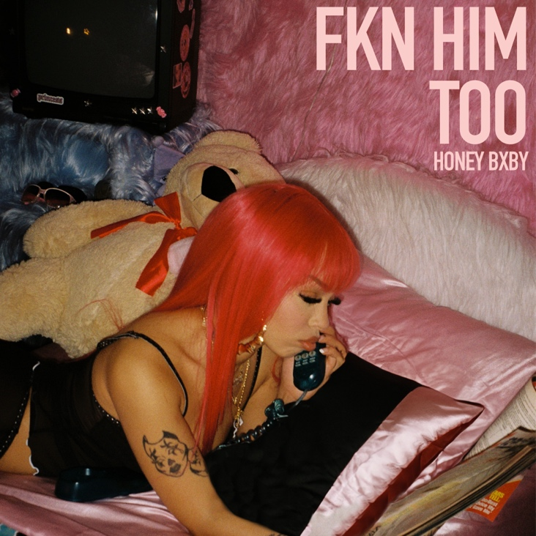
DOWNLOAD HI-RES ARTWORK

CONNECT WITH HONEY BXBY
TWITTER | TIKTOK | INSTAGRAM | YOUTUBE

FOR PRESS INQUIRIES
ARIANA WHITE | ARIANA.WHITE@ATLANTICRECORDS.COM

