FOR IMMEDIATE RELEASE
FEBRUARY 9, 2024

RAP’S IT-GIRL KALIII RETURNS WITH FIRST SINGLE OF THE YEAR “BOZO”

ACCOMPANIED BY AN OFFICIAL VISUAL

FOLLOW-UP TO LAST YEAR’S RELEASE OF “SAY TOO MUCH” FROM THE EP FCK GIRL SZN

“BOZO” WILL BE FEATURED ON FORTHCOMING EP DUE THIS SPRING

RECENTLY ANNOUNCED AS A PERFORMER FOR ROLLING LOUD LA 2024 ALONGSIDE POST MALONE, SUMMER WALKER, BIG SEAN, AND MORE

INCLUDED ON THE GRAMMY-AWARD WINNING BARBIE MOVIE SOUNDTRACK

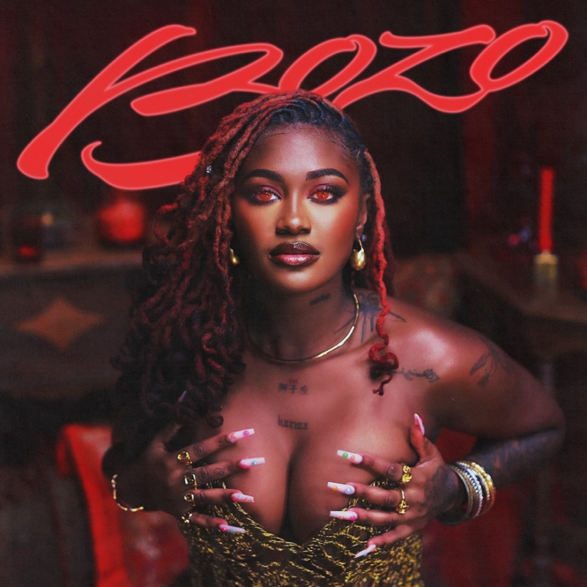
DOWNLOAD HI-RES ARTWORK
WATCH “BOZO” | DOWNLOAD “BOZO”

Today, rapstress Kaliii, released her first single of the year “Bozo.” The lively and female empowerment anthem is accompanied by a cinematic visual and samples Keyshia Cole’s iconic “Love” single. The release of “Bozo” coincides with Kaliii’s inclusion on the GRAMMY Award-winning soundtrack album for the Barbie Movie; on Sunday it took home the coveted trophy for Best Compilation Soundtrack For Visual Media. The single also serves as the follow-up to last year’s release of the visual for “Say Too Much” from her EP FCK GIRL SZN. “Bozo” will be featured on her forthcoming EP due this spring. Kaliii was recently announced as a performer for Rolling Loud LA 2024 alongside Post Malone, Summer Walker, Big Sean, and more.

Rap’s it-girl reached new heights in 2023. Kaliii ignited her groundbreaking year with her viral single “Area Codes,” (43M views) and the Atlanta native has shown no signs of slowing down. She followed up with a Best New Artist nomination at the 2023 BET Awards along with her performance on the BET Amplified Stage. Kaliii was also nominated for Best Breakthrough Hip Hop Artist at last year’s BET Hip Hop Awards and Best New Artist at the MTV Video Music Awards. She followed up with her four-track EP, FCK GIRL SZN, which came on the heels of her single “K Toven” and the official DJ 809 remix. Kaliii continued dominating the year as direct support on tours for A Boogie and Sexyy Red before embarking on iHeart Radio’s annual Jingle Ball Tour that capped off the year.

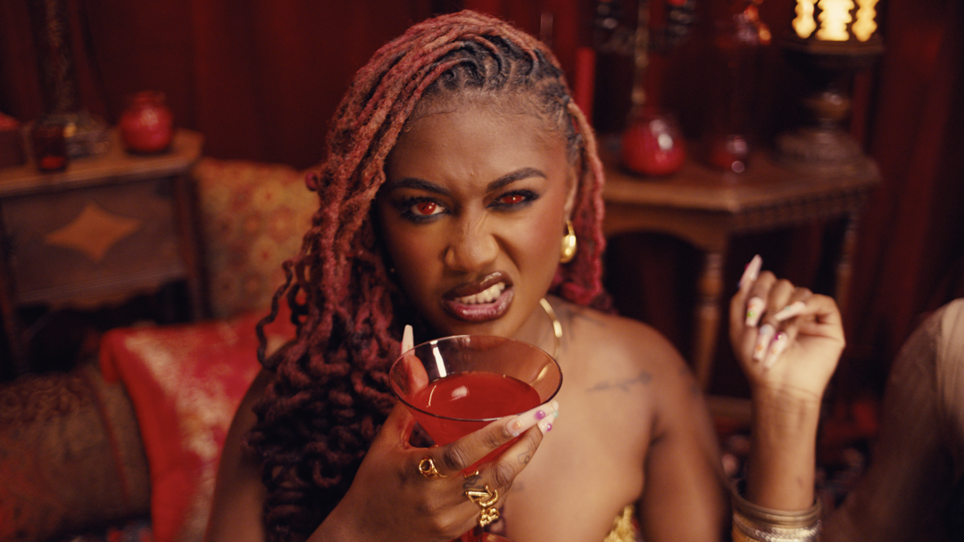

# # #

ABOUT KALIII
Kaliii’s has had a landmark year in 2023. Kaliii kicked off the year with her explosive viral hit “Area Codes” which has now spawned several regional remixes. The remixes are a part of Kaliii’s #ToxicThursday release series and have thus far included New York’s Kenzo B on the “718 Remix,” The Bay Area’s Lil Kayla on the “415 Remix,” St. Louis’s Sexyy Red on the “314 Remix,” and Tallahassee’s Luh Tyler on the “850 Remix.” She followed up by releasing the remixes as a combined pack aptly titled, Area Codes: The Remixes and a visual for “Area Codes (718 Remix)” featuring Kenzo B. Kaliii continued her “Area Codes” reign with the release of the project Toxic Chocolate: Area Codes Edition. Rap’s it-girl has stayed quite active since with her inclusion on the Barbie soundtrack, her nomination for ‘Best New Artist’ at the 2023 MTV Video Music Awards, and the release of her follow-up hit “K Toven.” Last month, Kaliii released her second project of the year, FCK GIRL SZN with features including Young Nudy, GloRilla, and NLE Choppa.

Making her label debut with the release of her highly acclaimed EP Toxic Chocolate, Kaliii was admitted into the XXL 2022 Freshman Class and created the foundation for her now monumental success. She continued her run with the release of the singles “FNF (Freestyle)” and “Wet” with each visual at over a combined 1M views via YouTube. Toxic Chocolate – available now at all DSPs and streaming services – arrived earlier in 2022 amidst both popular and critical acclaim, with Hot New Hip Hop simply declaring her “Rap's Next ‘It’ Girl.” The EP is highlighted by the incendiary singles, “UonU (Feat. Yung Bleu)“ and “Standards,” the latter of which had its exclusive premiere – alongside Kaliii’s debut interview – on Apple Music’s New Music Daily Radio with Zane Lowe. Kaliii then increased the power of Toxic Chocolate with the surprise addition of the fan favorite “Chainzzz (Feat. Muni Long)” as well as a revised sequence.

CONNECT WITH KALIII
TIKTOK | TWITTER | INSTAGRAM | FACEBOOK | YOUTUBE

PRESS CONTACT
Ariana White | Ariana.White@AtlanticRecords.com

