FOR IMMEDIATE RELEASE
FEBRUARY 5, 2024

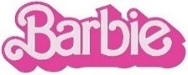
THIS BARBIE IS A GRAMMY® WINNER!

BARBIE THE ALBUM WINS BEST COMPILATION SOUNDTRACK FOR VISUAL MEDIA
AT THE 2024 GRAMMY® AWARDS

TAKES HOME A TOTAL OF 3 AWARDS
INCLUDING SONG OF THE YEAR AND BEST SONG WRITTEN FOR VISUAL MEDIA
FOR “WHAT WAS I MADE FOR?” BY BILLIE EILISH

LISTEN TO BARBIE THE ALBUM
SURPASSES 3B+ GLOBAL STREAMS

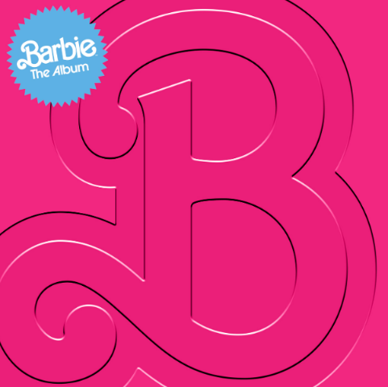
DOWNLOAD HI-RES IMAGES HERE + HERE

BARBIE THE ALBUM (available now via Atlantic Records) has officially won the GRAMMY® for Best Compilation Soundtrack For Visual Media. After dominating nominations earlier this year with the highest number of tracks nominated across all categories, BARBIE THE ALBUM took home a total of 3 awards including Song of the Year and Best Song Written For Visual Media for “What Was I Made For?” by Billie Eilish – Watch her performance from tonight HERE. When nominations were announced, the soundtrack made GRAMMY® history with the most songs nominated from a soundtrack and set a record for the most songs to ever be nominated in the “Best Song Written for Visual Media Category.” Full list of GRAMMY® BARBIE THE ALBUM wins include:

Best Compilation Soundtrack for Visual Media – Barbie The Album
Song of the Year – Billie Eilish – What Was I Made For?
Best Song Written for Visual Media – Billie Eilish – What Was I Made For?

In addition, BARBIE THE ALBUM’s “What Was I Made For?” by Billie Eilish won Best Original Song, Motion Picture at the Golden Globes and “I’m Just Ken” by Ryan Gosling won Best Song at the Critics Choice Awards earlier this year.

BARBIE THE ALBUM is the groundbreaking and star-studded musical companion to the record-breaking film Barbie, starring Margot Robbie and Ryan Gosling as Barbie and Ken and distributed by Warner Bros. Pictures. Quickly becoming a worldwide pop phenomenon with over 3 billion global streams and counting, BARBIE THE ALBUM features massive tracks from an unprecedented lineup of global superstars including Barbie star, Ryan Gosling, Dua Lipa, Nicki Minaj and Ice Spice, Billie Eilish, Lizzo, Sam Smith, Tame Impala, Charli XCX, KAROL G ft. Aldo Ranks, PinkPantheress, FIFTY FIFTY ft. Kaliii, The Kid LAROI, HAIM, Khalid, Dominic Fike, Ava Max, and GAYLE.

The dazzling soundtrack was executive produced by internationally renowned DJ and Oscar, Golden Globe and 7x GRAMMY® award winning artist and producer, Mark Ronson and Barbie writer/director/executive producer Greta Gerwig. The soundtrack album was produced and overseen by Atlantic Records’ West Coast President, Kevin Weaver (Soundtrack Album Producer of The Greatest Showman, Suicide Squad, Daisy Jones & The Six, Birds Of Prey, Furious 7, The Fault in Our Stars, The Fate of the Furious) and Atlantic Records’ EVP and Co-Head of Pop/Rock A&R, Brandon Davis. Additional key players involved on the project include Soundtrack Album Co-Producers, Brandon Creed and Joseph Khoury, as well as the GRAMMY® award winning Barbie Music Supervisor and Album Executive Producer, George Drakoulias. For more information on the soundtrack, visit barbiethealbum.com.

WHAT CRITICS ARE SAYING ABOUT BARBIE THE ALBUM

“The Barbie soundtrack is filled with bops…A fun pop soundtrack like the one Barbie boasts is worth its weight in rose gold”
– THE NEW YORK TIMES

“The soundtrack is more than just an accessory...it is a crucial element in bringing Gerwig’s creative vision to life”
– PEOPLE

“‘Barbie the Album’ Is Like a Perfect Night on the Dreamhouse Dancefloor. You Won’t Want It to End”
– ROLLING STONE

“a triumphant chart-topping multi-hit success”
– THE HOLLYWOOD REPORTER

CONNECT WITH BARBIE THE ALBUM:
BARBIETHEALBUM.COM | INSTAGRAM | TIKTOK | TWITTER | FACEBOOK | PRESS SITE

BARBIE THE ALBUM PRESS CONTACT:
ANDREW GEORGE | ANDREW.GEORGE@ATLANTICRECORDS.COM

