MICHELLE RELEASES NEW EP GLOW OUT NOW

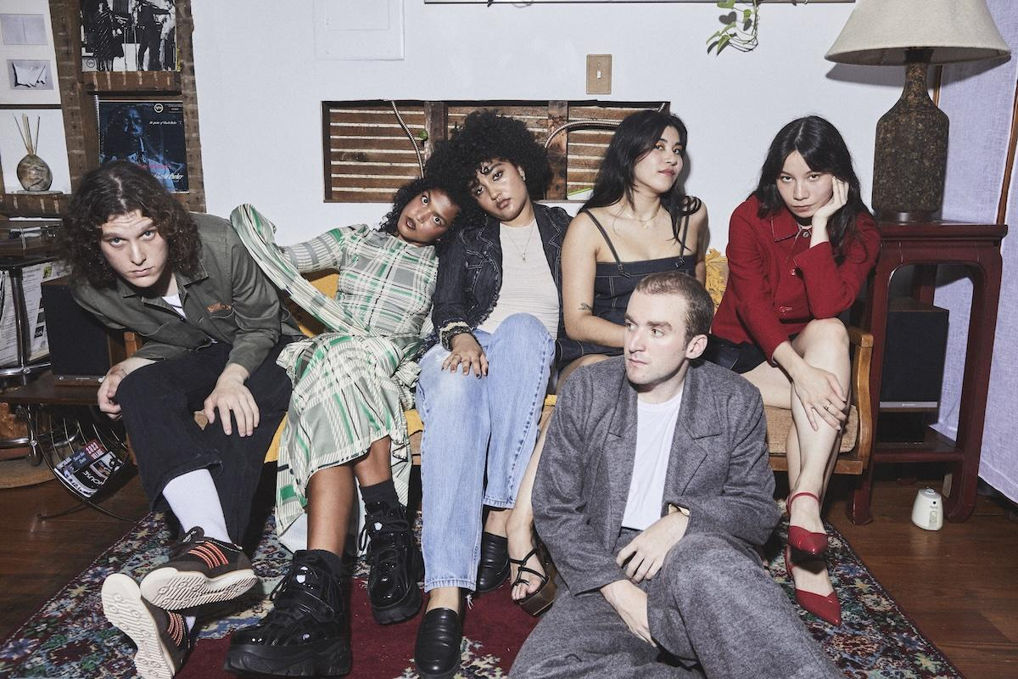
photo credit: Jimmy Fontaine

“An entirely new era of MICHELLE, emphasizing their creative maturity and growth as a collective"
V Magazine

"Plush R&B pop that feels wholly indebted to the flexuous city that surrounds them"
The FADER

"The kind of breezy, timeline-cleansing tunes our overstimulated brains are begging for right now"
Entertainment Weekly

"Crooning, dance-worthy tracks, euphoric R&B melodies, and sucker-punching lyrics"
Elle Magazine

GLOW EP
https://Michelle.lnk.to/glowepPR

(February 9th, 2024) - Today, MICHELLE releases their new EP GLOW via Atlantic Records and Transgressive Records in the UK. The project includes their previously released singles “GLOW”, “AGNOSTIC, and “NEVER AGAIN,” as well as focus single “ON THE LINE.” Speaking about the focus track the band shares, “Written after our first year of touring, ‘ON THE LINE’ narrates a phone call between lovers at a distance. This track highlights the simple warmth and comfort of a call, when you can't be near those you hold dear.”

The project is first introduced with “GLOW” featuring soft instrumentals reminiscent of a pinball machine that builds into layered and lush harmonies. The lively and incandescent nature of the first track transitions to its complimentary opposite, “DNR” (the abbreviation of Do Not Resuscitate), a slow-paced ballad detailing the unique rapture that only love can bring. On "ON THE LINE,” listeners will hear a shift from the collective as the song is led by an acoustic guitar, which creates a stripped-down ambiance continued onto track four, “AGNOSTIC.” While keeping in line with themes of intense yearning the lyrics on their fifth and final track, “NEVER AGAIN,” communicate the intensity of heartbreak while being guided by gentle taps on a xylophone to mimic a music box, effectively communicating the song’s nostalgic tone. In just five tracks, this latest offering is a testament to the band’s vocal and instrumental harmony, creative alignment, and masterful penmanship.

Born-and-bred New Yorkers, MICHELLE is comprised of Sofia D'Angelo, Julian Kaufman, Charlie Kilgore, Layla Ku, Emma Lee, and Jamee Lockard. The predominantly POC and queer collective mix and match the writing and production groups amongst the six of them.

The hallmarks of MICHELLE’s music—layered vocal harmonies, analog synthesizers, vibrant percussion, smoldering hooks—dominate the sonic landscape of their upcoming EP, with the four female vocalists pushing the boundaries of their considerable singing talents while Charlie and Julian fine-tune the production. Despite all the tinkering elsewhere, it is important to note that the vocals remain largely untouched and appear in their organic state. Songs hop across genres, from funky R&B to bedroom slow jams to amped-up beat-heavy anthems and more.
The forthcoming EP follows their critically acclaimed album AFTER DINNER WE TALK DREAMS, which was praised by Nylon as a band that "defies categorization" and MTV as "mesmerizing." The album included celebrated singles "MESS U MADE," "SYNCOPATE," and "POSE" and preceded their sold-out headline shows across the US, UK, and Europe. MICHELLE has also toured alongside Mitski, Arlo Parks, and Gus Dapperton, in addition to performing recent festival sets at Governors Ball, Outside Lands and Lollapalooza.

Listen to MICHELLE’s GLOW EP above and stay tuned for more from the New York collective coming soon.

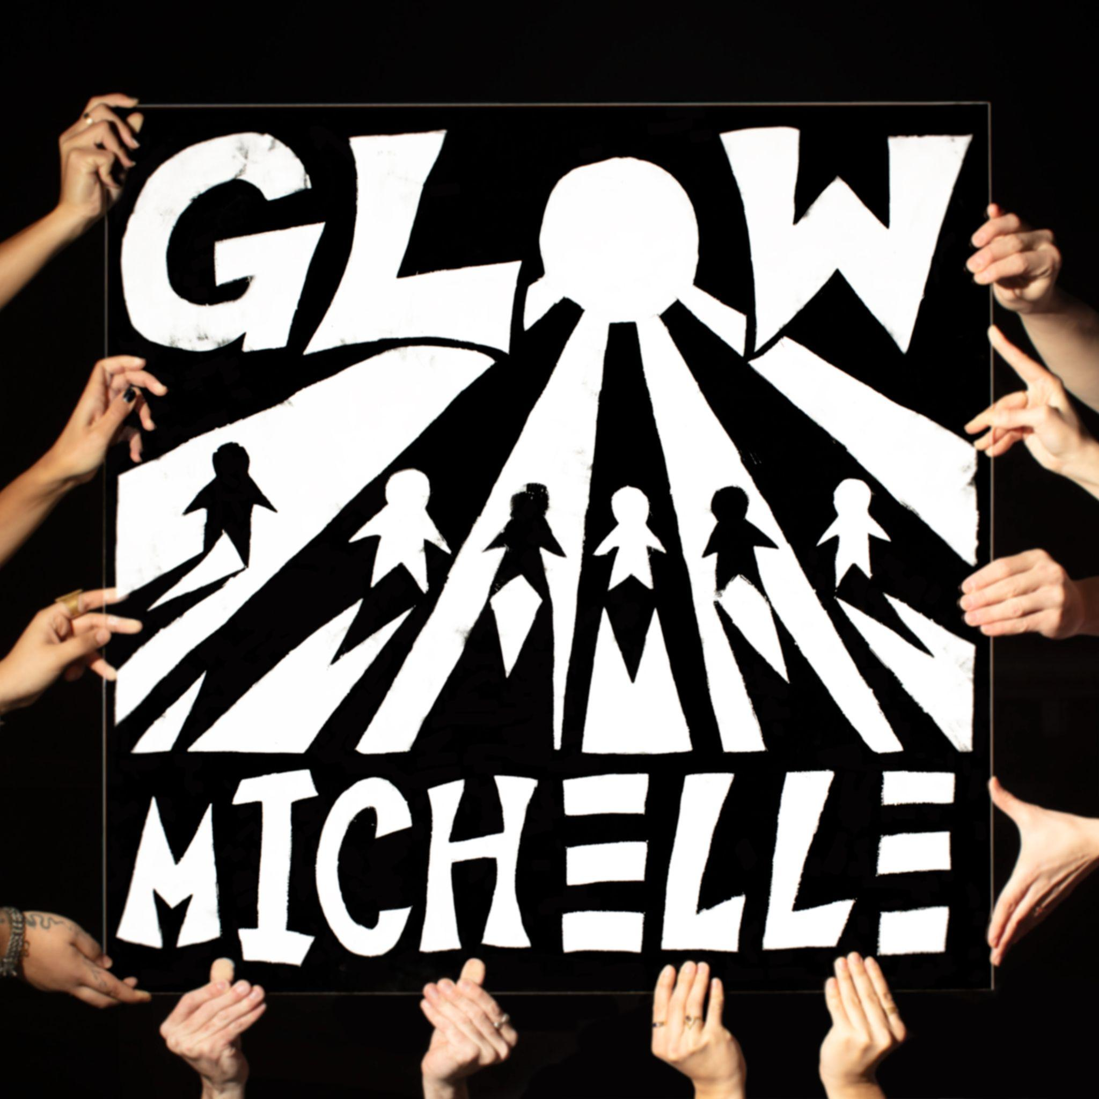

EP artwork

MICHELLE
GLOW EP
February 9th 2024
Atlantic Records/Transgressive Records

1. GLOW
2. DNR
3. ON THE LINE
4. AGNOSTIC
5. NEVER AGAIN

(Download Hi-Res assets HERE)

Connect with MICHELLE
Website | Instagram | Twitter | Facebook | YouTube

For MICHELLE press inquiries please contact Emily Mullen at Orienteer:
emily@orienteer.us

--
Emily Mullen
Orienteer
Los Angeles, CA | New York, NY

