FOR IMMEDIATE RELEASE
FEBRUARY 23, 2024

NOLAN TAYLOR RELEASES ACOUSTIC VERSION OF “CINCINNATI HEART”
LISTEN HERE

ACCOMPANIED BY A RAW PERFORMANCE VIDEO
WATCH HERE

UPCOMING HEADLINE “CINCINNATI HEART TOUR” SET TO KICK OFF IN MARCH

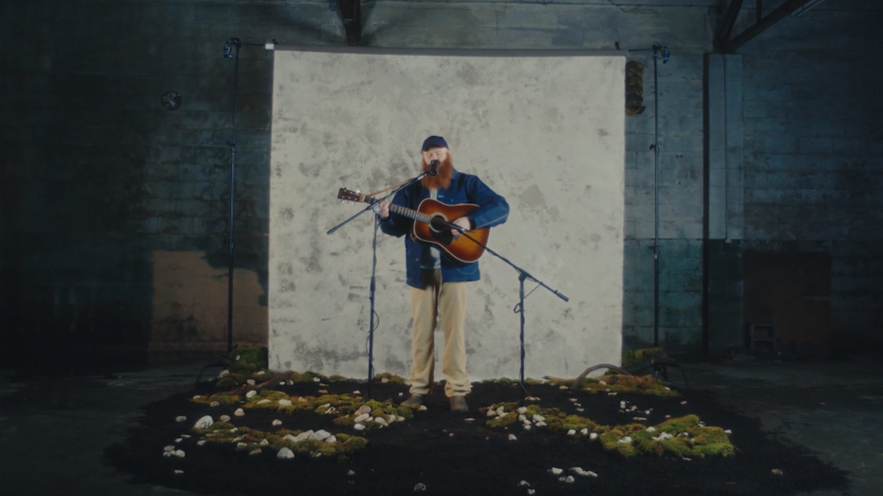
DOWNLOAD HI-RES ARTWORK + PRESS IMAGES

Rising singer-songwriter, Nolan Taylor has released an acoustic version of his latest single “Cincinnati Heart '' available now – HERE. The track is shared alongside a raw performance video showcasing his stirring vocals HERE.

“‘Cincinnati Heart’ is a true reflection on the swift passage of time and the challenges of distance in relationships,” shares Taylor. “The complexities of love and connection, exploring the impact of years together and the enduring bond that remains. ‘Cincinnati Heart’ is not just a song; it’s a journey through emotions, and I’m excited to take you on this ride with me. Onward & upward.”

“Cincinnati Heart (Acoustic)” comes after his latest 5-song live EP, radiowv. The EP is accompanied by an unplugged performance of “500” streaming on the radiowv channel HERE.

Taylor is preparing for his upcoming first-ever headline run, the CINCINNATI HEART TOUR. Kicking off in mid-March with notable stops at New York City’s Mercury Lounge (3/22) and Nashville's Basement East (4/14), Taylor will also join The Red Clay Strays, Sam Barber, and Wyatt Flores on support dates, including a SOLD OUT show at Ryman Auditorium this fall with The Red Clay Strays.

WATCH NOLAN TAYLOR’S GRAND OLE OPRY DEBUT
WATCH ‘LIFE LOVE’ LIVE DREAMY DRAW SESSION FOR HOLLER
WATCH A FULL SET LIVE PERFORMANCE ON JAM IN THE VAN
WATCH OLIVER ANTHONY PRAISE NOLAN ON JOE ROGAN EXPERIENCE
LISTEN TO THE LIVE VERSION OF FAN FAVORITE “DOUBLE LIFE”
WATCH WICKED WAYS [LIVE]

Announced Dates, Cities and Venues for the CINCINNATI HEART TOUR:

MARCH
14 - Philadelphia, PA - Milkboy
15 - Washington, DC - The Hamilton
16 - Richmond, VA - The Broadberry
21 - Cambridge, MA - The Sinclair
22 - New York, NY - Mercury Lounge
23 - Buffalo, NY - Buffalo Iron Works
APRIL
09 - Athens, GA - 40 Watt Club
10 - Knoxville, TN - Open Chord
11 - Louisville, KY - Zanzabar
12 - Nashville, TN - The Basement East
19 - Fort Worth, TX - Tulips
21 - Beaumont, TX - 7 Oaks
MAY
02 - Kansas City, MO - Record Bar
03 - Columbia, MO - Rose Music Hall
08 - Atlanta, GA - Terminal West
09 - Charlotte, NC - Amos' Southend
10 - Ashland, KY - Paramount Arts Center
11 - Indianapolis, IN - Hi-Fi Annex
16 - Pittsburgh, PA - Thunderbird Music Hall
17 - Columbus, OH - The Bluestone
31 - Virginia Beach, VA - Elevation 27

JUNE
01 - Durham, NC - Motorco Music Hall
27 - Des Moines, IA - XBK Live
29 - Omaha, NE - Reverb Lounge

With a voice that ranges from the soft fall of rain to a heavy crack of thunder, Taylor explores themes of hard times, wild nights, and heartbreak, drawing critical applause and a growing fan base. Longing, desperation, joy, and sorrow, genuinely fuel such strikingly powerful songs as “68,” which has earned the rising star over 5 MILLION worldwide streams to date.

“Nolan Taylor’s brutally honest lyrics, his raw, raspy vocals, and his passionate delivery have won over fans everywhere.” – WHISKEY RIFF

Taylor has shared the stage with like-minded artists as The Red Clay Strays, Charley Crockett, 49 Winchester, Morgan Wade, and Charles Wesley Godwin. He’ll continue to celebrate his new music on his headline tour, festival appearances, and more. For complete details and ticket availability, please visit www.nolantaylormusic.com/tour.

ABOUT NOLAN TAYLOR
The backroads of America tell its truest stories. The heartbreak and heartbeat of the country thumps the loudest in the cracks between its big cities. A 2021 census in Blanchester, OH registers the village’s population at around 4,230 people. Nolan Taylor isn’t quite sure of the exact number, but he knows it’s small from growing up in this place with his dad and older brother. His father managed plants and factories, yet money was scarce, and the winters were brutal. Mom battled addiction and mental struggles, eventually estranging her from the boys. When he could finally afford a left-handed guitar, he started to write and record music of his own, grafting hard-earned wisdom, heart-wrenching memories, and hypnotic melodies to rustic and ruddy acoustic phrasing. As a kid, he found solace in music. He discovered The Grateful Dead through his dad and developed an appreciation for Pinegrove. Throughout junior high, he studied classic MTV Unplugged concerts by the likes of Alice In Chains, Pearl Jam, and Nirvana. Even though he primarily focused on wrestling, working out, football, and baseball, he finally picked up a left-handed guitar in high school. After graduating, he spent years gigging around West Virginia, Virginia, and Kentucky, playing anywhere and everywhere. In 2023, a video of Taylor performing “68” in the woods went viral with 2.6 MILLION YouTube views on the Radio WV YouTube Channel. Achieving virality from obscurity and gathering millions of streams, he tells a true story all his own via a series of 2023 singles for Atlantic Records, beginning with “Wicked Ways” and the live recording of “Double Life.”
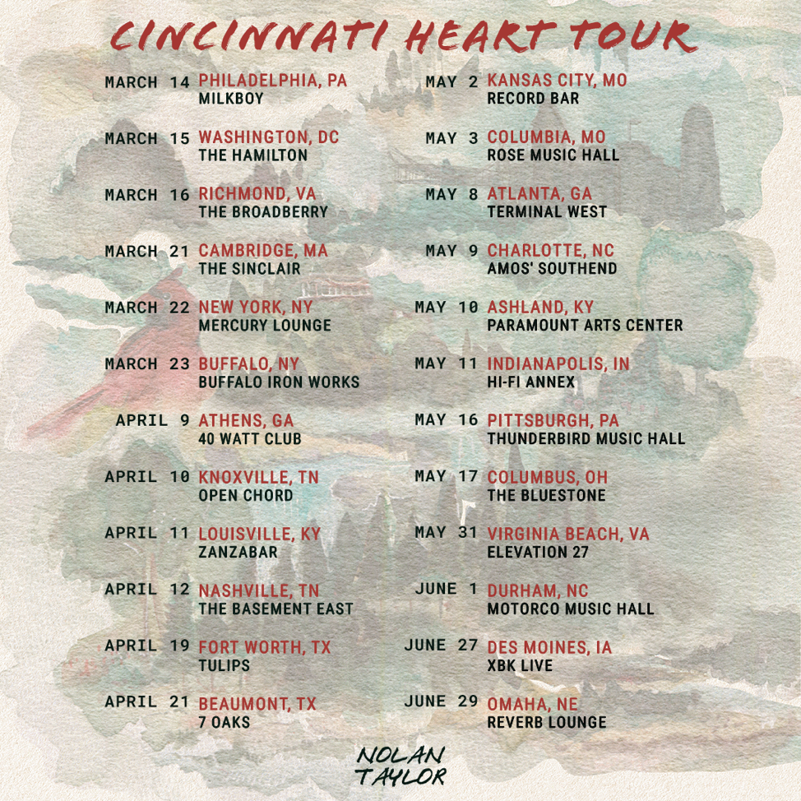
DOWNLOAD HI-RES ADMAT + PRESS IMAGES

# # #

CONNECT WITH NOLAN TAYLOR
OFFICIAL | FACEBOOK | INSTAGRAM | SPOTIFY | TIKTOK

PRESS CONTACTS
Corey Brewer | Corey.Brewer@atlanticrecords.com
Jensen Sussman | Jensen@sweettalkpr.com

