BRELAND ANNOUNCES HEADLINING LITTLE MORE COUNTRIER TOUR

KICKS OFF MARCH 26 WITH ANNUAL BRELAND & FRIENDS CHARITY CONCERT AT NASHVILLE’S RYMAN AUDITORIUM

BRAND-NEW SONG “HEARTBREAK & ALCOHOL” RELEASING THIS FRIDAY (2/16)

ICYMI: RISER JOINS NFL NETWORK’S ‘SUPER BOWL LIVE’ TO MAKE HALFTIME SHOW PREDICTIONS

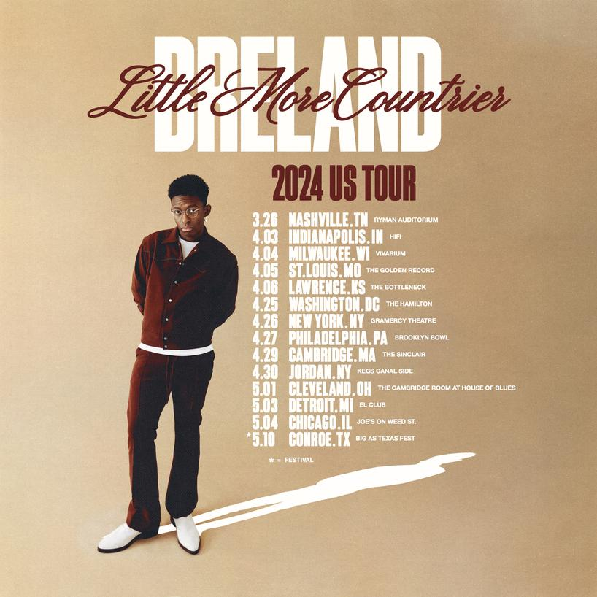
DOWNLOAD TOUR GRAPHIC HERE
CREDIT: HENRY AMMANN

Building on his reputation as a one of Country’s most electrifying entertainers on the rise, PLATINUM artist BRELAND is set to amp up the energy with a newly-announced 2024 headlining tour.

Kicking off this spring, BRELAND’s LITTLE MORE COUNTRIER TOUR will find the hitmaker bringing his infectious mix of Country, Hip-Hop and Soul to major cities all across the Midwest, Northeast and more, filling each venue with stadium-sized energy (and a thousand-watt smile).

The run begins with his third annual BRELAND & Friends charity concert at Nashville’s Ryman Auditorium on March 26 in support of the Oasis Center. From there he will visit Milwaukee, Wisconsin; Washington, DC; Cambridge, Massachusetts, and more – including iconic venues like New York City’s Gramercy Theatre, Chicago’s Joe’s on Weed St. and others.

General admission tickets go on sale Friday (2/16), with more dates to be announced soon.

Announced dates, cities, and venues for BRELAND’s LITTLE MORE COUNTRIER TOUR:

MARCH
26 | Nashville, TN – Ryman Auditorium (BRELAND & Friends)
APRIL
03 | Indianapolis, IN – HiFi
04 | Milwaukee, WI – Vivarium
05 | St. Louis, MO – The Golden Record
06 | Lawrence, KS – The Bottleneck
25 | Washington, DC – The Hamilton
26 | New York, NY – Gramercy Theatre
27 | Philadelphia, PA – Brooklyn Bowl
29 | Cambridge, MA – The Sinclair
30 | Jordan, NY – Kegs Canal Side
MAY
01 | Cleveland, OH – The Cambridge Room at House Of Blues
03 | Detroit, MI – El Club
04 | Chicago, IL – Joe’s on Weed St.
10 | Conroe, TX – Big As Texas Fest

BRELAND’s LITTLE MORE COUNTRIER TOUR will follow a fast start to 2024 for the emerging star, and a year of next-level success in 2023.

Last weekend (2/9), the exhilarating performer threw down in Las Vegas ahead of Super Bowl LVIII, taking the stage at the House of Blues for EA SPORTS™ Presents The Madden Bowl with Big Boi, Killer Mike and Green Day.

Following the night of electric nostalgia, BRELAND had the opportunity to join NFL Network’s ‘Super Bowl Live’ to speak with analyst Daniel Jeremiah to discuss his halftime show predictions. Watch the interview here.

A mega sports fan, BRELAND caught the attention of ESPN’s Pat McAfee with his viral NFL predictions on TikTok last month, resulting in an appearance on The Pat McAfee Show on January 26. There, he revealed his brand-new song “Heartbreak & Alcohol” is releasing this Friday, February 16, and serves as the start of his next creative chapter. Watch the full segment here (starting at 2:43:52) and pre-save/pre-add the track here.

Meanwhile, 2023 saw the release of the boot-stomping single “Cowboy Don’t,” BRELAND’s “Alcohol” collaboration with X Ambassadors and the deluxe album CROSS COUNTRY: THE EXTRA MILE (Bad Realm Records/Atlantic Records/Warner Music Nashville) – all on top of receiving the Lift Every Voice Award at the ACM Honors for his Country-expanding efforts.

Leading directly to the LITTLE MORE COUNTRIER TOUR, BRELAND spent much of 2023 thrilling fans on the road. Firing up huge crowds in support of Shania Twain’s QUEEN OF ME TOUR in the U.S. and U.K. (with stops at legendary venues like Madison Square Garden), BRELAND also headlined THE EXTRA MILE TOUR, traveling across the U.K., Germany, Netherlands, Denmark, Sweden, and Norway.

ABOUT BRELAND:
Boundary-shattering, breakout star BRELAND is pushing the possibilities of Country music on a global scale. Since the arrival of his PLATINUM-certified debut single “My Truck,” the New Jersey-bred singer/songwriter/producer has amassed over 1.1 BILLION career streams, brought his crowd-thrilling live show to an international headline tour, and gained acclaim from many of the world’s leading music publications (with Rolling Stone hailing him as “a symbol of Country music’s ongoing evolution” and Billboard calling him a “keen, visionary solo artist”). On his critically acclaimed 2022 debut album CROSS COUNTRY, the Bad Realm Records/Atlantic Records/Warner Music Nashville artist introduced a high-energy sound that blurs the barriers between Country, Pop, Hip-Hop, Soul, and Southern Gospel, offering up smash hits like the GOLD-certified “Praise The Lord (feat. Thomas Rhett).” A blockbuster year for BRELAND, 2023 has included such triumphs as teaming up with superstar Keith Urban to open the 16th annual Academy of Country Music Honors by performing their GOLD-certified collaboration “Throw It Back” and — immediately following the performance — receiving the ACM Lift Every Voice Award, recognizing his role in “elevating underrepresented voices throughout the Country music genre, transcending demographics and geography.” Released in September, CROSS COUNTRY: THE EXTRA MILE delivered a star-packed bonus version of his full-length debut, with the expanded album’s six fresh tracks including a brand-new feature with Brittney Spencer as well as live favorite “Cowboy Don’t.” With his high-profile TV appearances to date including Good Morning America, Jimmy Kimmel Live!, The Voice, and TODAY, he also spent much of 2023 on the road as support for the legendary Shania Twain’s QUEEN OF ME TOUR in the U.S. and U.K. (with stops at iconic venues like Madison Square Garden), in addition to taking his THE EXTRA MILE TOUR across the U.K., Germany, Netherlands, Denmark, Sweden, and Norway. A truly magnetic live performer, BRELAND has also graced the stage at major festivals like Stagecoach and C2C: Country to Country Festival, fulfilling his mission of uniting audience members from all walks of life with his wildly joyful music.

# # #

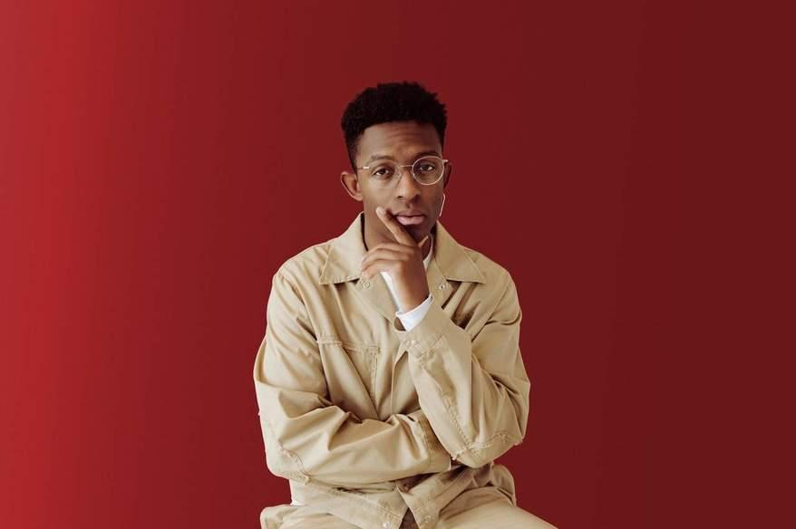

DOWNLOAD PROMO PHOTO HERE

PHOTO CREDIT: HENRY AMMANN

CONNECT WITH BRELAND
WEBSITE | INSTAGRAM | FACEBOOK | X
AMAZON MUSIC | YOUTUBE | SOUNDCLOUD

MEDIA CONTACTS
FAIRLEY MCCASKILL / FAIRLEY.MCCASKILL@ATLANTICRECORDS.COM
JENSEN SUSSMAN / JENSEN@SWEETTALKPR.COM
KRISTI BRADSHAW / KRISTI.BRADSHAW@WMG.COM

