PORTUGAL. THE MAN ANNOUNCE SUMMER 2024 US HEADLINE TOUR

EXTENDING LIVE DATES IN SUPPORT OF CHRIS BLACK CHANGED MY LIFE – BUY/STREAM THE ALBUM HERE

KICKS OFF MAY 1 IN WILMINGTON, NC + INCLUDES DATES AT NASHVILLE’S RYMAN AUDITORIUM, COLORADO’S RED ROCKS AMPHITHEATRE & MORE

PRE-SALES BEGIN FEBRUARY 7 @ 10AM (LOCAL) | GENERAL ON-SALE STARTS FEBRUARY 9 @ 10AM (LOCAL)

OFFICIAL MUSIC VIDEO FOR “GRIM GENERATION” OUT NOW
WATCH HERE

‘WINTER OF SUMMER OF LUV’ US TOUR CURRENTLY UNDERWAY
REMAINING TICKETS ON SALE HERE

SOLD-OUT ASBURY PARK, NJ SHOW AT LEGENDARY VENUE THE STONE PONY
SET FOR FRIDAY, FEBRUARY 23

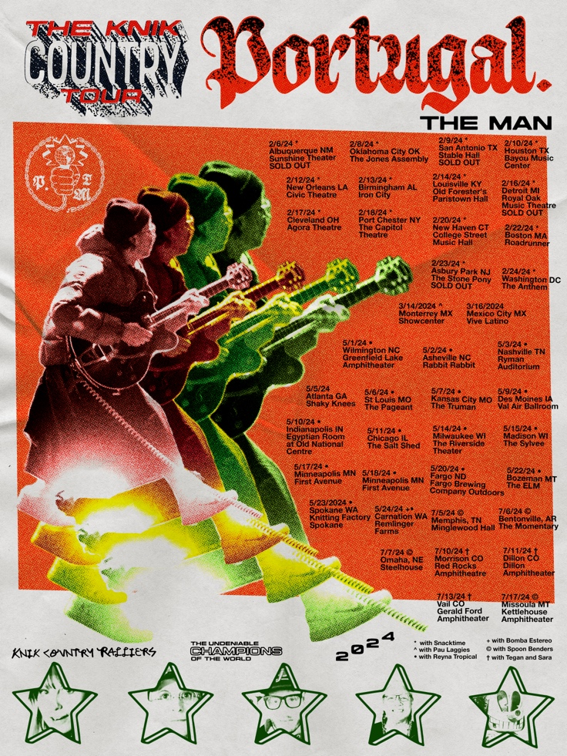
(download hi-res admat)

(February 6, 2024) Multi-platinum, GRAMMY® Award-winning rock band Portugal. The Man have unveiled a new slate of US headline tour dates, set for summer 2024. The run will kick off on May 1 in Wilmington, NC and feature marquee dates at Nashville’s Ryman Auditorium (May 3) and Morrison, Colorado’s Red Rocks Amphitheatre (July 10), among many other stops, in between.

Pre-sales begin tomorrow, Wednesday, February 7 at 10am (local), and general on-sale will start this Friday, February 9 at 10am (local). The band will be supported by Tegan and Sara, Spoon Benders, Reyna Tropical, and Bomba Estereo on select dates. For full ticketing information, visit the band’s website here.

Today, the band also shares their official music video for current single “Grim Generation” – watch here.

Portugal. The Man is currently playing the final dates of their previously-announced ‘Winter of Summer of Luv’ tour, which began last week in Del Mar, CA, and weaves through Houston, New Orleans, Cleveland, Boston and more US cities, before wrapping at The Anthem in Washington DC on February 24. The night prior, the band will play an already sold-out show at the iconic Asbury Park, New Jersey venue The Stone Pony. Remaining tickets for the ‘Winter of Summer of Luv’ tour can be found here.

All 2024 live dates come in celebration of the band’s most recent album – CHRIS BLACK CHANGED MY LIFE (listen HERE) – the critically acclaimed LP released in June 2023.

CHRIS BLACK CHANGED MY LIFE marked Portugal. The Man’s first full-length since the release of their 2017 album Woodstock, which spurned the Platinum-certified smash “Feel It Still.” The album’s title pays homage the band’s late friend and honorary band member, Chris Black.

Produced by the legendary Jeff Bhasker (Beyonce, Harry Styles, SZA, Mark Ronson), it features additional collaborations with Paul Williams (John Lennon, David Bowie, Mac Miller), Asa Taccone, Black Thought, Nick Reinhart, Homer Steinweiss, Natalia Lafourcade, and Bhasker.

Last fall, the band released a trilogy of official music videos for the project, directed by acclaimed cinematographer and frequent collaborator Michael Ragen. Starring various band members and collaborators, the videos were all filmed in the band’s home state of Alaska, where they’ve filmed most of the videos throughout the course of their career. Specifically, they were filmed on the unceded ancestral lands of the Knik Tribe, Yuhaaviatam, Maarenga’yam, Chumash, and Tongva (Gabrieleno).

The trilogy kicked off with “Doubt,” followed by “Anxiety:Clarity (ft. Paul Williams).” The third and final release marked a rework of “Doubt” courtesy of acclaimed, Portland, OR-based metal musician Mizmor, who also appeared in the video – watch “Doubt – Mizmor Version.”

###

UPCOMING PORTUGAL. THE MAN LIVE SHOWS
(new dates in red)
2/6/24 – Albuquerque, NM – Sunshine Theater – SOLD OUT
2/8/24 – Oklahoma City, OK – The Jones Assembly
2/9/24 – San Antonio, TX – Stable Hall – SOLD OUT
2/10/24 – Houston, TX – Bayou Music Center
2/12/24 – New Orleans, LA – Civic Theatre
2/13/24 – Birmingham, AL – Iron City
2/14/24 – Louisville, KY – Paristown Hall
2/16/24 – Royal Oak, MI – Royal Oak Music Theatre – SOLD OUT
2/17/24 – Cleveland, OH – Agora Theatre
2/18/24 – Port Chester, NY – Capitol Theatre
2/20/24 – New Haven, CT – College Street Music Hall
2/22/24 – Boston, MA – Roadrunner
2/23/24 – Asbury Park, NJ – Stone Pony – SOLD OUT
2/24/24 – Washington DC – The Anthem
5/1/24 – Wilmington, NC – Greenfield Lake Amphitheater
5/2/24 – Asheville, NC – Rabbit Rabbit
5/3/24 – Nashville, TN – Ryman Auditorium
5/6/24 – St. Louis, MO – The Pageant
5/7/24 – Kansas City, MO – The Truman
5/9/24 – Des Moines, IA – Val Air Ballroom
5/10/24 – Indianapolis, IN – Egyptian Room at Old National Centre
5/11/24 – Chicago, IL – The Salt Shed
5/14/24 – Milwaukee, WI – The Riverside Theater
5/15/24 – Madison, WI – The Sylvee
5/17/24 – Minneapolis, MN – First Avenue
5/18/24 – Minneapolis, MN – First Avenue
5/20/24 – Fargo, ND – Fargo Brewing Company Outdoors
5/22/24 – Bozeman, MT – The ELM
5/23/24 – Spokane, WA – Knitting Factory
5/24/24 – Carnation, WA – Remlinger Farms
7/5/24 – Memphis, TN – Minglewood Hall
7/6/24 – Bentonville, AR – The Momentary
7/7/24 – Omaha, NE – Steelhouse
7/10/24 – Morrison, CO – Red Rocks Amphitheatre
7/11/24 – Dillon, CO – Dillon Amphitheater
7/13/24 – Vail, CO – Gerald R. Ford Amphitheater
7/17/24 – Missoula, MT – Kettlehouse Amphitheater

DOWNLOAD ALL PRESS ASSETS

PRESS CONTACTS:

Portugal. The Man:
Jason Davis | Jason.Davis@atlanticrecords.com
Libby Kober | Libby.Kober@atlanticrecords.com

