FOR IMMEDIATE RELEASE
FEBRUARY 29, 2024

RICO NASTY & BOYS NOIZE ANNOUNCE NEW EP HVRDC0RE DR3AMZ
OUT MARCH 29TH

NEW SONG “ARINTINTIN” OUT NOW

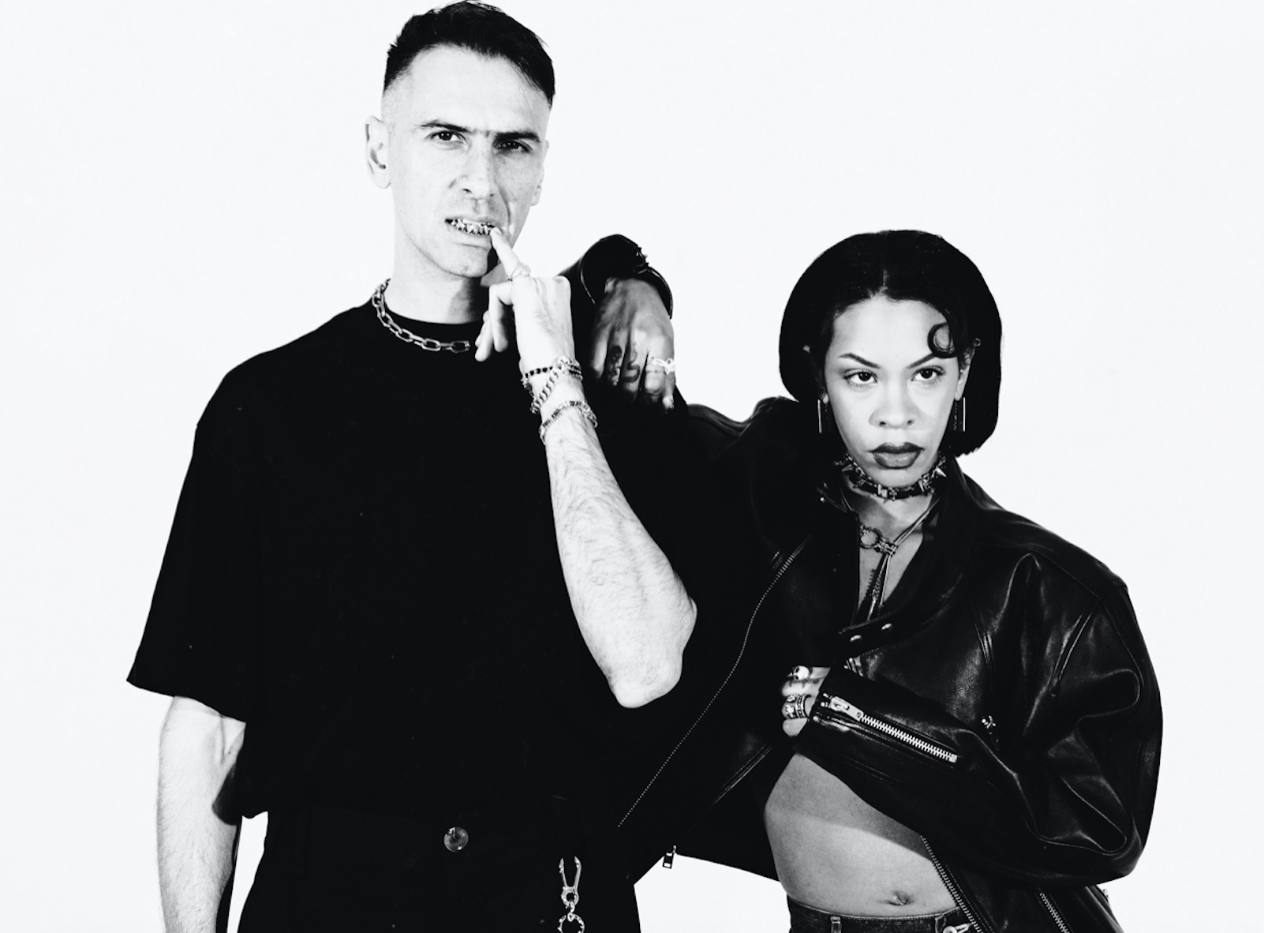
(Photo Credit: Jamie-Lee Boyd | download)
DOWNLOAD “ARINTINTIN” | PRE-ORDER HVRDC0RE DR3AMZ

After teasing the collab of the year earlier this month, American rapper, songwriter, fashion trailblazer and visionary Rico Nasty and German-Iraqi artist, DJ, producer and subcultural oracle Boys Noize are today dropping their debut single, “Arintintin” and revealing details of their new project in detail for the first time. The queen of versatility has added a new genre to her oeuvre and the pair will unleash their dance / techno-clash EP HARDC0RE DR3AMZ onto the world March 29th. Listen to the single “Arintintin” HERE.

The bond between the two artists is undeniable. Their previous collaboration on Rico Nasty's "Money" ft Flo MIlli and Boys Noize’s “Girl Crush” are evident of that. However, their recent reconnection offers a more eclectic and celebratory experience - one that will defy genre, expectation and creative boundaries. “Arintintin" is a display of pent up energy as it surges through higher BPMs and aughties-style hedonism and is only a taste of what's to come from the duo.

Rico Nasty and Boys Noize premiered the project for the first time last night with an exclusive show at the world famous Silencio Club in Paris. They will also perform these explosive songs for Berlin crowds on March 2nd at Trauma Bar.

(single art | download)

“Arintintin” kicks off with a Y2K electro bassline at hardcore speed as the sticky-staccato of the distortion-washed hook is introduced. Rico Nasty carries her memetic sing-(or-shout)-a-long cadence over a rollercoaster of builds and drops, each of which seems to rise in intensity. While “Arintintin” matches tempo with the hi-NRG and trance revival currently dominating clubland, Rico Nasty and Boys Noize inject a punk brashness needed to shake up the #technotok tourists. Besides, if the naughty aughties are back, someone has to start the mosh pit.

Rico Nasty tells us…. "Me and Boys Noize started working back in 2018... We finally met in real life after being mutuals for like a year. We did one session, it was fire! And then a few months later ended up on the Friendship Cruise together (for the first time). After the cruise, we made "Money (feat. Flomilli)" and "1+1" - a song you'll hear very soon on this project. Fast forward again, maybe 3-4 years, and we did a couple more sessions. We kept gravitating towards techno dance music. He started putting me on to German dance music, and we traded a bunch of songs back and forth. Little by little over a few days, we ended up making three more songs that we really loved and decided we wanted to share with the world. Every session was so much fun and I'm sure that energy is felt across all of these tracks. One of my favorite songs on the project is... all of them. That's why she is so short!! Talk to you later and see you guys soon."

(EP art | download)

RICO NASTY
Many artists change the game. However, Rico Nasty reinvents, recharges, and reimagines it with every move. Instead, the Washington, D.C.-born and Maryland-raised sonic sorceress shapeshifts at the speed of the culture, infusing airtight rap with uncontainable punk energy, hyperpop unpredictability, industrial intensity, and just the right amount of heavy metal attitude. Back in high school, she made waves with a series of independent projects before reaching critical mass with 2017’s Sugar Trap 2. On its heels, she maintained this momentum with the fan favorite Nasty in 2018. The collaborative mixtape Anger Management with Kenny Beats closed out 2019 on over a dozen year-end lists, including Complex, Dazed, Fact, The FADER, GQ, NME, Pitchfork, Rolling Stone, Stereogum, and Vice. During 2020, her full-length debut, Nightmare Vacation, boasted the gold-certified hit “Smack A Bitch.” Peers sought her out for high-profile collaborations, including the platinum “Tia Tamera” with Doja Cat, “#PROUDCATOWNERREMIX” with the late XXXTentacion, “¡aquí yo mando!” with Kali Uchis, and more. Rico’s’s the rare outlier who can grace the cover the XXL Freshman issue or light up Rihanna’s Savage X Fenty Show as an ambassador and ignite a mosh pit.

With an inimitable and influential signature style, she has reached multiplatinum status, posted up nearly 1 billion streams, and sold out countless shows. In 2022, she unleashed unfiltered truth with the force of a tornado through a tidal wave on Las Ruinas. After Las Ruinas, Rico hit the road first with Kehlani and then she embarked on a national tour in collaboration with Monster Energy Drink with direct support from Omeretta The Great. Since then, Rico has been gearing up for her latest release, “Arintintin,” in collaboration with Boyz Noise along with a new project on the horizon. The new single and project are a slight deviation from the signature Sugar Trap sound we know her for as she dives head first into the world of electronic and dance music.

BOYS NOIZE
BOYS NOIZE (Alex Ridha) builds worlds, then builds bridges between them. Propelled by an infatuation with sonic invention and a prescience for subculture, the German-Iraqi artist, DJ and producer has developed a peerless practice that is both deeply informed by electronic music history and determinedly transcending conventions. As an international festival headliner and A-list producer, BOYS NOIZE embodies the transformation and expansion of 21st century techno, house and electro into the current zeitgeist. Yet as a Berliner and lifelong DJ, he remains dedicated to the underground, regularly flexing the decks at BERGHAIN, TRESOR, RSO, and HÖR, all while running his record label BNR.

Some fans find BOYS NOIZE through his b2b sets with SOLOMUN and VTSS, others through his productions for A$AP ROCKY, TOMMY CASH and FRANK OCEAN; through his house hit "Mvinline" on DEFECTED RECORDS, his remixes for DAFT PUNK, YEAH YEAH YEAHs and DEPECHE MODE, or his EP with VIRGIL ABLOH; through features with RICO NASTY, PUSSY RIOT, SHYGIRL and KELSEY LU, or reworks of SEGA BODEGA and SOPHIE; through this year’s blazing run of 140+ bpm techno tracks, or his massive "Fine Day Anthem" with SKRILLEX, his other half in the duo DOG BLOOD. BOYS NOIZE's most important collaboration of all, however, is with the ravers that join him across the globe from basements to warehouses to the main stage. Ridha’s sets open a dialogue between DJ and dancefloor, always unique and always peaking in ecstatic nights and delirious dawns. There are many facets of BOYS NOIZE, but when the exchange of energy and music is alive and in full force, the one you’ll find is the one you make together.

CONNECT WITH RICO NASTY:
WEBSITE | INSTAGRAM | TWITTER | FACEBOOK | YOUTUBE

FOR PRESS INQUIRIES, PLEASE CONTACT:
Ariana White | Ariana.White@atlanticrecords.com

CONNECT WITH BOYS NOIZE
INSTAGRAM | TWITTER | FACEBOOK

