FOR IMMEDIATE RELEASE
FEBRUARY 9, 2024

SAM BARBER SHARES “S.O.B.”

RIAA GOLD-CERTIFIED SINGER-SONGWRITER HERALDS SOLD-OUT HEADLINE TOUR
WITH TENDER NEW SINGLE

TILL I RETURN TOUR BEGINS FEBRUARY 22 IN CHATTANOOGA, TN

HIGHLIGHTS INCLUDE SOLD-OUT SHOWS AT SUCH LEGENDARY VENUES AS BROOKLYN, NY’S MUSIC HALL OF WILLIAMSBURG AND WEST HOLLYWOOD, CA’S THE ROXY THEATRE

EPIC LIVE RUN INCLUDES STAGECOACH DEBUT PERFORMANCE AT THE PALOMINO STAGE

LISTEN TO “S.O.B.”

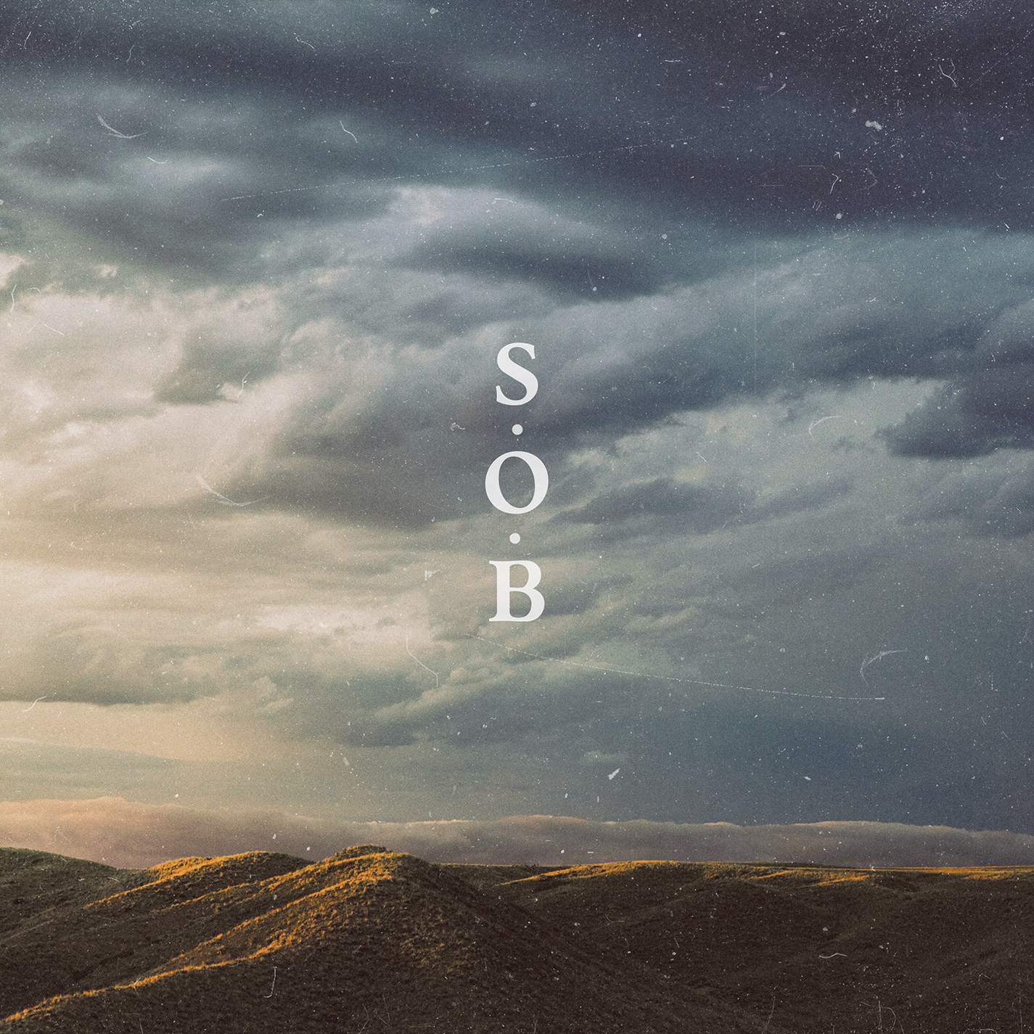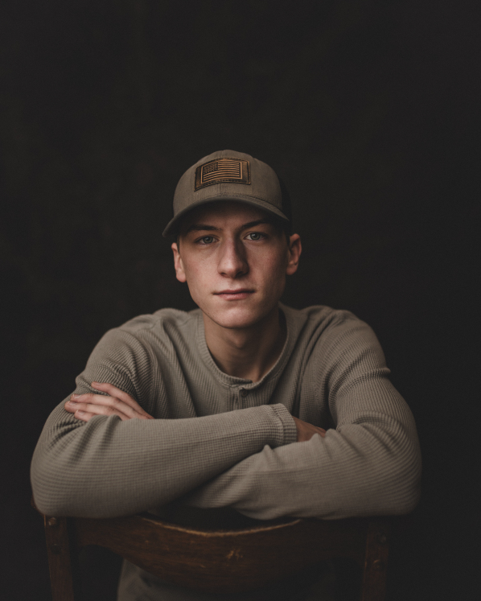
DOWNLOAD ASSETS HERE

“Sam Barber has a long future in country music.” – WHISKEY RIFF

“This guy is flying up the pantheon of country music kings…Sturgill, Zach Bryan, Tyler Childers, and Sam Barber.” – BARSTOOL SPORTS

RIAA Gold-certified singer-songwriter Sam Barber has shared his eagerly anticipated new single, “S.O.B.,” available now via Lockeland Springs/Atlantic Records HERE.

Produced by Eddie Spear (Zach Bryan, Brandi Carlile, Billie Eilish), “S.O.B.” was teased by a series of social media posts that earned over 2.3M views across Instagram and TikTok. The tender new track continues a seemingly unstoppable run of music from Barber that has seen the 20-year-old Southern Missouri-based artist generate more than 4.3M total monthly Spotify listeners along with critical acclaim and a rapidly increasing fan following around the world.

2024 kicked off with the recently released Live EP 001, showcasing a deeply personal onstage approach, with Whiskey Riff raving “Sam Barber’s fans show they are on another level with this EP. You can hear the crowd roaring in the background throughout each song on his setlist. From the first strums of a guitar opening each song, you can hear the audience members cheering wildly, and it just becomes louder once Barber starts to sing. I’m not going to lie…it’s honestly impressive.”

Barber will spend much of his time on the road in coming months, highlighted by his biggest headline run thus far and his Stagecoach debut in April on the Palomino Stage. The epic Till I Return Tour gets underway February 22 with a sold-out show at Chattanooga, TN’s The Barrelhouse Ballroom and then travels North America through mid-May. Most dates are now sold out, including shows at such legendary venues as Brooklyn, NY’s Music Hall of Williamsburg (March 23), West Hollywood, CA’s The Roxy Theatre (April 30), and Vancouver, BC's Commodore Ballroom (May 19). In addition to Stagecoach, Barber is set to perform at a number of upcoming Bulls, Bands & Barrels events, bringing together rodeo and live music in arenas across the United States, as well as at festivals such as Lexington, KY’s Railbird Festival (June 1) and Sacramento, CA’s GoldenSky Country Music Festival (October 18-20). For updates and remaining ticket availability, please visit sambarbermusic.com.

Named Billboard's October 2023 Rookie of the Month, Barber released his debut EP, Million Eyes last fall, which featured “Straight and Narrow,” which now boasts over 206M global streams and is RIAA Gold-certified. The EP also features deeply moving tracks such as “Dancing In The Sky” and “All That I Have,” with the latter declared one of Billboard’s “7 Must-Hear New Country Songs,” writing, “Barber’s amiable vocal, rippling acoustic guitar and a gentle tone are hallmarks of this hearty, romantic ballad.”

Barber has been on the road nearly non-stop since making his breakthrough, including a sold-out Detroit show as special guest of Ed Sheeran, a prestigious role supporting Bruce Springsteen and the E Street Band at London, England’s Hyde Park, and debut performance at Nashville’s historic Grand Ole Opry. Named among the first class in TikTok’s recently launched Elevate program to celebrate emerging music artists, Barber was among the stars performing to a sold-out crowd of 17,000 at Mesa, AZ,’s Sloan Park for TikTok In The Mix, a first-of-its-kind live global experience which shattered viewing records with a massive 9.6M viewers tuning in to catch the show live and over 33.5M total viewers for the original broadcast and subsequent rebroadcasts.

Sam Barber was raised on a farm in a small town in Southeast Missouri surrounded by a supportive family and an abundance of friends. Most of his childhood was devoted to athletics where he learned many lessons such as the importance of a team, practice, discipline, respect and hard work. When he was 16, Barber picked up his great grandfather's Gibson, out of tune with only five strings, and fell in love with the art of singing and writing songs. He began releasing original music in 2021, including “Straight and Narrow,” a bedroom recording of a song he’d written when he was just 16. A powerful acoustic track about overcoming life’s countless hurdles, “Straight and Narrow” proved an RIAA Gold certified sensation, reaching #1 on viral charts worldwide while landing on such multi-format Billboard charts as “Hot Rock Songs,” “Hot Rock & Alternative Songs,” and “Hot Country Songs.”

# # #

SAM BARBER
TILL I RETURN TOUR 2024

FEBRUARY
17 – Bossier City, LA – Bulls, Bands, and Barrels @ Brookshire Grocery Arena
22 – Chattanooga, TN – The Barrelhouse Ballroom (SOLD OUT)
23 – Atlanta, GA – Terminal West (SOLD OUT)
24 – Durham, NC – Motorco Music Hall (SOLD OUT)
28 – Oxford, OH – Brick Street Bar (SOLD OUT)
29 – Lakewood, OH – The Roxy at Mahall’s (SOLD OUT)

MARCH
1 – Detroit, MI – The Majestic Theatre
3 – Toronto, ON – The Phoenix Concert Theatre (SOLD OUT)
6 – Indianapolis, IN – HI–FI Indy(SOLD OUT)
8 – Fayetteville, AR – George’s Majestic Lounge (SOLD OUT)
9 – Springfield, MO – Bulls, Bands, and Barrels @ Great Southern Bank Arena
21 – McKees Rocks, PA – Roxian Theatre
22 – Washington, DC – The Atlantis (SOLD OUT)
23 – Brooklyn, NY – Music Hall of Williamsburg (SOLD OUT)
25 – Boston, MA – Royale (SOLD OUT)
27 – Philadelphia, PA – World Cafe Live (SOLD OUT)
29 – Asheville, NC – The Grey Eagle (SOLD OUT)
30 – Charlotte, NC – Amos’ Southend (SOLD OUT)

APRIL
5 – Memphis, TN – Grind City Music Fest *
10 – Columbia, MO – The Blue Note (SOLD OUT)
11 – Omaha, NE – The Waiting Room (SOLD OUT)
12 – Minneapolis, MN – Fine Line (SOLD OUT)
13 – Chicago, IL – Joe’s on Weed Street (SOLD OUT)
18 – Birmingham, AL – Saturn
19 – Biloxi, MS – Crawfish Festival *
20 – Georgetown, TX – Two Step Inn Festival *
28 – Indio, CA – Stagecoach * (SOLD OUT)
30 – West Hollywood, CA – The Roxy Theatre (SOLD OUT)

MAY
4 – St. Louis, MO – Old Rock House (SOLD OUT)
8 – Kansas City, MO – The Truman (SOLD OUT)
10 – Denver, CO – Ogden Theatre (SOLD OUT)
11 – Salt Lake City, UT – Soundwell (SOLD OUT)
14 – Boise, ID – Knitting Factory (SOLD OUT)
16 – Spokane, WA – Knitting Factory (SOLD OUT)
17 – Seattle, WA – Tractor Tavern (SOLD OUT)
18 – Vancouver, BC – Hollywood Theatre (SOLD OUT)
19 – Vancouver, BC – Commodore Ballroom (SOLD OUT)

JUNE
1 – Lexington, KY – Railbird Festival *

JULY
11– London, ON – Rock the Park Festival *
12-14 – Whitefish, MT – Under the Big Sky Festival *

OCTOBER
18-20 – Sacramento, CA – GoldenSky Country Music Festival *

* FESTIVAL PERFORMANCE

# # #

CONNECT WITH SAM BARBER
WEBSITE | INSTAGRAM | TIKTOK | YOUTUBE

PRESS CONTACTS:
Kelly McWilliam // Kelly.McWilliam@AtlanticRecords.com
Jensen Sussman // jensen@sweettalkpr.com

