Releases Live Version of Current #1 Crossover Hit
“A Symptom Of Being Human”
PRESS HERE To Listen

(Photo Credit: Sanjay Parikh)

February 2, 2024 – Multi-platinum, chart-topping band Shinedown has released a live version of their current #1 single “A Symptom Of Being Human.” The new version was recorded in Denver this past fall at the final date of their headlining The Revolutions Live Tour. PRESS HERE to download/stream. “A Symptom Of Being Human” remains atop the Active Rock chart and continues to move up the Alternative chart nearing Top 10 (currently #11), while gaining at Top 40 radio nationwide. The crossover hit, which also reached Top 15 at Hot AC in 2023, is Shinedown’s fourth #1 single from their acclaimed seventh studio album Planet Zero (Atlantic Records). “A Symptom Of Being Human” also marks Shinedown’s record-breaking 21st No. 1 song on the Mediabase Active Rock Chart and extends their record for the most No. 1’s in the history of Billboard’s Mainstream Rock Airplay chart with 19 total. 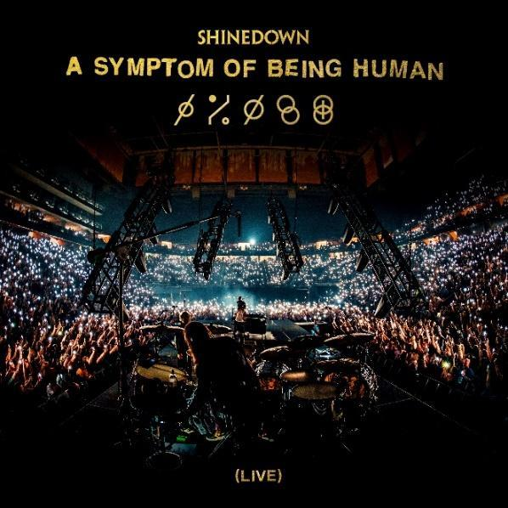

“Live music is such a part of who we are in Shinedown,” shares front man Brent Smith. “As we have said before, in this band we only have one boss, it just happens to be everybody in the audience. So, what better way to celebrate that connection than with a brand new live version of ‘A Symptom of Being Human.’ We hope you love it as much as we love you Shinedown Nation!”

While Shinedown is the most successful rock radio band of all time, recently honored by Mediabase with an award for the most No. 1’s, Top 5’s and Top 10’s in Mediabase Active Rock Chart history, they’ve always believed that music is universal and doesn’t have to be put in a genre box, as evidenced by the response to “A Symptom Of Being Human” resonating with all listeners with its uplifting and important message about how we are all a work in progress. The band’s exploration of the resilience of the human spirit, experiences with mental health, and the importance of empathy shine through in the track reminding us that we are more similar than we are different. PRESS HERE to watch the song’s official music video and PRESS HERE to download/stream. Collectively, “A Symptom Of Being Human” has amassed over 40 million streams across all versions including a pop remix, acoustic version, and piano version.

Shinedown is currently nominated for Rock Artist of the Year and Rock Song of the Year for their previous #1 “Dead Don’t Die” at this year’s iHeartRadio Music Awards. The band’s official photographer Sanjay Parikh is also up for Favorite Tour Photographer, a fan-voted award, for his work on their massively successful Revolutions Live Tour – PRESS HERE to vote for Sanjay.

PRESS HERE to read a recent interview with Rolling Stone on
“A Symptom Of Being Human,” Shinedown’s focus on human connection, and more.

ABOUT SHINEDOWN
Multi-platinum band Shinedown – Brent Smith [vocals], Zach Myers [guitar], Eric Bass [bass, production], and Barry Kerch [drums] – embody the kind of creative dynamism, constant evolution, singular vision, and uncompromising honesty that transcends boundaries. The record-breaking band, known for their timely and timeless messages behind their chart-topping songs that resonate with not only their global audience and the rock community, but our culture at large, has achieved astronomical success since its inception over two decades ago with 21 #1 Active Rock hits, 15 platinum and gold singles, platinum or gold certification for all of their albums, billions of global streams, and 10 million albums sold worldwide. Shinedown has also become an essential cultural force as evidenced by their major media acclaim, with looks including USA Today, PEOPLE, HuffPost, Forbes, Salon, Consequence, Men’s Journal, Buzzfeed, Interview Magazine, and Grammy.com, participation in the prestigious 92Y Talks series, and national TV performances. The band was named #1 on Billboard’s Greatest Of All Time Mainstream Rock Artists Chart, notching the most ever #1s (19) in the 40-year history of the Mainstream Rock Songs Chart, making Shinedown the biggest rock radio band in history. Their latest album, 2022’s Planet Zero, debuted in the Top 5 on the Billboard 200 Chart and the Official UK Albums Chart and at #1 on six other Billboard charts including Top Album Sales, Rock, Hard Rock, and Alternative Albums Charts, and has spawned 4 #1 rock singles.

FOLLOW SHINEDOWN
Facebook | Instagram | TikTok | X/Twitter | Website | Atlantic Records

