FOR IMMEDIATE RELEASE
FEBRUARY 2, 2024

TANNER USREY SHARES CROSSING LINES (DELUXE)

RISING ALT-COUNTRY TROUBADOUR’S ACCLAIMED DEBUT ALBUM
EXPANDED WITH FIVE NEW ACOUSTIC VERSIONS

RELEASES ALONGSIDE LIVE PERFORMANCE VIDEO FOR “GIVE IT SOME TIME”
WATCH HERE

BIGGEST HEADLINE RUN TO DATE INCLUDES HEADLINE DEBUTS AT VENUES INCLUDING
NYC’S BOWERY BALLROOM AND NASHVILLE’S BASEMENT EAST

BUSY LIVE SCHEDULE ALSO INCLUDES FESTIVAL PERFORMANCES AND
UK DEBUT AT LONDON’S HISTORIC ROYAL ALBERT HALL
TICKETS ON SALE NOW HERE

CROSSING LINES (DELUXE) AVAILABLE NOW VIA ATLANTIC RECORDS
LISTEN TO CROSSING LINES (DELUXE)

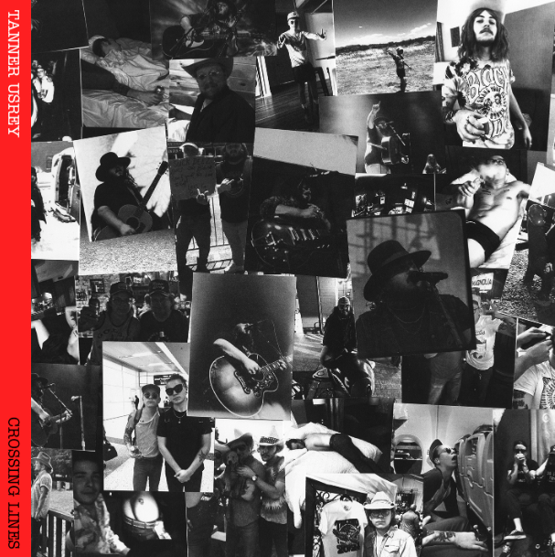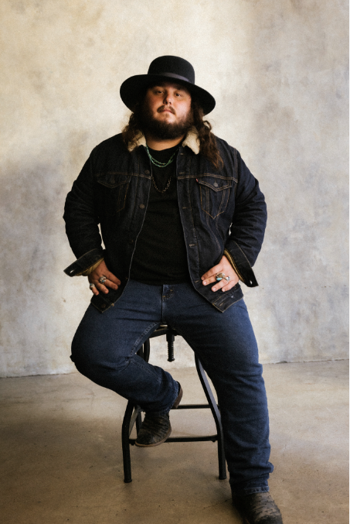
DOWNLOAD HI-RES ASSETS

“Tanner Usrey is a star on the brink of shooting across the sky.” – WHISKEY RIFF

“Usrey is rugged to the bone and real as they come…It’s humility, debauchery and redemption all wrapped into one.” – HOLLER

“Tanner Usrey is a quick riser in the Texas country world.” – THE COWBOY CHANNEL

Rising country star Tanner Usrey has shared Crossing Lines (Deluxe), a newly expanded version of his acclaimed debut album, Crossing Lines, available everywhere now via Atlantic Records HERE. Crossing Lines (Deluxe) adds five previously unreleased acoustic renditions of fan favorites including “Who I Am,” “Last Goodbye,” and the Texas-based artist’s label debut single, “Give It Some Time.” The deluxe album releases alongside a live performance video for “Give It Some Time” - Watch HERE.

Usrey is currently celebrating Crossing Lines with an epic US tour – his biggest headline run to date. The Crossing Lines Tour includes stops at such famed venues as Athens, GA’s 40 Watt Club (February 10), New York City’s Bowery Ballroom (February 23), South Burlington, VT’s Higher Ground (February 25), and Cleveland, OH’s Beachland Ballroom & Tavern (March 6), culminating with his eagerly awaited headline debut at Nashville, TN’s legendary Basement East on March 14. Support comes from JD Clayton and Kat Hasty on select dates. Tickets for The Crossing Lines Tour are on sale now.

Usrey will follow The Crossing Lines Tour with a wide range of festival performances, including his hugely anticipated UK debut at London, England’s historic Royal Albert Hall as part of the two-day Highways event alongside The Cadillac Three, Shane Smith and the Saints, and more (May 17-18). Additional dates include Boston, MA’s Boston Calling (May 25), Lexington, KY – Railbird Music Festival (June 1-2), Manchester, TN’s Bonnaroo Music & Arts Festival (June 13-16), and Whitefish, MT’s Under The Big Sky Festival (July 12-14). For complete details and remaining ticket availability, please visit www.tannerusreymusic.com/tour-dates.

Produced by Beau Bedford (Orville Peck, Paul Cauthen, The War and Treaty), Crossing Lines is highlighted by a brand-new version of Usrey’s breakout hit single, “Beautiful Lies,” now featuring rising country songstress Ella Langley and joined by a special live performance video streaming now at YouTube HERE. The collaboration received immediate praise from Billboard, which named it among the week’s “8 Must-Hear Country Songs,” writing, “Usrey trades in resignation rather than angst here, layered with Langley’s impassioned drawl, as they sing about a self-destructive relationship…Their harmonies are pristine, soaring over understated guitar and softened percussion. A superb pairing of two earnest vocalists.” Crossing Lines further features such critically acclaimed singles as “Crossing Lines,” “Destiny,” “Who I Am,” “Last Goodbye,” and this spring’s label debut, “Give It Some Time,” all available now at all DSPs and streaming services.

An electrifying and energetic live presence who played over 180 shows in 2022 alone, Usrey proved equally unrelenting in 2023, traveling on a non-stop live schedule which included headline shows, festival appearances, and dates alongside Charles Wesley Godwin, Turnpike Troubadours, Koe Wetzel, a very special show at Nashville’s historic Ryman Auditorium supporting Shane Smith & The Saints.

TANNER USREY
ON TOUR 2024

FEBRUARY
2 – Starkville, MS – Rick’s Café †
3 – Tallahassee, FL – Duke’s & Dottie’s †
4 – Decatur, GA – Eddie’s Attic †
6 – Birmingham, AL – Zydeco †
7 – Jackson, MS – Hal & Mal’s †
8 – Mobile, AL – Soul Kitchen Music Hall †
9 – Statesboro, GA – The Blue Room †
10 – Athens, GA – 40 Watt Club †
12 – Asheville, NC – The Grey Eagle †
14 – Greenville, SC – Radio Room †
15 – Charlotte, NC – Amos’ Southend †
17 – Knoxville, TN – Open Chord Music †
18 – Charlottesville, VA – The Southern Café & Music Hall †
21 – Washington, DC – Pearl Street Warehouse †
22 – Philadelphia, PA – The Fillmore Philadelphia †
23 – New York, NY – Bowery Ballroom †
24 – Hamden, CT – Space Ballroom †
25 – Cambridge, MA – The Sinclair †
28 – South Burlington, VT – Higher Ground †
29 – Albany, NY – Empire Live †

MARCH
1 – Syracuse, NY – The Song & Dance †
2 – Buffalo, NY – Buffalo Iron Works †
5 – Pittsburgh, PA – Thunderbird Café & Music Hall +
6 – Cleveland, OH – Beachland Ballroom & Tavern +
7 – Detroit, MI – The Shelter +
8 – Chicago, IL – Joe’s Bar +
9 – Indianapolis, IN – Hi-Fi +
10 – Columbus, OH – A&R Music Bar +
14 – Nashville, TN – The Basement East +

APRIL
12-14 – Gonzalez, TX – Cattle Country Fest *
17 – Los Angeles, CA – YouTube Theater ^
18 – Bakersfield, CA – Dignity Health Amphitheatre ^
19 – Paso Robles, CA – Vina Robles Amphitheatre ^
20 – San Diego, CA – Cal Coast Credit Union Open Air Theatre ^

MAY
17 – London, UK – Highways @ Royal Albert Hall *
18 – London, UK – Highways @ Royal Albert Hall *
25 – Boston, MA – Boston Calling *

JUNE
1-2 – Lexington, KY – Railbird Music Festival *
13-16 – Manchester, TN – Bonnaroo Music & Arts Festival

JULY
12-14 – Whitefish, MT – Under The Big Sky Festival *

* Festival Performance
† w/Special Guest JD Clayton
+ w/Special Guest Kat Hasty
^ w/ Koe Wetzel

# # #

ABOUT TANNER USREY
Tanner Usrey has earned national applause for channeling a classic spirit from a personal perspective, blending straight-shooting storytelling with country grit, rock ‘n’ roll energy, and Americana eloquence. Inspired by a range of influences – spanning George Strait, Tom Petty, Lynyrd Skynyrd, and The Rolling Stones to his favorite band, Whiskey Myers – Usrey grew up in the small town of Prosper, TX, where he worked as a skip tracer while honing his signature style by writing countless songs and performing gigs anywhere that had a stage. In 2019, he quit his job and unveiled the Medicine Man EP, followed in 2021 by the SÕL Sessions EP, earning tens of millions of streams and featured placement on the highly rated Yellowstone Season 4 finale. Now, his catalog has over 190M streams globally. Usrey kicked off 2023 with “Take Me Home,” drawing over 28M streams thus far. Now, as the latest member of the world-renowned Atlantic Records roster, Tanner Usrey is poised to fly even higher with the long awaited arrival of Crossing Lines and The Crossing Lines Tour.

“I hope you hear what you want to hear, enjoy it, resonate with it, and know it’s real,” Usrey says. “It’s been a wild ride. I’ve busted my ass. I started off doing all of this on my own, so it’s crazy to see how this and the team around me have grown. People are going after real music right now, and that’s great. I’m looking forward to seeing where it goes next.”

# # #

TANNER USREY
CROSSING LINES (DELUXE)
(Atlantic Records)

TRACKLIST:
Echo in the Holler
Guns Drugs and Allergy Pills
Take Me Home
Tanner Usrey & Ella Langley – Beautiful Lies
Crossing Lines
Who I Am
Give It Some Time
Pick Up Your Phone
Tanner Usrey & Graycie York – Last Goodbye
Black Widow
Make You Weep
Destiny
Evelyn’s Eyes (Feat. Jessi England)
Down Here at The Bottom
Beautiful Lies
Give It Some Time (Acoustic) *
Who I Am (Acoustic) *
Pick Up Your Phone (Acoustic) *
Evelyn's Eyes (feat. Jessi England) (Acoustic) *
Last Goodbye (Acoustic) *

* Bonus Track

# # #

CONNECT WITH TANNER USREY
OFFICIAL | FACEBOOK | INSTAGRAM | TWITTER | YOUTUBE

