WILLOW AVALON OFFICIALLY RELEASES VIRAL SONG
“GETTIN’ RICH, GOIN’ BROKE”

LISTEN HERE

TEASES OF TRACK AMASSED OVER 5 MILLION VIEWS ON TIKTOK, WHILE THE GEORGIA-BORN, NY-BASED ARTIST GAINED OVER 45K FOLLOWERS ON THE PLATFORM

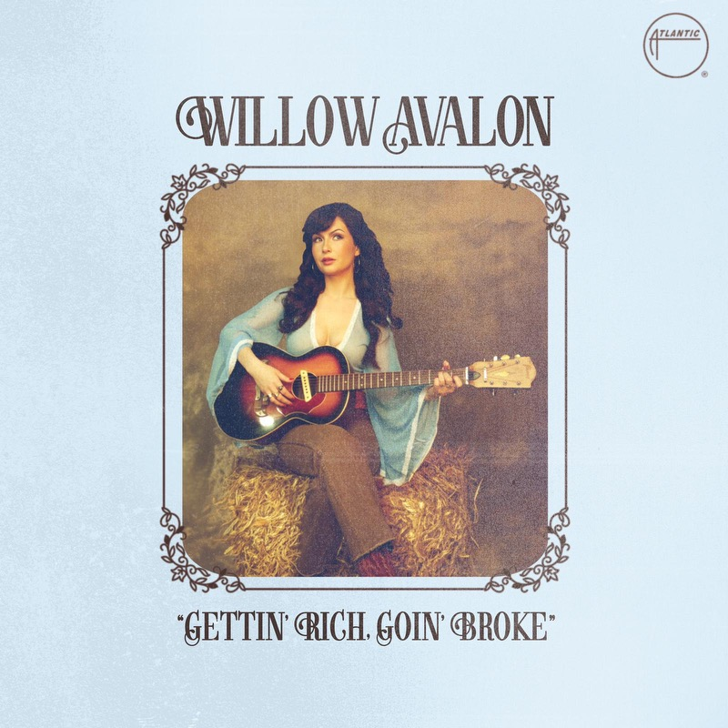

NEW SONG COMES OFF DEBUT EP STRANGER - DUE OUT FEBRUARY 29 VIA ATLANTIC RECORDS/ASSEMBLE SOUND

LEAD SINGLE “STRANGER” BECAME TOP PLAYED SONG ON
SIRIUSXM’S THE SPECTRUM & HITS1 RADIO

WILLOW SUPPORTING BRISTON MARONEY ON SELECT US DATES +
PLAYING HANGOUT MUSIC FESTIVAL THIS SPRING

“Channelling trans-generational trauma into superlative pop… Avalon’s songwriting bears the hallmarks of resilience and a life lived, hitting melancholic sweet spots with a grandiose flourish that recalls Stevie Nicks, Jackson Browne and Reba McEntire.” – THE LINE OF BEST FIT

“Viral sensation” – AMERICAN SONGWRITER

download hi-res press photo HERE; credit: Kristin Karch

###

ABOUT WILLOW AVALON:
A rural-Georgia native whose first word was Elvis, Willow Avalon grew up playing piano in church, taught herself guitar at age 12, and soon started writing songs as a form of escape and salvation. After leaving home at 15 and briefly living in her car, the 25-year-old singer-songwriter made her way to California and eventually settled in New York City, where she resides in a Hell’s Kitchen apartment transformed into her own outlandish wonderland. Newly signed to Atlantic Records – thanks in part to the breakout success of her self-released single “Drivin” – Willow is set to deliver her debut EP Stranger on February 29, 2024, a perfect introduction to her infinitely charmed and wildly unpredictable world.

CONNECT WITH WILLOW AVALON
INSTAGRAM | TIKTOK | YOUTUBE

FOR ALL PRESS INQUIRIES, PLEASE CONTACT:
Libby Kober | Libby.Kober@atlanticrecords.com

