MARYJO SHARES “I WOKE UP”

RISING SINGER-SONGWRITER UNVEILS NEW SINGLE

LISTEN

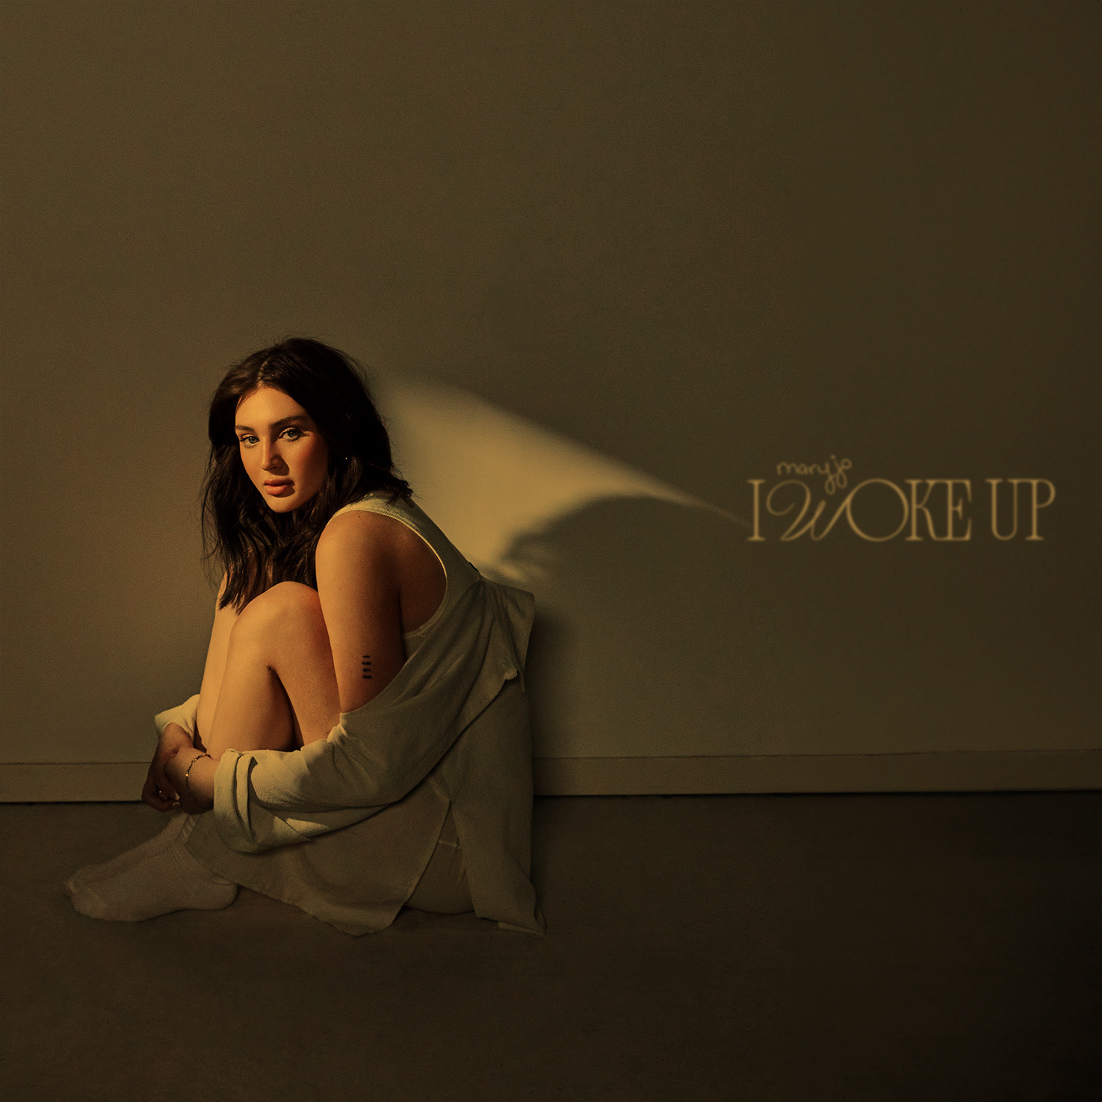
DOWNLOAD HI-RES ARTWORK + PRESS IMAGES

“I Woke Up” is the awakening from an emotional rollercoaster relationship,” says maryjo. “It is an energetic, drum-backed anthem that takes anger and frustration and channels your power back to realize what you deserve. Sometimes we are blinded by an outcome that we want but this song encapsulates coming out of the rut and realizing what we deserve! I wanted this song to challenge my sonic direction for this year. I found a way to have the production of the song shape my lyrics and the story.”

Currently boasting more than 1.3M TikTok followers and over 27.5M total likes, rising singer-songwriter maryjo has shared newest single, “I Woke Up,” available now via Atlantic Records. Produced by Josh Murty (Maggie Lindeman, Sebastian Yatra, Luis Fonsi) and co-written by maryjo, Murty, and Nolan Sipe (Colbie Caillat, Andy Grammar.

Maryjo is currently on the road supporting Knox’s sold-out “I’m So Good At Being Alone Tour,” continuing tonight at Indianapolis, IN’s Hi-Fi and then making two final stops at Nashville, TN - Exit/Inn (February 9) and Atlanta, GA’s The Masquerade (February 10).

“I Woke Up” marks the very latest in a series of singles which have already earned the Cleveland, OH-based artist more than 4M worldwide streams thus far. Among the fan favorites are such tracks as “Drunk Tattoo,” “Don’t Call Me,” the compelling “Traffic,” and “Cleveland,” the latter celebrating her hometown with an official music video showcasing her high school and other meaningful locations plus fashion from several Cleveland-based vendors.

Maryjo made her label debut with last spring’s acclaimed single, “Love Fools,” accompanied by an official music video which follows the intimate highs and lows of a stormy relationship via her home security cameras. Hailed by Billboard as “a showcase for Cleveland singer-songwriter Maryjo, whose words tumble out with searing emotion and who untangles some knotty melodies on this beautifully rendered piano ballad... a great introduction,” the tender ballad features backing from GRAMMY® Award-nominated, 2x ACM Award-winning blind piano virtuoso Gordon Mote.

Maryjo has the kind of phenomenal vocal command made for heart-melting piano ballads, often drifting from full-throated belting to a gorgeously fragile delivery inflected with cracks. Though it took years for the artist to overcome her fear of singing in front of others, she worked through her shyness by sharing videos on social media and quickly earned a devoted fan following for her singular and evocative vocal power. The 22-year-old artist continued to capture attention as a fan-favorite contestant on Season 19 of the landmark singing competition series, American Idol, earning praise for her unique renditions of songs by Ed Sheeran, James Bay, Tate McRae, and Jewel, teaming with the latter for a memorable duet performance of the classic “Foolish Games.” Now, with the electrifying “I Woke Up” – and more new music on the way – maryjo remains steadfast in her goals, relating breathtaking emotion and musical artistry by simply staying true to her instincts.

“With every song I sing, I try to think about every single angle that people could hear it from and all the ways they could possibly connect to it,” says maryjo. “I’m already getting my therapy from the whole process of writing and recording, so I want to make sure that I’m giving people something that helps them tap into their own emotions and makes them feel better about whatever they’re going through.”

DOWNLOAD HI-RES PRESS IMAGES + ARTWORK

# # #

CONNECT WITH MARYJO
WEBSITE | INSTAGRAM | TIKTOK | YOUTUBE

PRESS CONTACT
Christina.Kotsamanidis@atlanticrecords.com

