FOR IMMEDIATE RELEASE
FEBRUARY 23, 2024

RAP DUO FLYANA BOSS RELEASE NEW SINGLE “yeaaa”
TO KICK OFF SOLD OUT HEADLINE TOUR

THE BOSSTANICAL GARDEN TOUR KICKS OFF TOMORROW
IN CHICAGO, IL AT SCHUBAS TAVERN

“yeaaa” FOLLOWS FIRST RELEASE OF 2024 “CANDYMAN” BOTH SINGLES FEATURED ON
FORTHCOMING EP, THIS AIN’T THE ALBUM, DUE ON MARCH 29

LISTEN TO “yeaaa” HERE

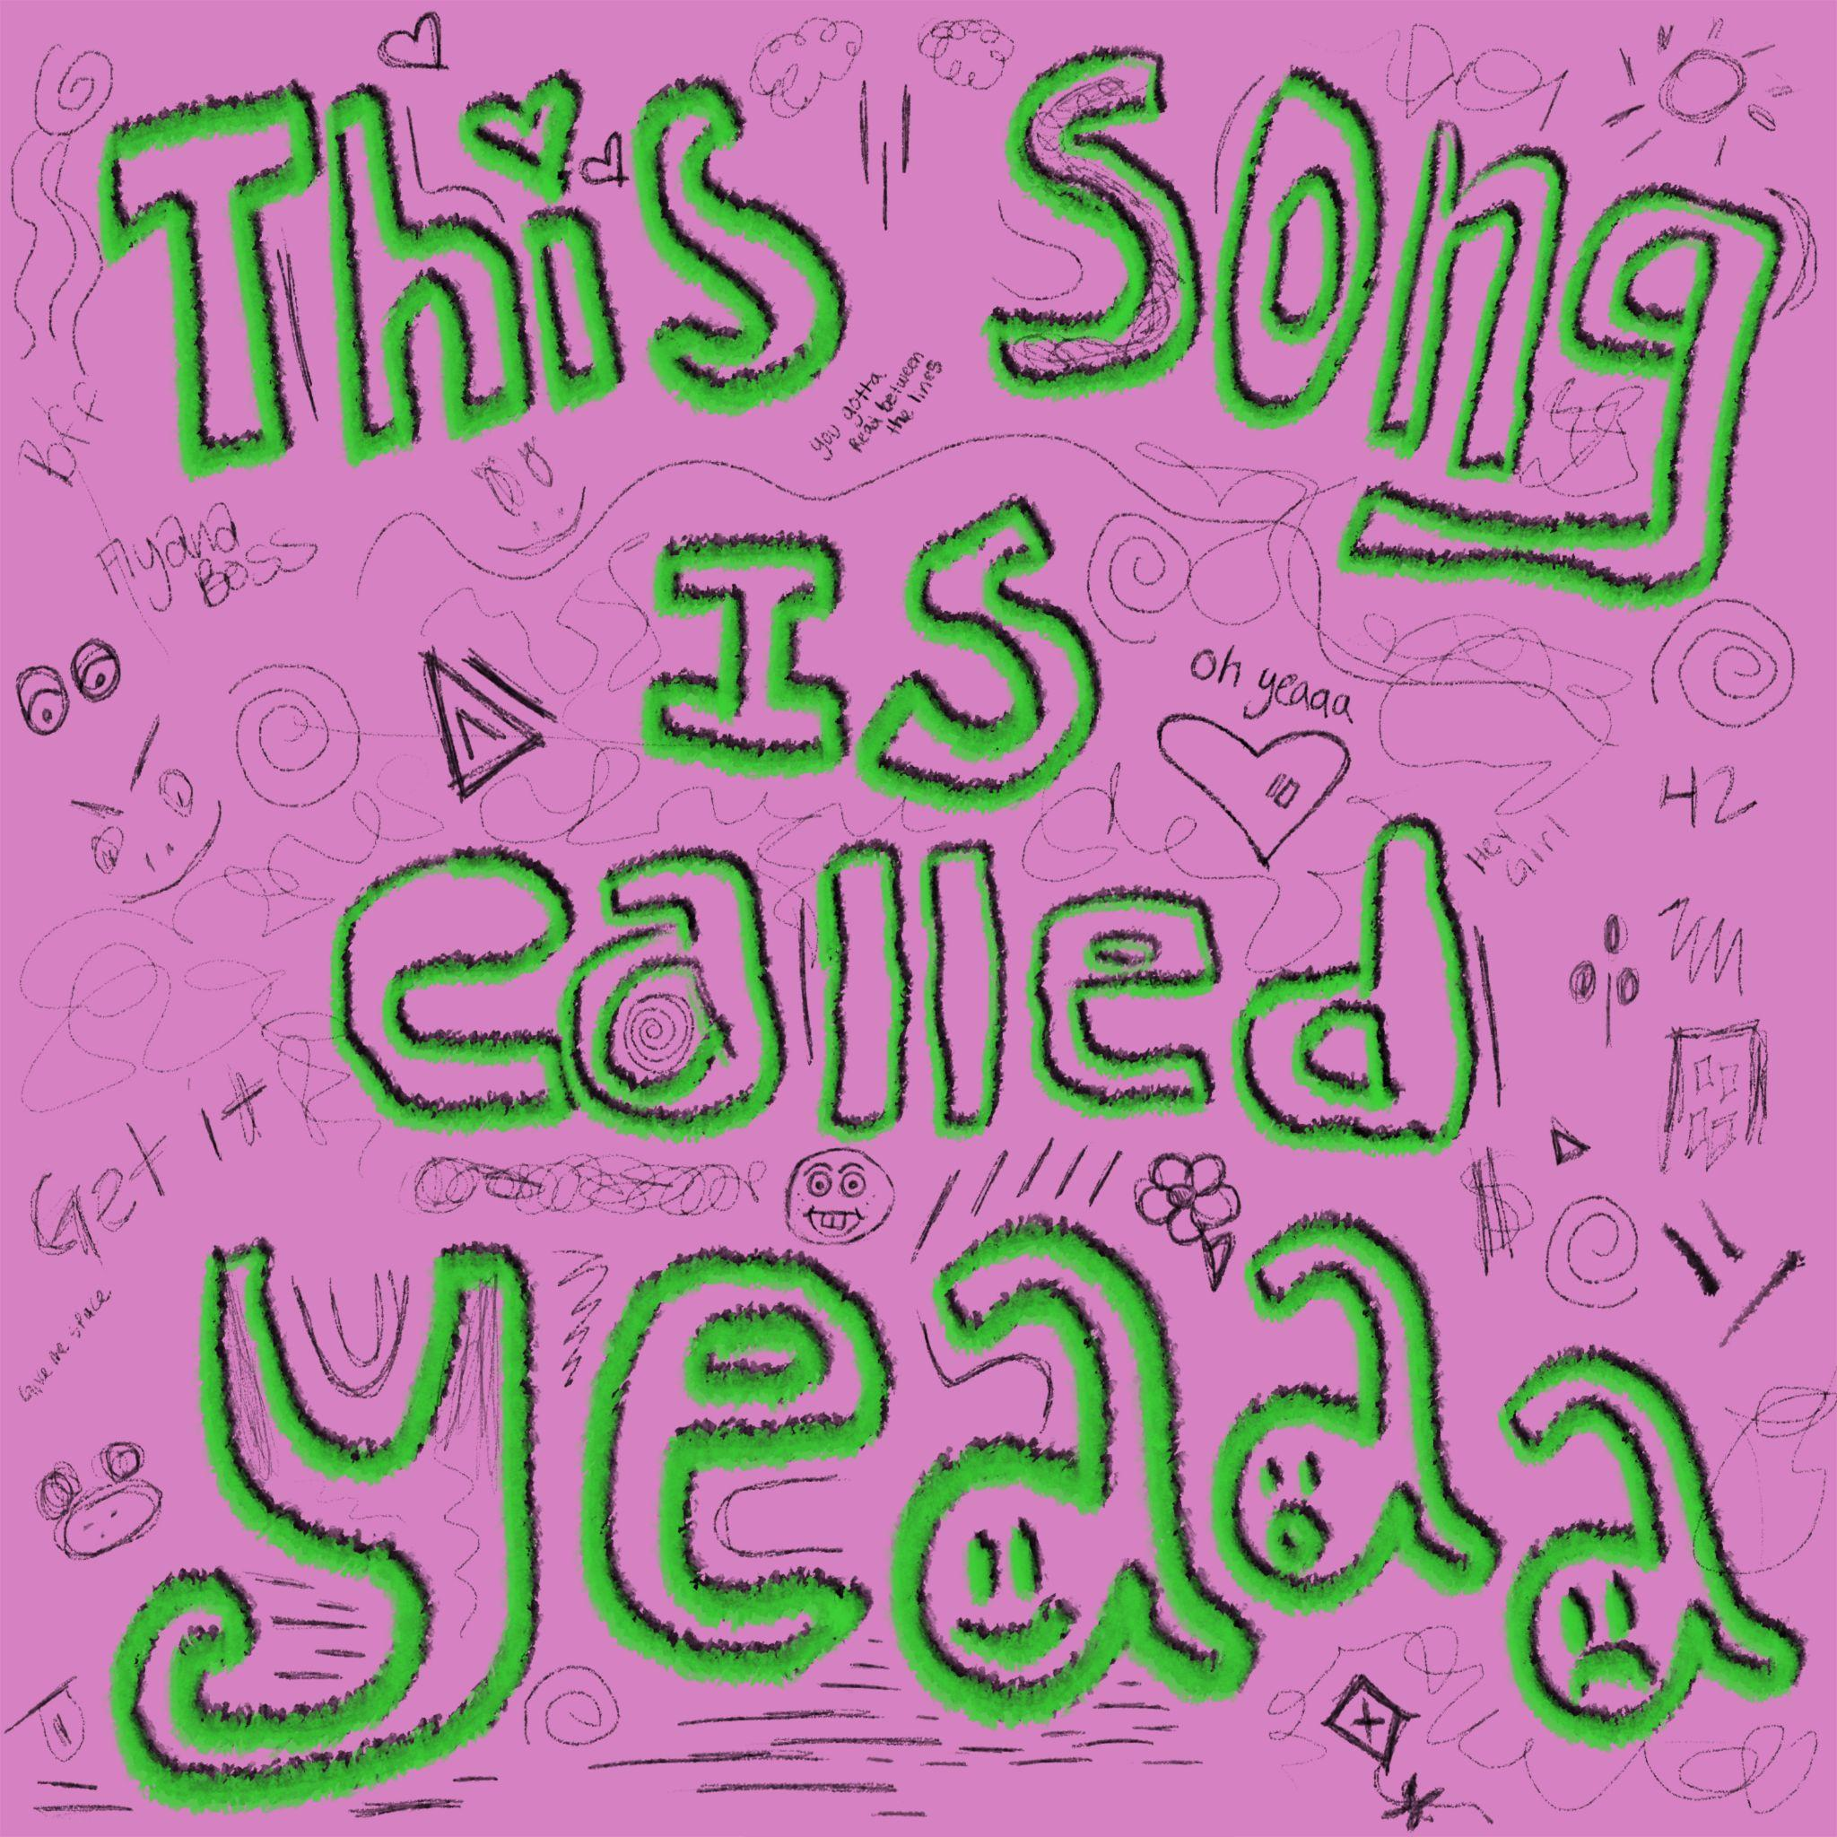
DOWNLOAD HI-RES ARTWORK HERE
CREDIT: FLYANA BOSS

Breakthrough rap besties Flyana Boss drop their second single of 2024, “yeaaa,” available everywhere now via vnclm_ x Atlantic Records HERE. Bobbi and Folayan, alongside their hit-making collaborator, Marky Style, effortlessly infuse their signature witty wordplay, making it crystal clear they're not here to steal your man. “yeaaa” follows “Candyman,” two records featured on the duo’s upcoming EP, This Ain’t The Album, slated to release March 29.

"Important reminder: we don’t want your man, never wanted your man, never will want your man. But we do love to dance." – Flyana Boss

The duo will hit the road starting tomorrow, following their first tour run as support for Janelle Monáe’s The Age Of Pleasure Tour and surprise guest run on Ke$ha's The Only Love Tour, this time with their own headlining tour–The Bosstanical Garden Tour. The 18-city tour kicks off on February 24, 2024 at Schubas Tavern in Chicago, IL. The viral sensations will make stops in their home cities of Detroit and Dallas, in addition to Toronto, Brooklyn, Washington D.C., Denver, and more before wrapping the tour in their home-base, Los Angeles. The duo will be joined by rising R&B songstress Honey Bxby during the first half of the tour, followed by soul-stirring vocal sensation Josh Levi during the second half. Further ticketing information can be found HERE.

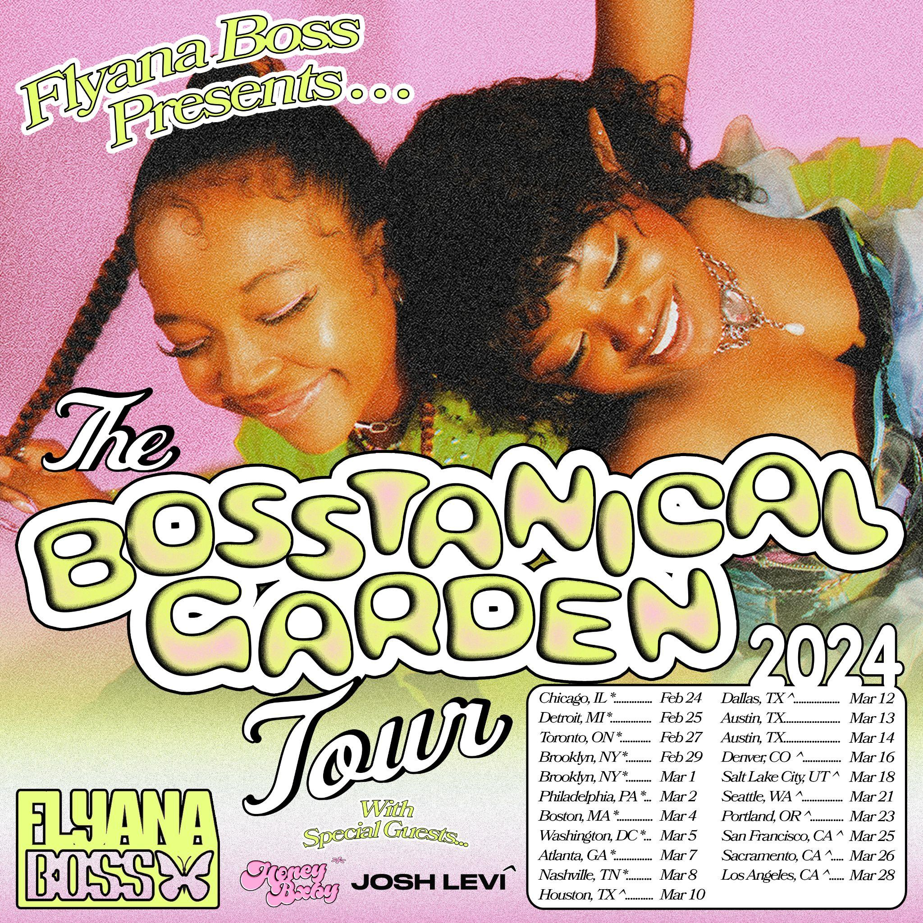
DOWNLOAD ADMAT HERE
PHOTO CREDIT : SJ SPRENG

FEBRUARY
24 – Chicago, IL – Schubas Tavern *
25 – Detroit, MI – Shelter *
27 – Toronto, ON – The Drake Underground *
29 – Brooklyn, NY – Baby’s All Right *

MARCH
1 – Brooklyn, NY – Baby’s All Right *
2 – Philadelphia, PA – The Foundry at The Fillmore *
4 – Boston, MA – Berklee College of Music – The Red Room at Cafe 939 *
5 – Washington, DC – The Atlantis *
7 – Atlanta, GA – Aisle 5 *
8 – Nashville, TN – The Basement East *
10 – Houston, TX – House of Blues Bronze Peacock **
12 – Dallas, TX – House of Blues Cambridge Room **
16 – Denver, CO – Meow Wolf **
18 – Salt Lake City, UT – Kilby Court **
21 – Seattle, WA – Barboza **
23 – Portland, OR – Holocene **
25 – San Francisco, CA – Cafe Du Nord **
26 – Sacramento, CA – Harlow’s – The Starlet Room **
28 – Los Angeles, CA – The Echo **

* support from Honey Bxby
** support from Josh Levi

ABOUT FLYANA BOSS
Hailing from Detroit, MI and Dallas, TX respectively, Bobbi and Folayan met at a music college in Los Angeles where they immediately hit it off and began collaborating. The fierce duo adopted the name Flyana Boss (rhymes with Diana Ross), repping the Vagina Dynasty while simultaneously embodying the spirit of flyness and bossness. Together, Bobbi and Folayan form a formidable union that pushes the boundaries of contemporary hip-hop, seamlessly blending their individual strengths to create a sound that is distinctively Flyana Boss. Bobbi brings a knack for storytelling and infuses her music with authenticity and vulnerability as Folayan effortlessly switches between different styles and genres, adding depth and dimension to Flyana Boss’ one-of-a-kind music. See full length bio HERE.

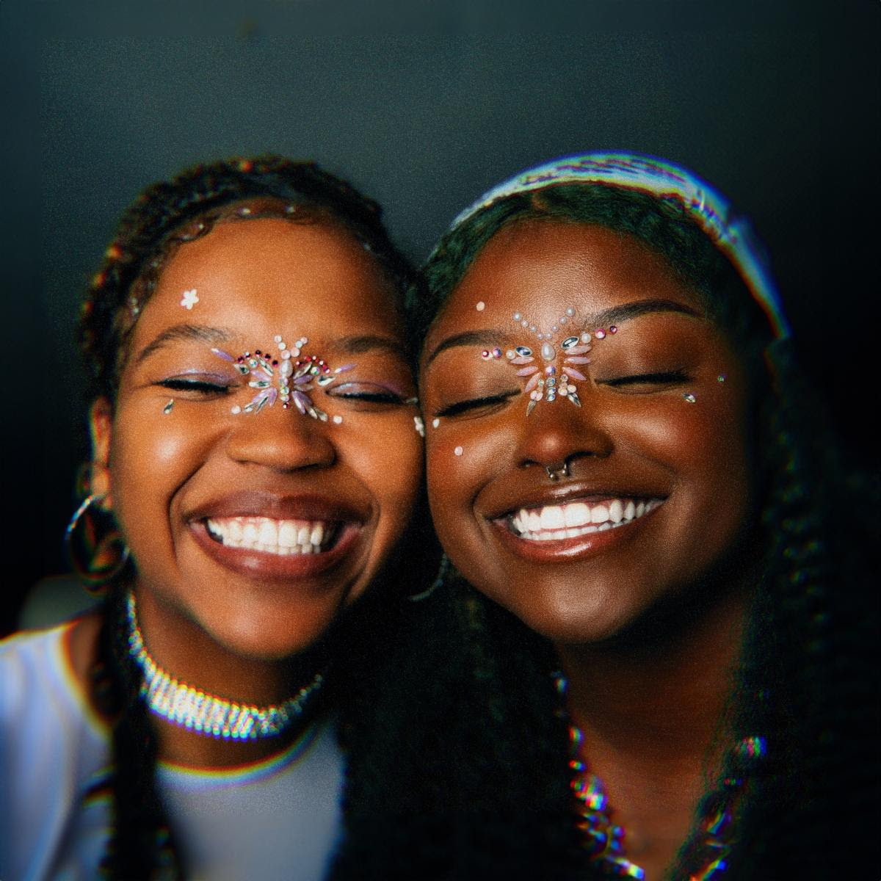
DOWNLOAD HI-RES PRESS PHOTO HERE
PHOTO CREDIT: SJ SPRENG

CONNECT WITH FLYANA BOSS
FLYANABOSS.COM | PRESS SITE | INSTAGRAM | TIKTOK | TWITTER | YOUTUBE

LISTEN TO MORE FLYANA BOSS
“YOU WISH” | “YOU WISH REMIX” | “BITCH IMMA STAR” | “BIG ONE” | “CANDYMAN”

PRESS CONTACT
FAIRLEY MCCASKILL | FAIRLEY.MCCASKILL@ATLANTICRECORDS.COM

