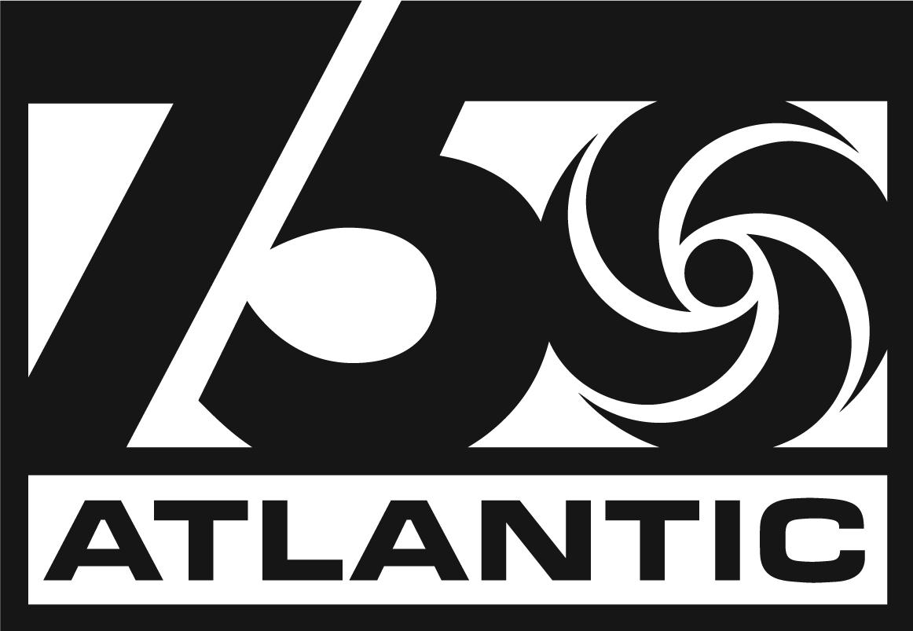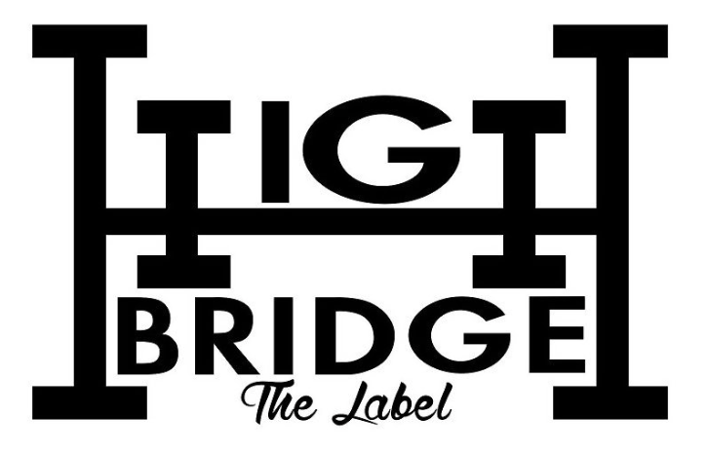

GLOBAL SUPERSTAR A BOOGIE WIT DA HOODIE ANNOUNCES NEW ALBUM ‘BETTER OFF ALONE’ AVAILABLE EVERYWHERE MAY 17

NEW SINGLE “STEPPAS” OUT TODAY ALONGSIDE COMPANION VISUAL
Directed by: Phil Meyer

DOWNLOAD/STREAM | WATCH OFFICIAL MUSIC VIDEO

PRE-ORDER BETTER OFF ALONE

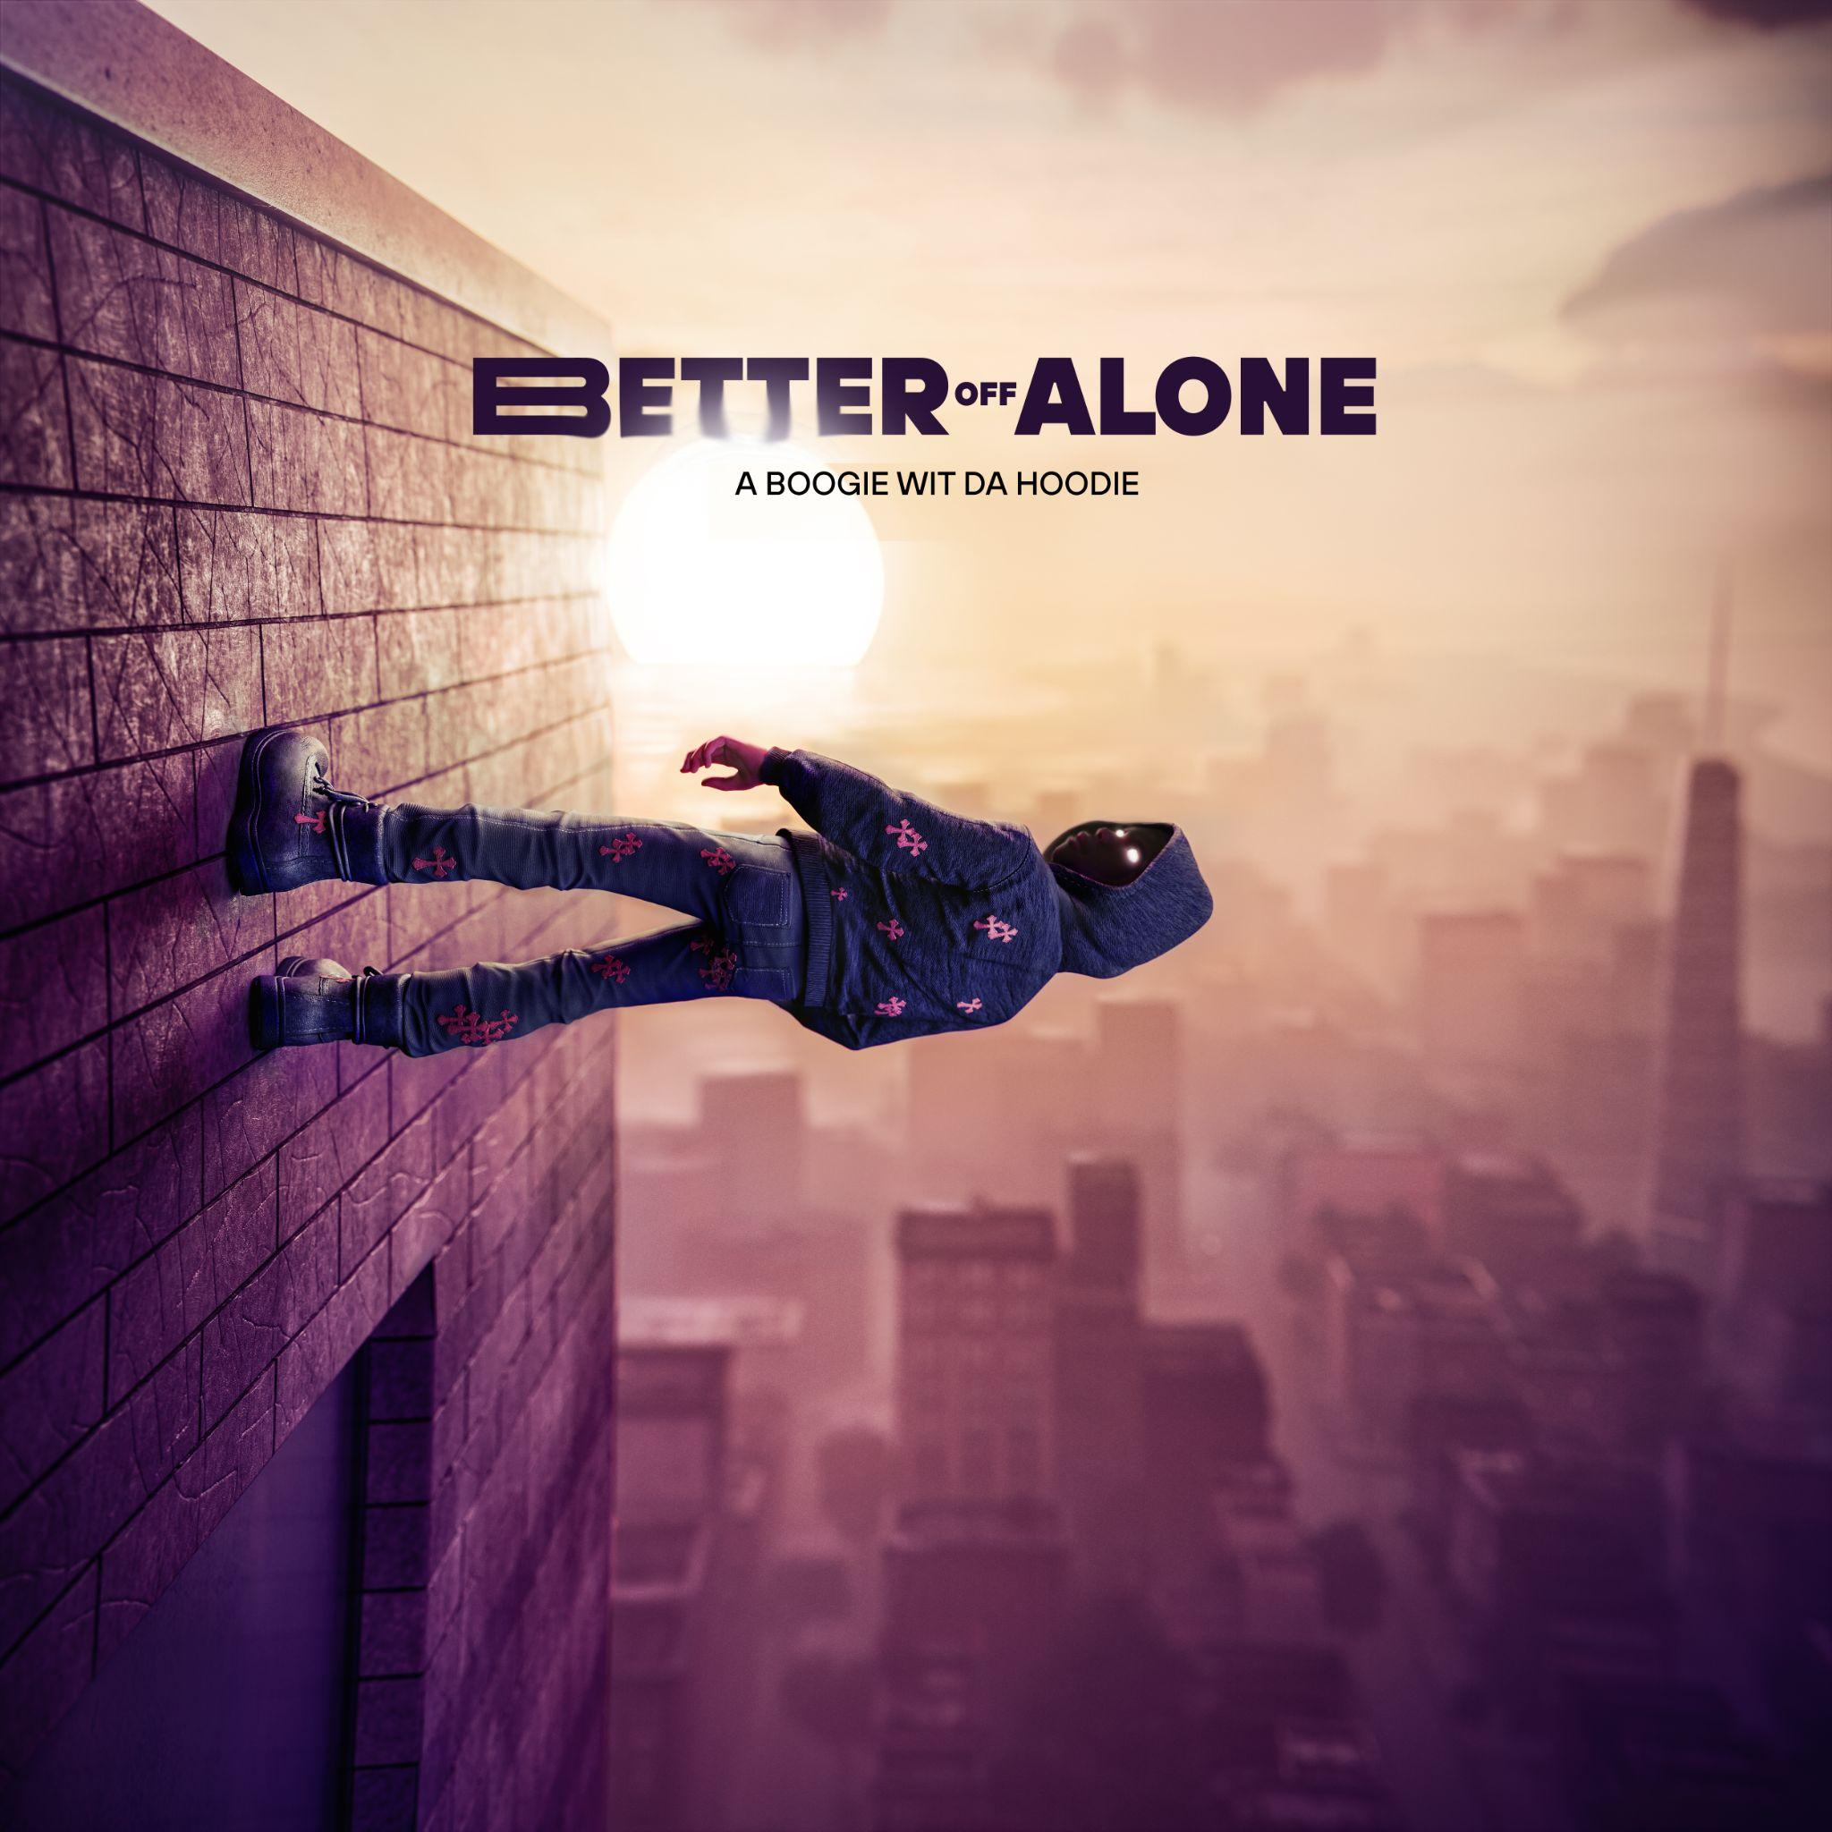

“BETTER OFF ALONE WORLD TOUR” KICKS OFF MAY 18 WITH SOLD OUT DATES AT NYC’S MADISON SQUARE GARDEN, LONDON’S THE O2 ARENA AND MORE

FULL LIST OF TOUR DATES

DOWNLOAD PRESS ASSETS

For all A Boogie Wit da Hoodie press inquiries, please contact:
Jason Davis – Jason.Davis@atlanticrecords.com

Connect with A Boogie Wit da Hoodie: Instagram | Twitter | Facebook | YouTube | Website

***
ABOUT A BOOGIE WIT DA HOODIE
Multi-platinum global superstar, A Boogie wit da Hoodie has been a force to be reckoned with since arriving on the scene in 2016. Credited for bringing the new sound of New York City to the masses, the Bronx, NY-native has been proclaimed “the most promising young rapper the city has produced in some time” by The New York Times, while boasting over 21B global streams and over 50 RIAA platinum and gold certifications to date.

With a dynamic catalog of world-renowned hit songs (“My Shit,” “Drowning (feat. Kodak Black),” “Swervin,” “Look Back At It” and more) and 3 critically-acclaimed albums under his belt (HOODIE SZN, THE BIGGER ARTIST and ARTIST 2.0), A Boogie has proven he is one of the music industry’s brightest generational stars.

A Boogie has also become one of music’s most in-demand collaborators, working with a wide variety of artists ranging from Ed Sheeran, Maroon 5 and Khalid to Chris Brown, DJ Khaled, Paulo Londra, Meek Mill, Pop Smoke and more.

***

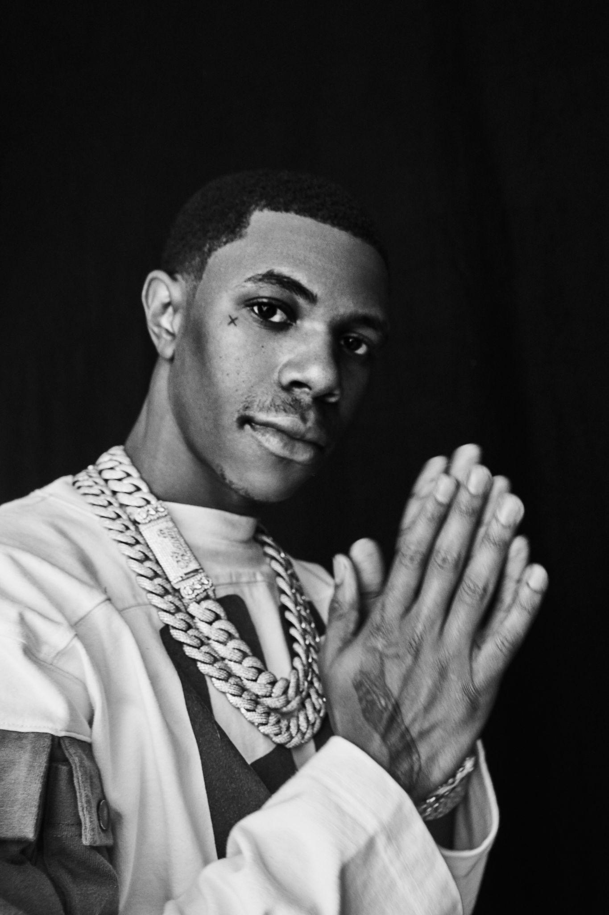
DOWNLOAD PRESS ASSETS
Photo Credit: Jimmy Fontaine

###

