FOR IMMEDIATE RELEASE
FEBRUARY 1, 2024

DON TOLIVER IS BACK WITH “BANDIT”

HIP-HOP SOUL ARTIST DROPS EAGERLY AWAITED FOLLOW-UP
TO AWARD-WINNING LOVE SICK PROJECT

UPCOMING LIVE DATES INCLUDE TOP-BILLED PERFORMANCES AT
HOLLYWOOD, CA’S ROLLING LOUD CALIFORNIA (MARCH 17) AND
NEW YORK CITY'S THE GOVERNOR’S BALL (JUNE 9)

LISTEN TO “BANDIT” HERE | WATCH OFFICIAL MUSIC VIDEO/VISUALIZER HERE

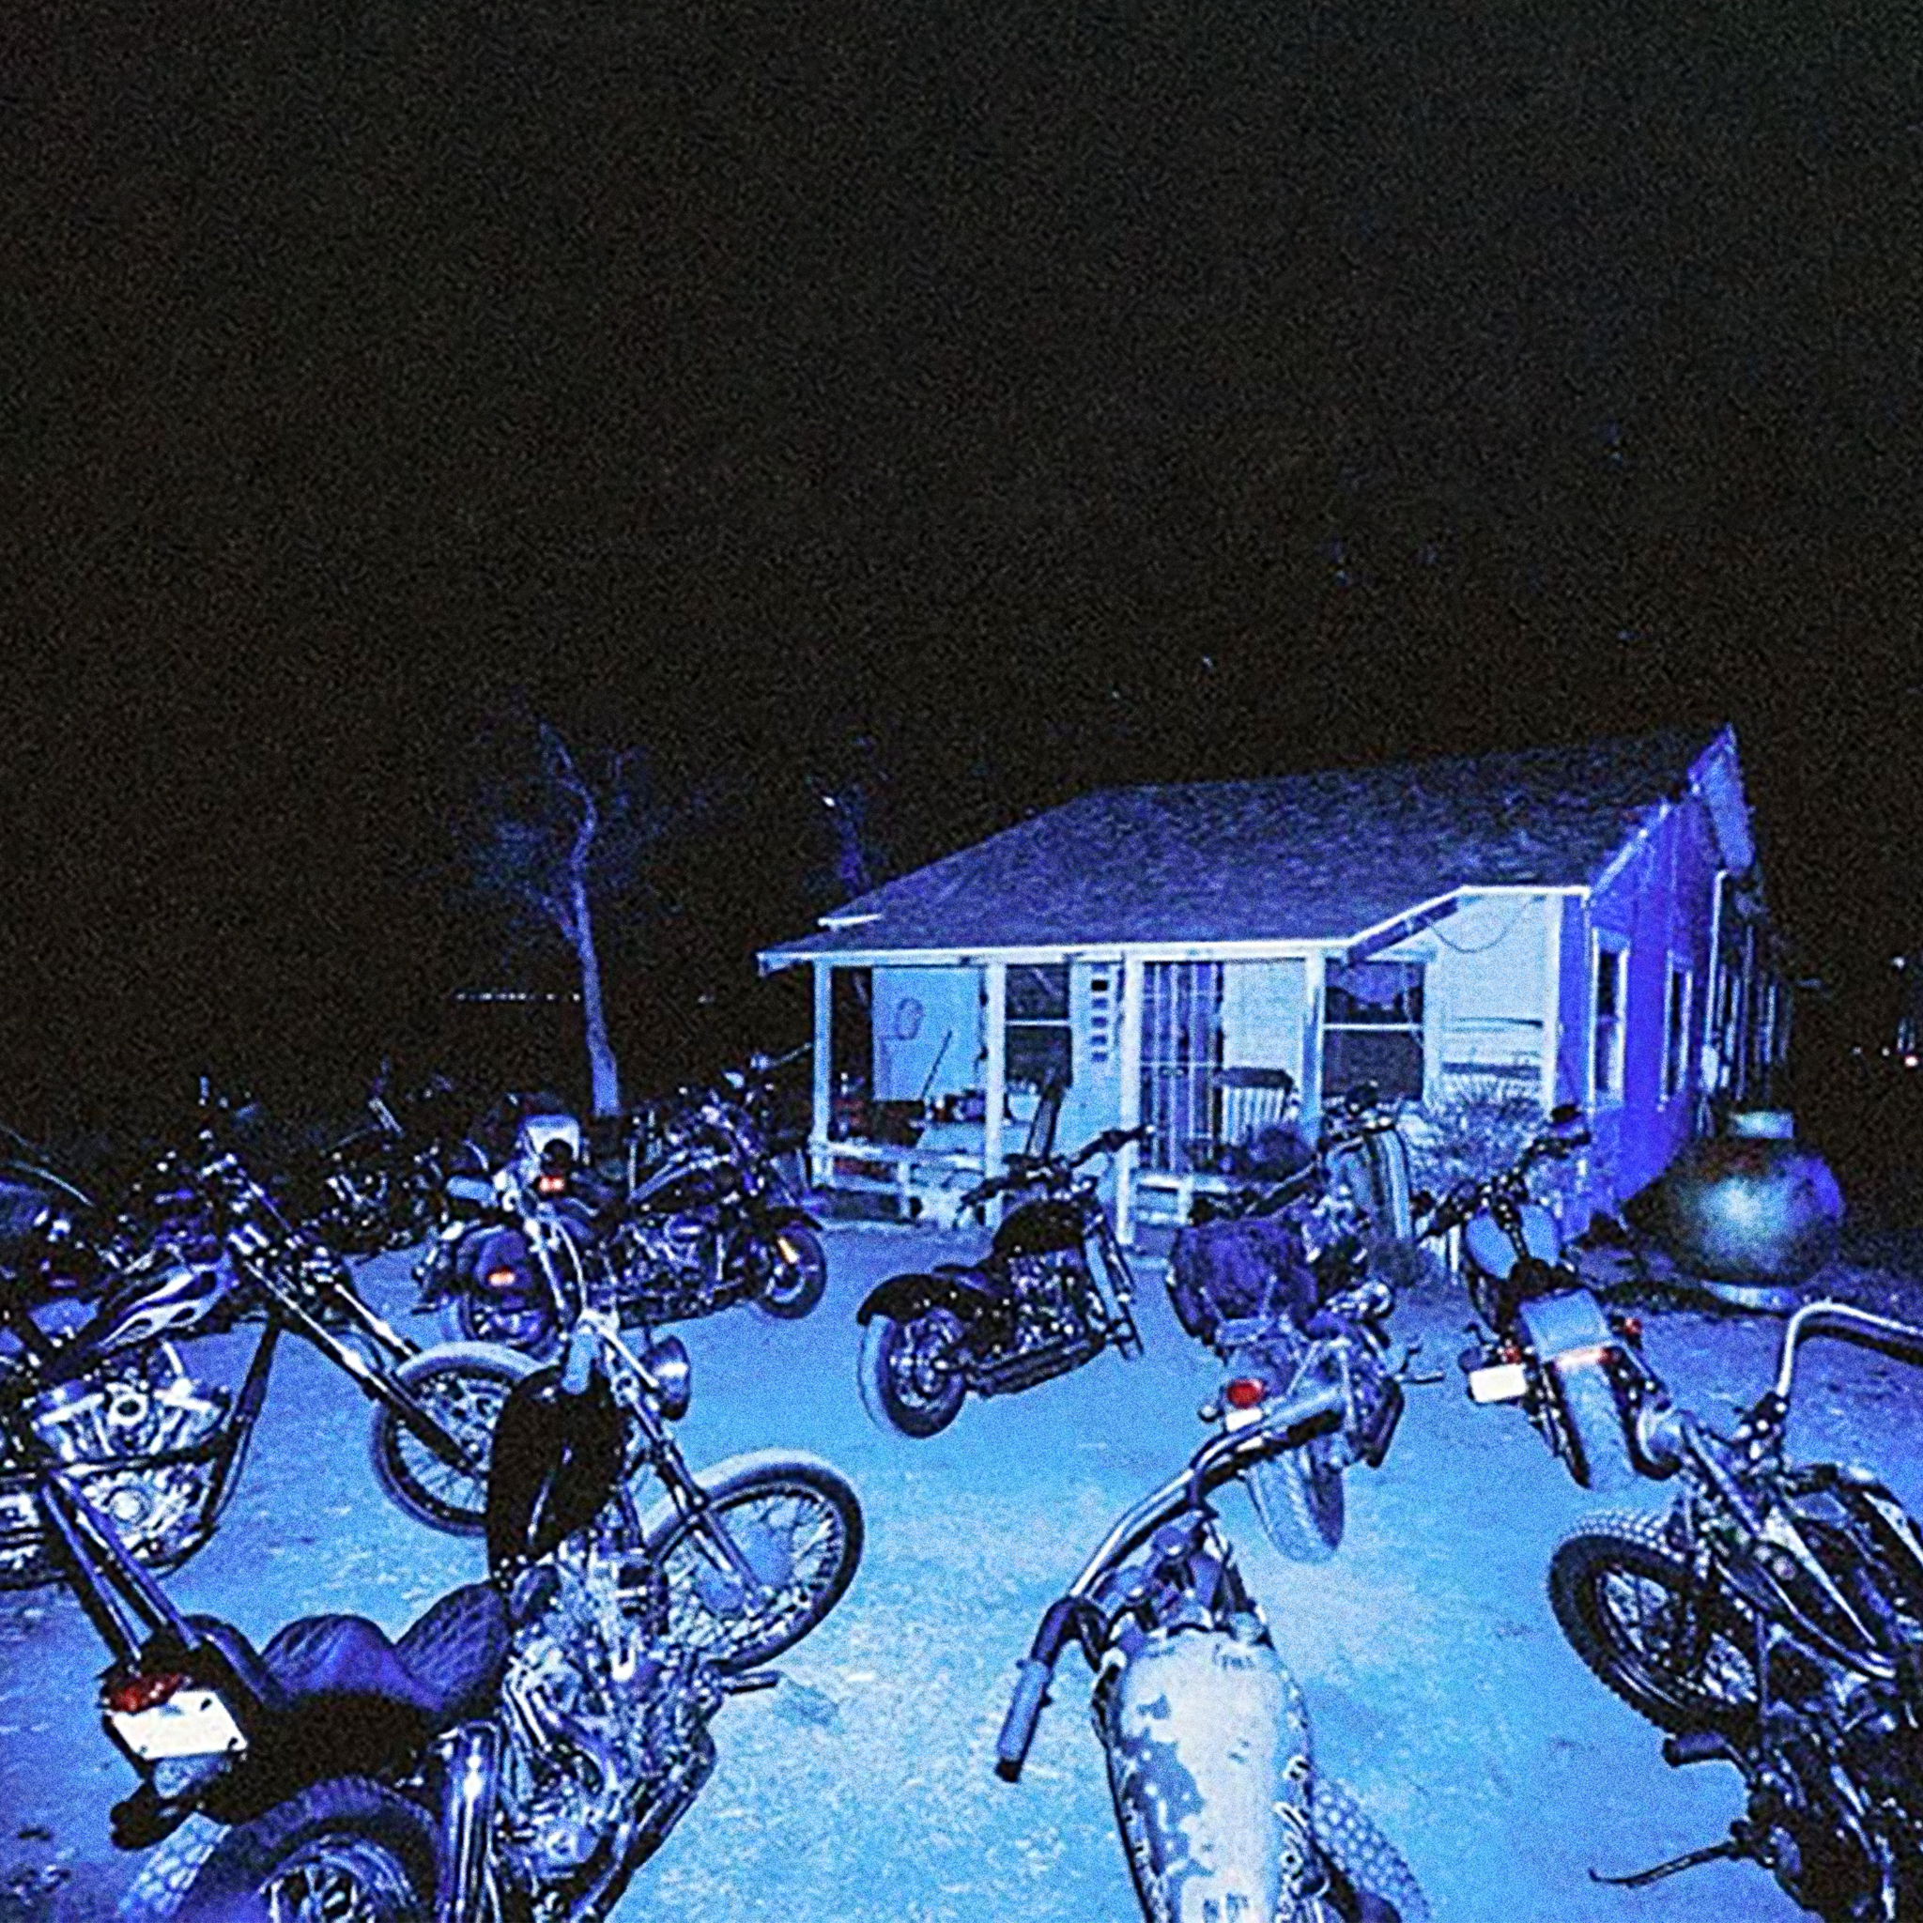
DOWNLOAD HI-RES ARTWORK HERE

Hip-hop soul artist Don Toliver has shared his highly anticipated new single, “Bandit,” available everywhere now via Atlantic Records HERE. Don and his Hardstone crew take center stage in the official music video HERE, riding their motorcycles, including two from Don’s personal collection, all while sporting distinctive custom jackets designed by Elliot Evan, emblazoned with the emblematic "Hard Stone Psycho."

Toliver has been offering sneak peeks of "Bandit" during his live performances since October 2023, leaving fans eagerly anticipating the official release that samples Tame Impala's "One More Hour." “Bandit” marks Don Toliver’s first single since last year’s acclaimed third studio album, Love Sick, available now in an Expanded Deluxe Edition HERE. The album includes standout favorite “Private Landing (Feat. Justin Bieber & Future)” and such hit singles as “Leave The Club (Feat. Lil Durk & GloRilla),” “4 Me (Feat. Kali Uchis),” and “Slow Motion (Feat. WizKid).”

Love Sick arrived alongside the self-written short film, Love Sick, which proved among the year’s most celebrated visuals including three prestigious Telly Awards honoring excellence in video and television across all screens. The video drew top trophies in a trio of “Branded Content” categories, including two Gold Telly Awards: Craft (for Directing and Videography/Cinematography) and a Bronze Telly Award: General (for Music). Further accolades include a prestigious “Best Music Video Film” award at Hollywood’s 5th Annual HollyShorts Film Festival devoted to showcasing the best and brightest short films from around the globe. Presented by Rotation (the hip-hop and R&B brand from Amazon Music), directed by award-winning French filmmaker Alexandre Moors (Kendrick Lamar, Juice WRLD, Miley Cyrus), and produced by Good Company (Lemonade, Pharrell Williams, Adele), Love Sick is streaming exclusively on Prime Video HERE.

Don Toliver – who celebrated the success of Love Sick with a major world headline tour – has slated a number of upcoming festival appearances, including top-billed performances at Hollywood Park, CA's Rolling Loud California (March 17) and New York City's The Governor’s Ball (June 9). For updates and ticket availability, please see www.dontolivermusic.com/tour.

ABOUT DON TOLIVER:
Soul singer, songwriter, and artist Don Toliver has earned worldwide attention for a unique sound that calls out his myriad musical influences of hip-hop, smoked-out R&B, ambitious pop, and even a bit of rock ‘n’ roll, creating a genre-bending lane of his own. After the 2018 mixtape Donny Womack, the Houston, TX native assembled his full-length debut, Heaven Or Hell, which claimed spots on mid-year and year-end lists by Complex and XXL, while Rolling Stone championed him among the “10 Biggest Breakthrough Artists of 2020.” Don then joined forces with Internet Money, NAV, and Gunna for the 4x platinum banger “Lemonade,” which they also performed on NBC’s The Tonight Show Starring Jimmy Fallon. 2021 saw Don team with Lil Durk and Latto for “Fast Lane,” the lead track on Atlantic Records’ F9: The Fast Saga (Original Motion Picture Soundtrack), followed by the blockbuster release of Life of a DON, once again showcasing his fluid ability to exist in multiple soundscapes and featuring production by Mike Dean, Hit-Boy, Mustard, and more. Through it all, he has gathered billions of streams, scored platinum plaques, and received praise courtesy of everybody from such media outlets as V MAN, W Magazine, Interview, and more.

# # #

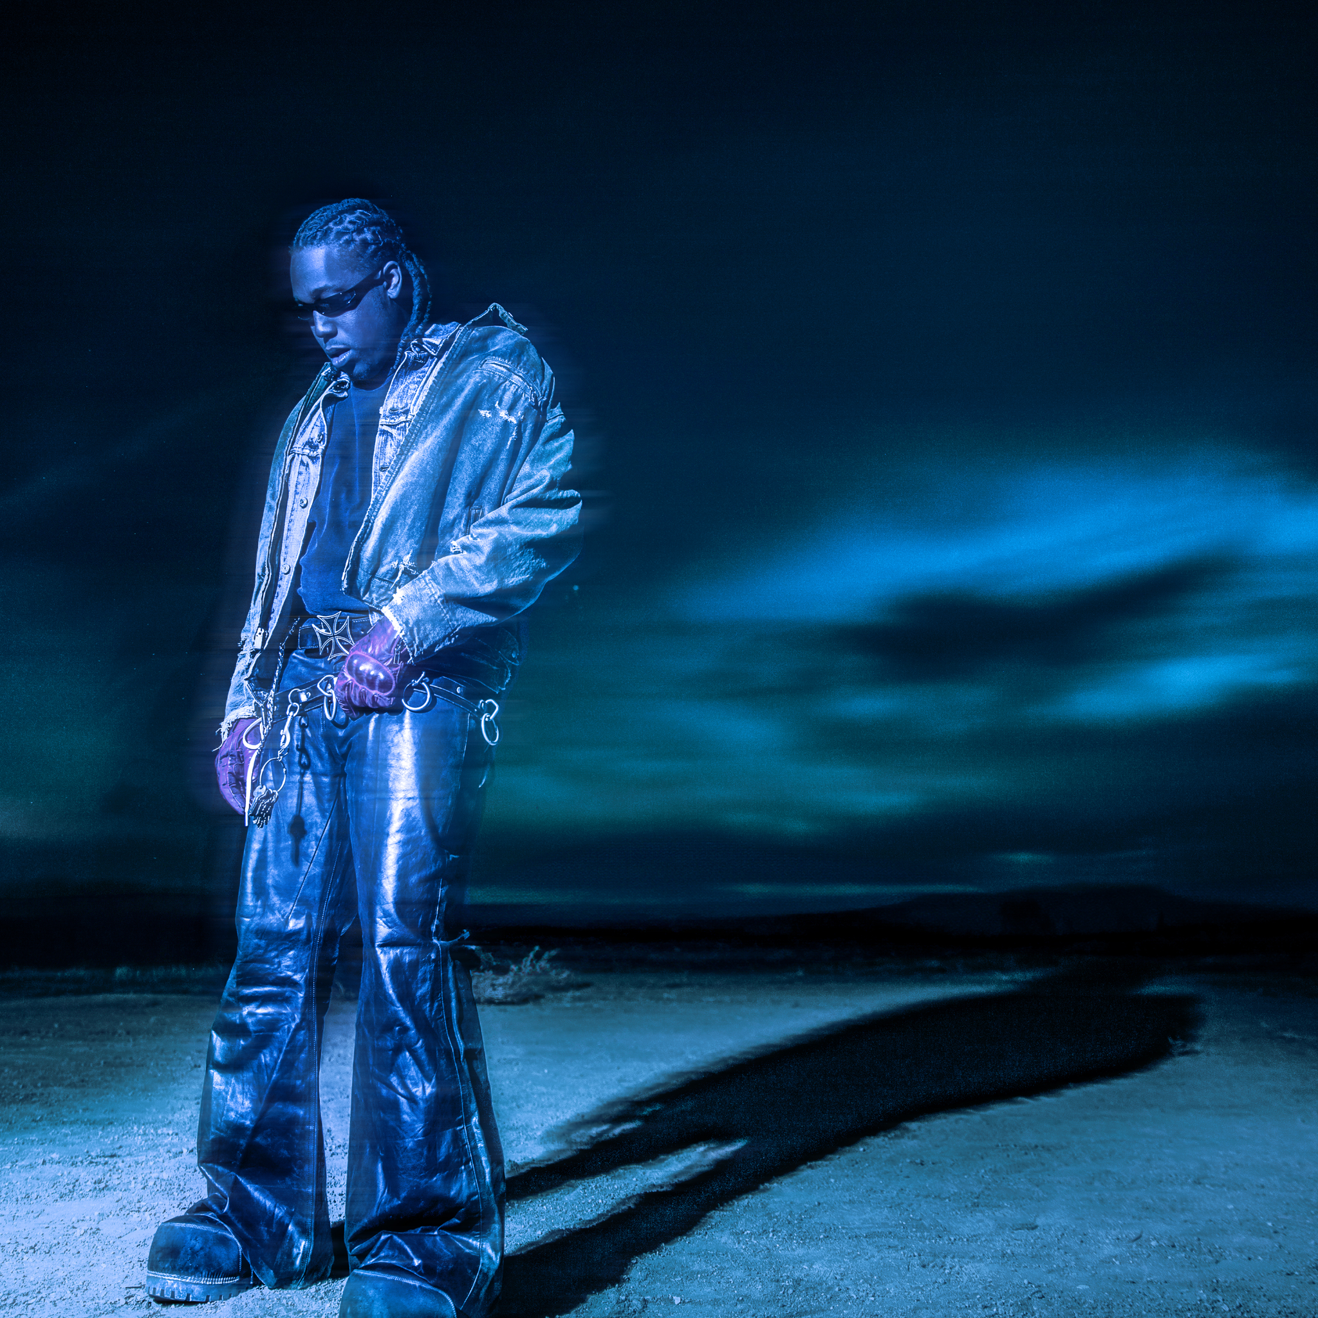
DOWNLOAD HI-RES PRESS IMAGE HERE

CONNECT WITH DON TOLIVER
OFFICIAL I FACEBOOK | INSTAGRAM | TWITTER | YOUTUBE

PRESS CONTACT:
BRITTANY BELL | BRITTANY.BELL@ATLANTICRECORDS.COM

