FOR IMMEDIATE RELEASE
MARCH 25, 2024

FLYANA BOSS DROP NEW TRACK “MONEY AT”

BREAKOUT RAP BESTIES’ LATEST SINGLE HERALDS EAGERLY AWAITED EP

THE BOSSTANICAL GARDEN TOUR CONTINUES THROUGH
SOLD-OUT HOMECOMING SHOW AT LOS ANGELES’ ECHOPLEX
ON MARCH 28

THIS AIN’T THE ALBUM ARRIVES VIA VNCLM_ X ATLANTIC RECORDS
ON FRIDAY, MARCH 29

LISTEN TO “MONEY AT” HERE | WATCH LYRIC VIDEO HERE

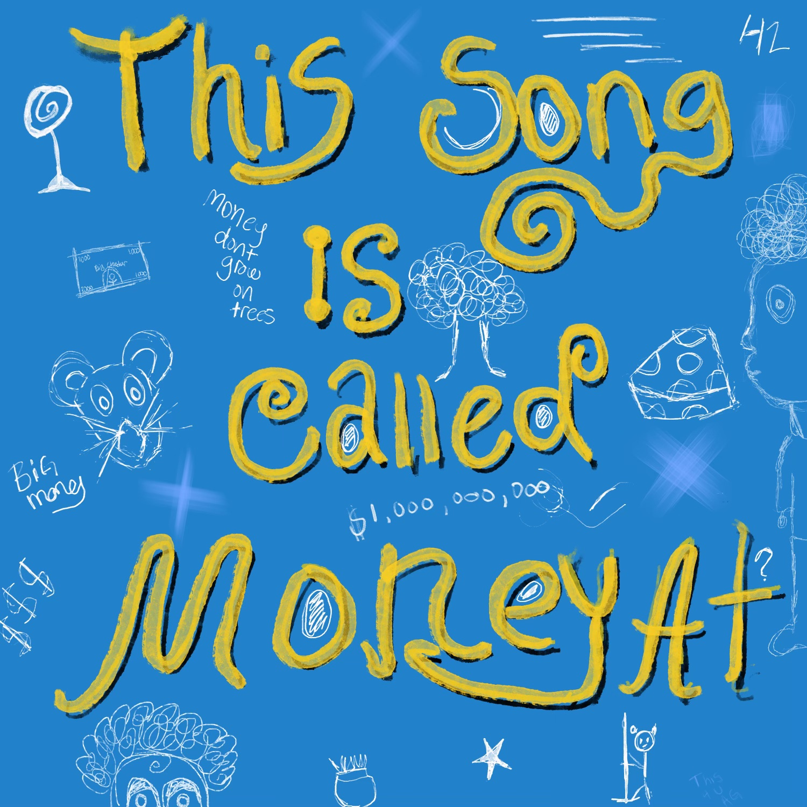
DOWNLOAD HI-RES ARTWORK HERE

Breakthrough rap duo Flyana Boss – a.k.a. besties Bobbi and Folayan – have satisfy hungry fans with today’s premiere of their latest single, “Money At,” available everywhere now via vnclm_ x Atlantic Records HERE. The track releases alongside an official lyric video - Watch HERE.
"You smell that? This city is crawling with rats…but we'll find out where they keep all the cheddar." –Flyana Boss
“Money At” heralds the acclaimed duo’s upcoming EP, This Ain’t The Album, arriving at last on Friday, March 29. The EP also includes such recent hits as “yeaaa” and “Candyman,” the latter of which was hailed by CLASH as “fun as hell… a gushing hymn to romance that shows the lyricists for the self-confessed ‘lover girls’ they truly are.” Official lyric videos are streaming now at YouTube.

Flyana Boss are currently celebrating the impending arrival of This Ain’t The Album on their first-ever headline tour. Now fully sold out, The Bosstanical Garden Tour makes stops along the West Coast wrapping this week and culminating in a sold-out homecoming show at Los Angeles, CA’s Echoplex on March 28. R&B sensation Josh Levi joins as support on all remaining dates.

In addition, Flyana Boss – who spent much of last year touring as special guests on Janelle Monáe’s The Age Of Pleasure Tour and Ke$ha’s The Only Love Tour – are set to light up a number of upcoming festivals, including recent stops at SXSW and at Boise, ID’s Treefort Music Fest, followed by appearances at Gulf Shores, AL’s Hangout Fest (May 17-19) and T-Pain’s Mansion in Wiscansin Festival in Milwaukee, WI (June 8). For updates and ticket availability, please visit www.flyanaboss.com/tour.

# # #

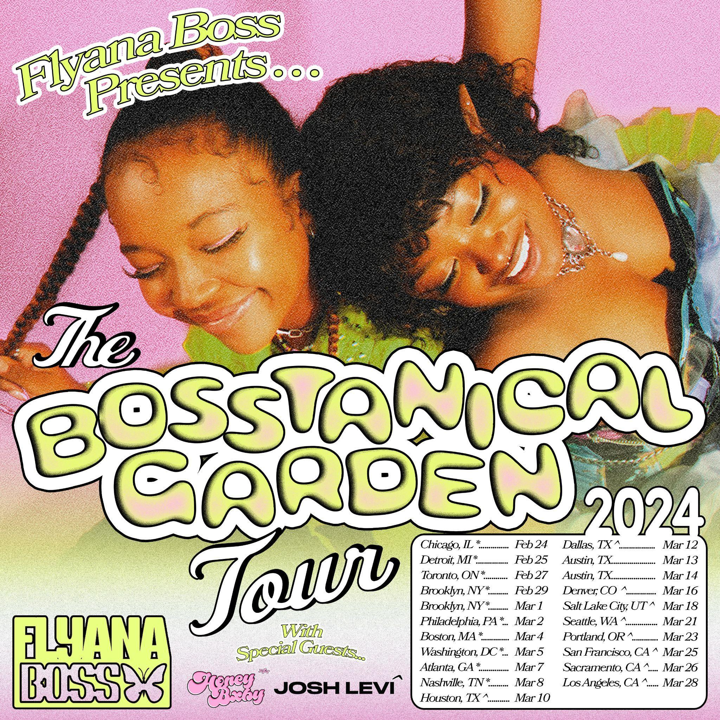
DOWNLOAD ADMAT HERE // PHOTO CREDIT : SJ SPRENG

MARCH
20 - Boise, ID – Treefort Music Fest †
21 – Seattle, WA – Barboza * (SOLD OUT)
23 – Portland, OR – Holocene * (SOLD OUT)
25 – San Francisco, CA – Cafe Du Nord * (SOLD OUT)
26 – Sacramento, CA – Harlow’s – The Starlet Room * (SOLD OUT)
28 – Los Angeles, CA –Echoplex * (SOLD OUT)

MAY
17-19 – Gulf Shores, AL – Hangout Fest †

JUNE
8 – Milwaukee, WI – T-Pain’s Mansion in Wiscansin Festival †

* w/ Special Guest Josh Levi
† Festival Appearance

ABOUT FLYANA BOSS
Hailing from Detroit, MI, and Dallas, TX, MCs and multi-instrumentalists Bobbi LaNea and Folayan met at a Los Angeles music college, immediately hitting it off and forming Flyana Boss (rhymes with Diana Ross). Praised by The Washington Post for their fashion, songwriting, and stage presence, Flyana Boss embodies the spirit of flyness and bossness, describing their unique concept as the “vagina dynasty.” Bursting onto the scene with their breakout single “You Wish,” produced by hitmaker Marky Style, Flyana Boss quickly gained attention, landing the duo a #1 debut on Spotify’s Viral 50 in the US and #6 globally. Following the success of “You Wish,” they dropped an iconic remix featuring rising it-girl Kaliii and the legendary Missy Elliott. The duo then embarked on their debut tour with Janelle Monáe, followed by a special guest appearance on Ke$ha’s The Only Love Tour. The duo continued to make waves with singles like “Bitch Imma Star,” “Big One,” and “UFHO,” recognition as Next Generation Wavemaker Honorees at the Girls Make Beats Gala, and presenting Janelle Monáe with the “Spirit of Soul Award” at the 2023 Soul Train Awards (a request from Janelle herself). Now, with This Ain’t The Album and more to come, Bobbi and Folayan remain committed to creating music that reflects their experiences, pushes boundaries, and uplifts others. With their talent, ambition, and unwavering drive, Flyana Boss is poised to become a prominent force in the hip-hop industry, leaving an indelible mark on music lovers worldwide.

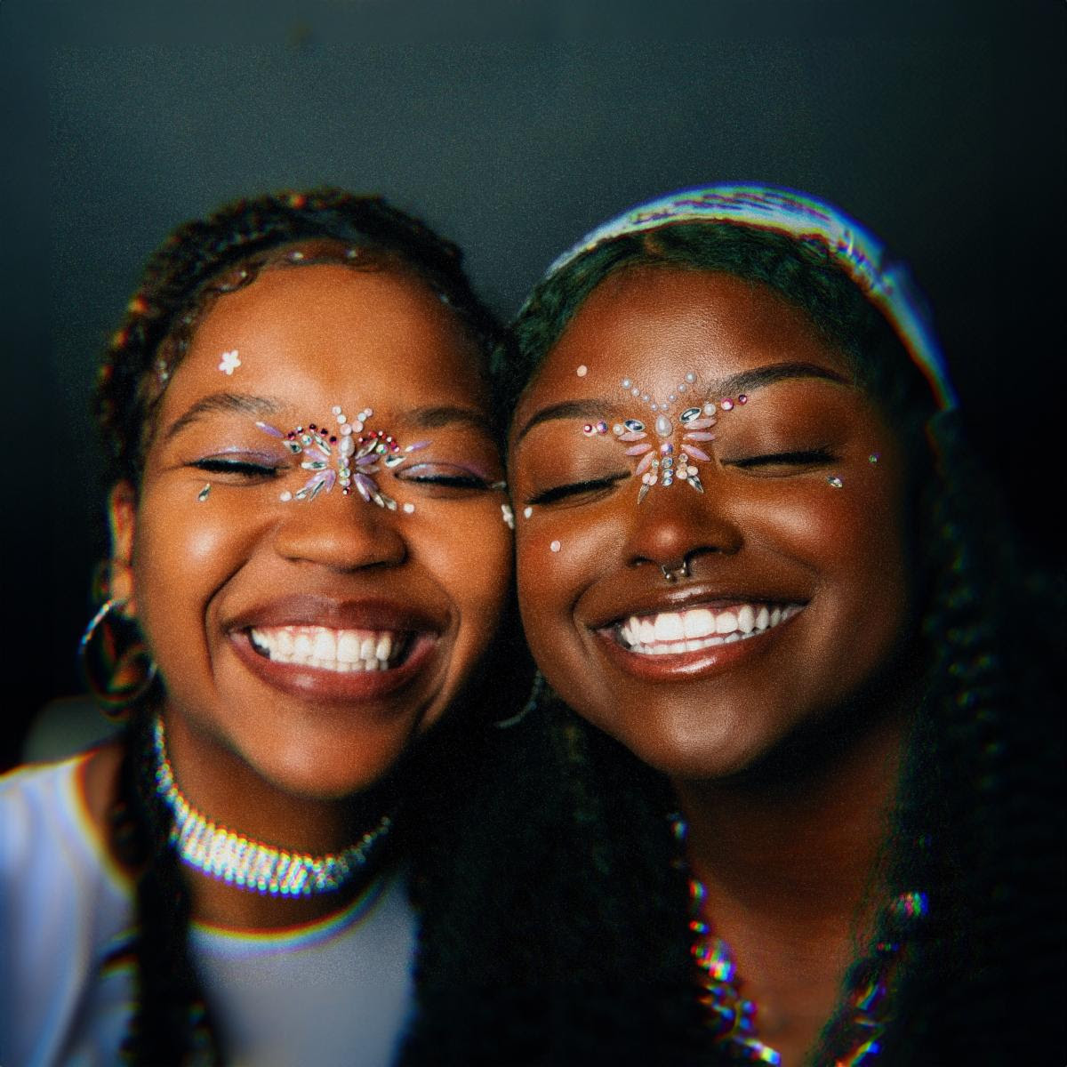
DOWNLOAD HI-RES PRESS PHOTO HERE // PHOTO CREDIT: SJ SPRENG

CONNECT WITH FLYANA BOSS
FLYANABOSS.COM | PRESS SITE | INSTAGRAM | TIKTOK | TWITTER | YOUTUBE

LISTEN TO MORE FLYANA BOSS
“YOU WISH“ | “YOU WISH REMIX“ | “BITCH IMMA STAR“ | “BIG ONE“ | “CANDYMAN“

PRESS CONTACT
FAIRLEY MCCASKILL | FAIRLEY.MCCASKILL@ATLANTICRECORDS.COM

