JOHNNY YUKON UNLEASHES “RIGHT NOW!”

ACCOMPANIED BY CINEMATIC MUSIC VIDEO
DIRECTED BY GRIFFIN OLIS

DOWNLOAD/STREAM | WATCH HERE

NEW SINGLE FOLLOWS 10-TRACK PROJECT MOVIES! WORLDWIDE: PART I

ACCLAIMED SONGWRITER RECENTLY CO-WROTE DON TOLIVER'S LATEST SINGLE “DEEP IN THE WATER”

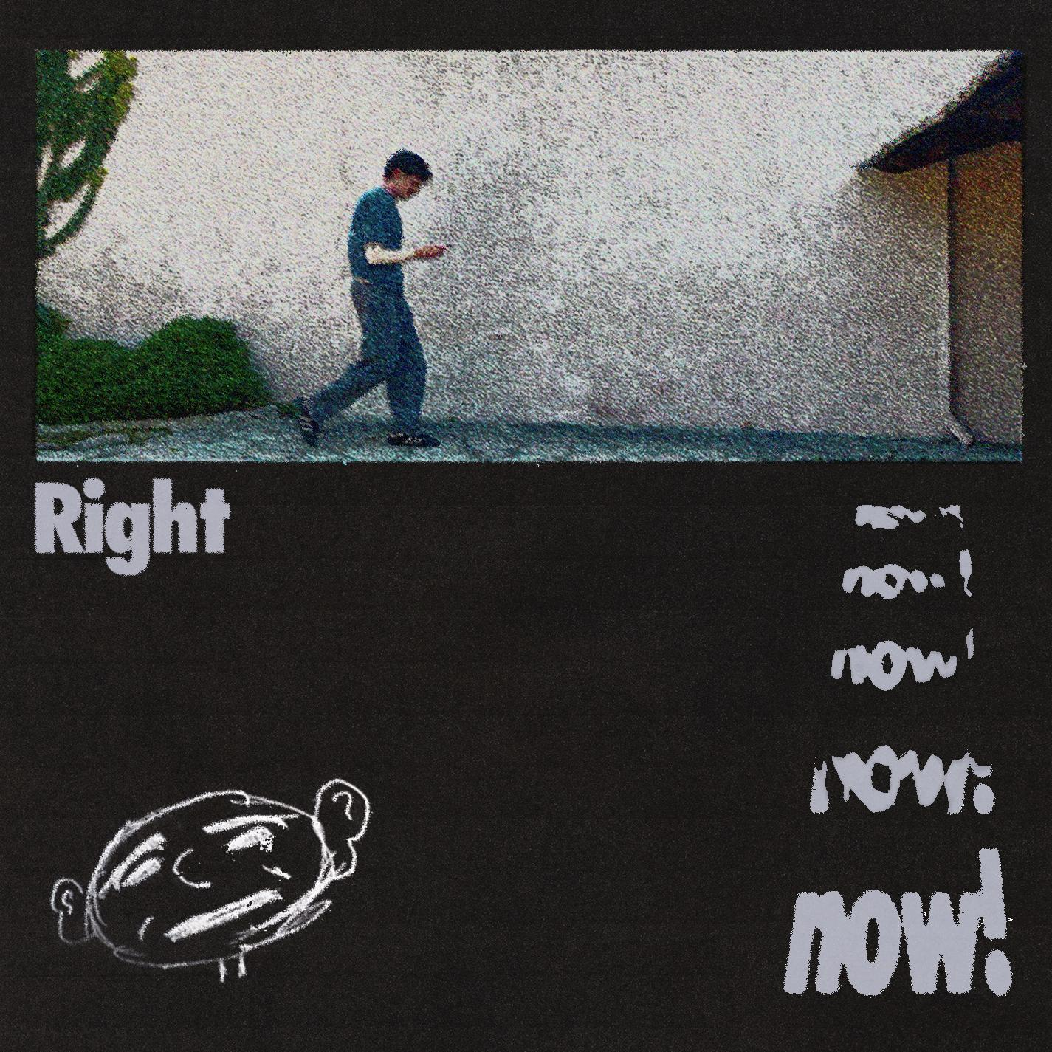
DOWNLOAD PRESS ASSETS HERE

​“Johnny Yukon’s resume reflects the range of influences on his own sound…”
-BILLBOARD

“Talented emerging artists making their mark this winter”
-PEOPLE

“Johnny Yukon is on a roll right now.”
– VARIANCE MAGAZINE

Known for pairing his projects with grainy visuals captured on Super 8 film and fashion-forward stills rooted in vintage, yet modern panache, Johnny Yukon upholds consistent cinematic motifs across sound and style. His world draws as much from Kubrickian attention to detail and Christopher Nolan-style scope as it does from unpredictable production and hazy melodicism. With a goal to “make bigger music that reaches a lot of people,”the Pennsylvania-born and Los Angeles-based artist kickstarted what has proven a truly prolific creative streak with such vibrantly original tracks as “Whispers,” “Moment“ (currently boasting over 2.6M Spotify streams), “Comet,” “Whatever You Want,” and a dazzling cover of The Buggles’ timeless “Video Killed The Radio Star.”

Alongside his own evolving body of work, Yukon is an in-demand collaborator, songwriter and producer partnerships alongside the likes of Lil Wayne, David Guetta, Ciara, Charlie Puth, Flo Rida, gnash, Alex Da Kid, Dr. Luke, JR Rotem, and Frank E, to name only a few.

High-water marks thus far include Jennifer Lopez’s 2016 charity single, “Love Make the World Go Round (Feat Lin-Manuel Miranda)” – which marked Yukon’s first Billboard “Hot 100” hit – and Internet Money’s RIAA 4x Platinum-certified blockbuster “Lemonade (Ft. Don Toliver, Gunna & Nav),” which reached #6 on the “Hot 100” and topped charts in the United Kingdom, Greece, and Portugal upon its 2020 release.

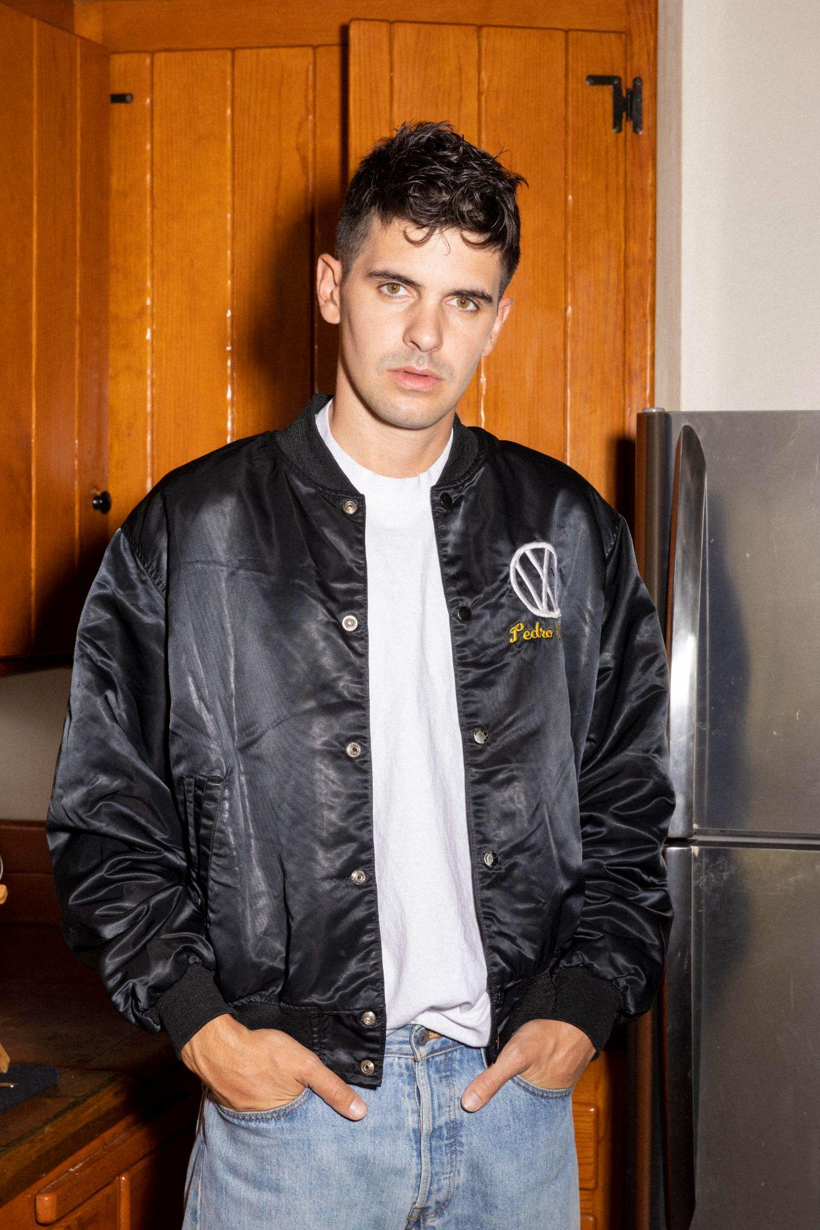
DOWNLOAD PRESS ASSETS HERE

CONNECT WITH JOHNNY YUKON
JOHNNYYUKON.COM | INSTAGRAM | TIKTOK | X | YOUTUBE | PRESS SITE

FOR ALL PRESS INQUIRIES, PLEASE CONTACT:
Jason Davis – jason.davis@atlanticrecords.com
Taylor Apel - taylor.apel@atlanticrecords.com

