FOR IMMEDIATE RELEASE
MARCH 8, 2024

NOLAN TAYLOR RELEASES FAN-FAVORITE COVER OF “BLUEFOOT”

STIRRING TAKE ON LOGAN HALSTEAD SONG PREMIERES TODAY
LISTEN HERE

ACOUSTIC PERFORMANCE VIDEO STREAMING NOW
WATCH HERE

CINCINNATI HEART TOUR GETS UNDERWAY MARCH 14 IN PHILADELPHIA

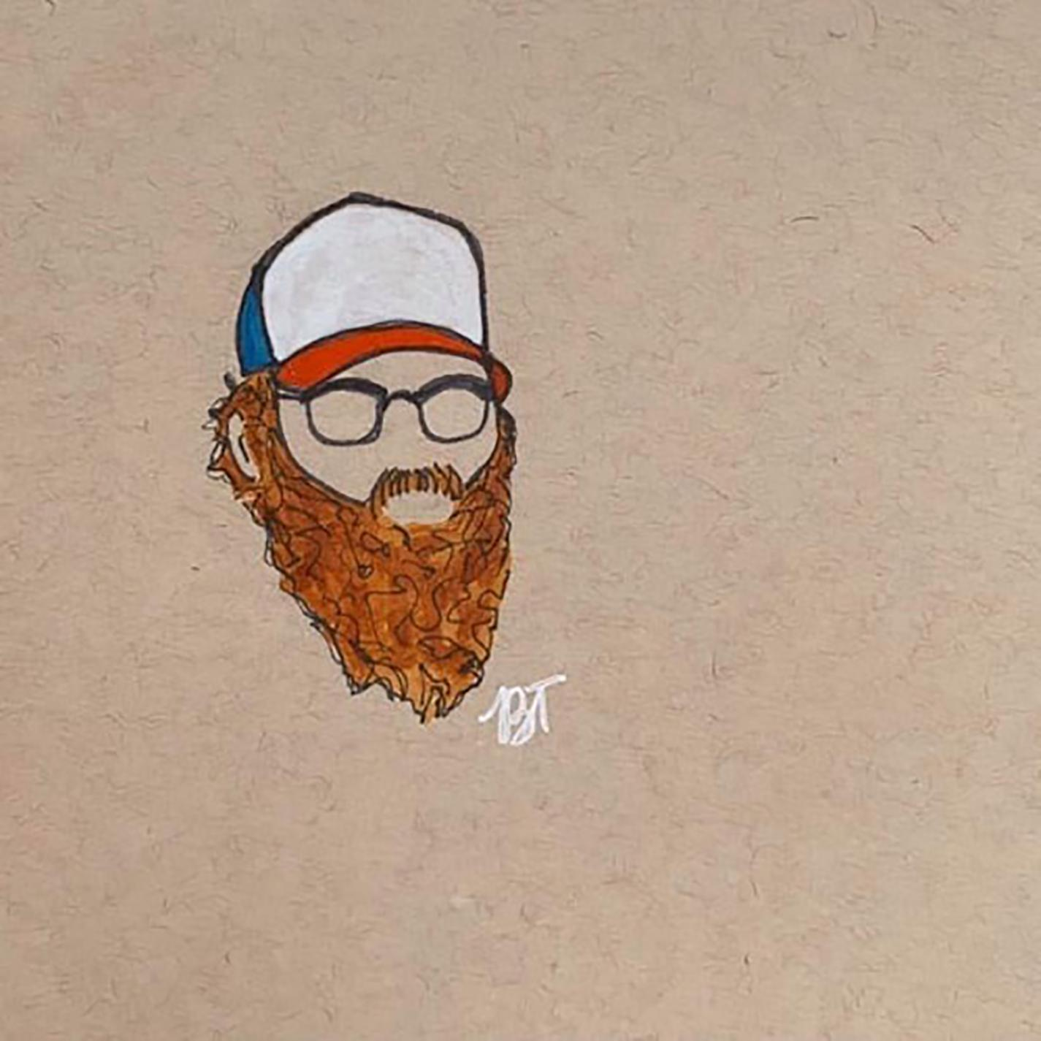
DOWNLOAD HI-RES ARTWORK + PRESS IMAGES

Rising singer-songwriter Nolan Taylor releases his fan-favorite cover of Logan Halstead’s, “Bluefoot.” Initially uploading the cover to SoundCloud in 2022, the Ohio-Native quickly gained support for his rendition and is now sharing it across all platforms via Atlantic Records HERE. The track is joined by a stirring live performance video premiering today HERE.

“Bluefoot” continues a string of powerful releases from Taylor, including such singles as “Cincinnati Heart,” “Double Life,” and “Wicked Ways,” as well as the EPs, Life & Love and radiowv, the latter highlighted by an unplugged version of “500“ streaming on the influential radiowv channel HERE. An array of live acoustic renditions, lyric videos, and more can be viewed now at Taylor’s official YouTube channel HERE.

Taylor is currently set to embark on his first-ever headline run with support from Clarke Sexton, Jack Wharff, Zandi Holup, Logan Halstead, and William Matheny. The Cincinnati Heart Tour kicks off March 14 at Philadelphia, Pennsylvania’s Milkboy and then travels through June, with highlights including stops at such historic venues as New York City’s Mercury Lounge (March 22) and Nashville, Tennessee’s The Basement East (April 12). In addition, coming months will see Taylor making festival appearances and sharing stages with such like-minded artists as Sam Barber and a sold-out show with The Red Clay Stays at Nashville’s world-famous Ryman Auditorium (September 5). For complete details and ticket information, please visit www.nolantaylormusic.com.

WATCH NOLAN TAYLOR’S GRAND OLE OPRY DEBUT
WATCH ‘LIFE LOVE’ LIVE DREAMY DRAW SESSION FOR HOLLER
WATCH A FULL SET LIVE PERFORMANCE ON JAM IN THE VAN
WATCH OLIVER ANTHONY PRAISE NOLAN ON JOE ROGAN EXPERIENCE
LISTEN TO THE LIVE VERSION OF FAN FAVORITE “DOUBLE LIFE”
WATCH WICKED WAYS [LIVE]

THE CINCINNATI HEART TOUR
With Support from Clarke Sexton, Jack Wharff, Zandi Holup, Logan Halstead, and William Matheny

MARCH
14 – Philadelphia, PA – Milkboy ^
15 – Washington, DC – The Hamilton ^
16 – Richmond, VA – The Broadberry ^^
21 – Cambridge, MA – The Sinclair ^^^
22 – New York, NY – Mercury Lounge ^^^
23 – Buffalo, NY – Buffalo Iron Works ^^^
APRIL
9 – Athens, GA – 40 Watt Club ^^^
10 – Knoxville, TN – Open Chord ^^^
11 – Louisville, KY – Zanzabar ^^^
12 – Nashville, TN – The Basement East ^^^
18 – Birmingham, AL – Saturn ***
19 – Fort Worth, TX – Tulips
20 – Georgetown, TX – Two Step Inn 2024 †
21 – Beaumont, TX – 7 Oaks
30 – Los Angeles, CA – The Roxy ****
MAY
2 – Kansas City, MO – Record Bar ^^^
3 – Columbia, MO – Rose Music Hall ^^^
4 – St. Louis, MO – Old Rock House ***
8 – Atlanta, GA – Terminal West ^^^
9 – Charlotte, NC – Amos’ Southend ^^^
10 – Ashland, KY – Paramount Arts Center
11 – Indianapolis, IN – Hi-Fi Annex
16 – Pittsburgh, PA – Thunderbird Music Hall *
17 – Columbus, OH – The Bluestone *
31 – Virginia Beach, VA – Elevation 27 **

JUNE
1 – Durham, NC – Motorco Music Hall **
2 – Lexington, KY – Railbird Music Festival †
27 – Des Moines, IA – xBk Live
29 – Omaha, NE – Reverb Lounge **

JULY
21 – Redmond, OR – FairWell Festival †

SEPTEMBER
5 – Nashville, TN – Ryman Auditorium # (SOLD OUT)

^ Clarke Sexton
^^ Jack Wharff
^^^ Zandi Holup
* Logan Halstead
** William Matheny
*** w/ Sam Barber
# w/ The Red Clay Strays
† Festival Appearance

# # #

ABOUT NOLAN TAYLOR
The backroads of America tell its truest stories. The heartbreak and heartbeat of the country thumps the loudest in the cracks between its big cities. A 2021 census in Blanchester, OH registers the village’s population at around 4,230 people. Nolan Taylor isn’t quite sure of the exact number, but he knows it’s small from growing up in this place with his dad and older brother. His father managed plants and factories, yet money was scarce, and the winters were brutal. Mom battled addiction and mental struggles, eventually estranging her from the boys. As a kid, Taylor found solace in music, discovering The Grateful Dead through his dad while developing an appreciation for Pinegrove. Throughout junior high, he studied classic MTV Unplugged concerts by the likes of Alice In Chains, Pearl Jam, and Nirvana. When Taylor could finally afford a left–handed guitar, he began to write and record music of his own, grafting hard-earned wisdom, heart-wrenching memories, and hypnotic melodies to rustic and ruddy acoustic phrasing. After graduating high school, he hit the road, playing anywhere and everywhere around West Virginia, Virginia, and Kentucky. In 2023, a live performance of “68“ filmed in the backwoods of West Virginia lit up the influential radiowv channel, now boasting over 4.5M views HERE. Taylor soon signed with Atlantic Records and began a new journey that has seen a steady stream of new releases, his debut performance at Nashville’s iconic Grand Ole Opry, and shows alongside such artists as The Red Clay Strays, Charley Crockett, 49 Winchester, Morgan Wade, and Charles Wesley Godwin.

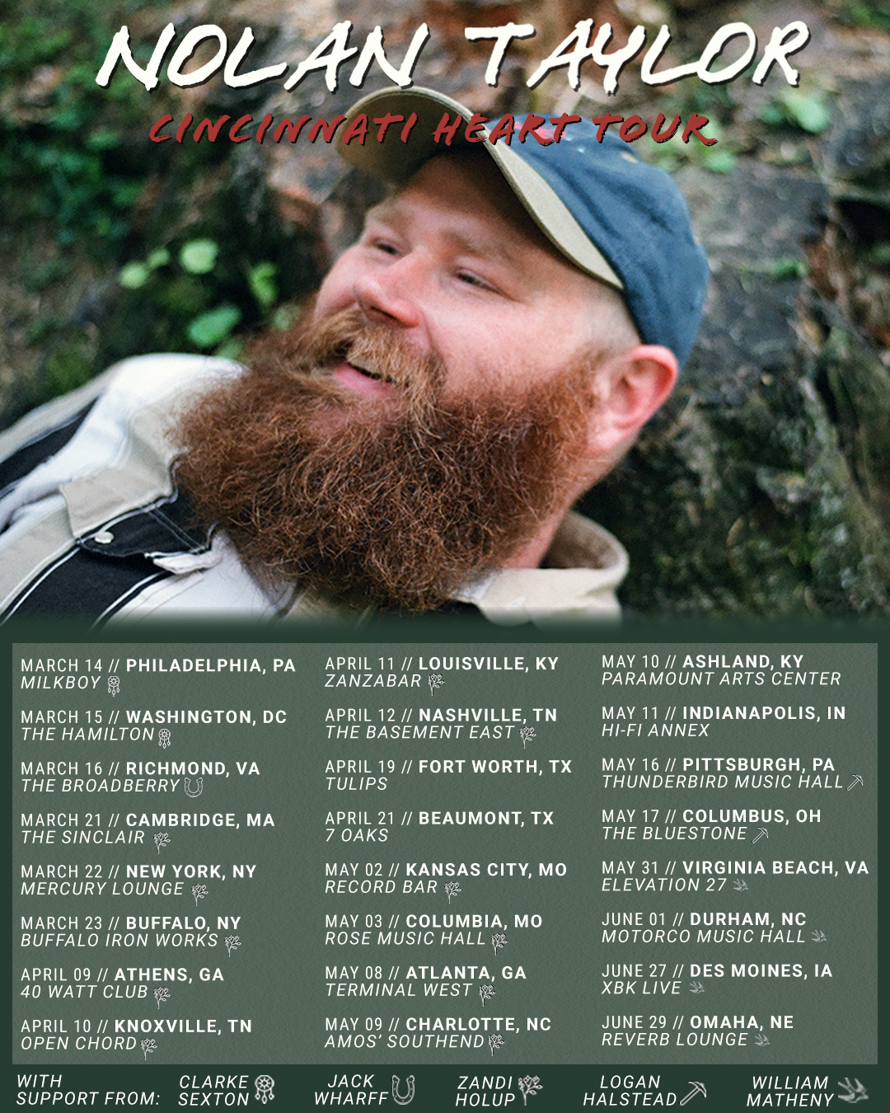
DOWNLOAD HI-RES ARTWORK + PRESS IMAGES

# # #

CONNECT WITH NOLAN TAYLOR
OFFICIAL | FACEBOOK | INSTAGRAM | SPOTIFY | TIKTOK | YOUTUBE

PRESS CONTACTS
Corey Brewer | Corey.Brewer@atlanticrecords.com
Jensen Sussman | Jensen@sweettalkpr.com

